

[Document title]

[Document subtitle]



[Date]

[Company name]

[Company address]

Contents

List of Figure 1

Code 1

Output 2

# List of Figure

Figure 1: PSD of signal 2

Figure 2: Design Filter 2

Figure 3: Noise Remove 3

# Code

clear; close all; clc;

% Edit following to point to location of the recording on your system

fname = 'BachWithNoise.ogg';

[y,Fs]=audioread(fname);

obj=audioplayer(y, Fs);

play(obj)

%% Power Spectral Density

windLength = 2048;

wind = hamming(windLength);

% PSD for channel 1

[Pyy,f]=pwelch(y(:,1),wind,[],[],Fs);

figure(1)

plot(f,10*log10(Pyy));grid

xlabel('Frequency (Hz)')

ylabel('Pyy (dB/Hz)')

title('PSD of Signal with High Frequency Noise')

[z,fs]=audioread('BachWithNoise.ogg');

bfil=fft(z); %?t of input signal

wn=[4000 8000]/(fs/2); %bandpass

[b,a]=butter(6,wn);

fvtool(b,a);

f=filter(b,a,z);

after_noise_remove=audioplayer(z, fs);

play(after_noise_remove)

afil=fft(f);

figure(2)

subplot(2,1,1)

plot(real(bfil))

title('frequency respones of input signal');

xlabel('frequency');

ylabel('magnitude');

subplot(2,1,2);

plot(real(afil));

title('frequency respones of filtered signal');

xlabel('frequency');

ylabel('magnitude');

# Output

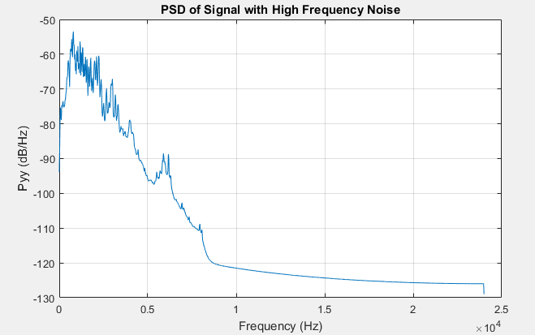

Figure : PSD of signal

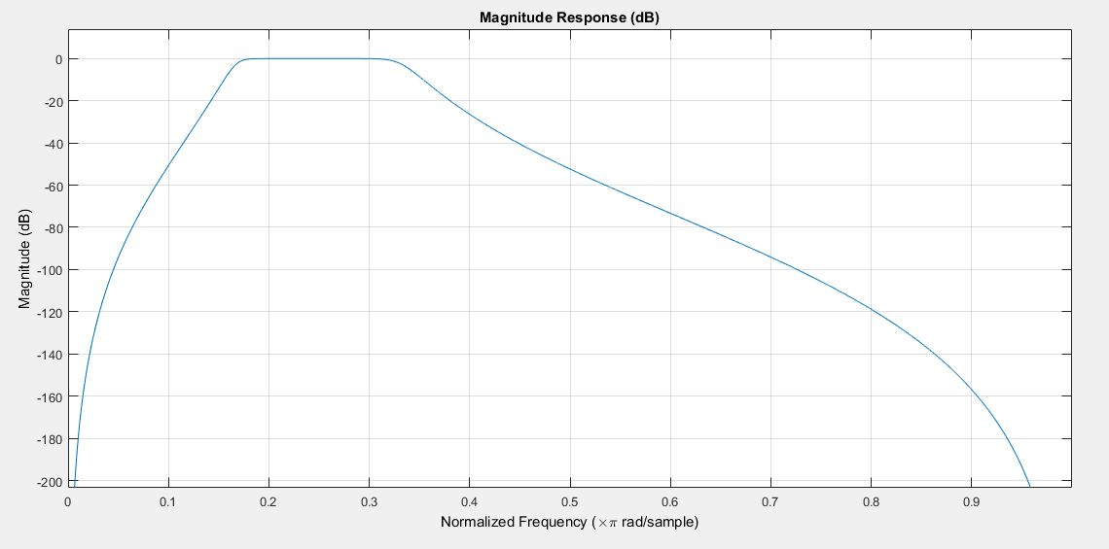

Figure : Design Filter

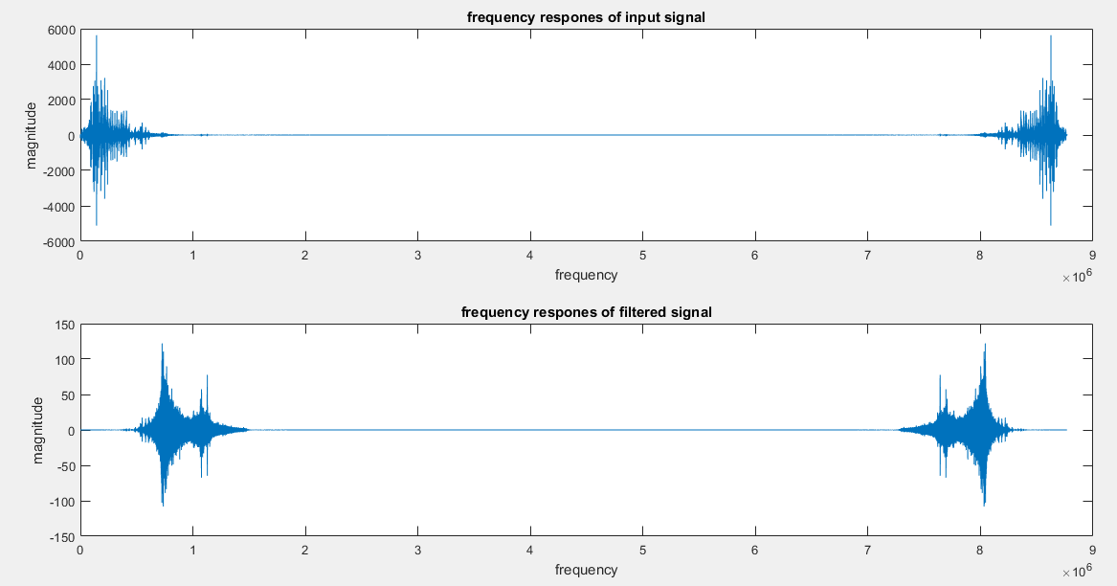

Figure : Noise Remove