# Objective

* Solve the block diagram
* Solve series sub system
* Solve parallel sub system
* Solve feedback sub system

# Code

## Problem 01

clc

clear all

G1=tf([1 1 ],[1 2 8])

G2=tf(2,[1 3])

part_a=series(G1,G2)

part_b=parallel(G1,G2)

part_c=feedback(G1,G2)

## Output

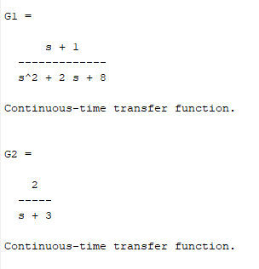

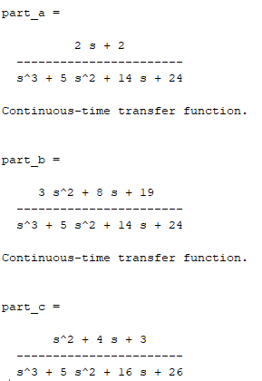

## Problem 02

clc

clear all

sys1=tf(4,1)

sys2=tf(2,[1 9 8])

sys3=tf(1,[1 0])

sysh=tf(0.2,1)

Output=feedback(series(series(feedback(sys2,sysh),sys3),sys2),1)

## Output

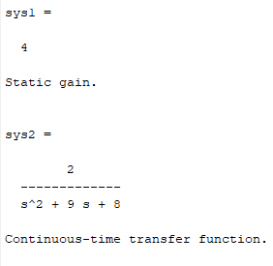

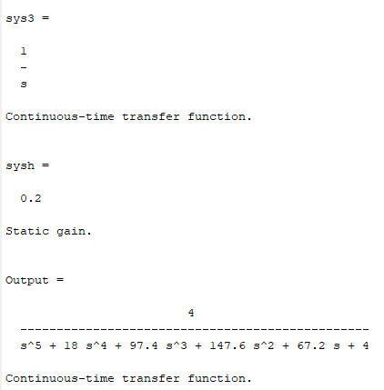

# Conclusion

We learn about the block representation and solve these sub systems into one system. For the lab session we use the build in function that perform the all case. First one is series, in which we multiply the response of both and in second case which say is parallel representation. In the parallel representation we add the response of the sub system. Last case is the feedback representation, in which we use the formula for the solving the feedback system. For the feedback we use the first system as it in numerator and then in denominator, one minus the product of system response and feedback response value. In the denominator sign is the opposite the as the feedback sign.