**ECE 315**

**Lab 2 Matlab representation of system in block diagram form**

**Description:** In this experiment, we will implement Matlab representation of system in block diagram form

The Matlab commends include:

sys = tf (num, den)

sys = series(sys1,sys2)

sys=parallel(sys1,sys2)

sys=feedback(sysg,sysh)

**MATLAB Program:**

1. Obtain the transfer function of the cascaded system, parallel system, and feedback system show in Figure 1. Assume that $G_{1}\left(s\right)$ and $G_{2}\left(s\right)$ are as follows:

$G_{1}(s)=\frac{s+1}{s^{2}+2s+8}$, $G_{2}\left(s\right)=\frac{2}{s+3}$

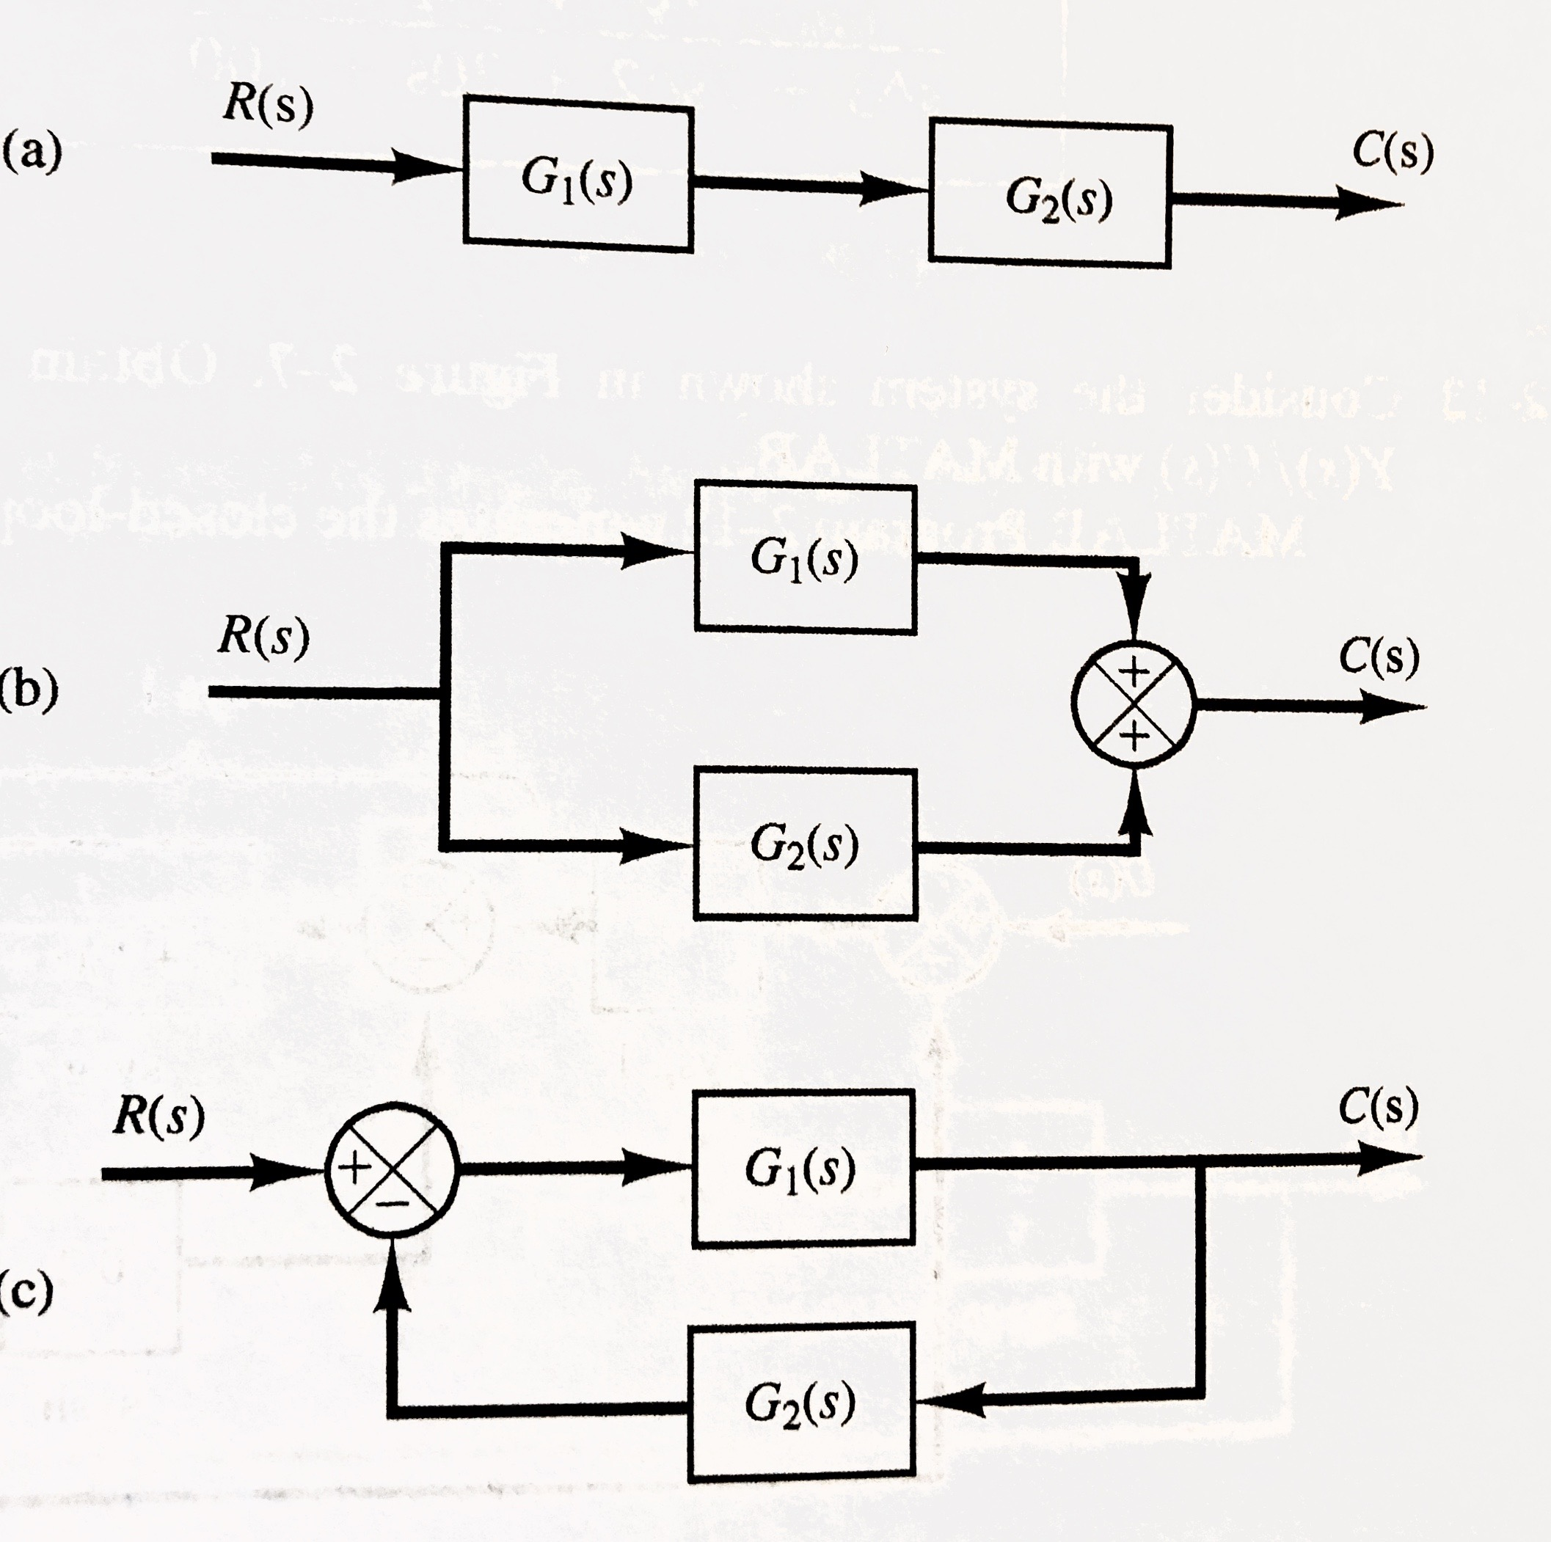

Figure 1

1. Consider the system shown in Figure 2. Obtain the closed-loop transfer function $\frac{Y(s)}{U(s)}$ with Matlab

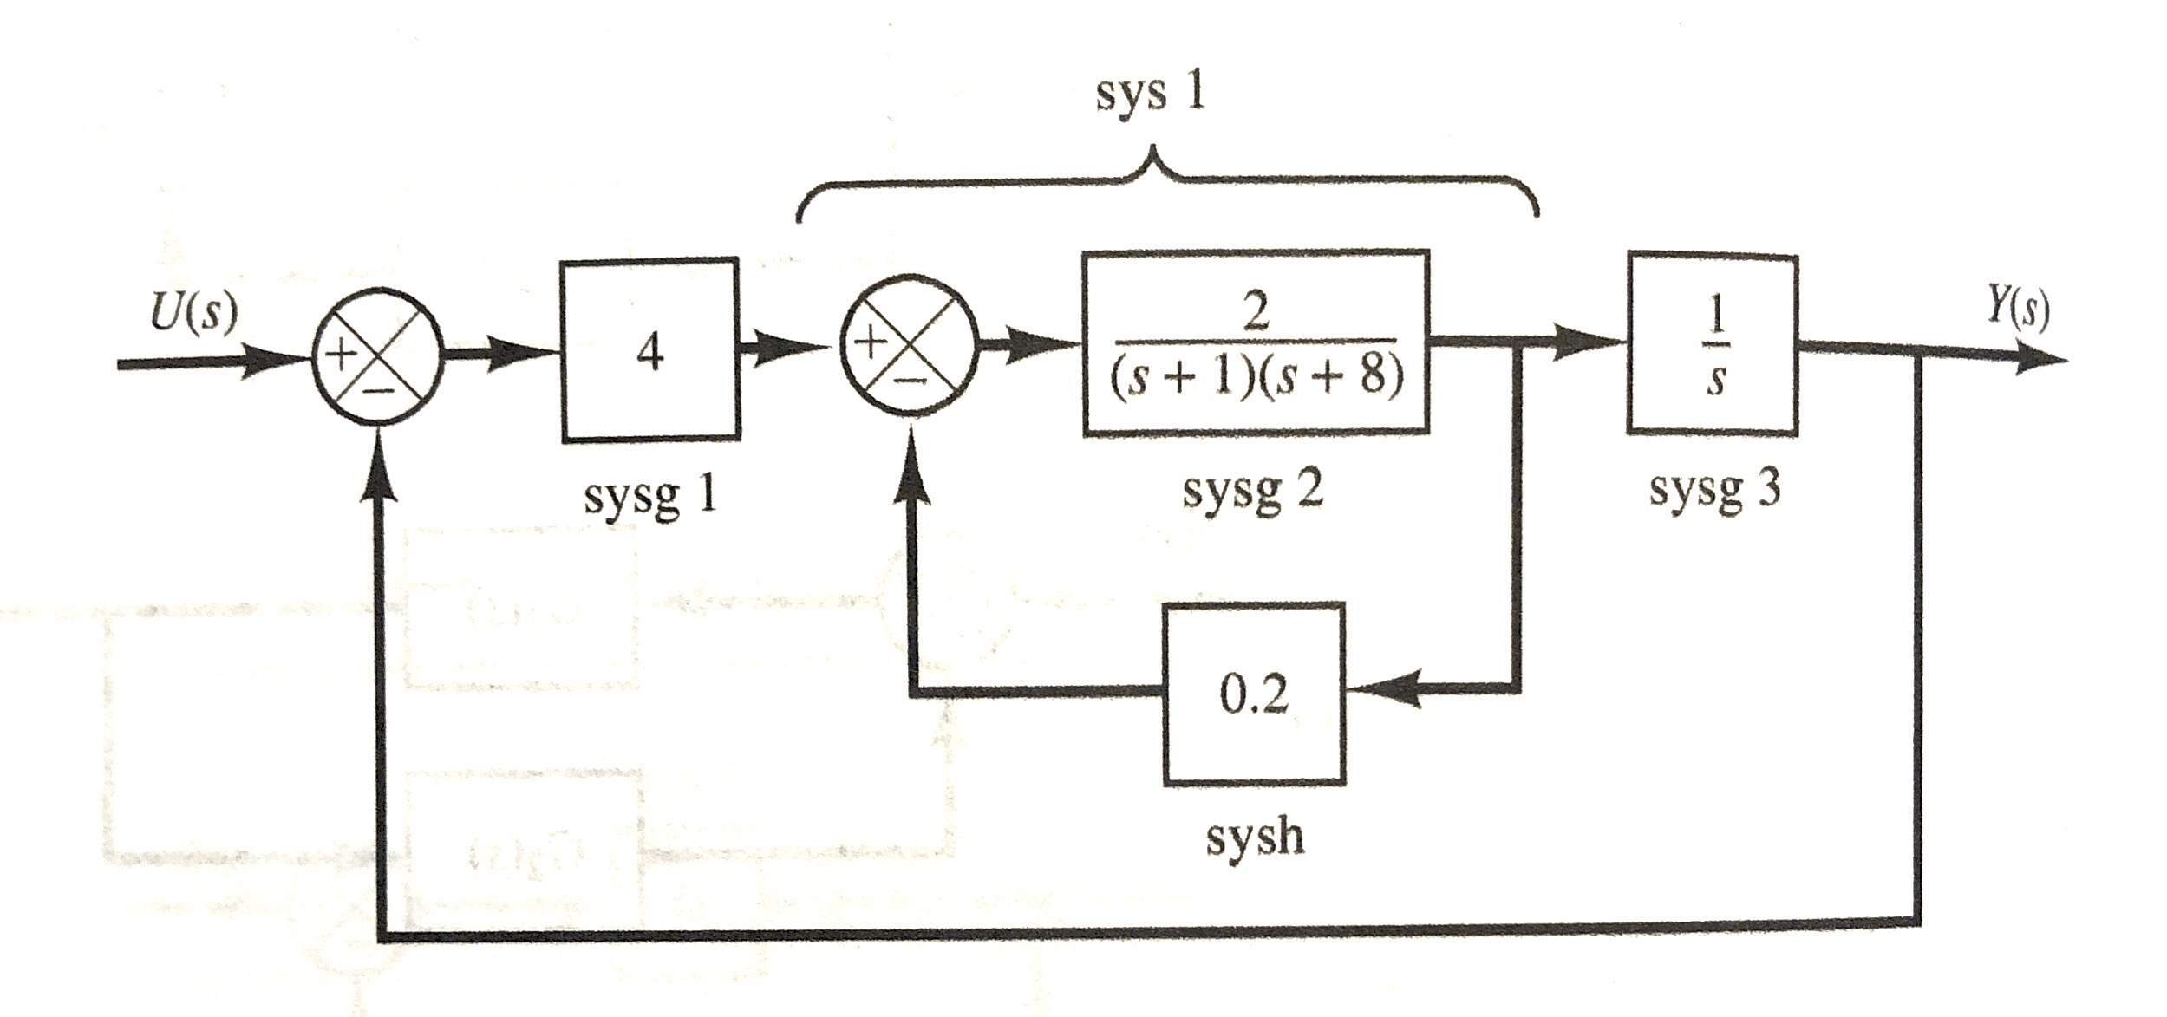

Figure 2

Submit requirements:

1. Objective of the lab
2. The results for problem 1 and 2
3. Matlab .m file
4. Screen short
5. Conclusions