1. In physics, an object that is in motion is said to have kinetic energy. The following formula can be used to determine a moving object’s kinetic energy: $$KE= \frac{1}{2}mv^{2}$$ 
     
   The variables in the formula are as follows: KE is the kinetic energy, m is the object’s mass in kilograms, and v is the object’s velocity, in meters per second.  
   Write a function named kinetic Energy that accepts an object’s mass (in kilograms) and velocity (in meters per second) as arguments. The function should return the amount of kinetic energy that the object has. Demonstrate the function by calling it from a script file that calculates and displays kinetic energy for objects of masses 1, 2, 3, 4, and 5 kilograms, each at velocities of 1, 2, 3, 4, 5, 6, 7, 8, 9, and 10 meters per second.

Code

function KE=kinetic_energy(m,v)

KE=(m*v.^2)/2;

end

clc

clear

% Q01

for i=1:5

for j=1:10

KE=kinetic_energy(i,j);

disp(['Kinetic Energy at m=',num2str(i),' and v=',num2str(j),' is ',num2str(KE)])

end

end

Output

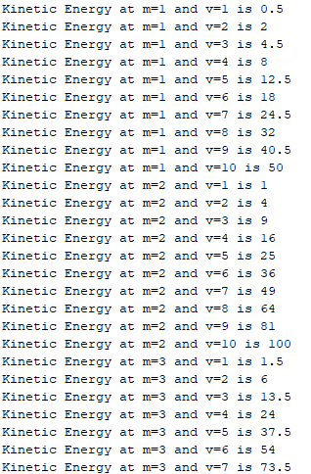

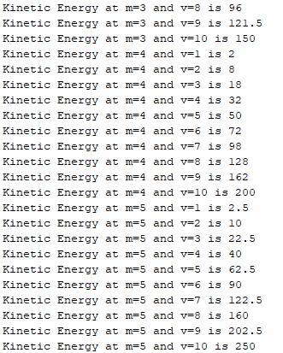

1. Let the mathematical function *u*() be defined as:  
   *u*(0)=3  
   *u*(1)=2  
   *u*(*n*)=*n*\**u*(*n*-1)+(*n*+1)\**u*(*n*-2)+*n*  
     
   For example, u(2) = 2\**u*(1)+3*u(0)+2 = 15

Write a function that asks the user to type an integer *N* and then computes and returns the values of *u*() for numbers 0 though *N* (that is, compute *u*(0) through *u*(*N*)). Demonstrate the function with a script file that calls the function and plots the values 0 through N against the values *u*(0) through *u*(*N*).   
Code

clc

clear

close

% Q02

N=input('Enter N:');

u(1)=3;

u(2)=2;

for n=3:N

u(n)=(n-1)*u(n-1)+ (n) * u(n-2) + (n-1);

end

plot(1:N,u)

xlabel('n')

ylabel('u(n)')

title('Q02')

Output

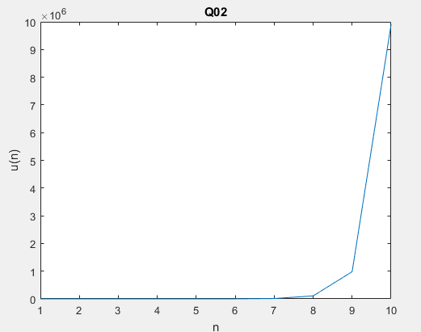

1. Write a MATLAB program that acts as a simple calculator. The program should ask the user for a number, then an operator (either ‘+’, ‘-‘, ‘*’, or ‘ /’), and then another number. The program should calculate the result and display it.   
   *INPUT VALIDATION:* display an error message and ask for new input, if the user enters any other character besides the four given operators or tries to divide by zero.

Code

% Q03

clc

clear

first=input('enter first number :');

oper=input('enter operator :','s');

second=input('enter second number :');

while (1)

if(second==0)

second=input('Re_enter second number :');

else

break

end

end

while (1)

if(oper=='+')

disp(['Result is :',num2str(first+second)])

break

elseif(oper=='-')

disp(['Result is :',num2str(first-second)])

break

elseif(oper=='*')

disp(['Result is :',num2str(first*second)])

break

elseif(oper=='/')

disp(['Result is :',num2str(first/second)])

break

else

oper=input('Re_enter operator :','s');

end

end

Output

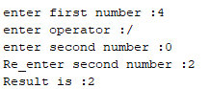

**Extra Credit:** Write a program that creates a structure named MovieData to store the following information about a movie:

* Title
* Director
* Year Released
* Running Time (in minutes)
* production costs
* first-year revenues

The program should create a vector of two of these structures variables, and store values in their members (you may pick any movie/values you wish), and pass each one, in turn, to a function that displays the following information about the movie in a clearly labeled format: the title, director, release year, running time, and first year’s profit or loss.

code

clc

clear

close

% credit

mem1=['Title',' Director',' YearReleased',' RunningTime',' ProductionCost',' FirstYearRevenues']

memdata=['Endgame',' AnthonyRusso',' 2019',' 2:01hour',' 356million',' 2.798 billion']

memdata2=['JohnWick',' ChadStahelski',' 2019',' 2:11hour',' 75million',' 326.7million ']

% MovieData=[mem1;memdata;memdata2]

Output

