Contents

List of Figure 2

Menu Function 3

Code 3

Output 3

Input Function 3

Code 3

Output 3

Read Data File 3

Code 3

Output 4

Function with Parameter 4

Code 4

Output 4

Plotting with function 4

Code 4

Output 5

Loop and condition statement 6

Code 6

Output 8

# List of Figure

Figure 1: Menu 3

Figure 2: Output of the menu after selection 3

Figure 3: Input function 3

Figure 4: Output of the file 4

Figure 5: Function with parameter 4

Figure 6: sin function 5

Figure 7: display angle 6

Figure 8: sin output 6

Figure 9: loop and condition statement 8

# Introduction

In this project collect the data set from given link, explore the matlab function with requirement. By doing this project learn about the matlab programming. In the code section each function is mention and details description discuss here. In the first section write the code for simple selection with menu base. We can interact with matlab workspace using menu and input in command window. In first section just take overview of the menu function and in the last section use the input function for taking input and work on the criteria.

Read and display the file that are download. In the section by using the function with argument and without argument declare function and plot simple function using the plot. In the last section first loop use for the taking right input. After taking the right input like 1 and 2 work on the matrix by using the index. Loop continue until all element are not shown. Then same select loop for vector and display full vector by using the loop which are select.

# Menu Function

## Code

clc

clear all

close all

choose_menu = menu('Select Menu','Number 1','Number 2','Number 3') ;

disp(['You Select the Choice is ', num2str(choose_menu)])

## Output

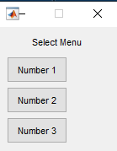

Figure : Menu



Figure : Output of the menu after selection

# Input Function

## Code

clc

clear all

input_=input('Enter Number:');

disp(['You Enter the :',num2str(input_)])

## Output



Figure : Input function

# Read Data File

## Code

clc

clear all

[file_num,file_str,file_data_raw]=xlsread('ncprp_2012.csv')

## Output

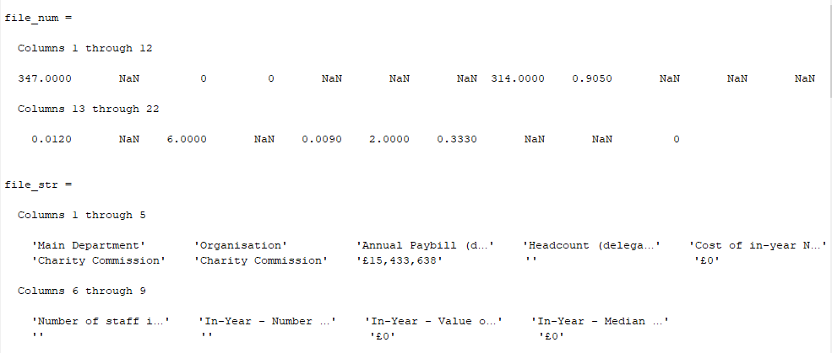

Figure : Output of the file

# Function with Parameter

## Code

function [out1,out2]=function_(input1,input2)

out2=input2*input1;

disp(['The Output 2 is the Multiplication:',num2str(out2)])

out1=input1/input2;

disp(['The Output 1 is the Divide of two Number:',num2str(out1)])

end

## Output



Figure : Function with parameter

# Plotting with function

## Code

function function_without_in_and_output()

clc

clear all

close all

fprintf('Angle:\n')

angle=[-pi:pi/100:pi]

fprintf('Sin Value :\n')

sin_=sin(angle)

plot(angle,sin_)

grid on

xlabel('angle')

ylabel('sin(angle)')

title('sin Function')

legend('sin Output')

end

## Output

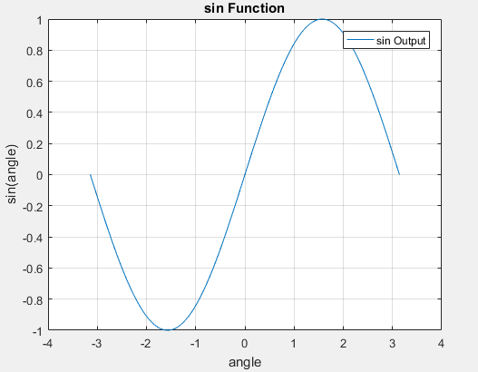

Figure : sin function

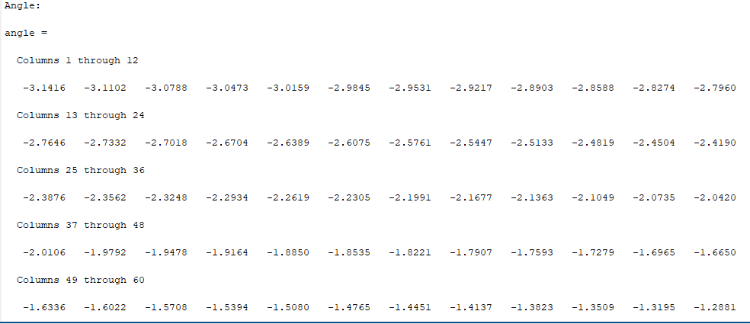

Figure : display angle

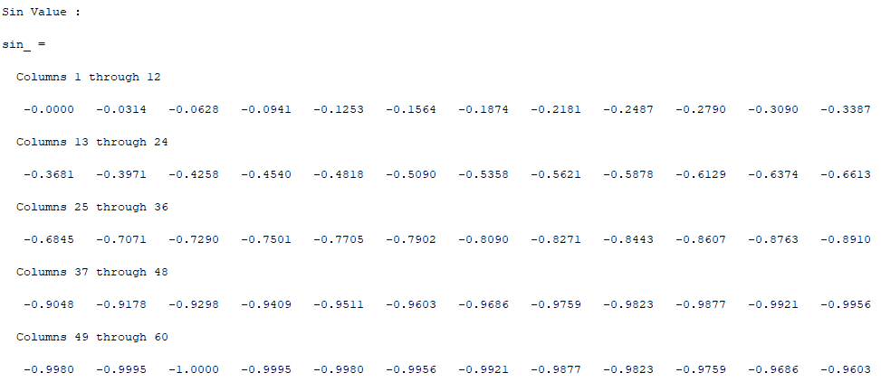

Figure : sin output

# Loop and condition statement

## Code

clc

clear all

close all

fprintf('\n****Choose Loop for Matrix****\n1. For Loop \n2. While Loop\n')

while (1)

select_loop=input('Enter Value:');

if(select_loop<1 || select_loop>2)

disp('You Enter the value Out of Range ')

else

break

end

end

matrix=[12 14 1 3 ; -7 9 55 63; 9 -8 100 114];

vector=[1:2:20];

[r,c]=size(matrix);

fprintf('********************\n The Matrix\n********************\n')

if (select_loop==1)

fprintf('********************\n you select the for loop\n********************\n')

for i=1:r*c

disp(['Matrix have Element at Index [',num2str(i),'] =',num2str(matrix(i))])

end

elseif (select_loop==2)

fprintf('********************\n you select while loop\n********************\n')

i=1;

while(i<=r*c)

disp(['Matrix have Element at Index [',num2str(i),'] =',num2str(matrix(i))])

i=i+1;

end

end

fprintf('****Choose Loop for Vector****\n1. For Loop \n2. While Loop\n')

while (1)

select_loop=input('Enter Value:');

if(select_loop<1 || select_loop>2)

disp('You Enter the value Out of Range ')

else

break

end

end

fprintf('********************\n The Vector\n********************\n')

if (select_loop==1)

fprintf('********************\n you select the for loop\n********************\n')

for i=1:length(vector)

disp(['Vector has Element at Index [',num2str(i),'] =',num2str(vector(i))])

end

elseif (select_loop==2)

fprintf('********************\n you select while loop\n********************\n')

i=1;

while(i<=length(vector))

disp(['Vector has Element at Index [',num2str(i),'] =',num2str(vector(i))])

i=i+1;

end

end

## Output

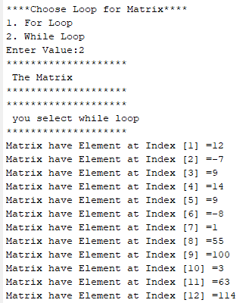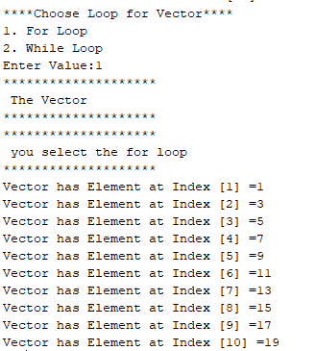

Figure : loop and condition statement