# Question 01

## Code

clc

clear all

a=[1 -2 3 ;0 1 5];

b=[3 4 3; 2 0 1];

c=eye(3);

part_a=a+b

part_b=b*c

## Output

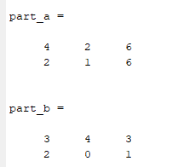

# Question 02

## Code

clc

clear all

A = [1 2; 3 4; 5 6];

part_a= A(2,:)'

part_b=[0:1.5:7]'

a = 2;

b = 8;

c = 4;

part_c=a + b / c

## Output

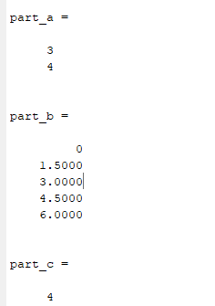

# Question 03

## Code

clc

clear all

part_a=linspace(4,34,6)

part_b=linspace(-4,3,8)

## Output

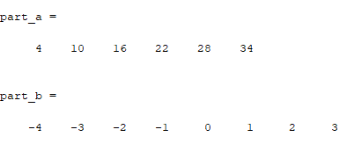

# Question 04

## Code

clc

clear all

close all

a=2;

b=3.5;

deltax=pi/35;

x=0:deltax:pi/2;

y=b.*exp(-a.*x).*sin(b.*x).*(0.011.*x.^4-0.14.*x.^3+0.075.*x.^2+3.5.*x);

z=y.^2;

format shortG

w=[x',y',z']

p=plot(x,y,x,z);

xlabel('x');

ylabel('y,z');

legend('y','z');

p(1).LineWidth=1.4;

p(1).LineStyle='-.';

p(1).Color='red';

p(1).Marker='pentagram';

p(1).MarkerSize=15;

p(1).MarkerEdgeColor='red';

p(1).MarkerFaceColor='white';

p(2).LineWidth=0.5;

p(2).LineStyle='-';

p(2).Color='blue';

p(2).Marker='diamond';

p(2).MarkerSize=6;

p(2).MarkerEdgeColor='black';

p(2).MarkerFaceColor='magenta';

## Output

