# Question 01

## Code

A = [1:3;2:2:6;3:-1:1]

A = A'

## Output

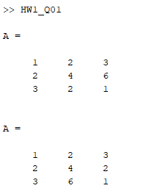

# Question 02

## Code

clc

clear

t=input('enter the vector "t":');

disp('the value of y is')

y=((6*t-4)./(8*t))-(pi/2)*t

## Output

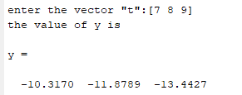

# Question 03

## Code

clc

clear all

A = [3 2 1; 0 : 0.5 : 1; linspace(6, 8, 3)]

c=A(2,:)* A(:,3)

## Output

