# Aim

In the lab session I learn about the Fourier series and Fourier transform. The main difference between them is Fourier series used for the parodic signals. By using the Fourier transform, we extract the harmonic of a signals. By extract harmonic part we can represent the highlight part rather than temporal.

# Algorithm

* Generate the cos function which depend on the given parameters.
* Use the subplot function for the location definition [1].
* First six signal calculate the by using the for loop [2].
* Plot all function and save all the result into new variable define by name x1 to x6.
* Add up all signal and show then final result at last.
* Calculate the fast Fourier transform of the all signal and plot the phase response and magnitude response of the signal.

# Sample Result

The figure (1) is the result of the code which take the initial parameter differently and plot all these six signals on same figure. Last row of this figure shows the addition of these signal. In the second figure (2), I plot the phase and magnitude respace of the final signal which come after the addition of six signals.

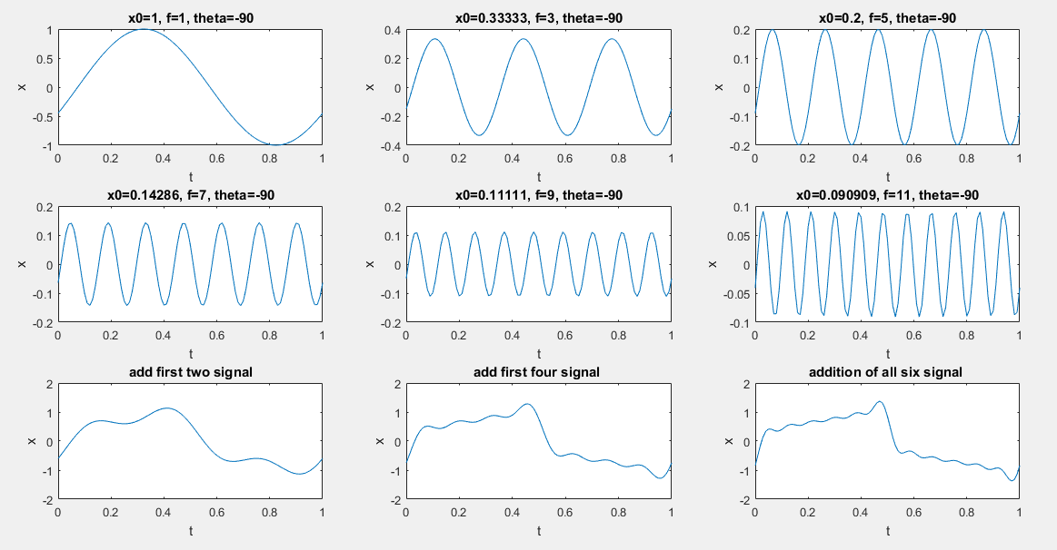

Figure (1)

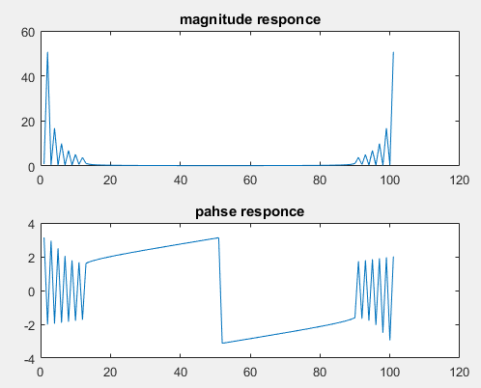

Figure (2) [3]

# Bibliography

|  |  |
| --- | --- |
| [1] | [Online]. Available: https://www.mathworks.com/matlabcentral/answers/50003-what-is-subplot-and-how-to-use-it. [Accessed 24 02 2020]. |
| [2] | [Online]. Available: https://www.mathworks.com/matlabcentral/answers/359396-subplots-within-for-loops. [Accessed 24 2 2020]. |
| [3] | [Online]. Available: https://www.mathworks.com/matlabcentral/answers/29696-fft-am-i-doing-anything-wrong. [Accessed 24 2 2019]. |