# Question 01

## Code

clc

clear all

close all

% from the given figure

% part_A

A=9;

T=2;

f=1/T;

w=2*pi*f;

phase_shift=45;

t=0:0.01:4;

s=A*cos(w.*t+phase_shift);

plot(t,s,'r')

xlabel('time(seconds)')

ylabel('s(t)')

title('Original plot')

grid on

% part_b

part_b=9*sin(-w.*t+phase_shift);

figure

plot(t,part_b,'r')

xlabel('time(seconds)')

ylabel('s(t)')

title('Sin plot')

grid on

## Output

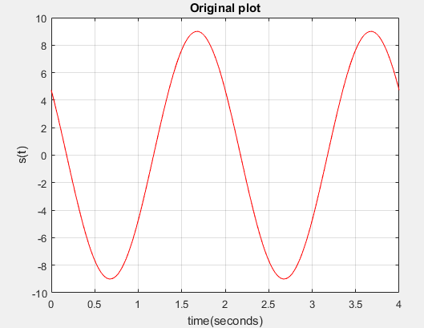

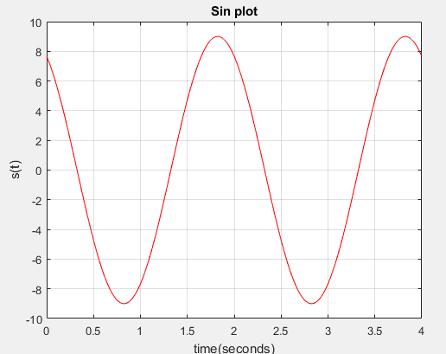

# Question 02

## Code

clc

clear all

close all

w=2*pi*30;

t=0:1/300:0.2;

x=2*cos(w.*t+5)+8*cos(w.*t+9)+4*cos(w.*t);

subplot 211

plot(t,x)

xlabel('time(seconds)')

ylabel('x(t)')

title('part a')

grid

subplot 212

part_b=3.0512*cos(w.*t+2.672);

plot(t,part_b)

xlabel('time(seconds)')

ylabel('x(t)')

title('part b')

grid

## Output

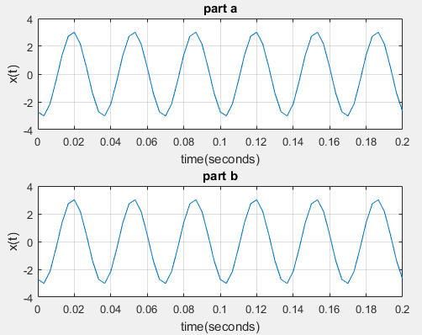

# Question 03

# Question 04

