**Question 01**

**Code**

clc

clear all

% a

% define a function is called num_grains(n)

% b

n=10:100;

N=num_grains(n)

% c

plot(n,N)

title('number of grains Vs grains size ')

xlabel('grain size(n)')

ylabel('number of grains ')

**Num_grains**

function N=num_grains(n)

N=2.^(n-1);

end

**Output**

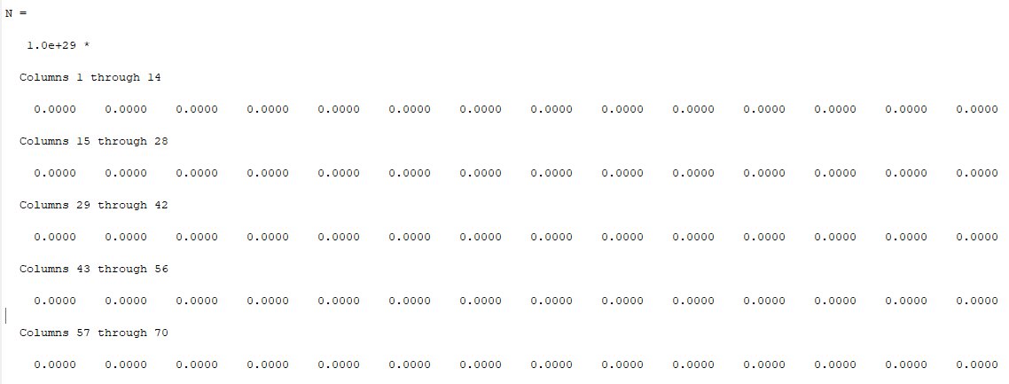

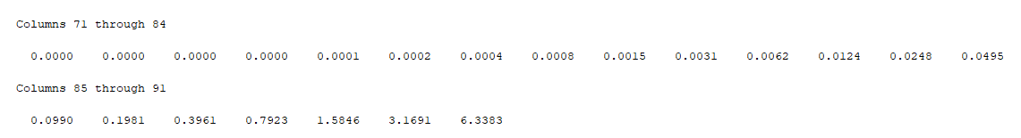

**Graph**

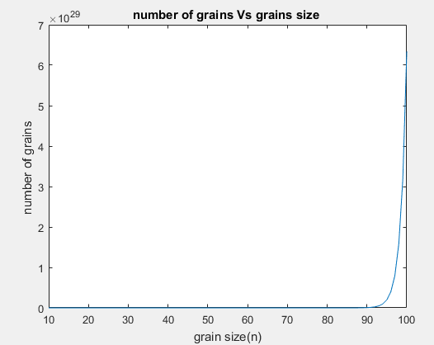

**Question 07**

**Code**

clc

clear all

close all

% a)

% define function is height

% b

t=0:0.5:30;

h=height(t);

plot(t,h)

title('Path of the rocket')

xlabel('time')

ylabel('height')

% c)

[h_max,time]=max(h);

T_hmax=t(time);

fprintf('The time at which the rocket starts falling is %d sec \n',T_hmax)

**Height function**

function h=height(t)

h=(-(9.8/2).*t.^2) + (125.*t) + 500;

end

**Output**



**Graph**

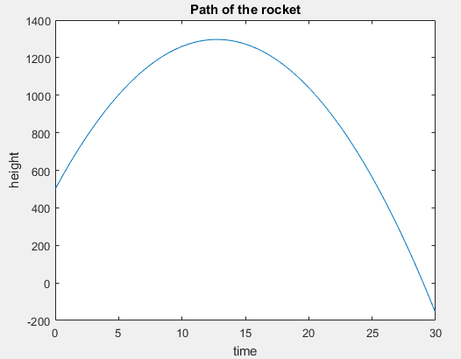

**Question 14**

**Code**

clc

clear all

close all

% a)

% define function height handle

% b)

he=@height_handle;

fplot(he,[0 60]);

% c)

fzero(he,35)

**Function**

function height= height_handle(t)

height=(-(9.8/2).*t.^2)+(125.*t)+500

end

**Output**

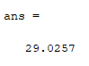

**Graph**

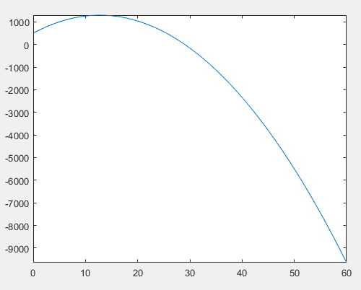

**Question 15**

**Code**

clc

clear all

close all

% a

f=0:20:200;

[K,R,F]=temperature_conversions(f,0,0);

table1=[f' K']

% b

cr=linspace(0,100,25);

[K,R,F]=temperature_conversions(0,cr,0);

table2=[cr' R']

% c

cf=0:10:100;

[K,R,F]=temperature_conversions(0,0,cf);

table3=[cf' F']

**Function**

function [K,R,F]=temperature_conversions(f,cr,cf)

K=F_to_K(f);

R=C_to_R(cr);%calling sub function

F=C_to_F(cf);

end

function k=F_to_K(f)

k=(5.*(f+459.67))./9;

end

function r=C_to_R(c)

r=((9.*c)./5)+491.67;

end

function F=C_to_F(c)

F=(9.*c)./5+32;

end

**Output**

