# Part A- Function

## Question 01

## Code

function maxPower=PartAQ1(data)

maxPower=max(data(:,2).*data(:,3));

end

## Output

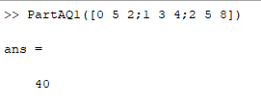

## Question 02

## Code

function PartAQ02(data)

close all

power=data(:,2).*data(:,3);

plot(data(:,1),power)

[max_ ind]=max(power);

hold on

grid on

plot(ind-1,max_,'o')

xlabel('time')

ylabel('power')

end

## Output



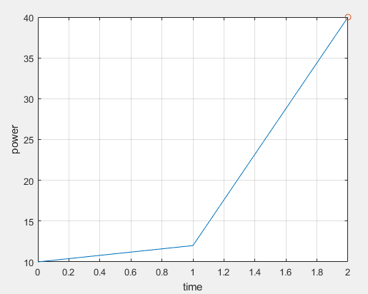

## Question 03

## Code

function [energy]=PartAQ03(data)

power=data(:,2).*data(:,3);

time=data(:,1);

energy=trapz(time,power);

end

## Output

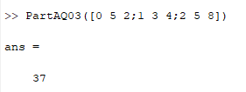

# Part B- Conditional Statements

## Question 01

## Code

function decison = PartBQ01(distance)

if distance>=20

decison = 'F';

else decison = 'S';

end

end

## Output

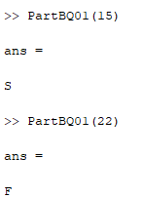

## Question 02

## Code

function decison = PartBQ02(left,forward,right)

allowed_dist = 20;

% start with checking the forward

if forward >= allowed_dist

decison = 'F';

% check for both left and right being allowed

elseif left >= allowed_dist && right >= allowed_dist

% decide on the furthest

if left > right

decison = 'L';

elseif left < right

decison = 'R';

else

% equal,

% choose right

decison = 'R';

end

% check left alone

elseif left >= allowed_dist

decison = 'L';

% check right alone

elseif right >= allowed_dist

decison = 'R';

else % no direction is allowed

decison = 'S';

end

end

## Output

