# Question 4

## Code

clc

clear all

close all

% Q03 and Q04

x=-pi:0.01*pi:pi;

y1=sin(x);

hold on

plot(x,y1,'--r')

title('Figures y1,y2 and y3')

xlabel('x in radians')

ylabel('sin(x)/sin(2x)/sin(3x)')

y2=sin(2*x);

hold on

plot(x,y2,'-b')

y3=sin(3*x);

hold on

plot(x,y3,':g')

## Plot

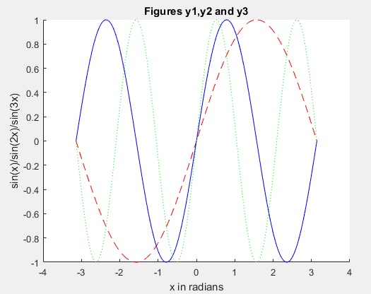

# Question 11

## Code

clc

clear all

close all

i0=2;

i=[2.0024 2.0047 2.007 2.0094 2.0128 2.0183 2.0308 2.0500 2.075];

f=[200 4000 6000 7500 8000 8500 9000 9500 10000];

d=0.505;

r=d/2;

area=pi*r^2;

stress=f./area;

strain=(i-i0)/i0;

plot(strain,stress,'-ok')

## Plot

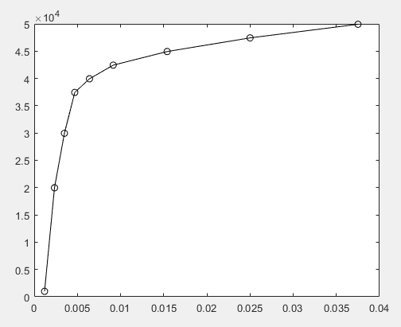

# Question 21

## Code

clc

clear all

close all

G=[68 83 61 70 75 82 57 5 76 85 62 71 96 78 76 68 72 75 83 93];

H=sort(G);

subplot(311)

bar(H)

title('Bar graph of the scores')

subplot(312)

histogram(H)

title('Histogram of the scores')

edges=[0 60 70 80 90 100];

subplot(313)

histogram(edges,H)

title('edges apply on scores')

## Plot

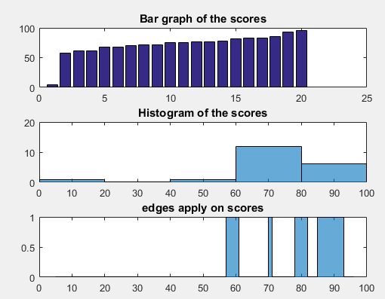

# Question 31

## Code

clc

clear all

close all

% a

x=-5:0.5:5;

y=x;

[X,Y]=meshgrid(x,y);

t1=sqrt(X.^2 + Y.^2);

Z1=sin(t1);

Z=mesh(Z1);

% b

figure

surf(Z1);

surf(X,Y,Z1)

## Plot

