# Question 01

## Code

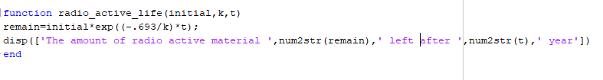

## Output

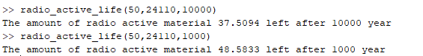

# Question 02

## Code

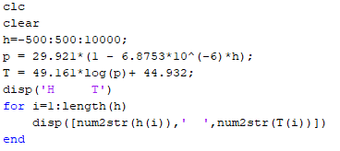

## Output

