# Question 01: Image

## Clown

### Code

clc

clear

close

%Q01 Image

load clown

[r,c]=size(X);

figure('Units','Pixels','Position',[100 100 c r])

image(X)

set(gca,'Position',[0 0 1 1])

colormap(map)

### Output

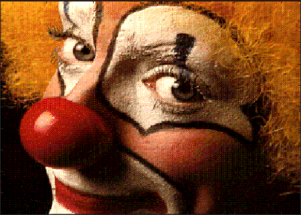

## Pepper

### Code

clc

clear

close

RGB=imread('peppers.png');

I=rgb2gray(RGB);

figure(1)

imshow(I)

figure(2)

imshow('peppers.png')

### Output

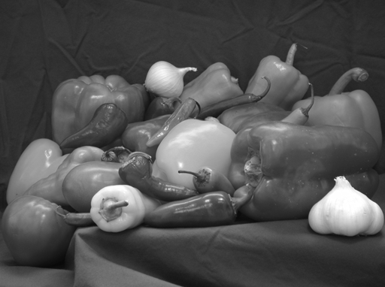

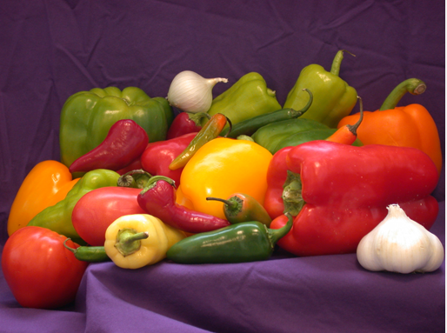

## Question 02: Movie

## Handel

### Code

clc

clear

close

load handel.mat

soundsc(y,2*Fs);

figure(1)

numframes=16;

A=moviein(numframes); % create the movie matrix

set(gca,'NextPlot','replacechildren')

axis equal % fix the axes

for i=1:numframes

plot(fft(eye(i+16)));

A(:,i)=getframe;

end

save movie.mat A % save the MATLAB movie to a file

mpgwrite(A,jet,'movie.mpg'); % Convert the movie to MPEG format

% Notice the MPEG file is about a quarter of the size of the MATLAB movie file

unix('mpeg_play movie.mpg') % Play the MPEG movie

### Output

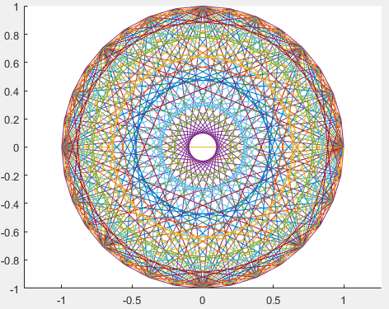

## 3-D plot

### Code

clc

clear

close

[X,Y,Z]=sphere(50);

surf(X,Y,Z,X)

axis vis3d tight off

for k=1:25

view(-37.5 + 15*(k-1),30)

m(k)=getframe(gcf);

end

movie(gcf,m)

### Output

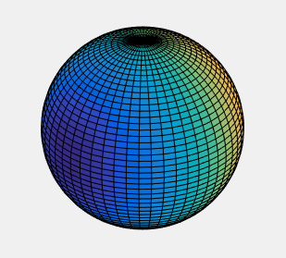

# Question 03: Sound

## Gong

### Code

clc

clear

close

load gong.mat

soundsc(y);

### Output



## Handel

### Code

clc

clear

close

load handel.mat

soundsc(y,2*Fs);

### Output

