

Resistor color code

[Document subtitle]



[Date]

[Company name]

[Company address]

Contents

List of Figure 2

Abstract 3

Introduction 4

Standard chart of the resistance 5

Objective 5

Methodology 6

Algorithm 6

Testing and result 7

Conclusion 7

Bibliography 9

Appendices 10

Code 10

# List of Figure

Figure 1: color code [1] 4

Figure 2: resistance with color 4

Figure 3: resistance 5

Figure 4: standard chart 5

Figure 5: flowchart 6

Figure 6: Test for 1Kohm 7

Figure 7: Gold as band 4 7

Figure 8: Silver as band 4 7

Figure 9: none case as band 4 7

# Abstract

Resistance calculation from the color code is tha major application in the engineering field, because circuit design is core process for any application even it depends on the software. Only software-based application still available and for the complete solution for any problem, we design hardware and software solution. We can control our circuit with resistance.

Color code scheme is saving too much time if we have practice on it. One other method is also available for the resistance calculation. We can calculate the resistance by using the DMM (digital multimeter). For the engineering practice, I design the method by using MATLAB program in which we can select the color band and tolerance type. After all value’s total resistance and range of resistance due to tolerance is shown.

# Introduction

Resistance is a component which resist in the flow of current. For the any circuit, resistance is basic element. Every resistance made by the 4 different color combination. The value of the resistance shows how much resist in the flow of current. First 3 color make the resistance value and 4 color band tell us the tolerance in the resistance. Tolerance means it also work for the fix % up and down value.

Each color has different importance. Each color has different code value.

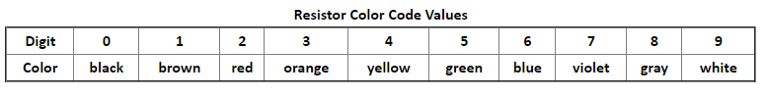

Figure 1: color code [1]

Each color gives the own importance and give idea to the value of the resistance [2].

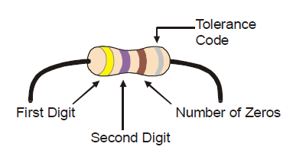

Figure 2: resistance with color

By using the color scheme, we can easily determine the resistance value. For example, first is yellow means yellow code is 4 and violet code is 7 and brown is 1. At the end 470 become. It means this resistance have 470ohm value.

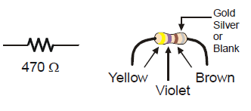

Figure 3: resistance

## Standard chart of the resistance

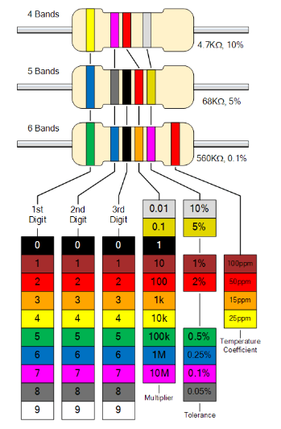

Figure : standard chart

# Objective

* Understand the resistance
* Understand the use of resistance
* Explore the color scheme
* Implement the color code into programming language
* Determine the resistance from color scheme
* Take user input and make sure right input or wrong
* Perform mathematically operation for the calculation of resistance

# Methodology

* Take the color of the first band color in cap
* Determine the color code by using loop
* Take second color of the band in cap
* Determine the color code
* Take third band code in cap
* Determine the color code value
* Take input of the last/fourth band color
* Determine the band code
* Convert band code to resistance value by first digits and second digits concatenation and then extend with number of zeros. Number of zeros equal to the third color band value
* Determine the range of the resistance check the band fourth value and apply the fix % and calculate two value max and min tolerance of the resistance
* Display the actual resistance and with tolerance [3]

# Algorithm

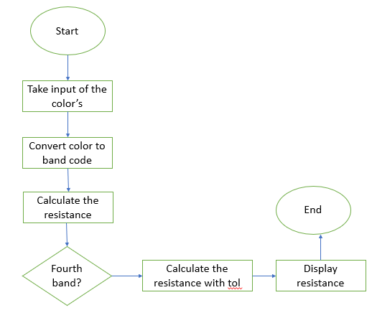

Figure 5: flowchart

# Testing and result

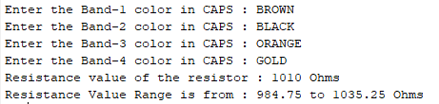

Figure : Test for 1Kohm

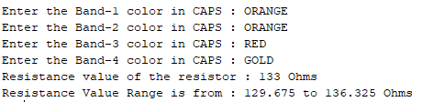

Figure : Gold as band 4

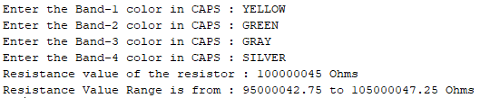

Figure : Silver as band 4

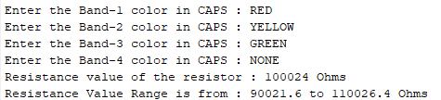

Figure : none case as band 4

# Conclusion

In this project we design the program which calculate the resistance according to the input color. Take the four colors band and given the final resistance and after including the tolerance. The main benefits of the project are that now we can calculate the resistance directly by seen the color code from the resistance. The resistance is core component for every electronic circuit. It provides the resist in the flow of current. It is necessary because we can adjust the flow of current by resistance. If we are not control the current flow than maybe our circuit is damage because attach device not capable to work with current which passed, that’s why we use the resistance.

# Bibliography

|  |  |
| --- | --- |
| [1] | "paralax," 2020. [Online]. Available: http://learn.parallax.com/tutorials/robot/shield-bot/robotics-board-education-shield-arduino/chapter-2-shield-lights-servo-19. [Accessed 24 4 2020]. |
| [2] | ElectronicTutorial, 2020. [Online]. Available: https://www.electronics-tutorials.ws/resistor/res_2.html?utm_referrer=https%3A%2F%2Fwww.google.com%2F. [Accessed 4 5 2020]. |
| [3] | "circuit crush," [Online]. Available: https://www.circuitcrush.com/resistor-color-code/. [Accessed 24 4 2020]. |

# Appendices

## Code

clear;

clc;

% In starting, initailaising the value of all bands to 0

band_1_Value = 0;

band_2_Value = 0;

band_3_Value = 0;

band_4_Value = 0;

% Color code and their values

color_Band = {'BLACK', 'BROWN', 'RED', 'ORANGE', 'YELLOW', 'GREEN', 'BLUE', 'VIOLET', 'GRAY', 'WHITE', 'NONE', 'SILVER', 'GOLD'};

color_Value = [0 , 1 , 2 ,3 , 4 , 5 , 6 , 7 , 8 , 9 , 20 ,10 , 5 ];

% Input the Colors of the di?erent color bands in CAPS

band_1_input = input('Enter the Band-1 color in CAPS : ', 's');

for i=1:13

if(strcmp((band_1_input),color_Band(i))==1)

band_1_Value=color_Value(i);

end

end

band_2_input = input('Enter the Band-2 color in CAPS : ', 's');

for i=1:13

if(strcmp((band_2_input),color_Band(i))==1)

band_2_Value=color_Value(i);

end

end

band_3_input = input('Enter the Band-3 color in CAPS : ', 's');

for i=1:13

if(strcmp((band_3_input),color_Band(i))==1)

band_3_Value=color_Value(i);

end

end

band_4_input = input('Enter the Band-4 color in CAPS : ', 's');

for i=1:13

if(strcmp((band_4_input),color_Band(i))==1)

band_4_Value=color_Value(i);

end

end

resistance_Value = band_1_Value*10 + band_2_Value + power(10,band_3_Value);

disp(['Resistance value of the resistor : ',num2str(resistance_Value), ' Ohms']);

% adding tolerance range

if(band_4_Value==20)

range_1_value = resistance_Value - ((10*resistance_Value)/100);

range_2_value = resistance_Value + ((10*resistance_Value)/100);

end

if(band_4_Value==10)

range_1_value = resistance_Value - ((5*resistance_Value)/100);

range_2_value = resistance_Value + ((5*resistance_Value)/100);

end

if(band_4_Value==5)

range_1_value = resistance_Value - ((2.5*resistance_Value)/100);

range_2_value = resistance_Value + ((2.5*resistance_Value)/100);

end

disp(['Resistance Value Range is from : ',num2str(range_1_value), ' to ',num2str(range_2_value), ' Ohms']);