# Question 01

x=[5:5:100];

# Question 02

X=2

Y=5

A=y*x^3/(x-y)

=5*8/-3

=40/-3

=-13.33

# Question 03

clc

clear all

close all

Vs=12;

rs=2.5;

Rl=1:10;

P=(Vs^2.*Rl)./(Rl+rs).^2;

plot(Rl,P)

xlabel('Rl')

ylabel('P')

title('power dissipatd')

## Output

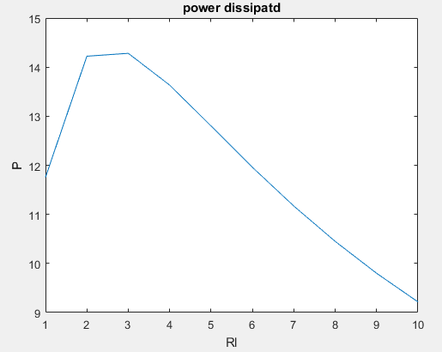

# Question 04

function Q04(x,y)

avgerage=(x+y)/2;

differance=x-y;

disp(['Avg is :',num2str(avgerage)])

disp(['Diff is :',num2str(differance)])

end

## Output

