# Question 01

x=linspace(5,100,20);

# Question 02

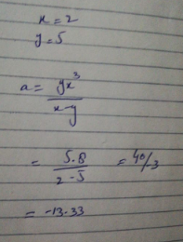

# Question 03

Rl=1:.1:10;

Vs=12;

rs=2.5;

P=(Vs^2.*Rl)./(Rl+rs).^2;

plot(Rl,P)

xlabel('---->Rl')

ylabel('---->P')

title('Question 03')

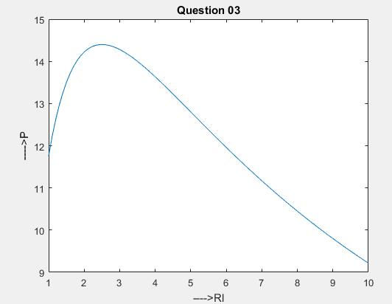

# Question 04

function [avg,diff]=Question04(a,b)

avg=sum(a,b)/2;

diff=a-b;

end

## Output

