Architecture Requirements
CSCI370 Renter Dispute Resolution Application
Purpose: This document defines the major architecture requirements and provides a high-level architecture diagram for the renter dispute application. The system focuses on two main features: generated renter dispute forms and AI-assisted arbitration between renters and landlords/property managers.

Architecture Diagram
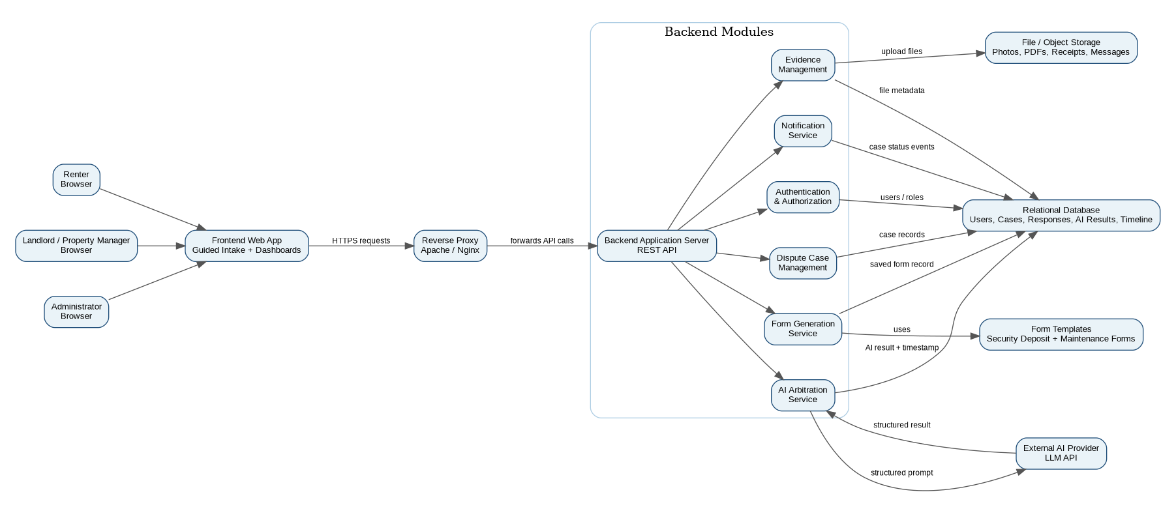
Figure 1. High-level architecture for the renter dispute resolution application.

Architecture Requirements
ID | Architecture Requirement
AR1 | The application shall use a client-server architecture with a browser-based frontend and a backend API.
AR2 | The frontend shall communicate only with backend API endpoints and shall not directly access the database, AI service, or file storage.
AR3 | The backend shall include separate modules for authentication, dispute case management, evidence management, form generation, AI arbitration, notifications, and administration.
AR4 | The application shall store users, dispute cases, parties, intake responses, evidence metadata, generated forms, AI results, and case timeline events in a relational database.
AR5 | The application shall store uploaded evidence files in file or object storage while storing searchable metadata in the database.
AR6 | The form generation module shall use saved case information and predefined templates to produce downloadable dispute forms.
AR7 | The AI arbitration module shall receive structured case summaries from the backend and return a structured result containing summary, key facts, disputed issues, and suggested resolution.
AR8 | The application shall save AI arbitration results with timestamps so both sides can reference the generated recommendation later.
AR9 | The application shall protect all dispute, evidence, form, and AI result endpoints with authentication and case-level authorization.
AR10 | The application shall maintain audit or timeline records for important case actions such as creation, evidence upload, response submission, form generation, and AI arbitration.
AR11 | The application shall support deployment behind a reverse proxy that forwards browser requests to the backend application server.
AR12 | The application shall handle invalid requests, unauthorized access, upload failures, and AI service failures with clear error responses.
AR13 | The application shall use environment-based configuration for database credentials, AI service credentials, file storage paths, and deployment settings.
AR14 | The architecture shall keep the AI arbitrator as a backend-controlled service so users cannot directly send unvalidated prompts to the AI provider.
AR15 | The architecture shall allow project team members to trace stakeholder requirements, functional requirements, architecture requirements, Jira tickets, and GitHub files.

Main Request Flow
- A renter or landlord uses the browser-based frontend to access the application.
- The frontend sends authenticated requests through the reverse proxy to the backend API.
- The backend validates the user, checks case permissions, and routes the request to the correct module.
- Case information is stored in the relational database while uploaded evidence files are stored separately in file or object storage.
- The form generation service uses saved case data and templates to create downloadable forms.
- The AI arbitration service prepares a structured case summary, sends it to the AI provider, and stores the returned non-binding recommendation.

Important Design Notes
- The AI arbitrator should be treated as a non-binding project-generated recommendation, not as legal advice or a legally enforceable decision.
- The frontend should never directly connect to the database, file storage, or AI provider.
- Requirement IDs should be referenced in Jira ticket descriptions and GitHub pull requests to support traceability.

