Architecture Requirements
CSCI370 Renter Dispute Assistant

Clean Architecture Diagram
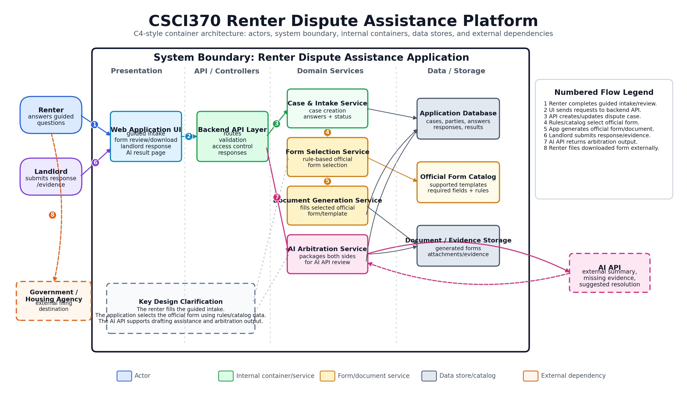
Figure 1. System architecture showing who fills out the form, how the application selects the official form, and where the AI API is used.

Architecture Requirements

AR1
The system shall separate the frontend user interface from backend application logic so renter, landlord, and arbitration flows remain maintainable.

AR2
The frontend shall include pages or views for guided renter intake, form review/download, case details, landlord response, and AI arbitration results.

AR3
The backend shall expose separate controller/API endpoints for case intake, form routing, document generation, landlord response, AI arbitration, and case retrieval.

AR4
The application shall use a validation layer before saving case data, generating official forms, or sending arbitration requests to the AI API.

AR5
The application shall use a form-routing service to choose supported official form templates based on renter-selected dispute type and jurisdiction.

AR6
The form-routing service shall be rule-based so the application, not the AI API, decides which supported official form template is used.

AR7
The document-generation service shall map validated renter answers into the selected official form or document template.

AR8
The AI integration layer shall call an AI API for drafting renter explanation text and generating neutral arbitration summaries.

AR9
The AI integration layer shall not be responsible for directly submitting official forms to any government agency.

AR10
The case service shall store renter intake data, selected template information, landlord response data, generated document references, and AI arbitration results.

AR11
The database shall persist dispute cases, parties, form-generation records, landlord responses, evidence metadata, and arbitration results.

AR12
The file storage layer shall store generated documents and supported evidence files while keeping references in the database.

AR13
The system shall protect case access using authenticated users, secure case links, or access tokens appropriate for the MVP implementation.

AR14
The system shall handle unsupported form templates, validation failures, invalid response links, missing landlord responses, and AI API failures as explicit error paths.

AR15
The architecture shall support a complete MVP demo flow from renter guided intake to official form download to landlord response to AI arbitration recommendation.

Recommended MVP Code Structure
- Frontend pages/views: Home, Guided Renter Intake, Form Review/Download, Case Details, Landlord Response, Arbitration Result.
- Frontend components: guided question form, validation messages, form preview, download action, landlord response form, arbitration result display.
- Backend controllers/endpoints: Case Intake, Form Routing, Document Generation, Landlord Response, AI Arbitration, Case Retrieval.
- Backend services: Validation Service, Case Service, Form Routing Service, Official Form Template Service, Document Generation Service, Landlord Response Service, AI Drafting/Arbitration Service.
- Data layer: case records, party/contact records, selected template records, generated document records, landlord response records, evidence metadata, arbitration result records.
- External integration: AI API client used only through the AI Drafting/Arbitration Service.

Primary Logic Paths
- Official form path: renter intake -> validation -> rule-based form routing -> template loading -> document generation -> renter review -> download/print.
- Unsupported form path: renter intake -> validation -> no matching template -> unsupported message -> optional general summary document.
- Drafting path: renter requests narrative help -> AI API draft -> renter reviews/edits -> approved text used in form.
- Landlord response path: case link/access -> renter claim summary -> landlord response validation -> response saved to case.
- AI arbitration path: renter facts + landlord response available -> AI API arbitration request -> required output sections validated -> result saved and displayed.
- Failure paths: missing fields, invalid amounts/dates, unsupported templates, invalid case links, missing landlord response, AI API failure, and document generation failure.

