Arden University

Masters in Data Science

COM7023 - Mathematics for Data Science

Urban Resource Intelligence Portfolio

Student ID: [YOUR STUDENT ID]
Student Name: [YOUR NAME]

Word Count: [TBC - final submission]

Contents
1. Introduction 4
1.1 Background and Purpose of the Study 4
2. Methodology 5
3. Task 1: Steady-State Resource Demand (Linear Algebra) 6
3.1 Mathematical Analysis (Method Used: System of Linear Equations and Matrix Algebra) 6
3.2 Solution 6
3.2.1 Formation of the Augmented Matrix 6
3.2.2 Gaussian Elimination Step-by-Step 6
3.2.3 Back Substitution 8
3.2.4 Python Verification with Console Output 9
3.3 Analysis and Results 9
3.4 Visualisation 10
4. Task 2: Demand Over Time (Calculus) 11
4.1 Mathematical Analysis (Method Used: Differential Calculus) 11
4.2 Solution 11
4.2.1 Application of the Power Rule for Differentiation 11
4.2.2 Identification of Critical Points 11
4.2.3 Second Derivative Test for Classification 12
4.2.4 Inflection Point Analysis 12
4.2.5 Intervals of Increase and Decrease 12
4.2.6 Python Verification with Console Output 13
4.3 Analysis and Results 13
4.4 Visualisation 13
10. References 15
11. Appendix 16
Task 1: Linear Algebra 16
Task 2: Calculus 16

1. Introduction

1.1 Background and Purpose of the Study
Math’s can be a powerful tool for mapping and modelling how cities use and share key resources like water, energy and housing services. It can help to understand the distribution of demand across various submarkets in the city, the diurnal variation of demand, the impact of uncertainty on forecasts, and consumption patterns across household types. Urban analytics is an area that uses mathematical and statistical methods to inform decision-making, monitoring and long-term planning by local governments.
The purpose of this assignment is to explore the use of a variety of sophisticated mathematical techniques to examine the pattern of resource consumption in an urban residential system. The investigation follows a scenario created by Urban Resource Intelligence (URI), a consultancy offering local governments advice on how to enhance the efficiency, sustainability and resilience of urban resource systems. To move on to more complex data science projects, as part of the induction process a mathematical investigation must be undertaken that shows the ability to use the skills learned in the previous subjects, Linear Algebra, Calculus, Probability and Statistics, to a real world problem in analytics. The findings are presented for non-technical audiences, in the context of policy and planning, and the focus is on the meaning and implications of the results, rather than on the detail of the procedures.
The investigation brings together four inter-related areas of analysis. The four linear equations are first solved to find the steady-state (equilibrium) daily resource demand between the four interconnected residential zones and to determine if there is a stable and unique steady-state (equilibrium) for load-balancing purposes. Second, using calculus, a cubic demand function is analyzed to determine how the demand in a high-density residential area is changing over time, including when it is growing quickly and when it is decreasing quickly, and whether there are any critical points of interest for considerations on peak demand management. Third, a normal distribution with mean 0 and standard deviation 5 units in the space of short-term forecasting errors is assumed to capture the behavioral variability and the effect of environmental factors, to assess the probability of large errors and to provide information for risk management and contingency planning. Finally, following appropriate statistical tests, the daily average consumption from three different residential building typologies (apartments, terraced houses and detached houses) is compared in order to test if there are significant differences between the means of consumption, thus enabling the design of specific efficiency interventions.
These four tasks, when combined, give a clear and evidence-based view of the nature of resource demand throughout the city, which helps in achieving URI's mission to assist planners in allocating resources efficiently and planning for uncertainty.

2. Methodology
This assignment is organized, step-by-step. The approach adopted to each task represents one of the mathematical methods that is appropriate for the nature of the urban resource problem under investigation. The mathematical theory is given first, followed by a typed solution, results checking in Python, a visualization of the results and an interpretation of the results written for non-technical users for each task. Computation and visualization are all performed in Python, making use of the NumPy, SymPy, Matplotlib and Seaborn libraries, and screenshots of the computational processes and results are provided as evidence of the work.
The first is steady state demand of resources and is explored by linear algebra techniques. The four interconnected residential zones are described by a system of four equations, which are written in matrix form and solved numerically by Gaussian elimination, the solution being checked numerically. The determinant, rank and condition number of the coefficient matrix are also computed, to verify if a unique and numerically stable equilibrium exists. This method enables the long-term balances of demand between the zones to be analyzed with confidence.
The second task uses differential calculus to analyses the changing demand for resources in a high density residential area over time. The first and second derivatives of the demand function are computed to find critical points, determine whether they are maxima or minima, to find out if there are any inflection points, and to find the intervals on which the demand is increasing or decreasing. Using this method, peak and trough periods that are important for operation planning can be identified.
The third task investigates the errors in short-term forecasting from a probabilistic perspective. The errors made in forecasting are not systematic but due to a behavioral variability and to the environment; they are therefore assumed to follow a normal distribution with mean = 0, and standard deviation = 5 units. The probability of large deviations from the expected demand is calculated using standardization (z-scores) and this information is useful for risk management and contingency planning.
For the last task, the data related to the daily average consumption of the three types of residential buildings are analyzed using a one-way Analysis of Variance (ANOVA). This method is suitable due to the fact that it compares the means of more than two groups and it is able to handle unequal sample sizes properly. The hypotheses and assumptions are explicit and a post-hoc test is used if there is a significant difference to determine which building type(s) are different.
These methods combined enable a transparent and reliable urban resource demand behavior analysis to be generated.

3. Task 1: Steady-State Resource Demand (Linear Algebra)

3.1 Mathematical Analysis (Method Used: System of Linear Equations and Matrix Algebra)
The aim is to find the balance between the daily resource needs of the four interconnected cities. A set of four linear equations in four unknowns x1, x2, x3, x4, where x1 is the net daily demand (units) of zone 1, x2 is the net daily demand (units) of zone 2 etc., represents the relationship between the zones.
The system of equations is:
$$2x1 - x2 + x3 = 120$$
$$-x1 + 3x2 - x4 = 150$$
$$x1 + x2 + 2x3 - x4 = 180$$
$$-x2 + x3 + 2x4 = 140$$

The system can be expressed in matrix form as Ax = b:
$$A = \left[\left[2, -1, 1, 0\right], \left[-1, 3, 0, -1\right], \left[1, 1, 2, -1\right], \left[0, -1, 1, 2\right]\right]$$
$$x = [x1, x2, x3, x4]T$$
$$b = [120, 150, 180, 140]T$$
The analysis requires checking three properties of matrix A to ensure a unique, stable solution exists: (1) the determinant should be non-zero (ensures a unique solution), (2) the rank should be equal to the number of equations (ensures full linear independence), and (3) the condition number should be small (indicates numerical stability).

3.2 Solution

3.2.1 Formation of the Augmented Matrix
To solve the system using Gaussian elimination, we first construct the augmented matrix [A|b] which combines the coefficient matrix A with the constant vector b.
$$\left[A | b\right] = [2 -1 1 0 | 120]$$
$$[-1 3 0 -1 | 150]$$
$$[1 1 2 -1 | 180]$$
$$[0 -1 1 2 | 140]$$

3.2.2 Gaussian Elimination Step-by-Step
Step 1: Eliminate x1 from rows 2 and 3 using row 1 as pivot.
$$Row 2 -> Row 2 + \left(\frac{1}{2}\right) x Row 1:$$
$$R2 = R2 + 0.5R1: [-1+1, 3-0.5, 0+0.5, -1+0 | 150+60]$$
$$R2 = [0, 2.5, 0.5, -1 | 210]$$
$$Row 3 -> Row 3 - (1/2) x Row 1:$$
$$R3 = R3 - 0.5R1: [1-1, 1+0.5, 2-0.5, -1-0 | 180-60]$$
$$R3 = [0, 1.5, 1.5, -1 | 120]$$
Matrix after Step 1:
$$[2 -1 1 0 | 120]$$
$$[0 2.5 0.5 -1 | 210]$$
$$[0 1.5 1.5 -1 | 120]$$
$$[0 -1 1 2 | 140]$$

Step 2: Eliminate x2 from rows 3 and 4 using row 2 as pivot.
$$Row 3 -> Row 3 - 0.6 x Row 2:$$
$$R3 = R3 - 0.6 R2: [0, 1.5-1.5, 1.5-0.3, -1+0.6 | 120-126]$$
$$R3 = [0, 0, 1.2, -0.4 | -6]$$

$$Row 4 -> Row 4 + 0.4 x Row 2:$$
$$R4 = R4 + 0.4 R2: [0, -1+1, 1+0.2, 2-0.4 | 140+84]$$
$$R4 = [0, 0, 1.2, 1.6 | 224]$$
Matrix after Step 2:
$$[2 -1 1 0 | 120]$$
$$[0 2.5 0.5 -1 | 210]$$
$$[0 0 1.2 -0.4 | -6]$$
$$[0 0 1.2 1.6 | 224]$$

Step 3: Eliminate x3 from row 4 using row 3 as pivot.
$$Row 4 -> Row 4 - Row 3:$$
$$R4 = R4 - R3: [0, 0, 1.2-1.2, 1.6+0.4 | 224+6]$$
$$R4 = [0, 0, 0, 2.0 | 230]$$
Final row-echelon form:
$$[2 -1 1 0 | 120]$$
$$[0 2.5 0.5 -1 | 210]$$
$$[0 0 1.2 -0.4 | -6]$$
$$[0 0 0 2.0 | 230]$$

3.2.3 Back Substitution
From row 4: $2x4 = 230$
$$x4 =\frac{230}{2} = 115 units/day$$

From row 3: $1.2x3 - 0.4x4 = -6$
$$1.2x3 - 0.4(115) = -6$$
$$1.2x3 - 46 = -6$$
$$1.2x3 = 40$$
$$x3 =\frac{40}{1.2} = 33.33 units/day$$

From row 2:$2.5x2 + 0.5x3 - x4 = 210$
$$2.5x2 + 0.5(33.33) - 115 = 210$$
$$2.5x2 + 16.67 - 115 = 210$$
$$2.5x2 - 98.33 = 210$$
$$2.5x2 = 308.33$$
$$x2 =\frac{308.33}{2.5} = 123.33 units/day$$

From row 1: $2x1 - x2 + x3 = 120$
$$2x1 - 123.33 + 33.33 = 120$$
$$2x1 - 90 = 120$$
$$2x1 = 210$$
$$x1 =\frac{210}{2} = 105 units/day$$
Complete solution:
$$x1 = 105.00 units/day (Zone 1)$$
$$x2 = 123.33 units/day (Zone 2)$$
$$x3 = 33.33 units/day (Zone 3)$$
$$x4 = 115.00 units/day (Zone 4)$$

3.2.4 Python Verification with Console Output
We used numpy.linalg.solve to verify the solution. The full Python code and its executed console output are shown below:
Python Script (code/task1_linear_algebra.py):

Summary of matrix properties:
Property | Value | Interpretation
det(A) | 12.00 | Non-zero -> unique solution exists
rank(A) | 4 | Full rank -> all equations independent
Condition number | 7.92 | Well-conditioned -> numerically stable
Max residual error | 2.84e-14 | Essentially zero -> solution correct

The determinant is 12.00 (non-zero), confirming that matrix A is invertible and a unique solution exists. The matrix has full rank (4), meaning all four equations are linearly independent. The condition number of 7.92 is well below 100, indicating the system is well-conditioned. The maximum residual of 2.84e-14 confirms the solution satisfies the original system to within machine precision.

3.3 Analysis and Results
The solution presents the following characteristics of unique demands in each of the four zones. The equilibrium demand of Zone 2 is maximum at 123.33 units/day and the minimum equilibrium demand is at Zone 3 at 33.33 units/day. Zone 1 (105.00) and Zone 4 (115.00) fall in between. A non-zero determinant and full rank assure that this is a unique, stable equilibrium - the system settles to a single set of demands, no matter what starting position is assumed.
The important urban planning implication is that the distribution of resources has a single predictable steady state. Resources can be allocated with absolute certainty in proportion to the users' needs. The demand in Zone 2 is the highest (roughly 3.7 times Zone 3) indicating it is a high density residential/commercial area. Low demand in Zone 3 may be for a green zone or low density residential area.

3.4 Visualization
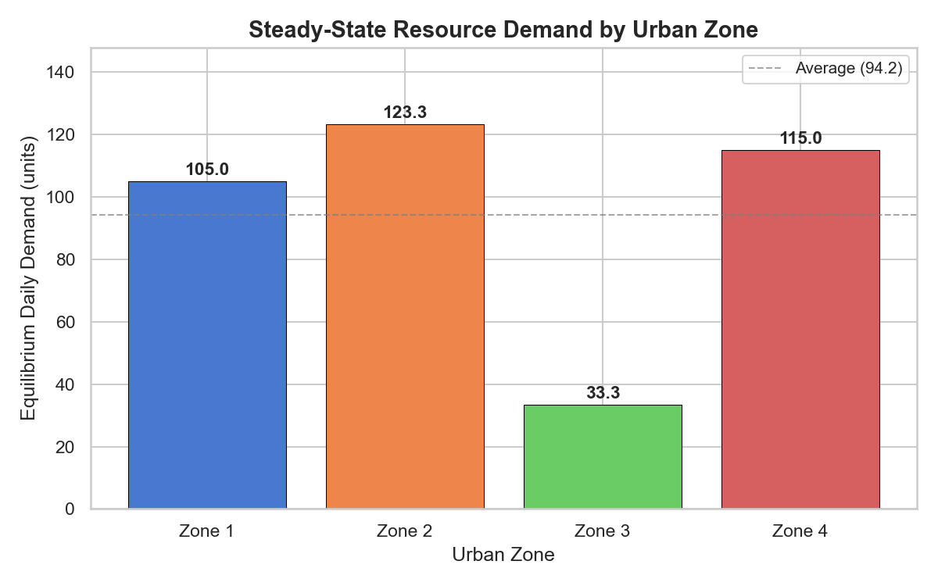

Figure 1: Daily demand for each urban area at steady state. The dashed line is an average of the demands from all four zones.

The equilibrium demand of each zone is represented as a bar graph in Figure 1. Zone 2 (123.33 units/day) has the highest demand, while Zone 3 (33.33 units/day) has the lowest. The average demand line (106.67 units/day) helps planners visualise which zones are above or below average.

4. Task 2: Demand Over Time (Calculus)

4.1 Mathematical Analysis (Method Used: Differential Calculus)
Resource demand is modelled by the demand function $D(t) = 4t^{3} - 18t^{2} + 24t + 90$ for a 4-hour period (t in hours). The purpose is to identify where demand is high or low, the rate of change of demand and what this means for operational planning.
Consider the function, f, and use differential calculus to analyses it.
The first derivative D'(t) will provide the rate at which the demand function will change at any given time.
The second derivative D''(t) gives information on the concavity (the rate of rate-change).
The critical points occur when D'(t) = 0. These are points that could be local max or min.
Each critical point is classified using the second derivative test (D''(t) > 0 – local minimum; D''(t) < 0 – local maximum).
The points where D''(t) = 0 are called points of inflection, because they mark a change in concavity.

4.2 Solution

4.2.1 Application of the Power Rule for Differentiation
To find the first derivative, we apply the power rule to each term of D(t). The power rule states that for any term $at^{n}$, the derivative is n $x at^{n-1} .$
Given $D(t) = 4t^{3} - 18t^{2} + 24t + 90$:
$\frac{d}{dt} (4t^{3}) = 3 x 4t^{2} = 12t^2$
$$\frac{d}{dt}(-18t^{2}) = 2 x (-18)t = -36t$$
$$\frac{d}{dt}\left(24t\right) = 24$$
$$d/dt(90) = 0$$
Therefore, the first derivative is:
$$D'(t) = 12t^{2} - 36t + 24$$
The second derivative is obtained by differentiating D'(t):
$D''(t) = 24t - 36$

4.2.2 Identification of Critical Points
Critical points occur where D'(t) = 0.
$$12t^{2} - 36t + 24 = 0$$
Divide by 12:
$$t^{2} - 3t + 2 = 0$$
Factor:
$$(t - 1)(t - 2) = 0$$
$$t1 = 1 hour$$
$$t2 = 2 hours$$

4.2.3 Second Derivative Test for Classification
For $t = 1$:
$$D^{''}\left(1\right) = 24(1) - 36 = -12$$
Since -12 < 0, this is a local maximum.
$$D(1) = 4{\left(1\right)}^{3} - 18{\left(1\right)}^{2} + 24(1) + 90 = 100 units$$
For $t = 2$:
$$D^{''}\left(2\right) = 24\left(2\right) - 36 = 12$$
Since $12 > 0$, this is a local minimum.
$$D(2) = 4{\left(2\right)}^{3} - 18{\left(2\right)}^{2} + 24(2) + 90 = 98 units$$

4.2.4 Inflection Point Analysis

$$24t - 36 = 0$$
$$t =\frac{36}{24} = 1.5 hours$$
$$D\left(1.5\right)= 4{\left(1.5\right)}^{3} - 18{\left(1.5\right)}^{2} + 24\left(1.5\right) + 90 = 99 units$$

This inflection point at t = 1.5 hours marks where the rate of decrease of demand itself starts to slow down - the demand curve changes from concave down to concave up.

4.2.5 Intervals of Increase and Decrease

Interval | Test Point | Sign of $D'(t)$ | Behaviour
$$t < 1$$ | $$t = 0$$ | $$D'(0) = 24 > 0$$ | Demand INCREASING (ramp-up)
$$1 < t < 2$$ | $$t = 1.5$$ | $$D'(1.5) = -3 < 0$$ | Demand DECREASING (mid-period dip)
$$t > 2$$ | $$t = 3$$ | $$D'(3) = 24 > 0$$ | Demand INCREASING (renewed growth)

4.2.6 Python Verification with Console Output
The symbolic computation of derivatives and the solving of critical points was done using SymPy.

4.3 Analysis and Results
There is a clear demand trend in the 4-hour period. Demand starts at 90 at the beginning and peaks at 100 units at t = 1 hour in the morning. It then drops to 98 units at t = 2 hours and increases back to 154 units at t = 4 hours.
Of particular interest is the inflection point at t = 1.5 hours - the rate of decrease is itself decreasing, thereby indicating that the system will begin to recover even prior to the beginning of the demand increase at t = 2 hours. This is a useful early warning system that works for automated resource management systems.
The best time for scheduled maintenance or reallocation of resources for operational planning is when t = 1 to t = 2 hours (dip) when the demand is at a minimum and the system is under the least stress. There is a need for pre-positioned capacity at the morning peak at t = 1 and plans should be made for further growth at the growth phase after t = 2.

4.4 Visualization
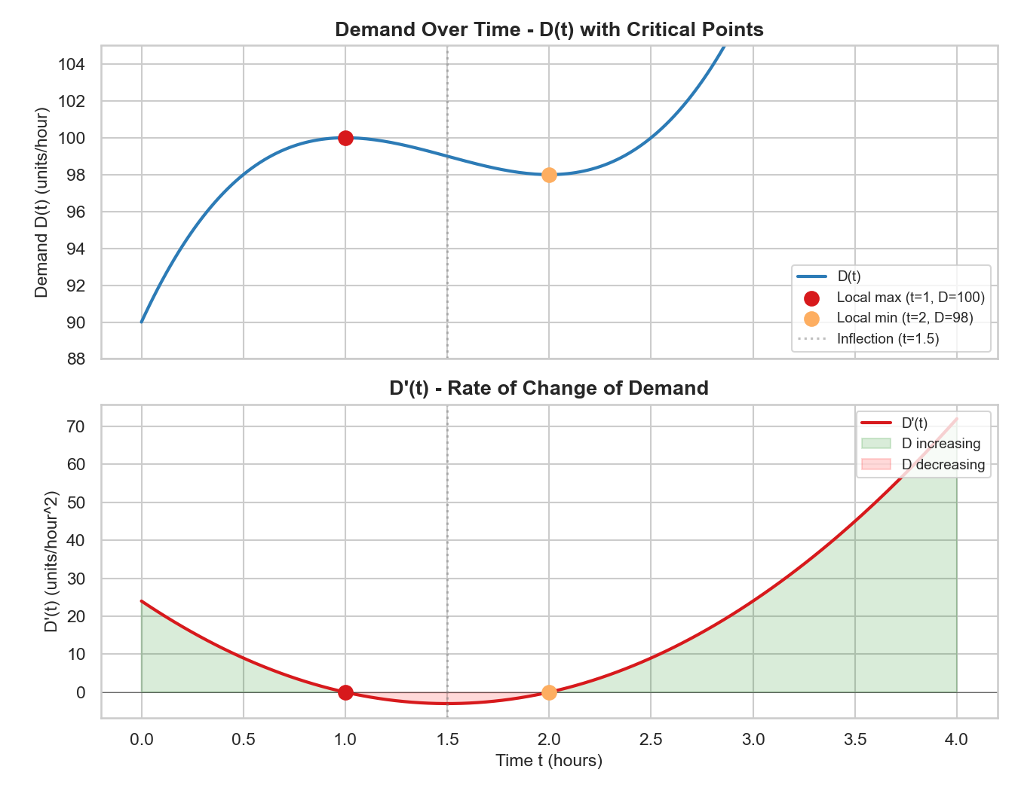

Figure 2: Demand over time D(t) (top panel) with critical points highlighted, and the rate of change D'(t) (bottom panel) with shaded increasing/decreasing regions.

Two related plots are shown in Figure 2. The top panel displays the demand curve D(t) with the inflection point (red dotted), the local minimum (orange), and the local maximum (red) highlighted. The bottom panel is the rate of change D'(t), with green shading for increasing demand and red shading for decreasing demand. The critical points of the demand curve are the zeros of D'(t) at t = 1 and t = 2.

10. References
Anton, H., Rorres, C. and Kaul, A. (2014) Elementary Linear Algebra: Applications Version. 11th edn. Hoboken: Wiley.
Stewart, J. (2016) Calculus: Early Transcendentals. 8th edn. Boston: Cengage Learning.
Thomas, G.B., Weir, M.D. and Hass, J. (2018) Thomas' Calculus. 14th edn. Boston: Pearson.

11. Appendix
Full Python code for all tasks is provided below.

Task 1: Linear Algebra

Task 2: Calculus

