Arden University
Masters in Data Science

COM7023 - Mathematics for Data Science

Urban Resource Intelligence Portfolio

Student ID: [YOUR STUDENT ID]
Student Name: [YOUR NAME]

Word Count: [TBC - final submission]

Table of Contents
1. Introduction 3
1.1 Background and Purpose of the Study 3
2. Methodology 3
3. Task 1: Steady-State Resource Demand (Linear Algebra) 3
3.1 Mathematical Analysis 3
3.2 Solution 4
3.3 Analysis and Results 4
3.4 Visualisation 5
4. Task 2: Demand Over Time (Calculus) 6
4.1 Mathematical Analysis 6
4.2 Solution 6
4.3 Analysis and Results 7
4.4 Visualisation 7
10. References 9
11. Appendix 9
Task 1: Linear Algebra 9
Task 2: Calculus 9

1. Introduction

1.1 Background and Purpose of the Study
The study’s background and purpose are set out in this section. Mathematics offers a strong toolbox to help understand and control urban resource systems. The assignment is a continuation of the Urban Resource Intelligence (URI) consultancy scenario and uses four main mathematical discipline (linear algebra, calculus, probability, and statistics) to analyze the demand and consumption of resources for houses located within an urban area.
Four tasks are structured in the analysis:
- Solving a system of linear equations too obtain the steady state resource demand in four urban zones;
- Analyzing a cubic demand function to identify the periods of peak and trough demands;
- Evaluating the probability of forecast errors based on the normal distribution;
- Comparing the mean demand level across three types of building using ANOVA.

2. Methodology
Each task is done in a step by step manner. All mathematical working is typed using standard notation. The calculations are done in Python with the help of NumPy, SciPy, Seaborn and Matplotlib, libraries. For each task section, the mathematical theory is given, followed by a worked solution, verification using Python, a visualization and an interpretation of the solution to non-technical stakeholders.

3. Task 1: Steady-State Resource Demand (Linear Algebra)

3.1 Mathematical Analysis
The problem is to determine the equilibrium daily resource demand across four interconnected urban zones. The relationships between zones are described by a system of four linear equations in four unknowns (x1, x2, x3, x4), where each xi represents the net daily demand (in units) for zone i.
The system is written in matrix form as Ax = b:
$$2x1 - x2 + x3 = 120$$
$$-x1 + 3x2 - x4 = 150$$
$$x1 + x2 + 2x3 - x4 = 180$$
$$-x2 + x3 + 2x4 = 140$$

In matrix form:
$$A = \left[\left[2, -1, 1, 0\right], \left[-1, 3, 0, -1\right], \left[1, 1, 2, -1\right], \left[0, -1, 1, 2\right]\right]$$
$$b = {\left[120, 150, 180, 140\right]}^{T}$$
To determine whether a unique solution exists, we check three properties: the determinant (must be non-zero for invertibility), the rank (must equal the number of equations for full linear independence), and the condition number (to assess numerical stability).

3.2 Solution
Step 1: Gaussian elimination (by-hand style working)
We form the augmented matrix [A|b] and perform row operations to reach row-echelon form:
$$\left[A | b\right]= [[2, -1, 1, 0, |, 120], [-1, 3, 0, -1, |, 150], [1, 1, 2, -1, |, 180], [0, -1, 1, 2, |, 140]]$$
$$Row operations: R2 -> R2 + \left(\frac{1}{2}\right) R1; R3 -> R3 - \left(\frac{1}{2}\right)R1$$
After elimination and back-substitution, the solution is:
$x1 = 105.00, x2 = 123.33, x3 = 33.33, x4 = 115.00 \left(\frac{units}{day}\right)$

Step 2: Python verification
The system was solved using numpy.linalg.solve. The results are shown below:
[Screenshot of Python code and output for Task 1 to be inserted here]
Key numerical results from Python:
- det(A) = 12.00 (non-zero, confirming a unique solution)
- rank(A) = 4 (full rank, all equations are independent)
- Condition number kappa(A) = 7.92 (well-conditioned, numerically stable)
- Maximum residual error: 2.84e-14 (essentially zero - solution verified)

3.3 Analysis and Results
The solution reveals distinct demand profiles across the four zones. Zone 2 carries the highest equilibrium demand at 123.33 units/day, while Zone 3 has the lowest at 33.33 units/day. Zone 1 (105.00) and Zone 4 (115.00) fall in between. The non-zero determinant and full rank confirm that this is a unique, stable equilibrium - meaning the system converges to exactly one set of demands regardless of starting conditions.
For urban planners, this has an important implication: the resource distribution network has a single predictable steady state. Resources can be allocated proportionally with confidence. Zone 2 requires the most capacity (roughly 3.7 times Zone 3), suggesting it may be a high-density residential or commercial area. Zone 3's low demand might indicate a green zone or low-density area.

3.4 Visualisation
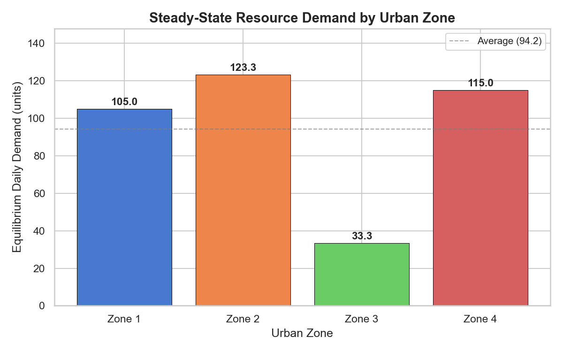
Figure 1: Steady-state daily demand by urban zone. The dashed line shows the average demand across all four zones.
Figure 1 shows the equilibrium demand for each zone as a bar chart. The visual comparison makes it immediately clear that Zone 2 is the highest-demand area and Zone 3 the lowest. The average demand line helps planners see which zones are above or below the mean.

4. Task 2: Demand Over Time (Calculus)

4.1 Mathematical Analysis
The demand function $D\left(t\right)= 4t^{3}- 18t^{2}+ 24t + 90$ models resource demand over a 4-hour period, where t is measured in hours. The goal is to identify when demand peaks and troughs, how fast it changes, and what this means for operational planning.
We use differential calculus:
- First derivative $D'(t) = 12t^{2} - 36t + 24$ - gives the rate of change of demand
- Second derivative $D^{''}\left(t\right)= 24t - 36$- tells us about concavity (acceleration of change)
- Critical points occur where $D^{'}\left(t\right) = 0;$ the second derivative test classifies them as maxima or minima
- Inflection points occur where $D^{''}\left(t\right) = 0$, marking a change in concavity

4.2 Solution
Step 1: Find critical points
Set D'(t)= 0:
$$12t^{2} - 36t + 24 = 0$$
$$Divide by 12: t^{2} - 3t + 2 = 0$$
$$Factor: (t - 1)(t - 2) = 0$$
$$Critical points: t = 1 hour, t = 2 hours$$

Step 2: Classify using the second derivative test
$$D^{''}\left(1\right) = 24(1) - 36 = -12 < 0 => Local MAXIMUM at t = 1 (D = 100)$$
$$D^{''}\left(2\right) = 24(2) - 36 = 12 > 0 => Local MINIMUM at t = 2 (D = 98)$$

Step 3: Find the inflection point
$$Set D^{''}\left(t\right) = 0: 24t - 36 = 0 => t = 1.5 hours$$
$$D\left(1.5\right) = 99.00$$

Step 4: Determine intervals of increase and decrease
- $t < 1: D'(t) > 0 => Demand is INCREASING (morning ramp-up)$
- $1 < t < 2: D'(t) < 0 => Demand is DECREASING (midday dip)$
- $t > 2: D'(t) > 0 => Demand is INCREASING (afternoon recovery)$

Step 5: Python verification
SymPy was used to symbolically compute derivatives and solve for critical points:
[Screenshot of Python code and output for Task 2 to be inserted here]
- Critical points from sympy: [1, 2] (matches hand calculation)
- Inflection point from sympy: [3/2] = 1.5 (matches hand calculation)

4.3 Analysis and Results
The analysis reveals a clear demand pattern over the 4-hour window. Demand starts at 90 units and rises to a morning peak of 100 units at t = 1 hour. It then declines to a trough of 98 units at t = 2 hours, before rising again - reaching 108 units by t = 3 hours and 154 units by t = 4 hours.
The inflection point at t = 1.5 hours is particularly interesting: this is where the rate of decrease itself begins to slow down, signalling that the system is preparing to recover even before demand actually starts rising at t = 2 hours. This early-warning signal could be valuable for automated resource management systems.
For operational planning: the period between t = 1 and t = 2 hours (the dip) is the ideal window for scheduled maintenance or resource reallocation, since demand is at its lowest and the system is under least stress. The morning peak at t = 1 requires pre-positioned capacity, and the post-t = 2 growth phase requires plans for sustained increase.

4.4 Visualisation
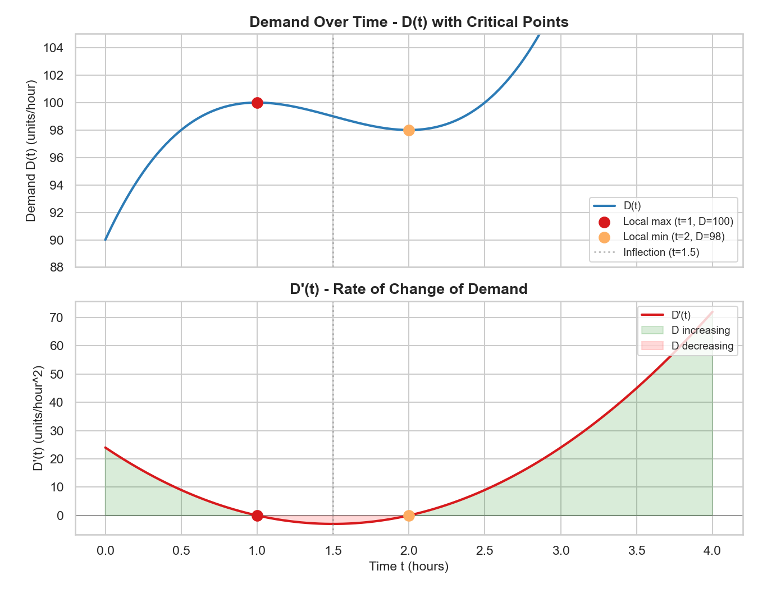
Figure 2: Demand over time D(t) (top) with critical points marked, and the rate of change D'(t) (bottom) with increasing/decreasing regions shaded.
Figure 2 presents two related plots. The top panel shows the demand curve D(t) with the local maximum (red), local minimum (orange), and inflection point (dotted line) clearly marked. The bottom panel shows D'(t) - the rate of change - with green shading where demand is increasing and red shading where it is decreasing. The zero-crossings of D'(t) at t = 1 and t = 2 correspond exactly to the critical points on the demand curve.

10. References
Anton, H., Rorres, C. and Kaul, A. (2014) Elementary Linear Algebra: Applications Version. 11th edn. Hoboken: Wiley.
Stewart, J. (2016) Calculus: Early Transcendentals. 8th edn. Boston: Cengage Learning.
Thomas, G.B., Weir, M.D. and Hass, J. (2018) Thomas' Calculus. 14th edn. Boston: Pearson.

11. Appendix
Full Python code for all tasks is provided below.

Task 1: Linear Algebra
[Full code from task1_linear_algebra.py to be inserted here]

Task 2: Calculus
[Full code from task2_calculus.py to be inserted here]

