Awarding Body:
Arden University
Programme Name:
[ ]
Module Name (and Part if applicable):
Machine Learning (COM7022)
Assessment Title:
Machine Learning Portfolio
Student Number:
[ ]
Tutor Name:
[ ]
Word Count:
3000
Please refer to the Word Count Policy on your Module Page for guidance

Table of Contents
1. Introduction 3
2. Methodology 3
2.1 Data Collection and Overview 3
2.2 Exploratory Data Analysis (EDA) 6
2.3 Data Preprocessing and Cleaning 8
2.4 Feature Engineering and Selection 10
2.5 Reducing Dimensions with PCA 14
3. Model Development 15
3.1 Choosing the Number of Clusters 15
3.2 Model Selection and Training 16
3.3 Model Evaluation Metrics 20
4. Results and Analysis 22
4.1 Visualisation Analysis 22
4.2 Cluster Profiling 24
4.3 Model Performance Comparison 26
5. Critical Evaluation 27
5.1 Summary of the Findings 27
5.2 Suitability of the Methods 27
5.3 Final Model Justification 27
5.4 Limitations and Other Approaches 27
6. Business Recommendations 28
7. Conclusion 28
References 29
Appendix 30

1. Introduction
Anyone selling perfume online ends up with a long list of products, and it quickly becomes hard to tell which ones deserve attention. Managing a range like that is easier when similar products are grouped, because effort can then go to the groups that matter. In this report I apply clustering to 1,000 perfume listings to find such groups from their characteristics and sales performance.
The report follows the two tasks in the brief. Task 1, the practical project, takes up sections 2 to 4. This is where I clean the data, pick the features and explain why, and then try K-Means, hierarchical clustering and DBSCAN before comparing them. Task 2 is the critical report for executives and covers sections 5 to 7. In it I look back at whether the methods were a good fit, explain why I settled on one model and suggest what the business could do next.
I did all of the analysis in Python with pandas, SciPy and scikit-learn (Pedregosa et al., 2011). Each step below shows the code with its output, and the complete notebook code is given in the appendix.

2. Methodology

2.1 Data Collection and Overview

Libraries Used
Code
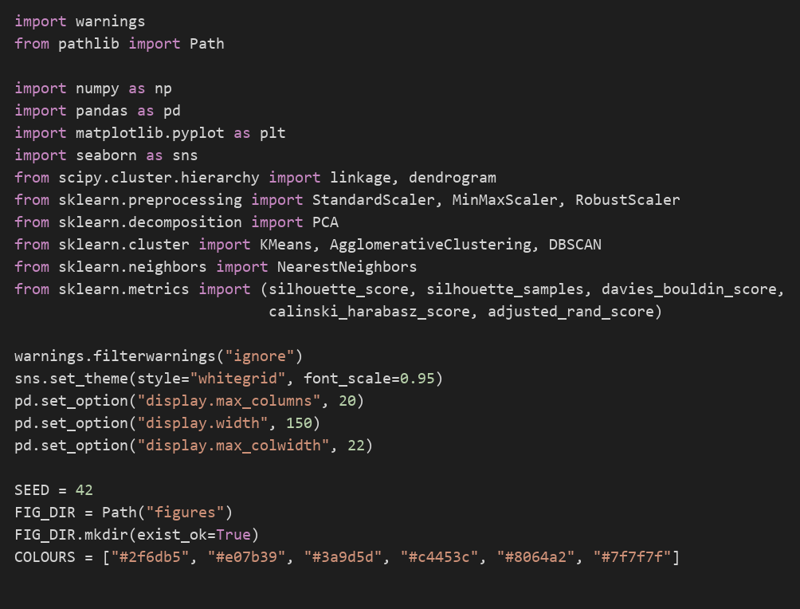

The code starts by importing the libraries. Most of the work uses pandas and scikit-learn, with SciPy for the dendrogram and matplotlib and seaborn for the charts. I set the random seed to 42 so that running the notebook again gives the same numbers.

Loading the Dataset
Code
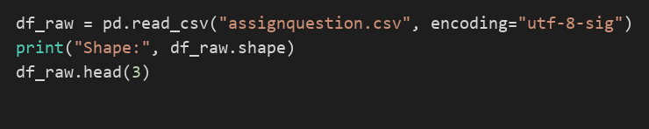
Output
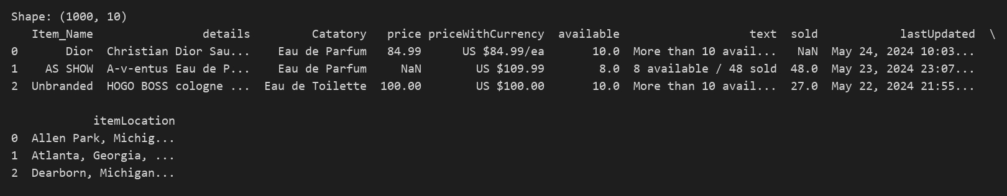

When I first opened the CSV, the first column name started with a hidden character (a byte order mark), so I read it with the utf-8-sig encoding. That gives 1,000 rows and ten columns. Only price, available and sold are numeric and the other seven are text, so much of the useful information sits inside text columns.

Data Types and Summary Statistics
Code
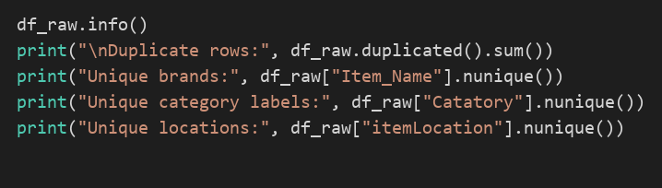
Output
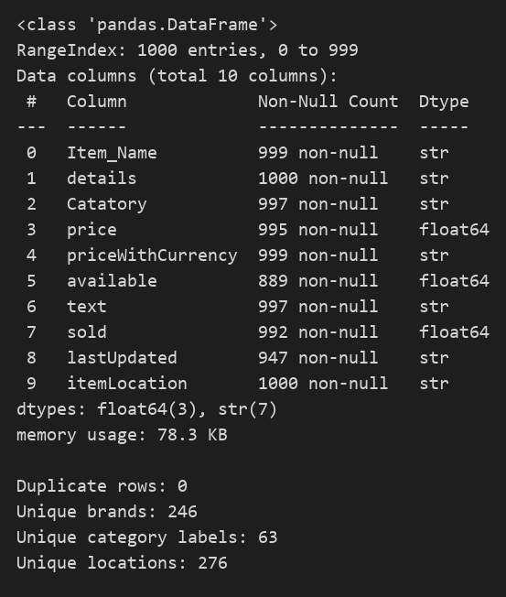
Code
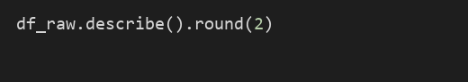
Output
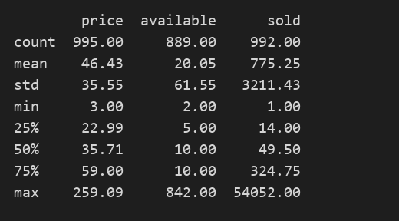

The info() output shows no duplicate rows, so no records needed removing. Skew is already visible in the summary statistics. The median price is 35.71 against a maximum of 259.09, and the median of sold is 49.5 against a maximum of 54,052.

2.2 Exploratory Data Analysis (EDA)

Missing Value Analysis
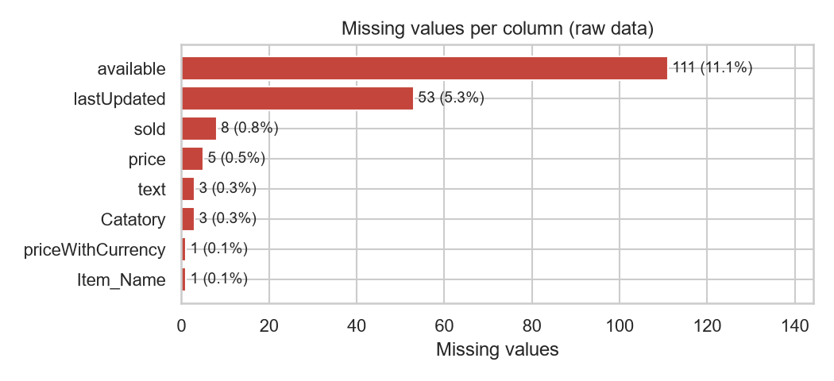
Figure 1: Missing values per column in the raw data
Figure 1 gives the number of missing values in each column. Units available is missing for 111 listings (11.1%) and the update time for 53 (5.3%), while every other column has fewer than ten gaps. These gaps are not spread at random. When I checked, most of them were listings where the stock text says 'Limited quantity' or 'Last One', so the seller simply never gave a number. I therefore filled gaps from related columns where I could, rather than deleting rows.

Text Fields
Code
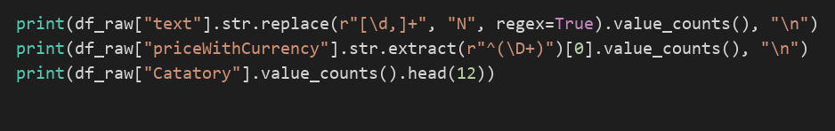
Output
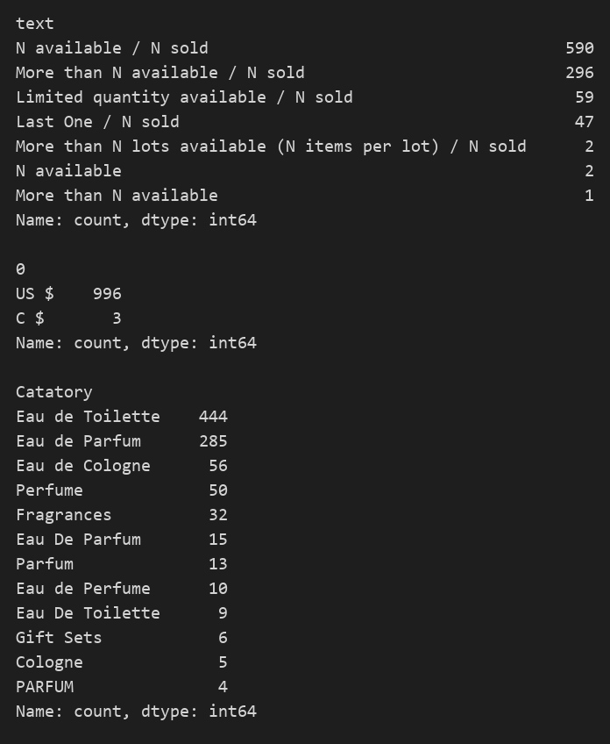

The stock text uses a small set of patterns, for example 'N available / N sold', 'More than N available / N sold', 'Limited quantity available / N sold' and 'Last One / N sold'. From the price text, 996 prices are in US dollars and three are in Canadian dollars. The category column contains 63 different labels and had to be cleaned before use.

2.3 Data Preprocessing and Cleaning

Repairing and Creating Columns
Code
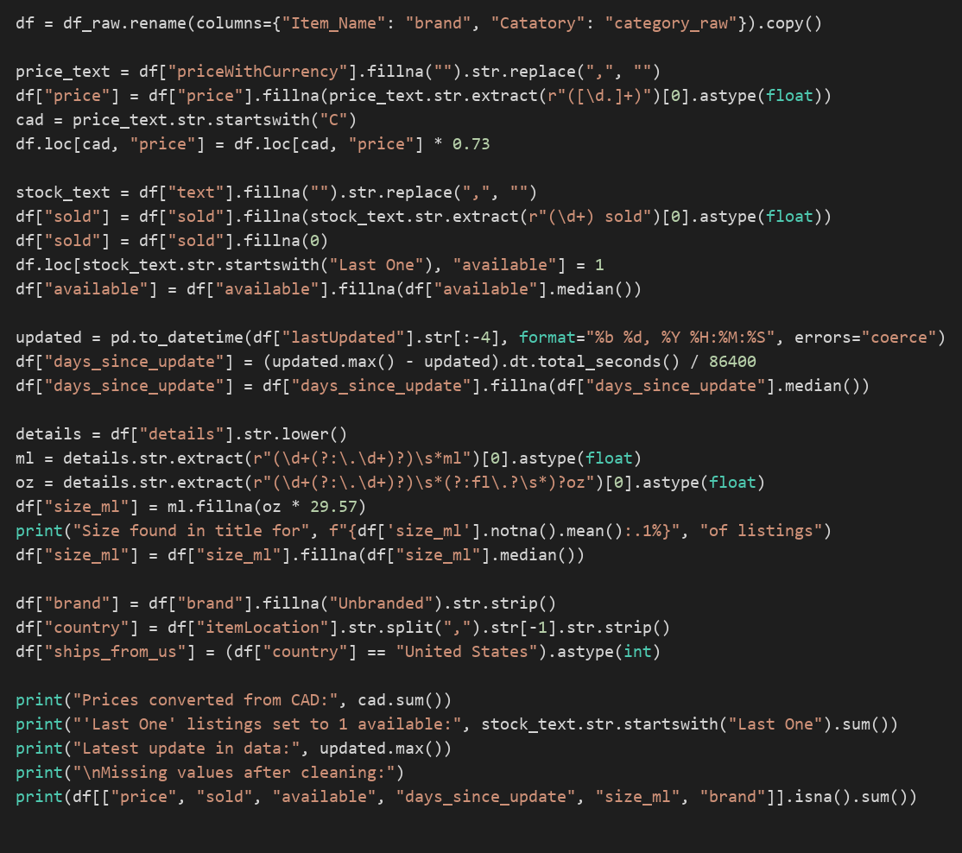
Output
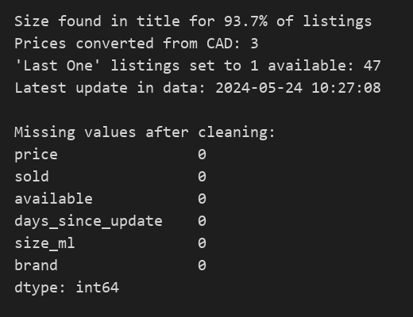

Other columns were enough to fix most gaps. I took the five missing prices from the price with currency text and converted the three Canadian dollar prices at an assumed rate of 0.73. Two missing sold counts were recovered from the stock text. The other six I set to zero, on the assumption that those listings had not yet made a sale. I gave the 47 'Last One' listings an availability of 1 and filled the remaining gaps in availability and update time with the median.
I also created two features from the text. Bottle size in millilitres came from the listing title and was found for 93.7% of listings; the rest received the median, and ounces were converted at 29.57 ml. The update time was turned into days since update, measured back from the newest timestamp in the file (24 May 2024).

Grouping the Category Labels
Code
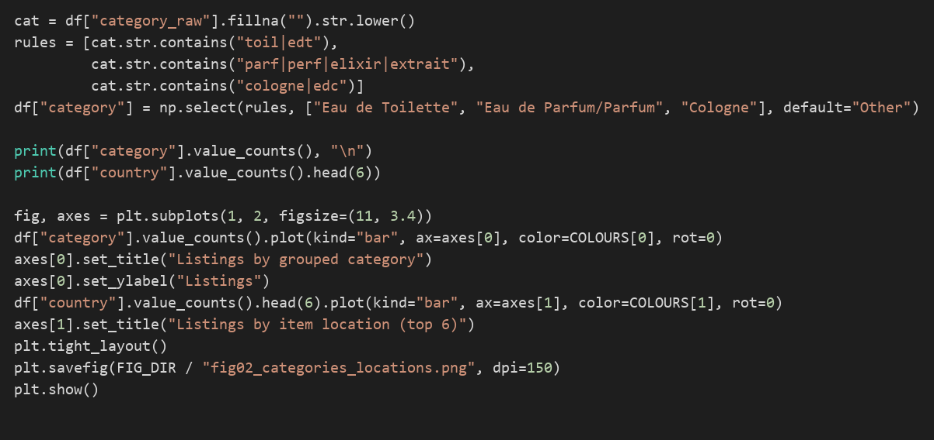
Output
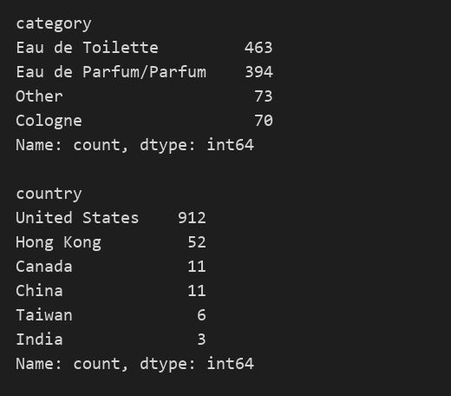

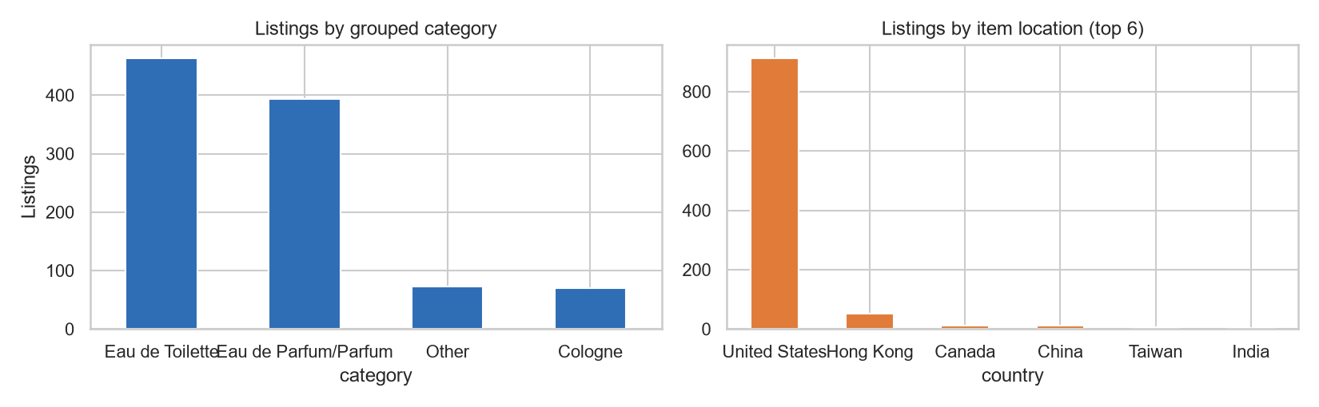
Figure 2: Listings by grouped category and by item location
Many of the 63 category labels were spelling variants of each other, such as 'Eau de Parfum' and 'Eau De Parfum'. Simple text rules reduced them to four groups: Eau de Toilette (463 listings), Eau de Parfum/Parfum (394), Other (73) and Cologne (70). Figure 2 also shows that 912 of the 1,000 listings ship from the United States, so location varies very little.

2.4 Feature Engineering and Selection

Feature Selection
For the clustering I kept five numeric columns: price, sold, available, days since update and size in ml. Price and size describe the product itself, sold and available show how it is trading, and days since update shows how actively the seller looks after it. Brand and location were left out. With 246 brands and 276 locations, one-hot encoding would add hundreds of mostly empty columns, and those would end up controlling the distances.

Testing the Category Variable
Code
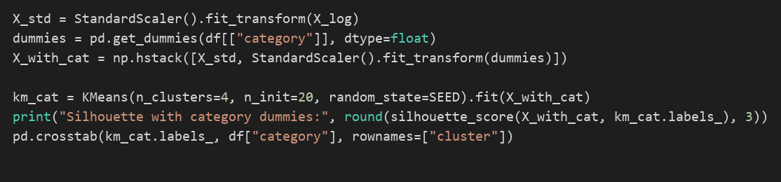
Output
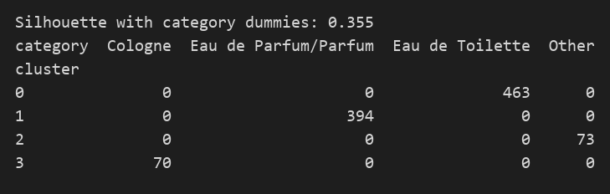

Category was tried as a one-hot encoded input. The resulting clusters were exactly the four category groups. The silhouette rose to 0.355, but only because dummy variables separate easily, and the clusters told me nothing about sales. Category, brand and country were therefore kept for describing the clusters after fitting.

Outliers and Skewness
Code
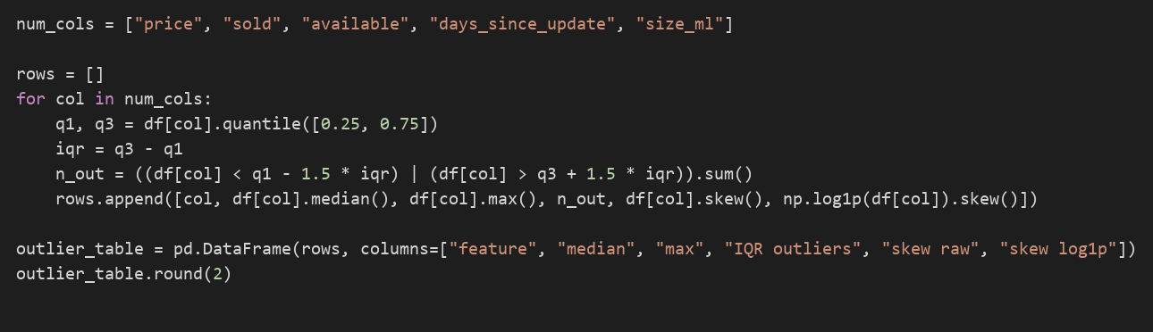
Output
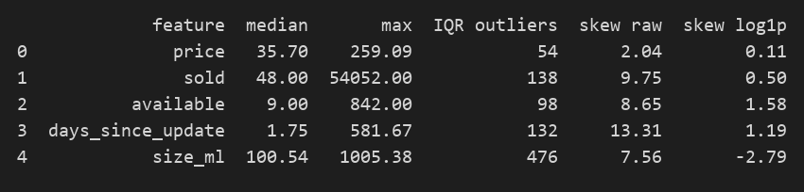

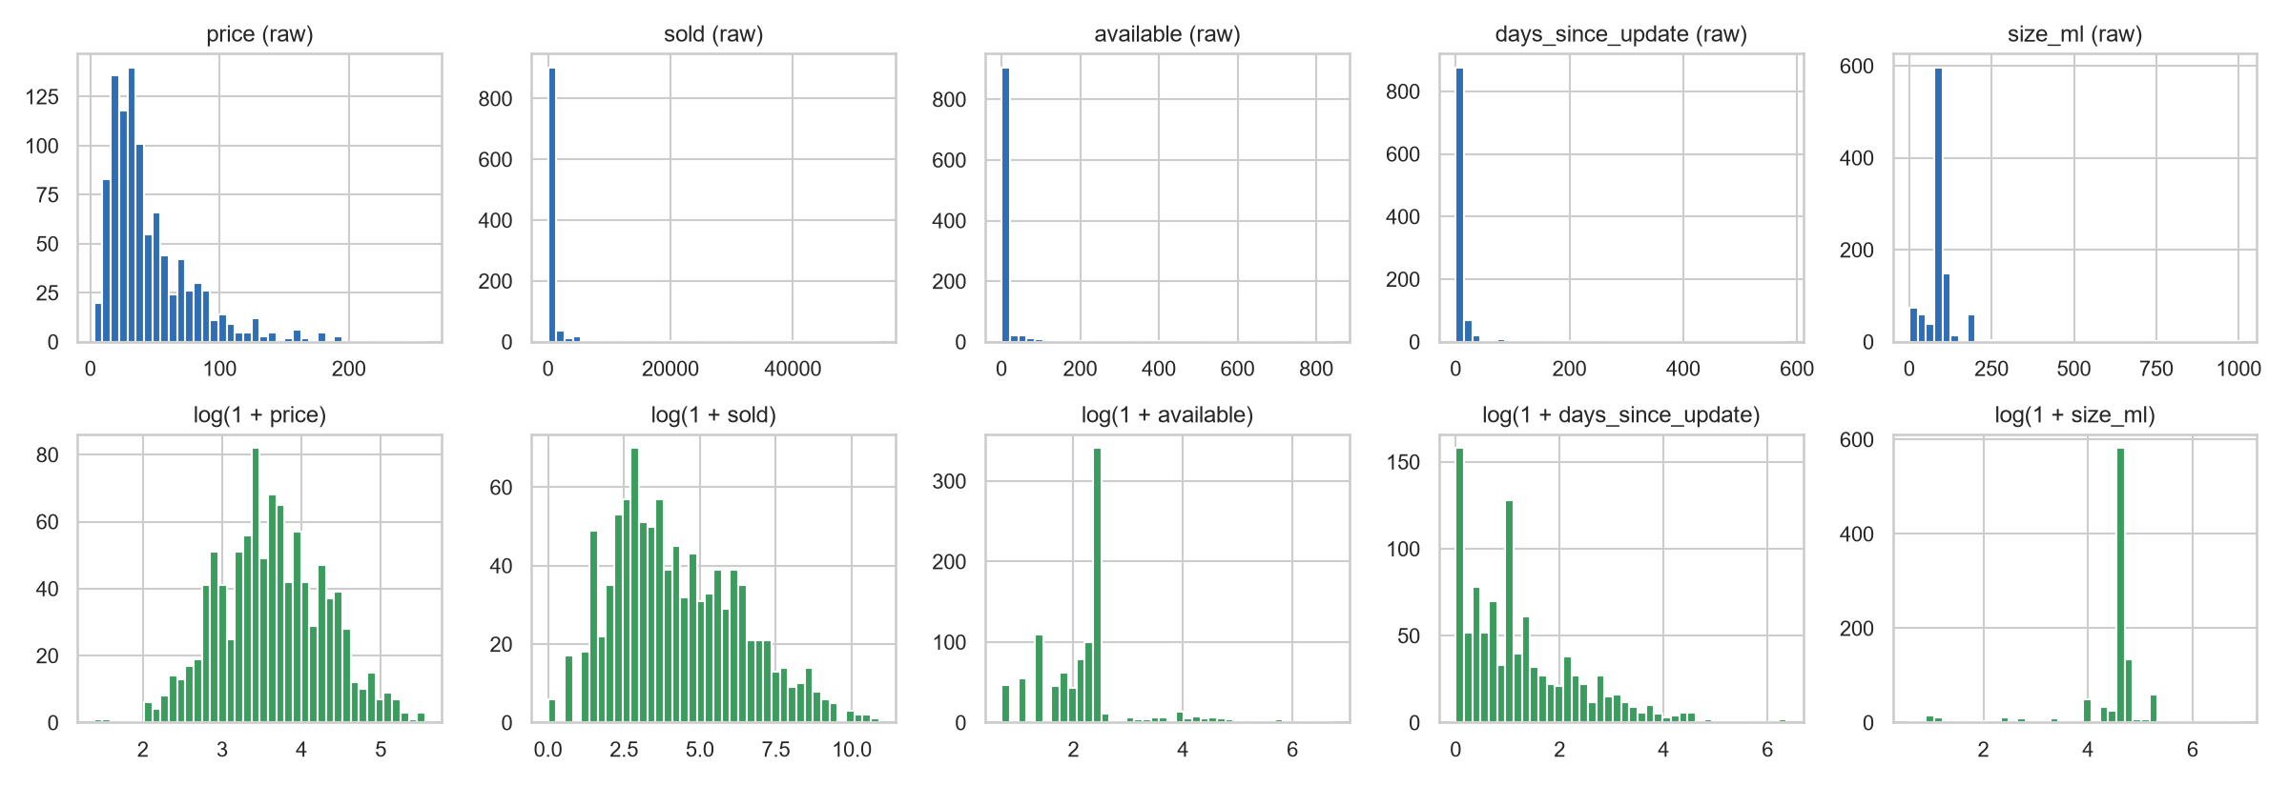
Figure 3: Histograms of each feature, raw (top row) and after log(1 + x) (bottom row)
Every numeric feature had a long right tail. The skewness was 9.75 for sold, 8.65 for available and 13.31 for days since update. Under the IQR rule, between 54 and 476 listings per feature counted as outliers. These are genuine products, though. Some best sellers have more than 50,000 sales, and removing them would lose the listings the business cares about most. Instead I applied log(1 + x), which cut skewness to 0.11 for price and 0.50 for sold (Figure 3). Size stayed negatively skewed (-2.79) because of the small sample bottles.

Correlation
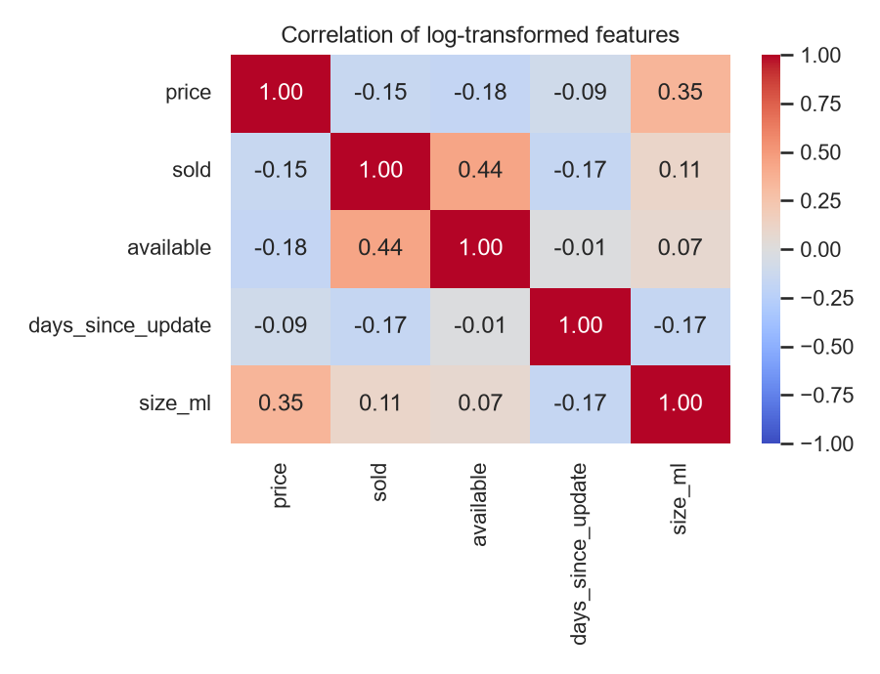
Figure 4: Correlation matrix of the log-transformed features
The strongest correlation between two features is 0.44, between sold and available, and price and size correlate at 0.35 (Figure 4). The features are related without being redundant, so all five were kept.

Scaling and Normalisation
Code
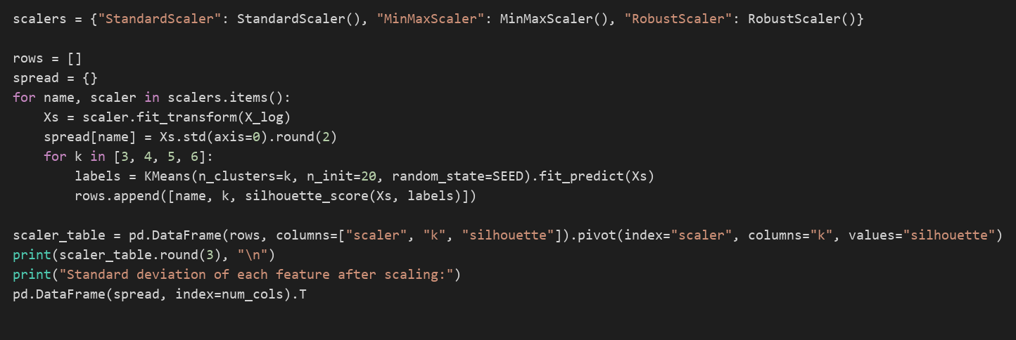
Output
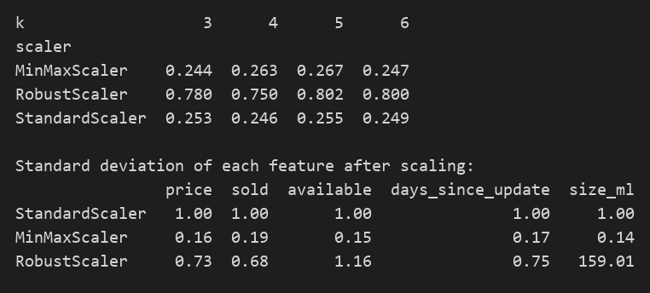
Code
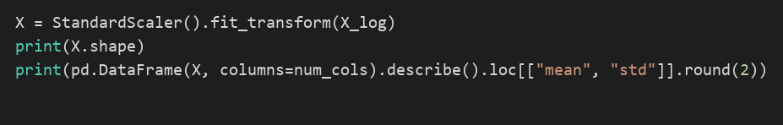
Output
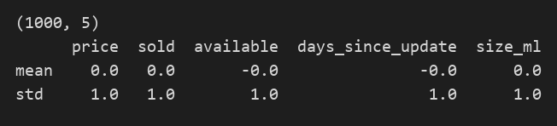

Because all three algorithms measure distances, a column with large numbers would outweigh the rest unless the data is scaled. To choose a scaler I ran K-Means at k = 5 once with each. StandardScaler gave a silhouette of 0.255, MinMaxScaler 0.267 and RobustScaler 0.802. The RobustScaler result is misleading. Because most bottles are 100 ml, the interquartile range of size is tiny, and after scaling the size column had a standard deviation of 159. Almost every distance was then decided by that one feature. I went with StandardScaler, which leaves every feature with a mean of 0 and a standard deviation of 1.

2.5 Reducing Dimensions with PCA
Code
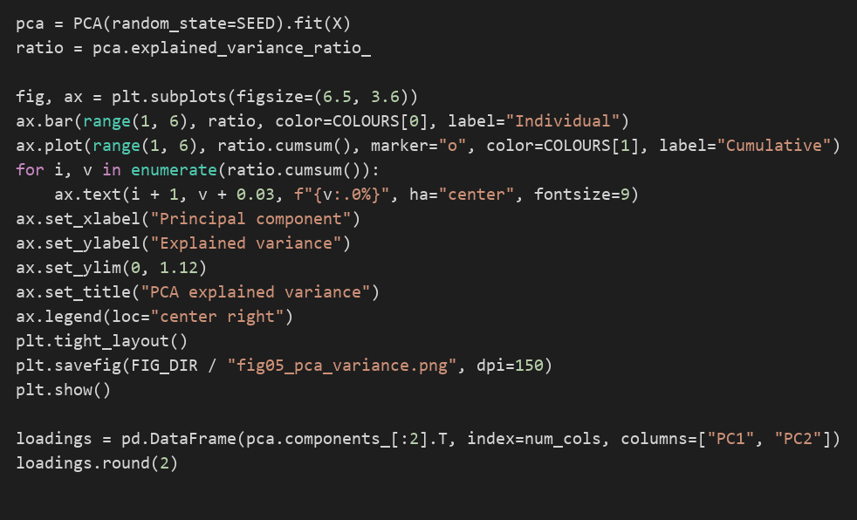
Output
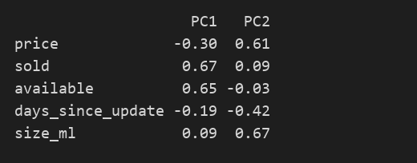

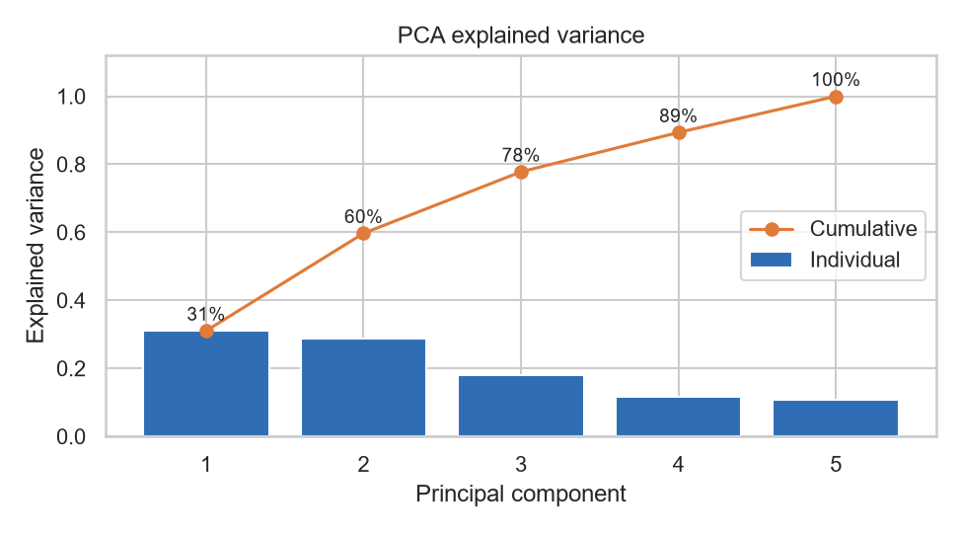
Figure 5: PCA scree plot with cumulative explained variance
I ran PCA on the standardised data mainly so that it could be plotted. Two components keep 59.7% of the variance and three keep 77.8% (Figure 5; Jolliffe, 2002). Sold (0.67) and available (0.65) have the biggest loadings on PC1, so the first component is really about sales volume and stock. PC2 is driven by size (0.67) and price (0.61). The models themselves were fitted on all five scaled features.

3. Model Development

3.1 Choosing the Number of Clusters
Code
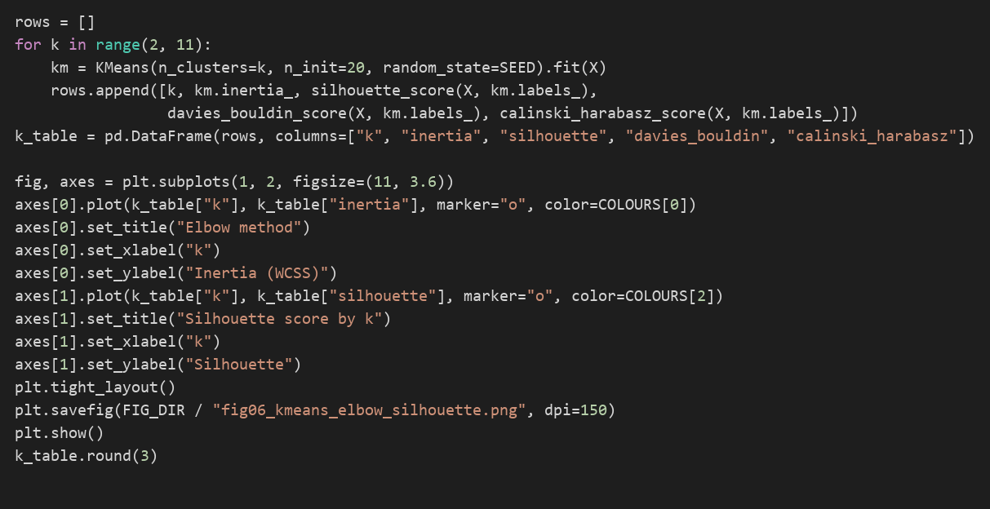
Output
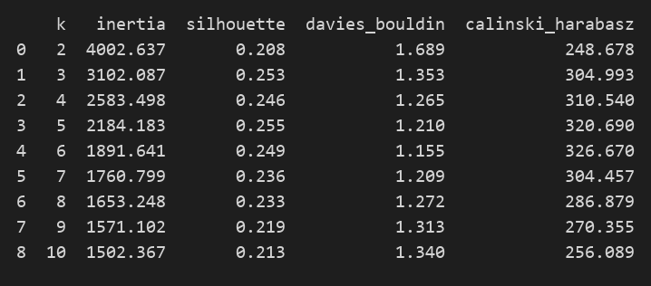

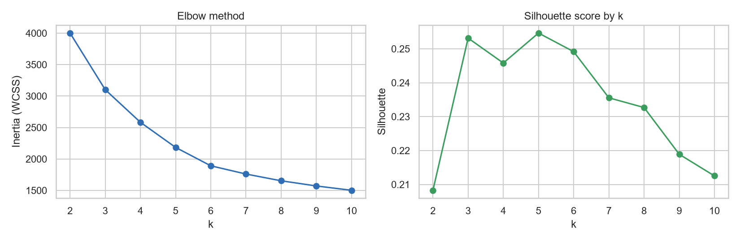
Figure 6: Elbow curve and silhouette score for K-Means
For K-Means I used k-means++ starting points (Arthur and Vassilvitskii, 2007) with 20 starts, and tried every k from 2 to 10. The silhouette barely moved between k = 3 and k = 6, staying between 0.246 and 0.255, and its highest value was at k = 5. The elbow in Figure 6 is not sharp and the bend falls between 4 and 6. Two other scores leaned slightly towards k = 6: Davies-Bouldin was 1.155 against 1.210, and Calinski-Harabasz 326.7 against 320.7. I kept k = 5. It had the best silhouette, and the only real change at k = 6 was that the large slow-selling group divided into a premium part (median price 80) and a budget part (27). That did not seem worth an extra cluster.
Code
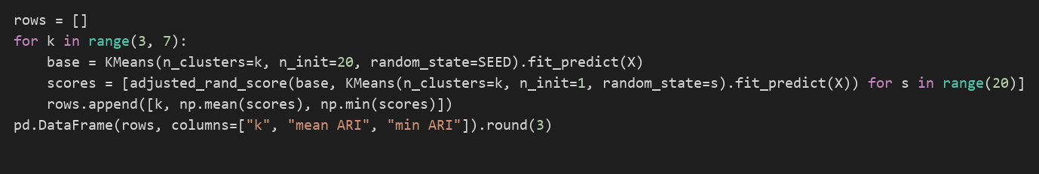
Output
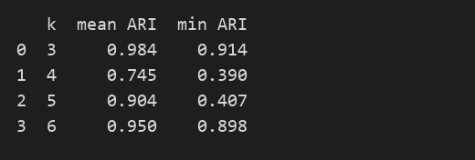

I was also worried that the result might depend on the random start. So I ran K-Means again from 20 single random starts and compared each run with my final solution using the adjusted Rand index. At k = 5 the average agreement was 0.90 but the worst was 0.41, so an unlucky start can land in a different local optimum. Running 20 starts reduces this risk.

3.2 Model Selection and Training
I picked three models that define a cluster in different ways. K-Means puts each listing with its nearest centre, so it tends to find compact, round groups. Ward's method starts with every listing on its own and keeps merging the two groups that add the least variance (Ward, 1963). DBSCAN works differently again: it grows clusters out of dense areas and leaves isolated points as noise (Ester et al., 1996).
K-Means (k = 5) | Hierarchical (Ward, k = 5) | DBSCAN (eps = 1.2)
Code  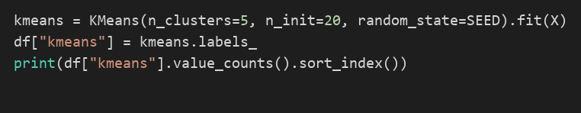 | Code  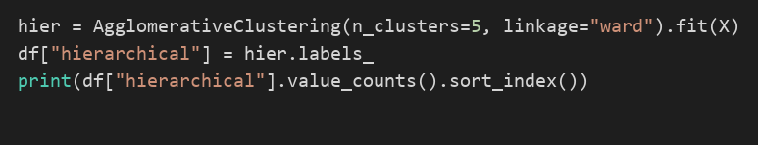 | Code  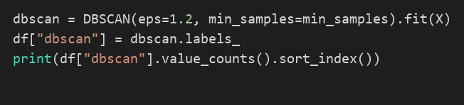
Output  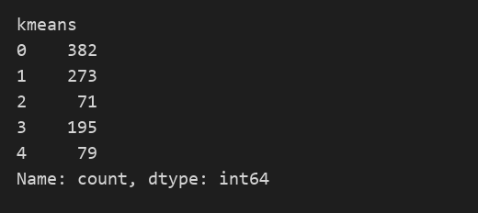 | Output  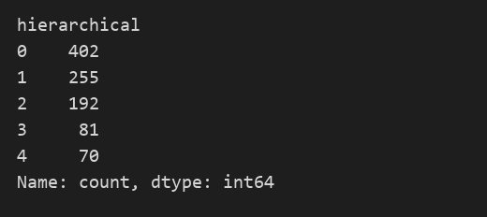 | Output  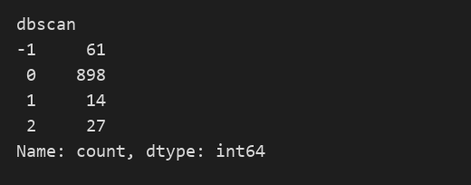
Groups around centres, with all 1,000 listings assigned. Cluster sizes run from 71 to 382. | Joins the closest listings one merge at a time. Cluster sizes run from 70 to 402. | 61 listings (6.1%) end up as noise, and 898 of the rest fall into a single cluster.

Tuning the Hierarchical Model
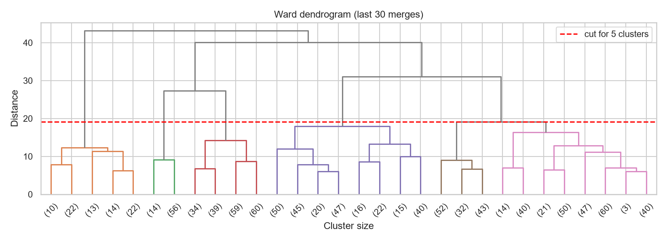
Figure 7: Ward dendrogram showing the last 30 merges
Code
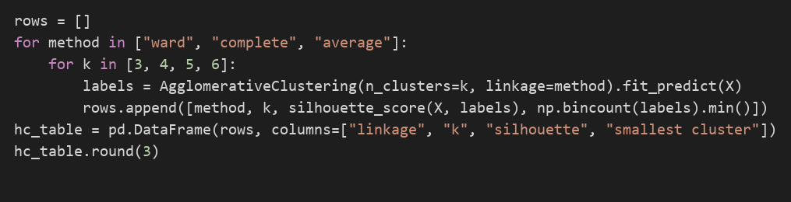
Output
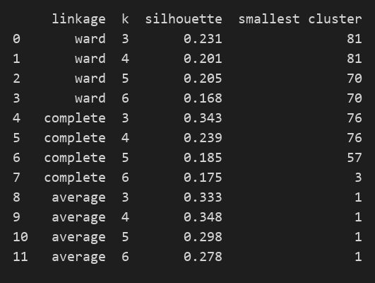

Ward linkage was applied to the scaled data and the dendrogram cut at five clusters (Figure 7). Average linkage produced a cluster containing a single listing, and complete linkage at k = 6 produced one of three, so only Ward gave usable cluster sizes (smallest 70).

Tuning DBSCAN
Code
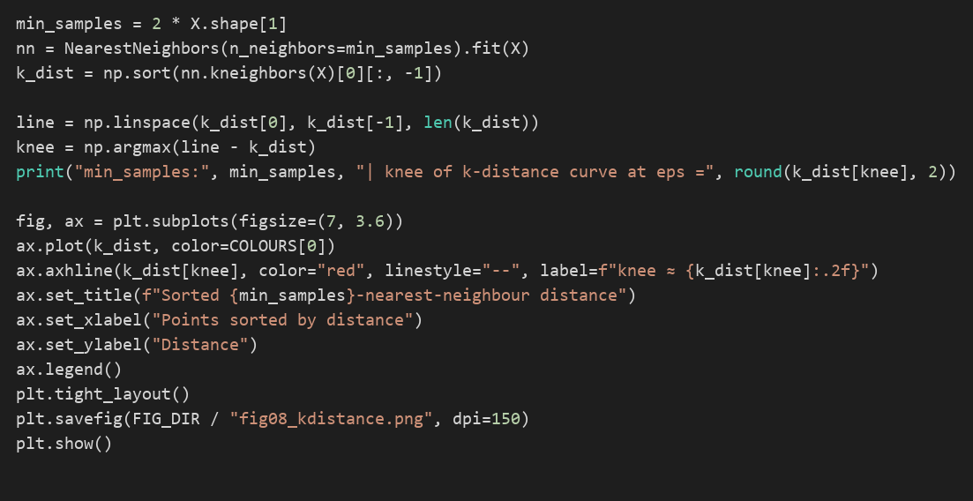
Output

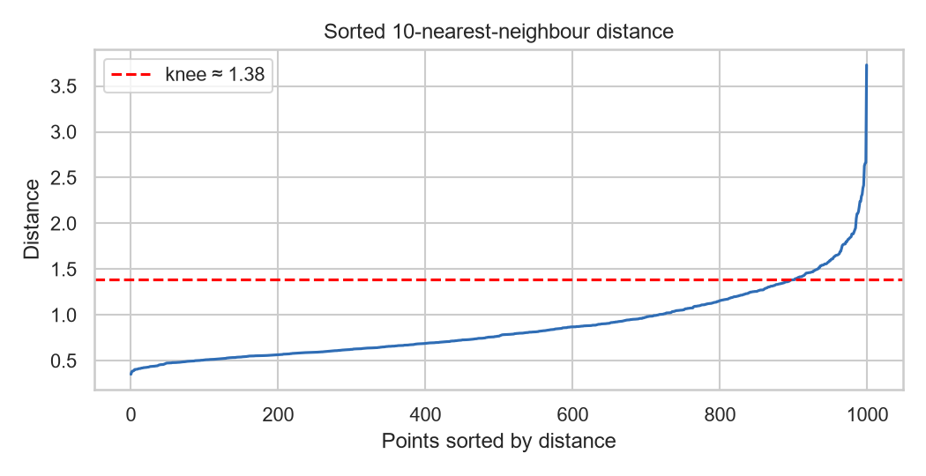
Figure 8: Sorted 10-nearest-neighbour distances used to choose eps
Code
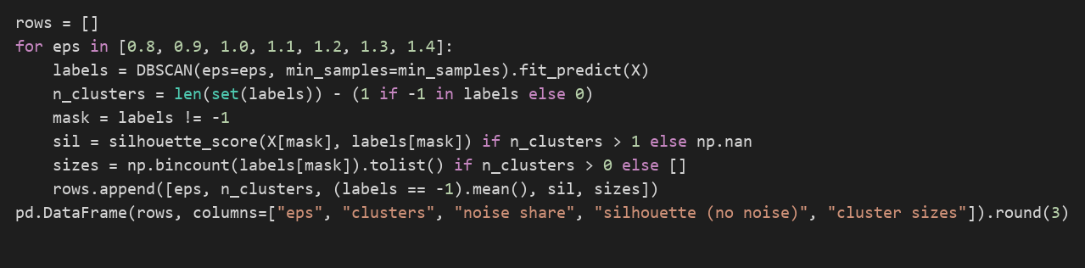
Output
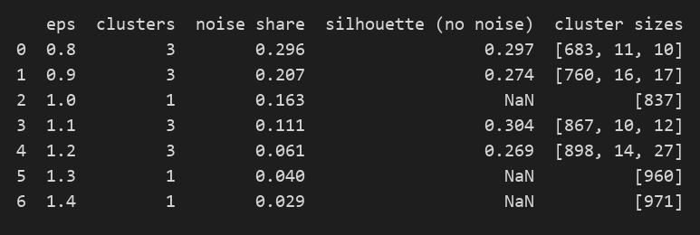

min_samples was set to 10, twice the number of features, and the k-distance curve bends at an eps of about 1.38 (Figure 8). I tested eps from 0.8 to 1.4. At 1.0, 1.3 and 1.4 DBSCAN found only one cluster, while 1.2 gave three clusters with 6.1% of listings as noise. Even then, one cluster held 898 of the 939 clustered listings (95.6%).

3.3 Model Evaluation Metrics
Without labels, the clusters can only be judged by internal measures. The silhouette score, from -1 to 1, compares how close a listing is to its own cluster and to the nearest other one, and higher is better (Rousseeuw, 1987). The Davies-Bouldin index compares the spread of each cluster with the distance between centres, and lower is better (Davies and Bouldin, 1979). The Calinski-Harabasz index divides between-cluster variance by within-cluster variance, and higher is better. The adjusted Rand index measures how far two models agree. For DBSCAN, noise points were removed before scoring.
Code
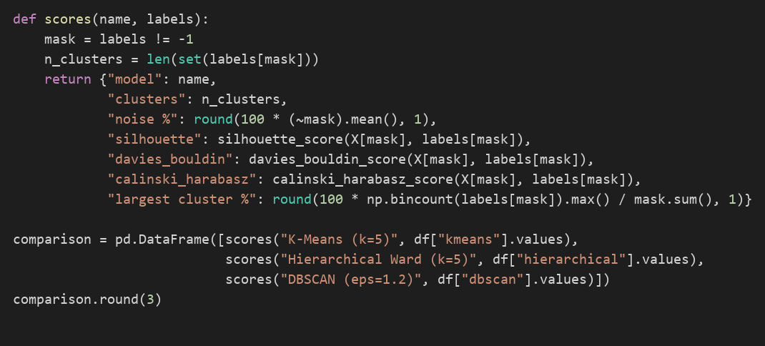
Output
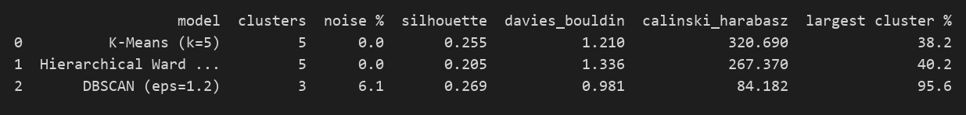
Code
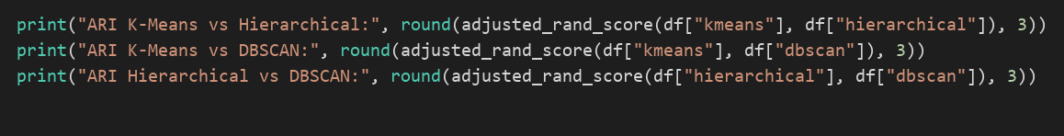
Output
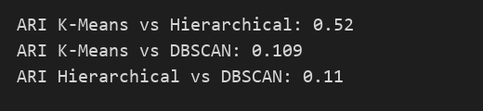

Section 4.3 brings the scores together. K-Means and Ward agree reasonably well (adjusted Rand index 0.52). DBSCAN hardly agrees with either of them, scoring 0.11 against both, so it is really giving a different answer to the question.

4. Results and Analysis

4.1 Visualisation Analysis
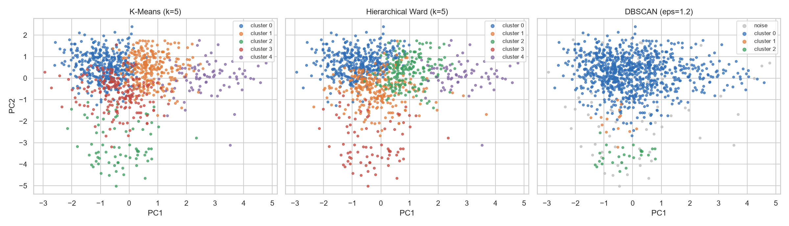
Figure 9: The three cluster solutions plotted on PC1 and PC2
In Figure 9 the three solutions are drawn on the first two principal components. For K-Means the groups mostly keep to their own areas. The high-volume cluster 4 sits out to the right, and the small samples in cluster 2 form a separate patch near the bottom. Ward's groups overlap more. DBSCAN shows one large cluster and a few small patches, in line with its 95.6% share.
Code
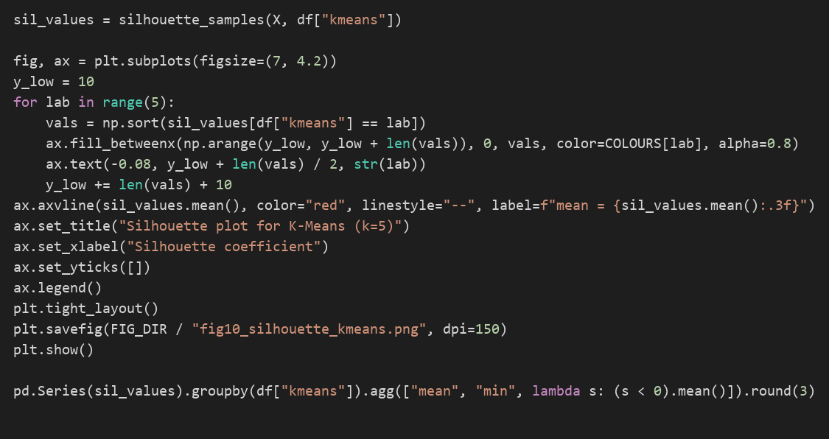
Output
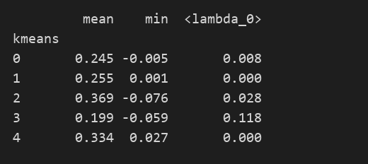

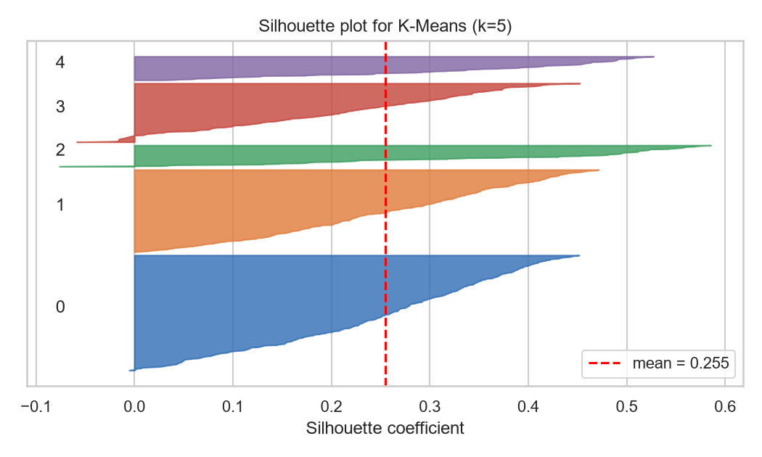
Figure 10: Silhouette plot for K-Means (k = 5)
In the silhouette plot (Figure 10), most listings have small positive values, which explains the low average of 0.255. Clusters 2 (0.369) and 4 (0.334) are the most clearly defined. Cluster 3 is the weakest, with a mean of 0.199 and 11.8% of its listings below zero.

4.2 Cluster Profiling
Code
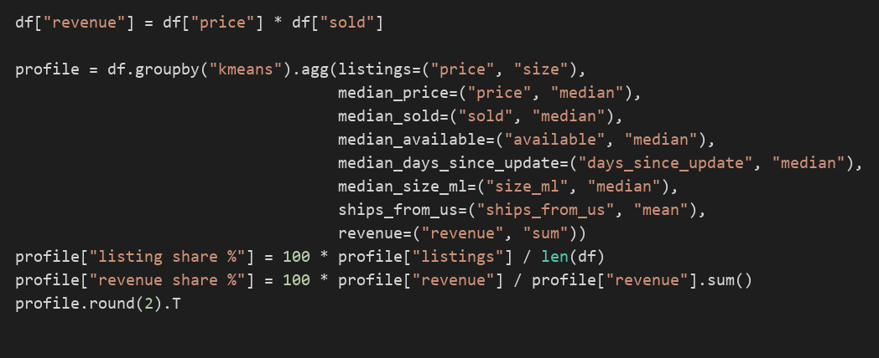
Output
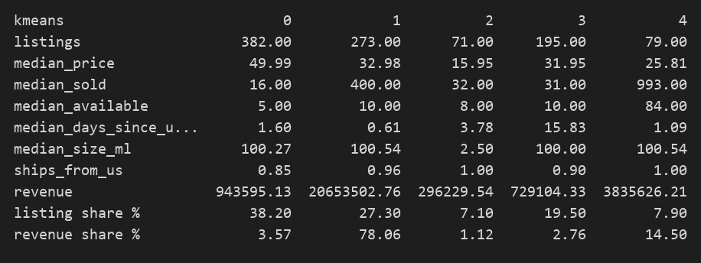

Output
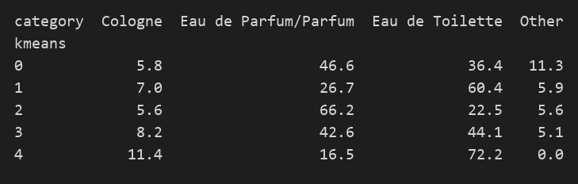

Table 1 lists the median profile of each K-Means cluster. To get a rough revenue figure I multiplied price by units sold. Since this treats the sold count as a lifetime total, it indicates relative importance rather than actual turnover.
Table 1: Profile of the five K-Means clusters (medians)
Cluster | Listings | Price ($) | Sold | Available | Days since update | Size (ml) | Revenue share
0 Premium slow movers | 382 | 49.99 | 16 | 5 | 1.6 | 100 | 3.6%
1 Core best sellers | 273 | 32.98 | 400 | 10 | 0.6 | 101 | 78.1%
2 Minis and samples | 71 | 15.95 | 32 | 8 | 3.8 | 2.5 | 1.1%
3 Stale listings | 195 | 31.95 | 31 | 10 | 15.8 | 100 | 2.8%
4 High-stock volume lines | 79 | 25.81 | 993 | 84 | 1.1 | 101 | 14.5%

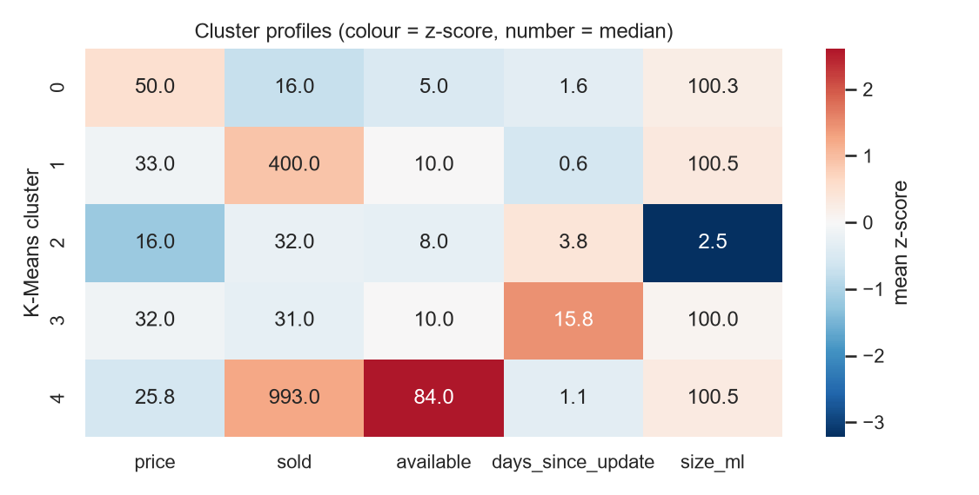
Figure 11: Cluster profiles: colour shows the mean z-score, numbers show the median
- Premium slow movers (38.2%). The largest group, and a quiet one. The median price is $49.99, with low stock and few sales. Of the full-size clusters it has the highest share of Eau de Parfum and Parfum.
- Core best sellers. Mid-priced listings that sell about 400 units each and are kept up to date. They make up 27.3% of listings and an estimated 78% of revenue.
- Minis and samples. Very small bottles of about 2.5 ml with a median price of $16. Two thirds are parfum, so I treat them as testers and samples, not standard products.
- Stale listings. Price and stock are typical, but the median listing was last updated 15.8 days before the cut-off, compared with under 4 days for every other cluster. Sales are low.
- High-stock volume lines. A median stock of 84 units and almost 1,000 sales per listing at a lower price. This is a small group, just 7.9% of listings, yet it brings in roughly 14.5% of revenue.
Code
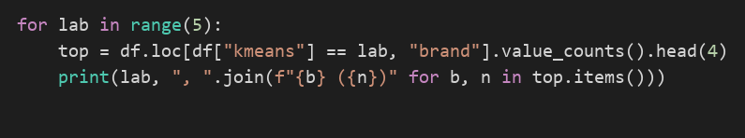
Output
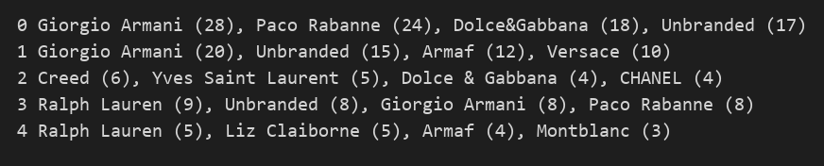

Figure 11 shows the differences clearly. Cluster 2 is well below average on size, cluster 4 well above on stock and sales, and cluster 3 stands out on days since update. Brand does not determine the segment. Giorgio Armani, for example, is in the top four brands of three different clusters. The minis cluster is the odd one out, because its most common brands are expensive ones such as Creed, Yves Saint Laurent and Chanel. That makes sense if these are testers of designer perfumes.

4.3 Model Performance Comparison
Table 2: Validation results for the three clustering models
Model | Clusters | Noise % | Silhouette | Davies-Bouldin | Calinski-Harabasz | Largest cluster %
K-Means (k = 5) | 5 | 0.0 | 0.255 | 1.210 | 320.7 | 38.2
Hierarchical Ward (k = 5) | 5 | 0.0 | 0.205 | 1.336 | 267.4 | 40.2
DBSCAN (eps = 1.2) | 3 | 6.1 | 0.269 | 0.981 | 84.2 | 95.6

K-Means
K-Means came out on top of the two models that place every listing in a cluster. Its silhouette was 0.255 and its Calinski-Harabasz value of 320.7 was the highest of all three. The smallest cluster still has 71 listings, and I could give each cluster a clear business meaning.

Ward Linkage
Ward linkage scored below K-Means on all three measures: a silhouette of 0.205, a Davies-Bouldin index of 1.336 and a Calinski-Harabasz value of 267.4. Agreement between the two partitions was moderate (adjusted Rand index 0.52). The dendrogram (Figure 7) makes the merge order easy to inspect, but the method needs the distance between every pair of listings, so its cost grows quickly with catalogue size.

DBSCAN
DBSCAN obtained the highest silhouette (0.269) and the lowest Davies-Bouldin index (0.981). These scores are computed without the noise points, and the partition is one large cluster plus two small dense groups, so 95.6% of the clustered listings sit together.

5. Critical Evaluation
Sections 5 to 7 are aimed at an executive reader and draw on the results of Task 1.

5.1 Summary of the Findings
The 1,000 perfume listings fall into five segments. The headline result is that the core best sellers make up only 27% of listings but an estimated 78% of revenue. The stale listings (20% of the range) sell poorly, and their median listing had not been updated for 15.8 days. Because the segments overlap at their edges (silhouette 0.255), they are best used to prioritise effort rather than as fixed categories.

5.2 Suitability of the Methods
As there is no labelled outcome to predict, clustering was the natural choice of method. In this project the choice of inputs affected the segments as much as the choice of algorithm (Hastie et al., 2009). When category was included, the clusters simply reproduced it, so category, brand and location were left out. Log-transforming the skewed sales and stock figures also reduced the pull of a few very large sellers.
K-Means assigns every product to a segment, and its five groups (71 to 382 listings) are a manageable size for a sales team. Ward does not need k in advance, but it scored lower here. DBSCAN suits flagging unusual listings better than segmentation, because the data has no clear density gaps and it placed 95.6% of clustered listings in one group.

5.3 Final Model Justification
I selected K-Means as the final model. Of the models that assign every listing, it scored best on all three measures (Table 2), and each cluster can be summarised in one sentence (section 4.2), which matters for business use. It has limits. A silhouette of 0.255 indicates weak separation, so decisions should rest on each segment's overall profile rather than on listings near a boundary. If the premium group needs splitting by price, the six-cluster solution from section 3.1 provides that split.

5.4 Limitations and Other Approaches
Data limitations. The data is one snapshot from May 2024, so seasonality and trends cannot be seen. Most listings were updated during the final week, so 'stale' only means older than the rest of this snapshot. Revenue is estimated from price and a lifetime sold count, not from dated sales.
Model assumptions. K-Means works best with compact clusters of similar size, which is only partly true here (71 to 382 listings). All three methods also rely on distances, and distances lose contrast as more features are added. The 0.73 exchange rate and the zero sold counts are assumptions, and median filling hides some real variation.
Potential biases. Since 912 of the 1,000 listings ship from the United States, the segments may not transfer to other markets. The sold count is cumulative, so older listings have had longer to build up sales and newer products may appear weaker than they are.
Alternative approaches. Dated sales records would allow revenue to be measured directly, and brand tier and customer ratings could be added as inputs. Gaussian mixture models are also worth testing, since they give each listing a probability of belonging to each segment and so suit overlapping groups.

6. Business Recommendations
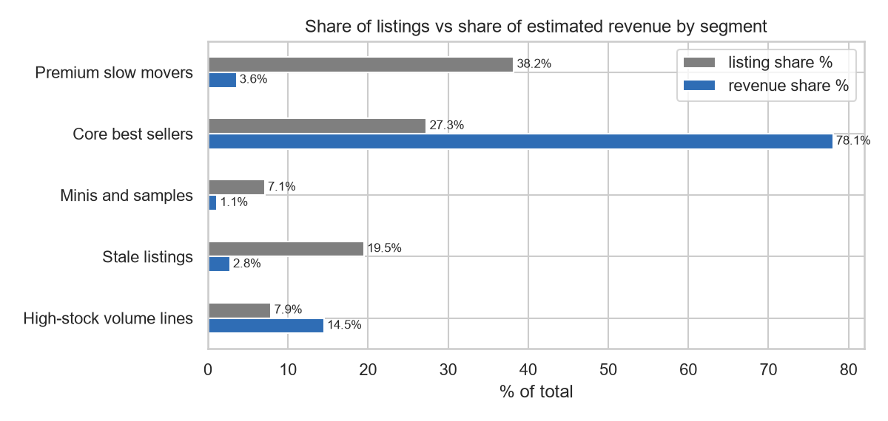
Figure 12: Share of listings and share of estimated revenue by segment
Together, the core best sellers and high-stock volume lines account for 35% of listings and about 93% of estimated revenue (Figure 12). The largest group (38% of listings) combines higher prices, little stock and few sales, and brings in under 4% of revenue.
- Look after the winners. Prioritise stock availability and stable pricing for the core best sellers and high-stock lines, which produce about 93% of estimated revenue.
- Refresh the stale listings. The 195 stale listings should be reviewed in the next update cycle, with titles, photos and prices refreshed and non-sellers withdrawn. Sales should then be compared before and after, because this data cannot show whether the lack of updates causes the weak sales or follows from them.
- Trial discounts first. Price cuts or bundles should be trialled on a small sample of premium slow movers before any wider change, as their higher prices (median $49.99) may reflect deliberate positioning.
- Separate the samples. The 71 sample listings (median size 2.5 ml) sell at a median of $15.95 and behave unlike full-size products. Reporting them separately would stop them distorting averages in sales dashboards.
- Monitor movement. Rerun the model each month on new data to see whether listings move between segments.

7. Conclusion
In this project I grouped 1,000 perfume listings into five segments with K-Means. K-Means gave the most useful result, although its silhouette of 0.255 shows only weak separation. The clearest finding is how concentrated sales are: the core best sellers, 27% of listings, account for an estimated 78% of revenue. The recommendations therefore centre on protecting that segment and dealing with the 195 stale listings. Dated sales records and probabilistic models would show whether the five segments hold over time.

References
Arthur, D. and Vassilvitskii, S. (2007) 'k-means++: the advantages of careful seeding', Proceedings of the 18th Annual ACM-SIAM Symposium on Discrete Algorithms, pp. 1027-1035.
Davies, D.L. and Bouldin, D.W. (1979) 'A cluster separation measure', IEEE Transactions on Pattern Analysis and Machine Intelligence, PAMI-1(2), pp. 224-227.
Ester, M., Kriegel, H.-P., Sander, J. and Xu, X. (1996) 'A density-based algorithm for discovering clusters in large spatial databases with noise', Proceedings of the Second International Conference on Knowledge Discovery and Data Mining, pp. 226-231.
Hastie, T., Tibshirani, R. and Friedman, J. (2009) The Elements of Statistical Learning. 2nd edn. New York: Springer.
Jolliffe, I.T. (2002) Principal Component Analysis. 2nd edn. New York: Springer.
Pedregosa, F. et al. (2011) 'Scikit-learn: machine learning in Python', Journal of Machine Learning Research, 12, pp. 2825-2830.
Rousseeuw, P.J. (1987) 'Silhouettes: a graphical aid to the interpretation and validation of cluster analysis', Journal of Computational and Applied Mathematics, 20, pp. 53-65.
Ward, J.H. (1963) 'Hierarchical grouping to optimize an objective function', Journal of the American Statistical Association, 58(301), pp. 236-244.

Appendix
1. Libraries and settings
import warnings
from pathlib import Path
import numpy as np
import pandas as pd
import matplotlib.pyplot as plt
import seaborn as sns
from scipy.cluster.hierarchy import linkage, dendrogram
from sklearn.preprocessing import StandardScaler, MinMaxScaler, RobustScaler
from sklearn.decomposition import PCA
from sklearn.cluster import KMeans, AgglomerativeClustering, DBSCAN
from sklearn.neighbors import NearestNeighbors
from sklearn.metrics import (silhouette_score, silhouette_samples, davies_bouldin_score,
calinski_harabasz_score, adjusted_rand_score)
warnings.filterwarnings("ignore")
sns.set_theme(style="whitegrid", font_scale=0.95)
pd.set_option("display.max_columns", 20)
pd.set_option("display.width", 150)
pd.set_option("display.max_colwidth", 22)
SEED = 42
FIG_DIR = Path("figures")
FIG_DIR.mkdir(exist_ok=True)
COLOURS = ["#2f6db5", "#e07b39", "#3a9d5d", "#c4453c", "#8064a2", "#7f7f7f"]
2. Loading and understanding the data
df_raw = pd.read_csv("assignquestion.csv", encoding="utf-8-sig")
print("Shape:", df_raw.shape)
df_raw.head(3)
df_raw.info()
print("\nDuplicate rows:", df_raw.duplicated().sum())
print("Unique brands:", df_raw["Item_Name"].nunique())
print("Unique category labels:", df_raw["Catatory"].nunique())
print("Unique locations:", df_raw["itemLocation"].nunique())
df_raw.describe().round(2)
missing = df_raw.isna().sum()
missing = missing[missing > 0].sort_values()
fig, ax = plt.subplots(figsize=(7, 3.2))
ax.barh(missing.index, missing.values, color="#c4453c")
for i, v in enumerate(missing.values):
ax.text(v + 1, i, f"{v} ({v / len(df_raw):.1%})", va="center", fontsize=9)
ax.set_xlabel("Missing values")
ax.set_title("Missing values per column (raw data)")
ax.set_xlim(0, missing.max() * 1.3)
plt.tight_layout()
plt.savefig(FIG_DIR / "fig01_missing_values.png", dpi=150)
plt.show()
print(df_raw["text"].str.replace(r"[\d,]+", "N", regex=True).value_counts(), "\n")
print(df_raw["priceWithCurrency"].str.extract(r"^(\D+)")[0].value_counts(), "\n")
print(df_raw["Catatory"].value_counts().head(12))
3. Data cleaning
df = df_raw.rename(columns={"Item_Name": "brand", "Catatory": "category_raw"}).copy()
price_text = df["priceWithCurrency"].fillna("").str.replace(",", "")
df["price"] = df["price"].fillna(price_text.str.extract(r"([\d.]+)")[0].astype(float))
cad = price_text.str.startswith("C")
df.loc[cad, "price"] = df.loc[cad, "price"] * 0.73
stock_text = df["text"].fillna("").str.replace(",", "")
df["sold"] = df["sold"].fillna(stock_text.str.extract(r"(\d+) sold")[0].astype(float))
df["sold"] = df["sold"].fillna(0)
df.loc[stock_text.str.startswith("Last One"), "available"] = 1
df["available"] = df["available"].fillna(df["available"].median())
updated = pd.to_datetime(df["lastUpdated"].str[:-4], format="%b %d, %Y %H:%M:%S", errors="coerce")
df["days_since_update"] = (updated.max() - updated).dt.total_seconds() / 86400
df["days_since_update"] = df["days_since_update"].fillna(df["days_since_update"].median())
details = df["details"].str.lower()
ml = details.str.extract(r"(\d+(?:\.\d+)?)\s*ml")[0].astype(float)
oz = details.str.extract(r"(\d+(?:\.\d+)?)\s*(?:fl\.?\s*)?oz")[0].astype(float)
df["size_ml"] = ml.fillna(oz * 29.57)
print("Size found in title for", f"{df['size_ml'].notna().mean():.1%}", "of listings")
df["size_ml"] = df["size_ml"].fillna(df["size_ml"].median())
df["brand"] = df["brand"].fillna("Unbranded").str.strip()
df["country"] = df["itemLocation"].str.split(",").str[-1].str.strip()
df["ships_from_us"] = (df["country"] == "United States").astype(int)
print("Prices converted from CAD:", cad.sum())
print("'Last One' listings set to 1 available:", stock_text.str.startswith("Last One").sum())
print("Latest update in data:", updated.max())
print("\nMissing values after cleaning:")
print(df[["price", "sold", "available", "days_since_update", "size_ml", "brand"]].isna().sum())
cat = df["category_raw"].fillna("").str.lower()
rules = [cat.str.contains("toil|edt"),
cat.str.contains("parf|perf|elixir|extrait"),
cat.str.contains("cologne|edc")]
df["category"] = np.select(rules, ["Eau de Toilette", "Eau de Parfum/Parfum", "Cologne"], default="Other")
print(df["category"].value_counts(), "\n")
print(df["country"].value_counts().head(6))
fig, axes = plt.subplots(1, 2, figsize=(11, 3.4))
df["category"].value_counts().plot(kind="bar", ax=axes[0], color=COLOURS[0], rot=0)
axes[0].set_title("Listings by grouped category")
axes[0].set_ylabel("Listings")
df["country"].value_counts().head(6).plot(kind="bar", ax=axes[1], color=COLOURS[1], rot=0)
axes[1].set_title("Listings by item location (top 6)")
plt.tight_layout()
plt.savefig(FIG_DIR / "fig02_categories_locations.png", dpi=150)
plt.show()
4. Outliers and skewness
num_cols = ["price", "sold", "available", "days_since_update", "size_ml"]
rows = []
for col in num_cols:
q1, q3 = df[col].quantile([0.25, 0.75])
iqr = q3 - q1
n_out = ((df[col] < q1 - 1.5 * iqr) | (df[col] > q3 + 1.5 * iqr)).sum()
rows.append([col, df[col].median(), df[col].max(), n_out, df[col].skew(), np.log1p(df[col]).skew()])
outlier_table = pd.DataFrame(rows, columns=["feature", "median", "max", "IQR outliers", "skew raw", "skew log1p"])
outlier_table.round(2)
fig, axes = plt.subplots(2, 5, figsize=(16, 5.5))
for i, col in enumerate(num_cols):
axes[0, i].hist(df[col], bins=40, color=COLOURS[0])
axes[0, i].set_title(f"{col} (raw)")
axes[1, i].hist(np.log1p(df[col]), bins=40, color=COLOURS[2])
axes[1, i].set_title(f"log(1 + {col})")
plt.tight_layout()
plt.savefig(FIG_DIR / "fig03_distributions_raw_vs_log.png", dpi=150)
plt.show()
5. Feature selection
X_log = np.log1p(df[num_cols])
fig, ax = plt.subplots(figsize=(6, 4.6))
sns.heatmap(X_log.corr(), annot=True, fmt=".2f", cmap="coolwarm", vmin=-1, vmax=1, ax=ax)
ax.set_title("Correlation of log-transformed features")
plt.tight_layout()
plt.savefig(FIG_DIR / "fig04_correlation.png", dpi=150)
plt.show()
X_std = StandardScaler().fit_transform(X_log)
dummies = pd.get_dummies(df[["category"]], dtype=float)
X_with_cat = np.hstack([X_std, StandardScaler().fit_transform(dummies)])
km_cat = KMeans(n_clusters=4, n_init=20, random_state=SEED).fit(X_with_cat)
print("Silhouette with category dummies:", round(silhouette_score(X_with_cat, km_cat.labels_), 3))
pd.crosstab(km_cat.labels_, df["category"], rownames=["cluster"])
6. Scaling and normalisation
scalers = {"StandardScaler": StandardScaler(), "MinMaxScaler": MinMaxScaler(), "RobustScaler": RobustScaler()}
rows = []
spread = {}
for name, scaler in scalers.items():
Xs = scaler.fit_transform(X_log)
spread[name] = Xs.std(axis=0).round(2)
for k in [3, 4, 5, 6]:
labels = KMeans(n_clusters=k, n_init=20, random_state=SEED).fit_predict(Xs)
rows.append([name, k, silhouette_score(Xs, labels)])
scaler_table = pd.DataFrame(rows, columns=["scaler", "k", "silhouette"]).pivot(index="scaler", columns="k", values="silhouette")
print(scaler_table.round(3), "\n")
print("Standard deviation of each feature after scaling:")
pd.DataFrame(spread, index=num_cols).T
X = StandardScaler().fit_transform(X_log)
print(X.shape)
print(pd.DataFrame(X, columns=num_cols).describe().loc[["mean", "std"]].round(2))
7. Dimensionality reduction with PCA
pca = PCA(random_state=SEED).fit(X)
ratio = pca.explained_variance_ratio_
fig, ax = plt.subplots(figsize=(6.5, 3.6))
ax.bar(range(1, 6), ratio, color=COLOURS[0], label="Individual")
ax.plot(range(1, 6), ratio.cumsum(), marker="o", color=COLOURS[1], label="Cumulative")
for i, v in enumerate(ratio.cumsum()):
ax.text(i + 1, v + 0.03, f"{v:.0%}", ha="center", fontsize=9)
ax.set_xlabel("Principal component")
ax.set_ylabel("Explained variance")
ax.set_ylim(0, 1.12)
ax.set_title("PCA explained variance")
ax.legend(loc="center right")
plt.tight_layout()
plt.savefig(FIG_DIR / "fig05_pca_variance.png", dpi=150)
plt.show()
loadings = pd.DataFrame(pca.components_[:2].T, index=num_cols, columns=["PC1", "PC2"])
loadings.round(2)
X_pca = PCA(n_components=2, random_state=SEED).fit_transform(X)
8. K-Means
rows = []
for k in range(2, 11):
km = KMeans(n_clusters=k, n_init=20, random_state=SEED).fit(X)
rows.append([k, km.inertia_, silhouette_score(X, km.labels_),
davies_bouldin_score(X, km.labels_), calinski_harabasz_score(X, km.labels_)])
k_table = pd.DataFrame(rows, columns=["k", "inertia", "silhouette", "davies_bouldin", "calinski_harabasz"])
fig, axes = plt.subplots(1, 2, figsize=(11, 3.6))
axes[0].plot(k_table["k"], k_table["inertia"], marker="o", color=COLOURS[0])
axes[0].set_title("Elbow method")
axes[0].set_xlabel("k")
axes[0].set_ylabel("Inertia (WCSS)")
axes[1].plot(k_table["k"], k_table["silhouette"], marker="o", color=COLOURS[2])
axes[1].set_title("Silhouette score by k")
axes[1].set_xlabel("k")
axes[1].set_ylabel("Silhouette")
plt.tight_layout()
plt.savefig(FIG_DIR / "fig06_kmeans_elbow_silhouette.png", dpi=150)
plt.show()
k_table.round(3)
rows = []
for k in range(3, 7):
base = KMeans(n_clusters=k, n_init=20, random_state=SEED).fit_predict(X)
scores = [adjusted_rand_score(base, KMeans(n_clusters=k, n_init=1, random_state=s).fit_predict(X)) for s in range(20)]
rows.append([k, np.mean(scores), np.min(scores)])
pd.DataFrame(rows, columns=["k", "mean ARI", "min ARI"]).round(3)
kmeans = KMeans(n_clusters=5, n_init=20, random_state=SEED).fit(X)
df["kmeans"] = kmeans.labels_
print(df["kmeans"].value_counts().sort_index())
9. Hierarchical clustering
Z = linkage(X, method="ward")
fig, ax = plt.subplots(figsize=(11, 4))
dendrogram(Z, truncate_mode="lastp", p=30, ax=ax, color_threshold=Z[-5, 2], above_threshold_color="grey")
ax.axhline(Z[-5, 2], color="red", linestyle="--", label="cut for 5 clusters")
ax.set_title("Ward dendrogram (last 30 merges)")
ax.set_xlabel("Cluster size")
ax.set_ylabel("Distance")
ax.legend()
plt.tight_layout()
plt.savefig(FIG_DIR / "fig07_dendrogram.png", dpi=150)
plt.show()
rows = []
for method in ["ward", "complete", "average"]:
for k in [3, 4, 5, 6]:
labels = AgglomerativeClustering(n_clusters=k, linkage=method).fit_predict(X)
rows.append([method, k, silhouette_score(X, labels), np.bincount(labels).min()])
hc_table = pd.DataFrame(rows, columns=["linkage", "k", "silhouette", "smallest cluster"])
hc_table.round(3)
hier = AgglomerativeClustering(n_clusters=5, linkage="ward").fit(X)
df["hierarchical"] = hier.labels_
print(df["hierarchical"].value_counts().sort_index())
10. DBSCAN
min_samples = 2 * X.shape[1]
nn = NearestNeighbors(n_neighbors=min_samples).fit(X)
k_dist = np.sort(nn.kneighbors(X)[0][:, -1])
line = np.linspace(k_dist[0], k_dist[-1], len(k_dist))
knee = np.argmax(line - k_dist)
print("min_samples:", min_samples, "| knee of k-distance curve at eps =", round(k_dist[knee], 2))
fig, ax = plt.subplots(figsize=(7, 3.6))
ax.plot(k_dist, color=COLOURS[0])
ax.axhline(k_dist[knee], color="red", linestyle="--", label=f"knee ≈ {k_dist[knee]:.2f}")
ax.set_title(f"Sorted {min_samples}-nearest-neighbour distance")
ax.set_xlabel("Points sorted by distance")
ax.set_ylabel("Distance")
ax.legend()
plt.tight_layout()
plt.savefig(FIG_DIR / "fig08_kdistance.png", dpi=150)
plt.show()
rows = []
for eps in [0.8, 0.9, 1.0, 1.1, 1.2, 1.3, 1.4]:
labels = DBSCAN(eps=eps, min_samples=min_samples).fit_predict(X)
n_clusters = len(set(labels)) - (1 if -1 in labels else 0)
mask = labels != -1
sil = silhouette_score(X[mask], labels[mask]) if n_clusters > 1 else np.nan
sizes = np.bincount(labels[mask]).tolist() if n_clusters > 0 else []
rows.append([eps, n_clusters, (labels == -1).mean(), sil, sizes])
pd.DataFrame(rows, columns=["eps", "clusters", "noise share", "silhouette (no noise)", "cluster sizes"]).round(3)
dbscan = DBSCAN(eps=1.2, min_samples=min_samples).fit(X)
df["dbscan"] = dbscan.labels_
print(df["dbscan"].value_counts().sort_index())
11. Comparing the three models
def scores(name, labels):
mask = labels != -1
n_clusters = len(set(labels[mask]))
return {"model": name,
"clusters": n_clusters,
"noise %": round(100 * (~mask).mean(), 1),
"silhouette": silhouette_score(X[mask], labels[mask]),
"davies_bouldin": davies_bouldin_score(X[mask], labels[mask]),
"calinski_harabasz": calinski_harabasz_score(X[mask], labels[mask]),
"largest cluster %": round(100 * np.bincount(labels[mask]).max() / mask.sum(), 1)}
comparison = pd.DataFrame([scores("K-Means (k=5)", df["kmeans"].values),
scores("Hierarchical Ward (k=5)", df["hierarchical"].values),
scores("DBSCAN (eps=1.2)", df["dbscan"].values)])
comparison.round(3)
print("ARI K-Means vs Hierarchical:", round(adjusted_rand_score(df["kmeans"], df["hierarchical"]), 3))
print("ARI K-Means vs DBSCAN:", round(adjusted_rand_score(df["kmeans"], df["dbscan"]), 3))
print("ARI Hierarchical vs DBSCAN:", round(adjusted_rand_score(df["hierarchical"], df["dbscan"]), 3))
fig, axes = plt.subplots(1, 3, figsize=(16, 4.6), sharex=True, sharey=True)
for ax, col, title in zip(axes, ["kmeans", "hierarchical", "dbscan"],
["K-Means (k=5)", "Hierarchical Ward (k=5)", "DBSCAN (eps=1.2)"]):
for lab in sorted(df[col].unique()):
mask = df[col].values == lab
colour = "#bbbbbb" if lab == -1 else COLOURS[lab]
name = "noise" if lab == -1 else f"cluster {lab}"
ax.scatter(X_pca[mask, 0], X_pca[mask, 1], s=10, alpha=0.7, color=colour, label=name)
ax.set_title(title)
ax.set_xlabel("PC1")
ax.legend(fontsize=8, markerscale=1.5)
axes[0].set_ylabel("PC2")
plt.tight_layout()
plt.savefig(FIG_DIR / "fig09_pca_clusters.png", dpi=150)
plt.show()
sil_values = silhouette_samples(X, df["kmeans"])
fig, ax = plt.subplots(figsize=(7, 4.2))
y_low = 10
for lab in range(5):
vals = np.sort(sil_values[df["kmeans"] == lab])
ax.fill_betweenx(np.arange(y_low, y_low + len(vals)), 0, vals, color=COLOURS[lab], alpha=0.8)
ax.text(-0.08, y_low + len(vals) / 2, str(lab))
y_low += len(vals) + 10
ax.axvline(sil_values.mean(), color="red", linestyle="--", label=f"mean = {sil_values.mean():.3f}")
ax.set_title("Silhouette plot for K-Means (k=5)")
ax.set_xlabel("Silhouette coefficient")
ax.set_yticks([])
ax.legend()
plt.tight_layout()
plt.savefig(FIG_DIR / "fig10_silhouette_kmeans.png", dpi=150)
plt.show()
pd.Series(sil_values).groupby(df["kmeans"]).agg(["mean", "min", lambda s: (s < 0).mean()]).round(3)
12. Profiling the K-Means clusters
df["revenue"] = df["price"] * df["sold"]
profile = df.groupby("kmeans").agg(listings=("price", "size"),
median_price=("price", "median"),
median_sold=("sold", "median"),
median_available=("available", "median"),
median_days_since_update=("days_since_update", "median"),
median_size_ml=("size_ml", "median"),
ships_from_us=("ships_from_us", "mean"),
revenue=("revenue", "sum"))
profile["listing share %"] = 100 * profile["listings"] / len(df)
profile["revenue share %"] = 100 * profile["revenue"] / profile["revenue"].sum()
profile.round(2).T
pd.crosstab(df["kmeans"], df["category"], normalize="index").mul(100).round(1)
for lab in range(5):
top = df.loc[df["kmeans"] == lab, "brand"].value_counts().head(4)
print(lab, ", ".join(f"{b} ({n})" for b, n in top.items()))
z = pd.DataFrame(X, columns=num_cols).groupby(df["kmeans"]).mean()
fig, ax = plt.subplots(figsize=(7.5, 3.8))
sns.heatmap(z, annot=profile[["median_price", "median_sold", "median_available",
"median_days_since_update", "median_size_ml"]].round(1).values,
fmt="", cmap="RdBu_r", center=0, ax=ax, cbar_kws={"label": "mean z-score"})
ax.set_title("Cluster profiles (colour = z-score, number = median)")
ax.set_ylabel("K-Means cluster")
plt.tight_layout()
plt.savefig(FIG_DIR / "fig11_cluster_profiles.png", dpi=150)
plt.show()
segment_names = {0: "Premium slow movers", 1: "Core best sellers", 2: "Minis and samples", 3: "Stale listings", 4: "High-stock volume lines"}
share = profile[["listing share %", "revenue share %"]].rename(index=segment_names)
ax = share.plot(kind="barh", figsize=(8, 3.8), color=[COLOURS[5], COLOURS[0]])
for container in ax.containers:
ax.bar_label(container, fmt="%.1f%%", fontsize=8, padding=2)
ax.set_xlabel("% of total")
ax.set_ylabel("")
ax.set_title("Share of listings vs share of estimated revenue by segment")
ax.invert_yaxis()
plt.tight_layout()
plt.savefig(FIG_DIR / "fig12_segment_share.png", dpi=150)
plt.show()
df.to_csv("clustered_products.csv", index=False)

