Programming Language
- A Programming Language is a set of instructions and rules used to communicate with a computer.
- It allows developers to write programs to perform tasks like:
  - Calculations
  - Data Processing
  - Web Development
  - Artificial Intelligence (AI)

Types of Program Execution

Interpreter
  - Reads code line by line.
  - Slower execution but easier to debug.
  - Example: Python, JavaScript

Compiler
  - Reads the whole code at once and translates it into machine language.
  - Faster execution but harder to debug.
  - Example: C, C++, Java
Python 3 is the preferred language to use.

Data Types

Numeric
- Int
- Float

Boolean
- True
- False

Ordered Sequence
- List
- Tuple
- String

Unordered Sequence
- Dictionary
- Set
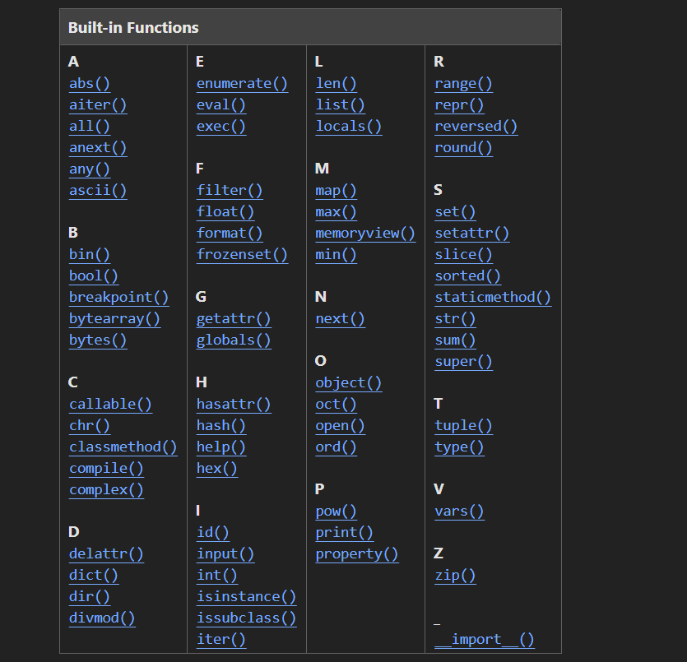

Rules of Programming

80/20 rule
- 20% of programming techniques are used in 80% of projects.
- Always go for “What is this?”.
- Do not memorize.
- No need to know everything about everything.

