Assignment 4

# Human-Computer Interaction



SUBMITTED BY: Sayad Muhammad Shahzaib

REGISTRATION NO: FA17-BCs-079

SUBMITTED TO: Mam Gulmina _

SEMESTER: 7th ___________

SUBMITION DATE: 14-Dec-2020_ _____

**Assignment 4**

**CLO 5**

Conduct a Cognitive Walkthrough (CW) of your group’s final paper prototype of your Assignment 3 in which you created paper prototypes of a Fitness App.

If your paper prototype is not complete to do this assignment, then complete it and do the Cognitive walkthrough of the following two situations, the user is also explained. You will have to attach the low-fi prototype of the screens needed to do a cognitive walkthrough of the tasks described below.

Remember CW needs four inputs, UI (your UI drawn for Assignment 3), user analysis (which I have given to you in the form of the Persona already in the slides), Task (given below), and the Steps needed to perform the task (this will vary for each of your prototypes so you will write them down).

**NOTE: Please include the UI here as well even if it’s the exact same one as you submitted previously**

**These are picture of screen that I had made previously.**

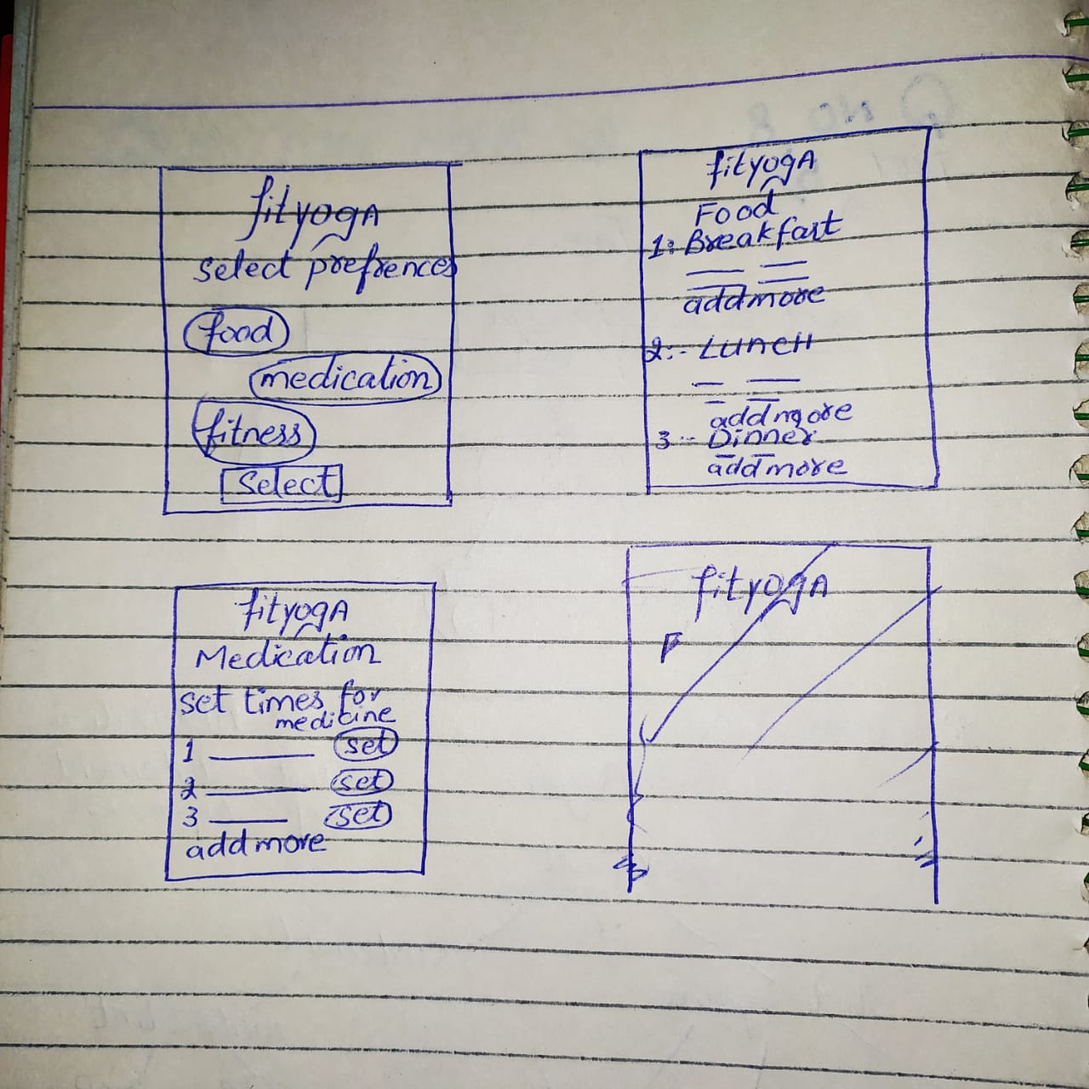

**Part A**

**Scenario 1:**

**Imran Sadiq (The Persona from slides) is trying to setup his Fitness App to select his food preferences, medication needs, Fitness goals etc.**

**This thing will be done by doing the following steps**

**Step 1: First user needs to set the preferences while making the ID (I am excluding those steps) in which he needs to select the food, meditation and fitness and then hit select. As soon as he selects the one presence its color will turn onto the green which will indicate that he has selected that.**

**Then for Food,**

**Steps**

1. **He needs to go to the food screen**
2. **There are three section one for breakfast, lunch and for dinner.**
3. **In order to set the timing and his food he needs to fill the blanks under each section**
4. **User will select the blank right under the breakfast tag.**
5. **First user be prompt to enter the food he wants to eat. User will type the name of food**
6. **As user press clicks ok on keyboard the curser will shift to the next blank in which user have to set the time for that specific food.**
7. **User will set the hours and minutes.**
8. **If user wants to add more food in same category, he will either select the blank right under it or will click on the add more button which will create a space for adding an item in the same section.**
9. **The food preferences for breakfast will be set.**
10. **Similarly, he can set food and time for lunch and dinner.**

**For meditation**

**Steps**

1. **First user will go onto the meditation screen**
2. **Then he will set the time by selecting the hours and then minutes.**
3. **Then he will type the name of medicine he wants to take at that time**
4. **After that he will click on the set button.**
5. **Medicine goal will be set.**

**For fitness goal**

**Steps**

1. **He will go onto Fitness screen**
2. **Then he can see what he can set for today goals options there**
3. **He will select the click button right before it in order to set that for today or even for tomorrow.**
4. **Fitness goal will be set this way**

* ***What is the user goal and why? (Is effect of current action same as user goal?)***

**User wants to set some goals for his food, medication and fitness so that if any how he forgets about it the application reminds him about his remaining goals. After that, he will take some necessary measurements to achieve those goals.**

* ***Is the action obviously available? (Is the action visible?)***

**Yes, actions were available.**

* ***Does the action or label match the goal? Will the user recognize the action as the correct one?***

**Yes, user’s action matches the label of the goal.**

* ***Is there good feedback?***

**Yes, there was enough feedback available for user. As soon as he clicks on the certain blank to enter something. Keyboard indicated him what to enter i.e., in order to set time keyboard only display him the numerical numpad so that he could easily understand what to enter and why.**

**Part B**

**Scenario 2**

Imran Sadiq wants to challenge his son Saif Sadiq to a calorie burn challenge for the next day. The progress will be shown through out the day and at the end both will see the winner.

Steps

1. First Imran Sadiq will come on to the Burn Challenge Screen
2. The three he will see his progress
3. After that he will enter the email to whom he wants to challenge for today. In this case that person is his son
4. He will tap onto the enter email text input box
5. Then he will type the email of his son
6. As he will enter the app will indicates his son’s todays progress
7. Then he will click onto the Alert him Button to alert his son for the challenge
8. His son will receive the notification about the challenge
9. In the same screen at the bottom, he will see about the summary of both progress
10. At the end he can clearly see the Winner at each moment. (After comparison application will write the Name of winner here)

* ***What is the user goal and why? (Is effect of current action same as user goal?)***

**User wants to set the Burn fat challenge to his son. So that by challenging him he can stay fit.**

* ***Is the action obviously available? (Is the action visible?)***

**Yes, actions were available.**

* ***Does the action or label match the goal? Will the user recognize the action as the correct one?***

**Yes, user’s action matches the label of the goal.**

* ***Is there good feedback?***

**Yes, there was a progress bar for each user’s indicating his progress for today. By looking at that each user can easily understand his position for today and by looking at the end of screen where winner name was completely written.**