**Content to Webiste Project**

Contents

Welcome - Welcome to my Personal Website 3

Large Texts: 3

Background Image: 3

About me - Personal Website 4

Header 4

Title 4

Quotation 4

About me 4

Details: 4

First Name 4

Last Name 4

Age 4

Gender 4

Location 4

Image: 4

Academics - Education, Courses, Awards and Achievements 5

Header: 5

Title: 5

Quotation 5

Tabels 5

Education 5

Courses 5

Awards 5

Skills - Professional and Pesonal Skills 6

Header: 6

Title: 6

Quotation 6

Rating 6

Professional Skills 6

Languages 6

Tools 6

Gallery - Cocurricular Activities, Hiking, Visits 7

Header: 7

Title: 7

Quotation 7

Video: 7

Pictures: 7

Contact - Details to contact me for feedback 11

Header: 11

Title: 11

Quotation 11

Form(Feedback) 11

Text inputs: 11

Radio Buttons: 11

Check Box: 11

Text Area: 11

Buttons: 11

Image: 12

Text Fields: 12

Name 12

Introduction 12

email 12

Linked Icons: 12

Navigation Bar 13

Footer 13

links: 13

# Welcome - Welcome to my Personal Website

## Large Texts:

**Muhammad Zafar Iqbal**

**Nazir**

**Welcome to my**

**Personal Website!**

## Background Image:

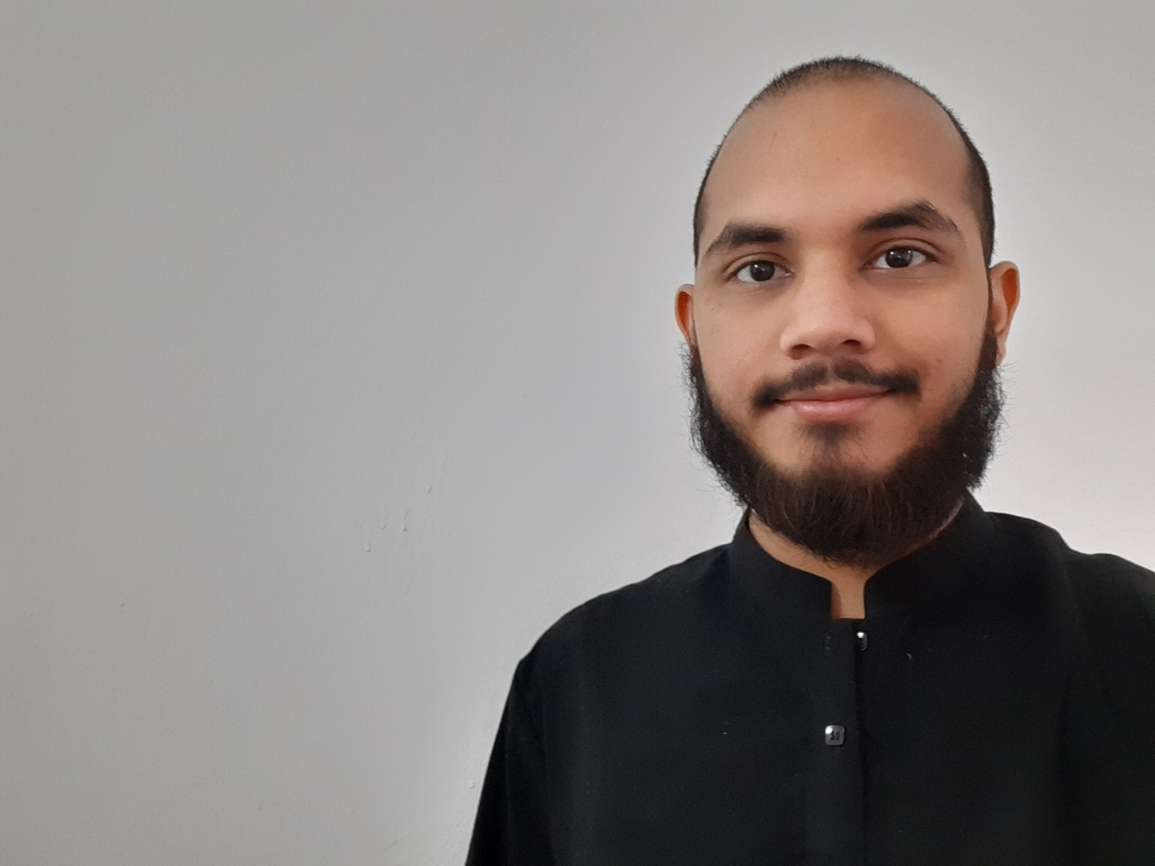

# About me - Personal Website

## Header

### Title

(Large Text)

Profile

### Quotation

“I am a Computer Science Specialist” (Short Introduction)

## About me

“I am a computer Science student. I love programming as I have good knowledge of logics and have good problem-solving skills. I also stand for quality. I love spending time on optimizing my own written codes. Also, I like working in a team, you'll learn faster and much more. I always try to learn new skills as the saying goes “Learning is the only thing the mind never exhausts, never fears, and never regrets”

## Details:

### First Name

Muhammad Zafar Iqbal

### Last Name

Nazir

### Age

19 years

### Gender

Male

### Location

Budapest Hungary

## Image:

Alternative Text: A profile picture of a person

# Academics - Education, Courses, Awards and Achievements

## Header:

### Title:

(Large Text)

Academics

### Quotation

“Learning is the only thing the mind never exhausts, never fears, and never regrets” (Lenardo da Vinci)

## Tabels

## Education

|  |  |  |  |
| --- | --- | --- | --- |
| Education Level | Institute | Duration | Place |
| Undergraduation | Eötvös Loránd Tudományegyetem | Ongoing | Budapest Hungary |
| High School | Govt. College University Lahore | 2016- 2018 | Lahore Pakistan |
| Secondary School | Govt. Model High School Model Town Lahore | 2014- 2016 | Lahore Pakistan |

## Courses

|  |  |  |  |
| --- | --- | --- | --- |
| Name | Institute | Duration | Place |
| Programming for Everybody (Getting Started with Python) | Coursera | Ongoing | Online |
| Data Science Math Skills | Coursera | 2016- 2018 | Online |

## Awards

|  |  |  |  |
| --- | --- | --- | --- |
| Award Name | Awarding Authority | Duration | Place |
| Stipendium Hungaricum Scholarship | Hungarian Government | 2020 - 2023 | Budapest Hungary |
| High Achievers Scholarship | Government of Pakistan | 2014 - 2018 | Lahore Pakistan |
| Chief Minister Punjab Laptop Award | Provincial Government | 2017 | Lahore Pakistan |

# Skills - Professional and Pesonal Skills

## Header:

### Title:

(Large Text)

Skills

### Quotation

“The future belongs to those who learn more skills and combine them in creative ways” (Robert Greene)

## Rating

(Starts/Bar with Percentages)

## Professional Skills

C++

Java

Clean

Assembly

UML

Pyhton

CSS3

HTML5

## Languages

English

Urdu

Punjabi

## Tools

MS Visual Studio

Code Blocks

Android Studio

MS Excel

MS Word

Common Elements

Unix

Windows

Clean IDE

# Gallery - Cocurricular Activities, Hiking, Visits

## Header:

### Title:

(Large Text)

Gallery

### Quotation

“Play is the way kids try the world on for size and imagine their place in it” (Raffi)

## Video:



Source: Gallery_Video or https://www.youtube.com/watch?v=MyqhDKNig88

## Pictures:

*Pécs* City Landscape

Alternative Text: A picture containing sky, outdoor, grass, field

In the above picture you can see an horizon of *pécs* city from *Tettye*. Pecs is the top of beatiful cities of hungary. It is much rich in history. There have been many battles and religious work in this city.

Date: January 2021

Moon and Snow

Alternative Text: A snowy landscape with trees and a moon

This place is a capture of moonligth mingling with the snow. The nature and sky colored in the happiness. Sky is expressing its hapiness with its unique colour.

Date: January 2021

Lake *Pécs*

Alternative Text: A person sitting on a rock by a lake

I am try to grasp the deepth of the lake. Thinking about the nature in a deserted, silent, vast lake. I feel like the lake water is trying to tell me the story of its life.

Date: February 2021

János Pál pápa tér

Alternative Text: A picture containing tree, outdoor, house, snow, stone

In the mid of the winter, a day outside may came up with such an attracting view. I feels like every thing is convulging and time is getting slower.

Date: December 2020

Way to the Journey

A picture containing a boy on a stony course

I am looking way back that how far I have come and aiming where do I have to go. It is way to the Lake *Pécs*. Travelling to touch some nature in this computer world.

Date: January 2021

PUCIT, Library

Alternative Text: A picture containing building, stairs, stone, old

A capture of the library in the one of the oldest University of the Pakistan “Punjab University College of Information and Technology”. A try to make best friend: *the book*.

Date: November 2020

# Contact - Details to contact me for feedback

## Header:

### Title:

(Large Text)

Contact

### Quotation

“You are too poor or too paranoid if you can’t find a single person to speak your heart out to and keep scrolling up and down your contacts” (n. m.)

## Form(Feedback)

**Form Fields**

### Text inputs:

* First Name
* Second Name
* Email

### Radio Buttons:

* Gender
* Male
* Female
* Others

### Check Box:

* How do youknow me?
* University Fellow
* School Fellow
* Co-Worker
* IT Professional
* Others

### Text Area:

* Your feedback

### Buttons:

* Send
* Reset

### Image:

Alternative Text: A picture of a smiling person

### Text Fields:

### Name

Muhammad Zafar Iqbal Nazir

### Introduction

I am a Computer Science Specialist

### email

[mziqbal909@outlook.com](mailto:mziqbal909@outlook.com)

### Linked Icons:

**

facebook

Mobile

[www.linkedin.com/in/muhammadzafariqbalnazir](http://www.linkedin.com/in/muhammadzafariqbalnazir)

<https://www.facebook.com/mzn.go/>

+36 30 3464877

# Navigation Bar

(Common On all Pages)

|  |
| --- |
| Welcome |
| About me |
| Academics |
| Skills |
| Gallery |
| Contact |

# Footer

® All Rights Reserved by © Muhammad Zafar Iqbal

Website was updates last time on March 11, 2021

### links:

*****

linked In facebook tumblr email mobile Goto Top

[www.linkedin.com/in/muhammadzafariqbalnazir](http://www.linkedin.com/in/muhammadzafariqbalnazir)

<https://www.facebook.com/mzn.go/>

<https://www.tumblr.com/settings/blog/muhammadzafariqbalnazir>

[mziqbal909@outlook.com](mailto:mziqbal909@outlook.com)

+36 30 3464877