Diabetes Classification Results using AdaBoost

Classification Report:
precision recall f1-score support
0 0.77 0.69 0.73 146
1 0.73 0.80 0.76 154
accuracy 0.75 300
macro avg 0.75 0.75 0.75 300
weighted avg 0.75 0.75 0.75 300

ROC AUC Score:
ROC AUC Score (AdaBoost): 0.8336817292296744

ROC Curve:
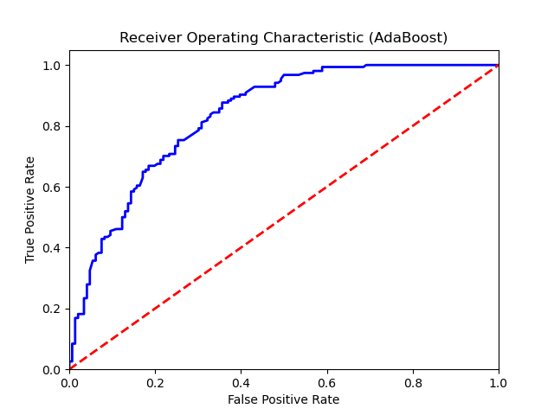

Confusion Matrix:
True Negatives: 101
False Positives: 45
False Negatives: 31
True Positives: 123

Confusion Matrix Plot:
