Diabetes Classification Results using AdaBoost

Classification Report:
precision recall f1-score support
0 0.75 0.70 0.72 149
1 0.72 0.77 0.74 151
accuracy 0.73 300
macro avg 0.73 0.73 0.73 300
weighted avg 0.73 0.73 0.73 300

ROC AUC Score:
ROC AUC Score (AdaBoost): 0.8307035868260813

ROC Curve:
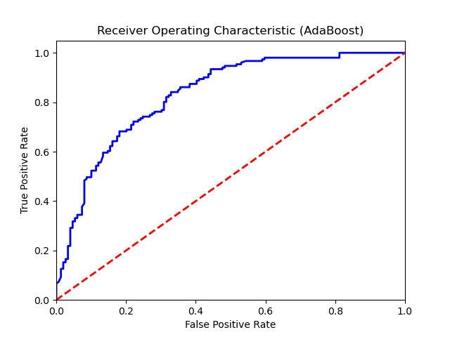

Confusion Matrix:
True Negatives: 104
False Positives: 45
False Negatives: 35
True Positives: 116

Confusion Matrix Plot:
