Diabetes Classification Results using AdaBoost

Classification Report:
precision recall f1-score support
0 0.75 0.69 0.72 153
1 0.70 0.76 0.73 147
accuracy 0.72 300
macro avg 0.72 0.72 0.72 300
weighted avg 0.73 0.72 0.72 300

ROC AUC Score:
ROC AUC Score (AdaBoost): 0.8132808679027166

ROC Curve:
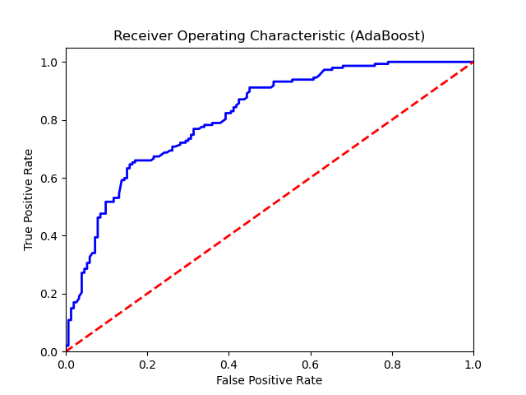

Confusion Matrix:
True Negatives: 105
False Positives: 48
False Negatives: 35
True Positives: 112

Confusion Matrix Plot:
