Diabetes Classification Results using GradientBoosting

Classification Report:
precision recall f1-score support
0 0.83 0.75 0.79 146
1 0.78 0.86 0.82 154
accuracy 0.80 300
macro avg 0.81 0.80 0.80 300
weighted avg 0.81 0.80 0.80 300

ROC AUC Score:
ROC AUC Score (GradientBoosting): 0.8675947340330903

ROC Curve:
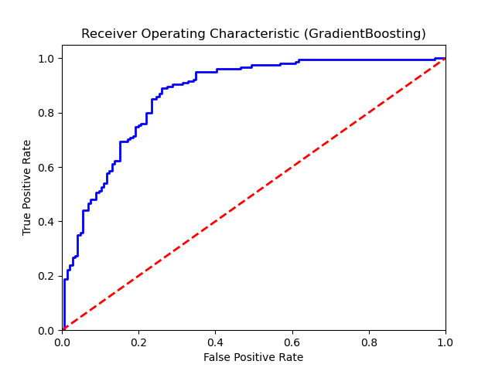

Confusion Matrix:
True Negatives: 109
False Positives: 37
False Negatives: 22
True Positives: 132

Confusion Matrix Plot:
