Diabetes Classification Results using GradientBoosting

Classification Report:
precision recall f1-score support
0 0.83 0.74 0.78 149
1 0.77 0.85 0.81 151
accuracy 0.79 300
macro avg 0.80 0.79 0.79 300
weighted avg 0.80 0.79 0.79 300

ROC AUC Score:
ROC AUC Score (GradientBoosting): 0.849148851060047

ROC Curve:
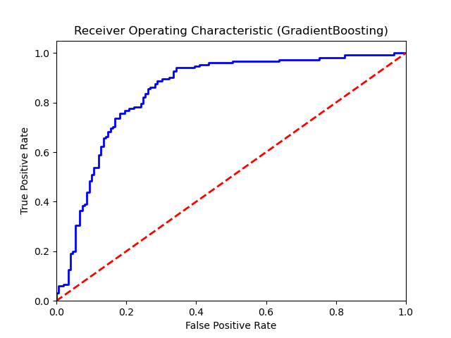

Confusion Matrix:
True Negatives: 110
False Positives: 39
False Negatives: 23
True Positives: 128

Confusion Matrix Plot:
