Diabetes Classification Results using GradientBoosting

Classification Report:
precision recall f1-score support
0 0.81 0.77 0.79 153
1 0.77 0.82 0.79 147
accuracy 0.79 300
macro avg 0.79 0.79 0.79 300
weighted avg 0.79 0.79 0.79 300

ROC AUC Score:
ROC AUC Score (GradientBoosting): 0.8495842781557067

ROC Curve:
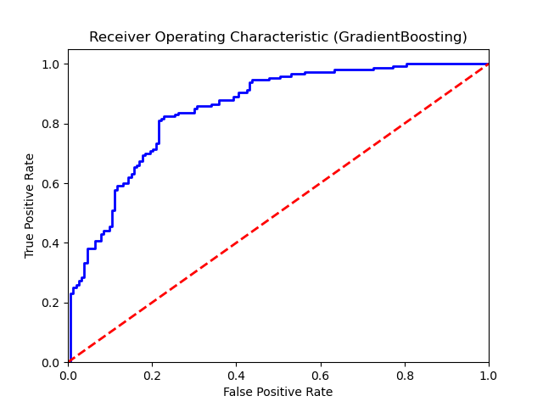

Confusion Matrix:
True Negatives: 118
False Positives: 35
False Negatives: 27
True Positives: 120

Confusion Matrix Plot:
