Diabetes Classification Results using LogisticRegression

Classification Report:
precision recall f1-score support
0 0.76 0.73 0.74 149
1 0.74 0.77 0.76 151
accuracy 0.75 300
macro avg 0.75 0.75 0.75 300
weighted avg 0.75 0.75 0.75 300

ROC AUC Score:
ROC AUC Score (LogisticRegression): 0.8338592826347837

ROC Curve:
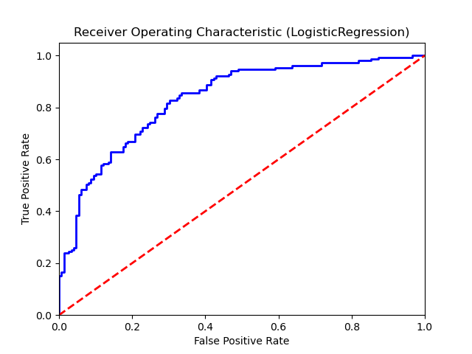

Confusion Matrix:
True Negatives: 109
False Positives: 40
False Negatives: 35
True Positives: 116

Confusion Matrix Plot:
