Diabetes Classification Results using LogisticRegression

Classification Report:
precision recall f1-score support
0 0.71 0.78 0.74 153
1 0.74 0.67 0.70 147
accuracy 0.72 300
macro avg 0.73 0.72 0.72 300
weighted avg 0.73 0.72 0.72 300

ROC AUC Score:
ROC AUC Score (LogisticRegression): 0.8152594371081766

ROC Curve:
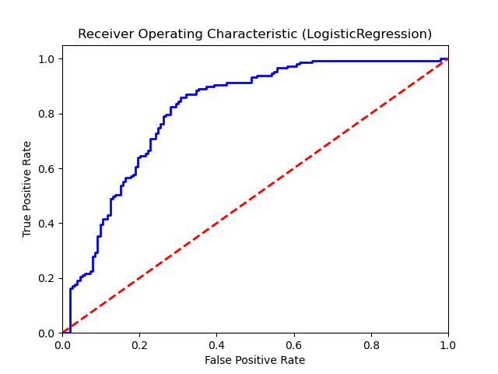

Confusion Matrix:
True Negatives: 119
False Positives: 34
False Negatives: 49
True Positives: 98

Confusion Matrix Plot:
