Diabetes Classification Results using RandomForest

Classification Report:
precision recall f1-score support
0 0.80 0.76 0.78 146
1 0.78 0.82 0.80 154
accuracy 0.79 300
macro avg 0.79 0.79 0.79 300
weighted avg 0.79 0.79 0.79 300

ROC AUC Score:
ROC AUC Score (RandomForest): 0.8785803237858033

ROC Curve:
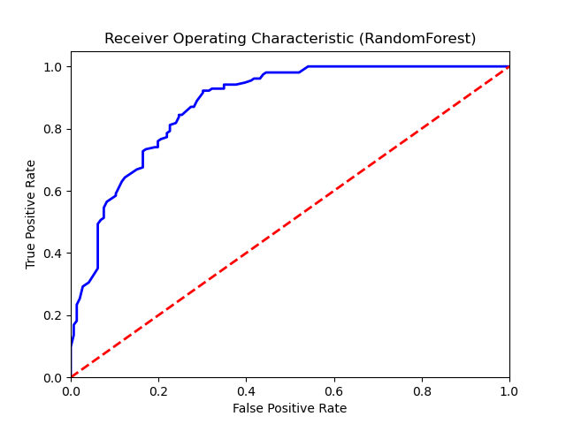

Confusion Matrix:
True Negatives: 111
False Positives: 35
False Negatives: 28
True Positives: 126

Confusion Matrix Plot:
