Diabetes Classification Results using RandomForest

Classification Report:
precision recall f1-score support
0 0.83 0.74 0.79 149
1 0.77 0.85 0.81 151
accuracy 0.80 300
macro avg 0.80 0.80 0.80 300
weighted avg 0.80 0.80 0.80 300

ROC AUC Score:
ROC AUC Score (RandomForest): 0.8593493044135294

ROC Curve:
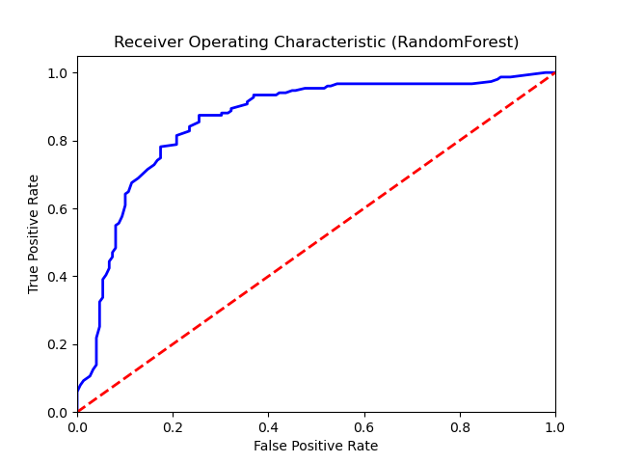

Confusion Matrix:
True Negatives: 111
False Positives: 38
False Negatives: 22
True Positives: 129

Confusion Matrix Plot:
