Diabetes Classification Results using RandomForest

Classification Report:
precision recall f1-score support
0 0.81 0.78 0.80 153
1 0.78 0.81 0.80 147
accuracy 0.80 300
macro avg 0.80 0.80 0.80 300
weighted avg 0.80 0.80 0.80 300

ROC AUC Score:
ROC AUC Score (RandomForest): 0.8787070383709039

ROC Curve:
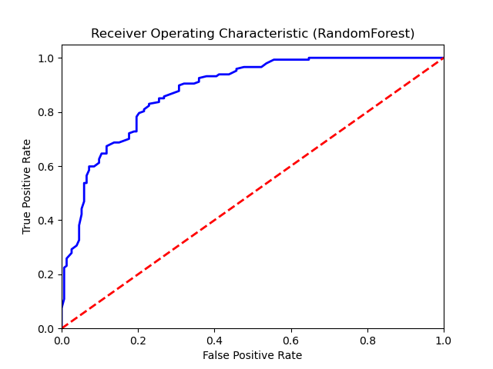

Confusion Matrix:
True Negatives: 120
False Positives: 33
False Negatives: 28
True Positives: 119

Confusion Matrix Plot:
