Diabetes Classification Results using SVC

Classification Report:
precision recall f1-score support
0 0.79 0.72 0.75 146
1 0.75 0.82 0.79 154
accuracy 0.77 300
macro avg 0.77 0.77 0.77 300
weighted avg 0.77 0.77 0.77 300

ROC AUC Score:
ROC AUC Score (SVC): 0.8436666073652376

ROC Curve:
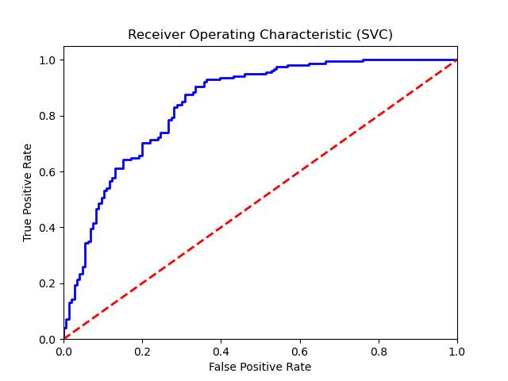

Confusion Matrix:
True Negatives: 105
False Positives: 41
False Negatives: 28
True Positives: 126

Confusion Matrix Plot:
