Diabetes Classification Results using SVC

Classification Report:
precision recall f1-score support
0 0.79 0.72 0.75 149
1 0.74 0.81 0.77 151
accuracy 0.76 300
macro avg 0.77 0.76 0.76 300
weighted avg 0.77 0.76 0.76 300

ROC AUC Score:
ROC AUC Score (SVC): 0.8297257655895818

ROC Curve:
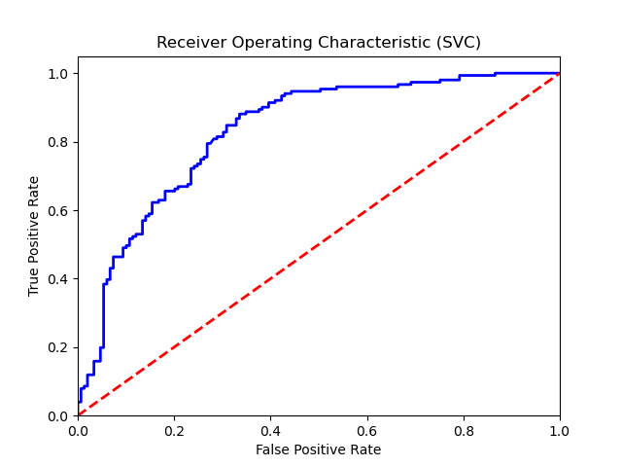

Confusion Matrix:
True Negatives: 107
False Positives: 42
False Negatives: 29
True Positives: 122

Confusion Matrix Plot:
