Diabetes Classification Results using SVC

Classification Report:
precision recall f1-score support
0 0.72 0.71 0.71 153
1 0.70 0.71 0.71 147
accuracy 0.71 300
macro avg 0.71 0.71 0.71 300
weighted avg 0.71 0.71 0.71 300

ROC AUC Score:
ROC AUC Score (SVC): 0.8205282112845137

ROC Curve:
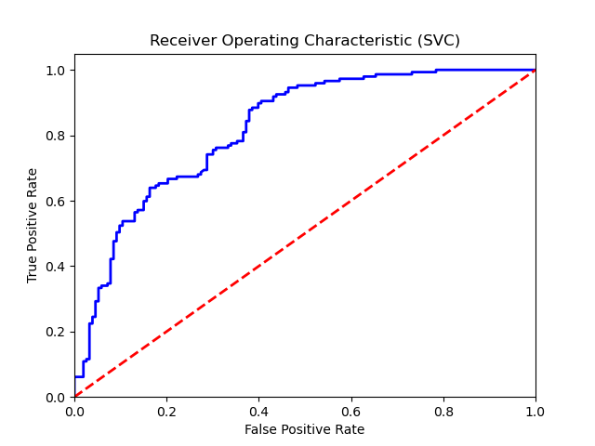

Confusion Matrix:
True Negatives: 109
False Positives: 44
False Negatives: 43
True Positives: 104

Confusion Matrix Plot:
