# PROBLEM DESCRIPTION:

Online shopping cart is a virtual shopping trolley, where shoppers can put all of their want-to-buy products in, review to make adjustments in quantity, product attributes, etc., and remove it before or during the checkout if they change their mind.

# DISTINGUISHING FEATURES:

I have tried to make the checks at login time as tight as possible. No user can enter the market without signing up or without signing in with correct email or password.

I have also included admin sign in feature. Admin can add or remove the product from market.

# CHALLENGING PART:

The most challenging part which I feel was to relate all the classes in a UserInterface class.

# ANY NEW THING LEARN:

No not so. As I have implemented all the already learned features of OOP in lectures and haven’t gone for any external library except for time feature. But still it was a good experience to build such application first time.

# FUTURE EXPANSION:

One of the expansion can be for graphical user interface (GUI)

# FLOW OF PROJECT:

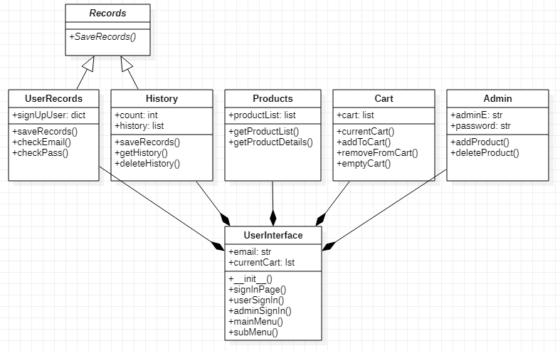

As can be seen from class diagram that both UserRecords and History are inheriting from Records. All other classes including these two classes are relate to UserInterface where methods of each class are called on the requirement.

# TEST CASES:

## All Admin possible cases are checked

## 

## C:\Users\dell\AppData\Local\Microsoft\Windows\INetCache\Content.Word\Test 1.2.PNG

## a user sign up and just see product details

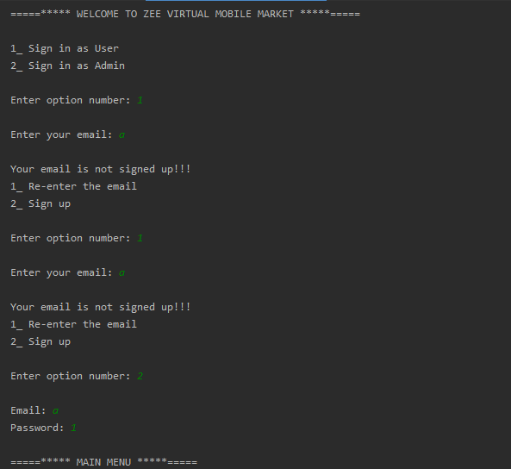

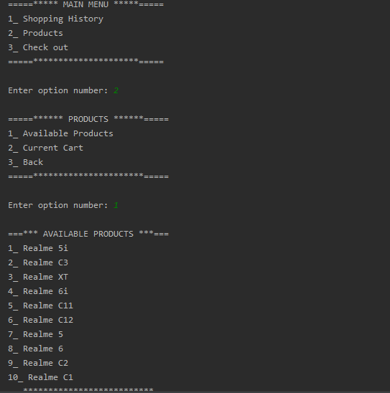

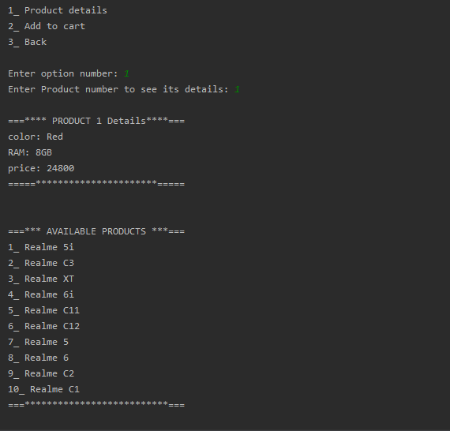

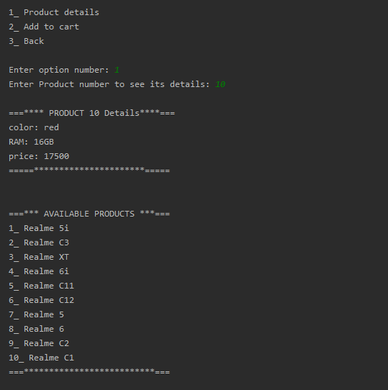

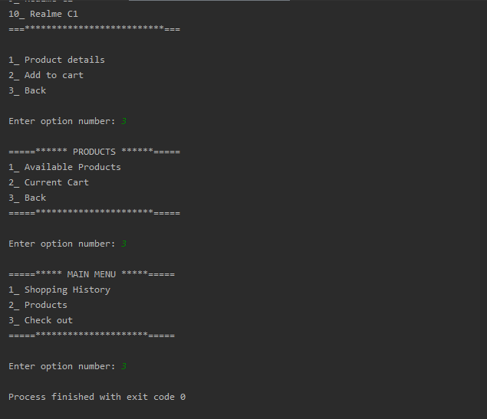

## ‘b’ user sign up and add and remove products from cart

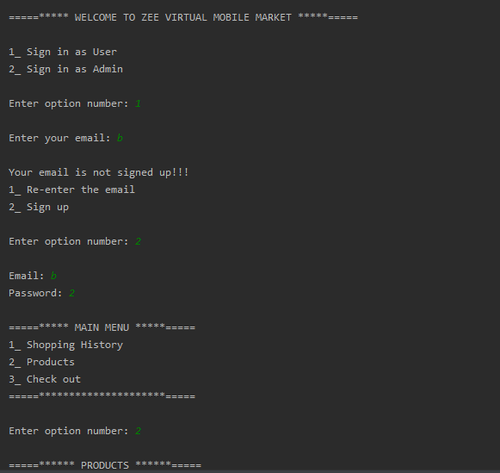

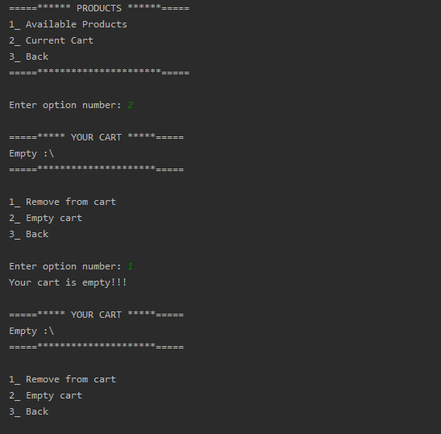

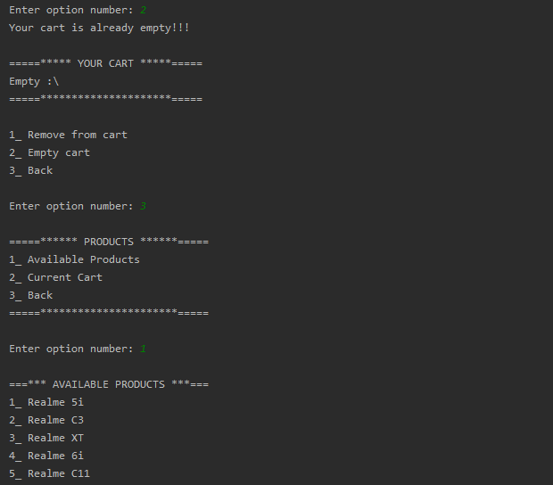

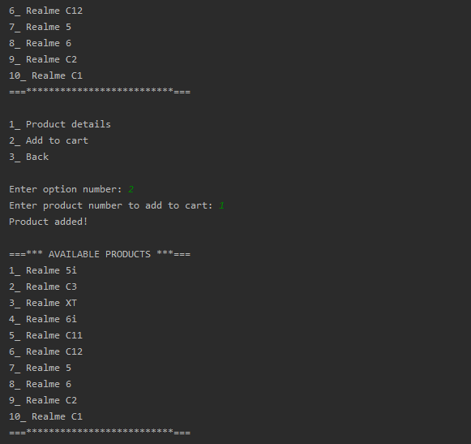

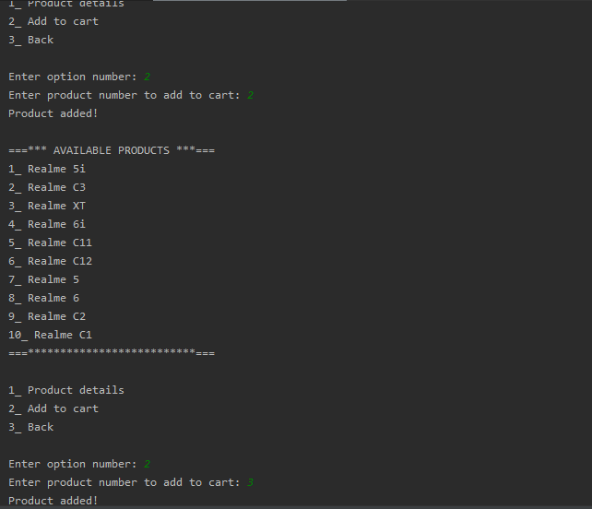

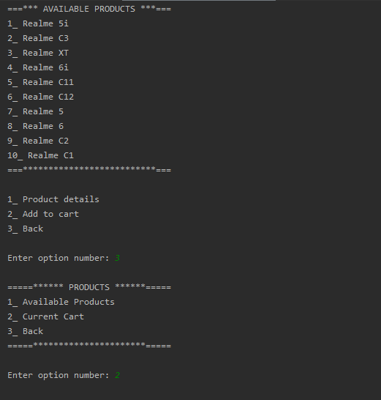

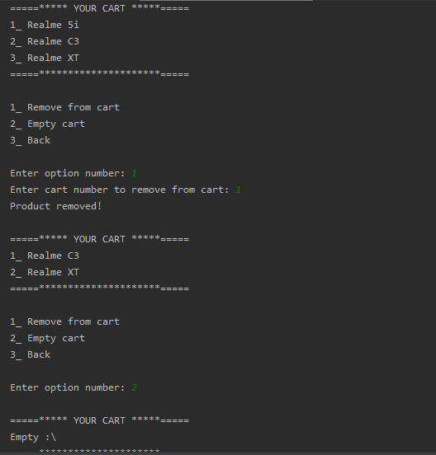

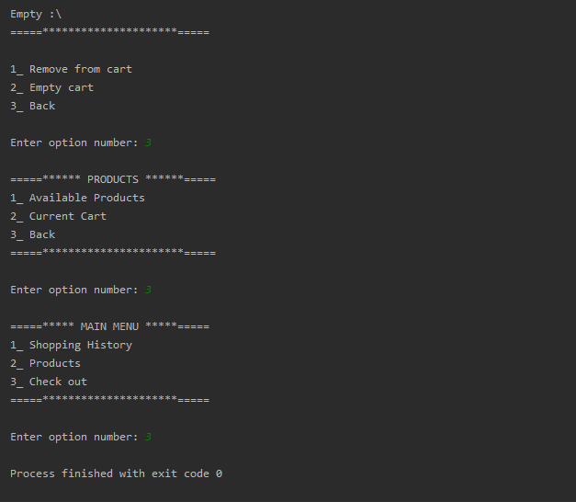

## ‘a’ user sign in with wrong password then with correct pass and do some shopping

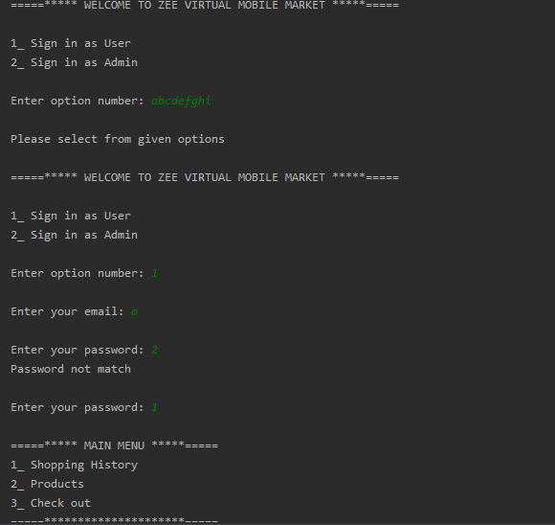

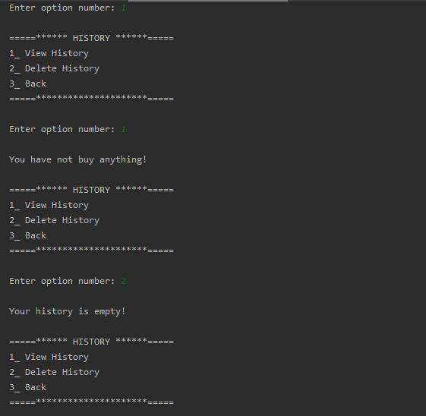

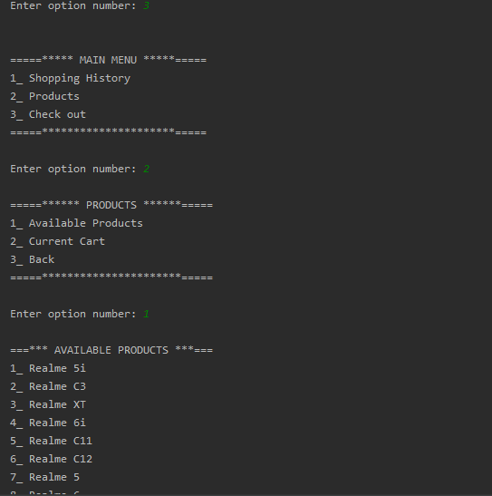

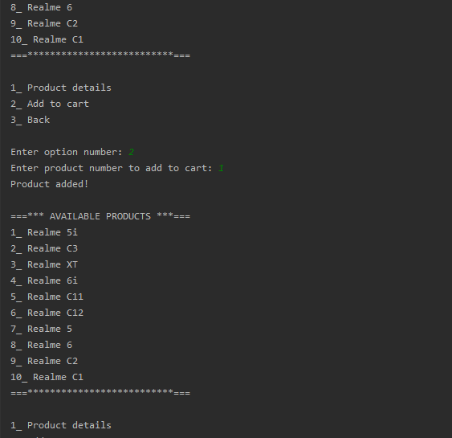

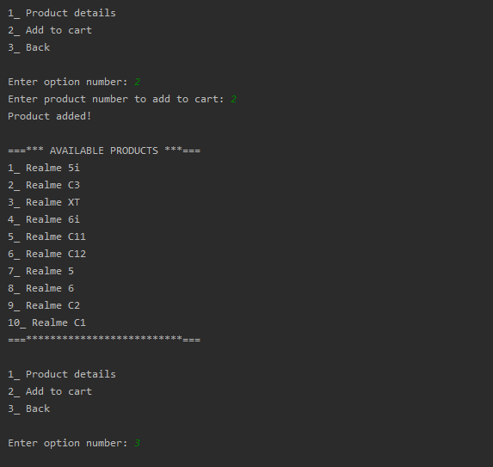

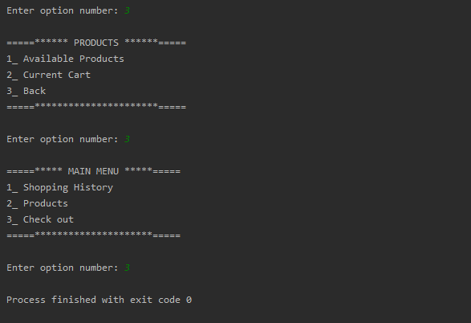

## ‘a’ user again sign in do some shopping after seeing his previous history

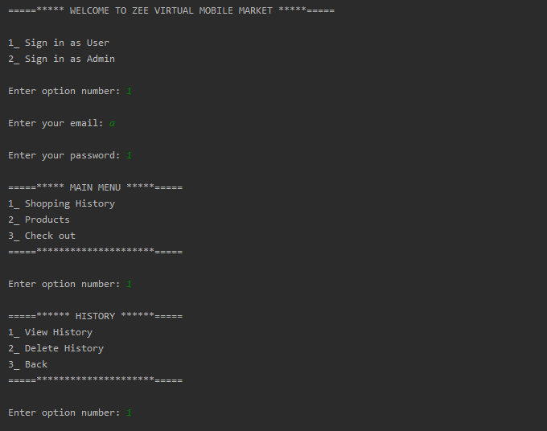

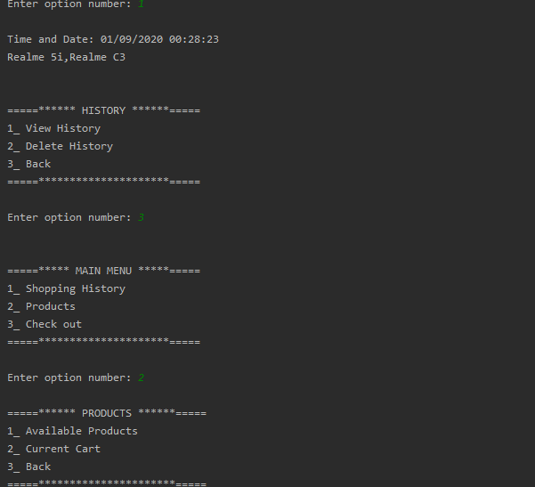

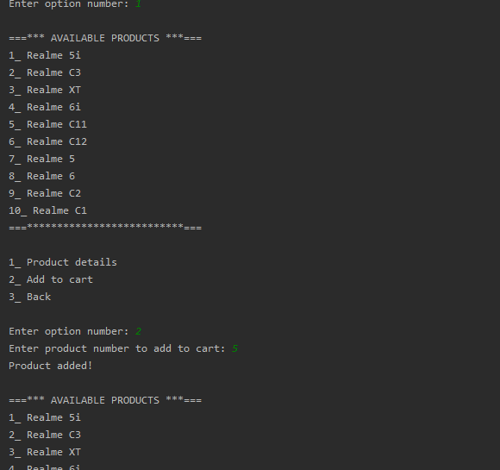

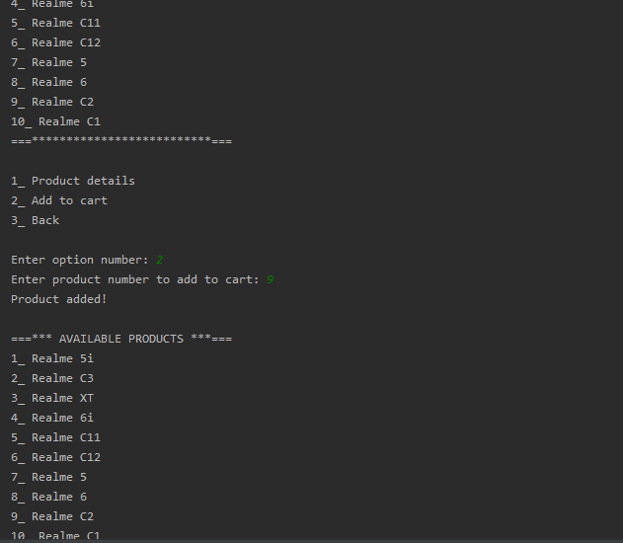

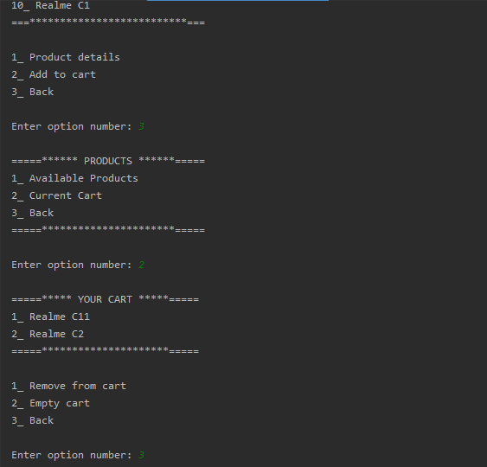

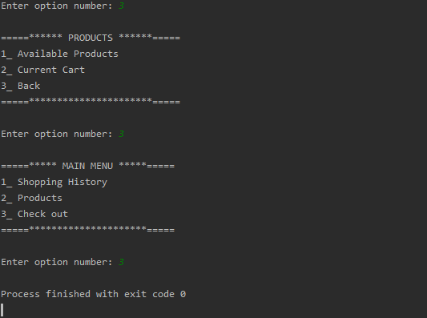

## ‘a’ user sign in to see his histories and then clear his history

