**ASSIGNMENT # 3**

**Name:** Muhammad Zawahir

**Roll No.:** PIAIC227599

**Batch:** 57

**Course Name:** Certified Cloud Applied Generative AI Engineer

**CODE**

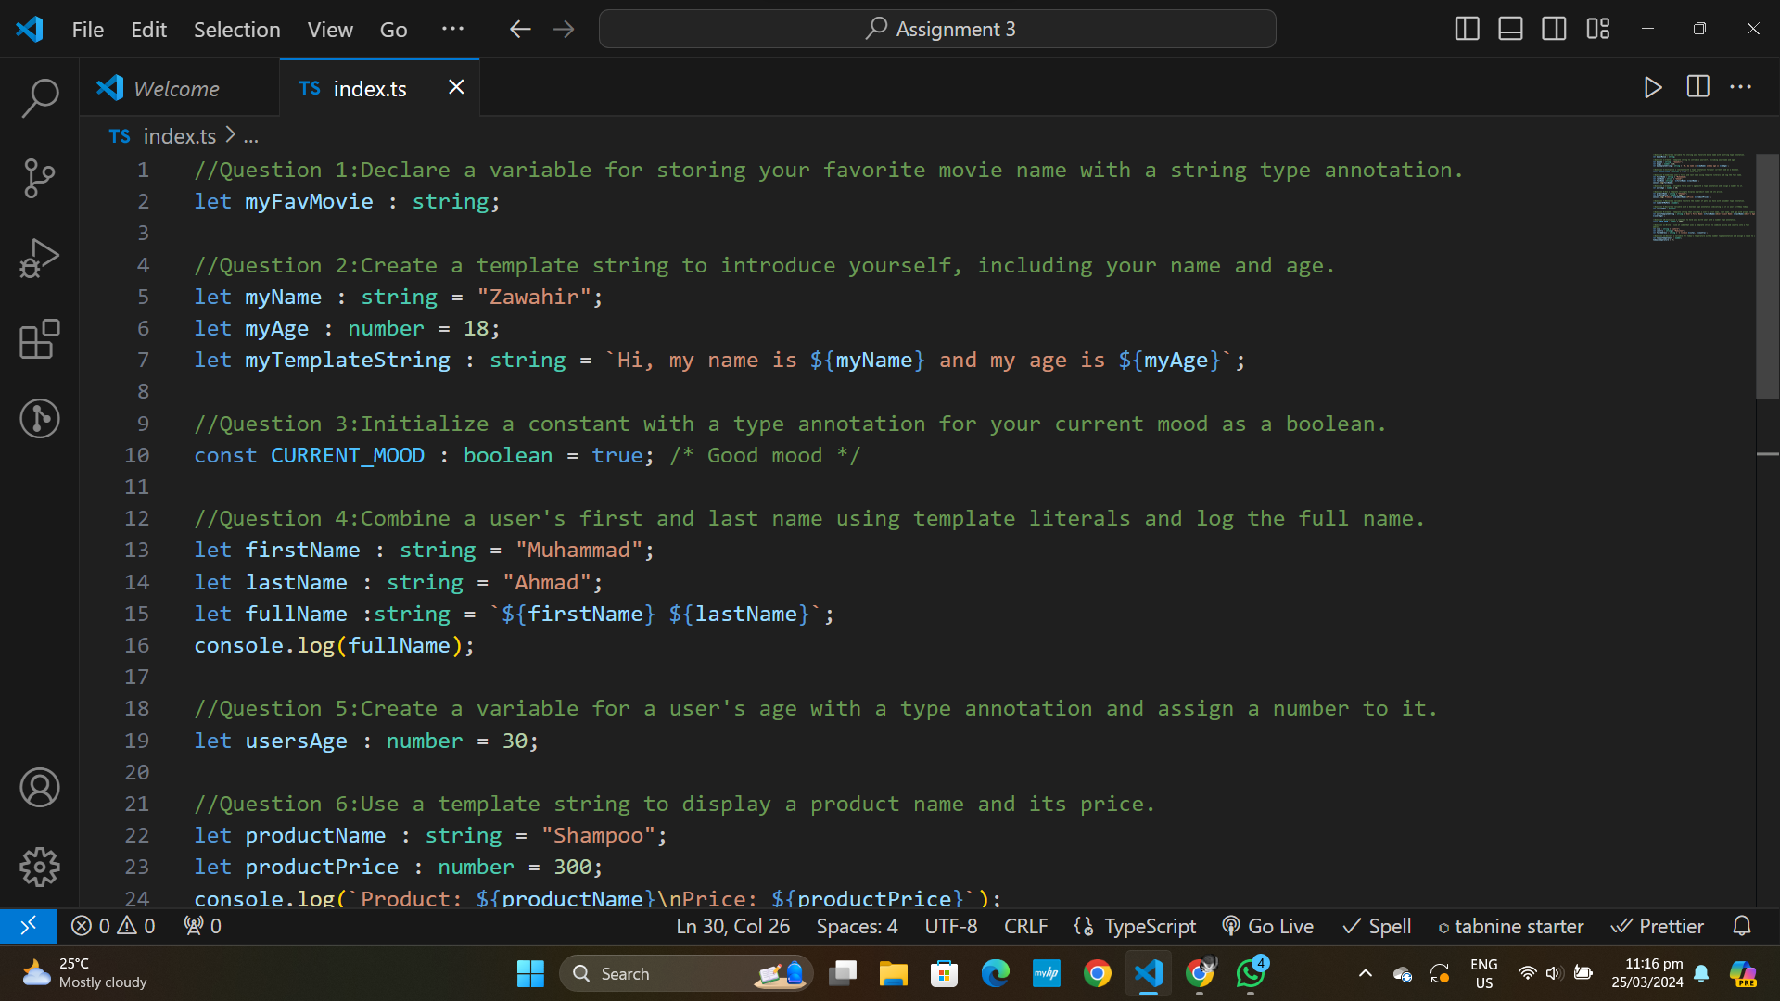

1 of 2

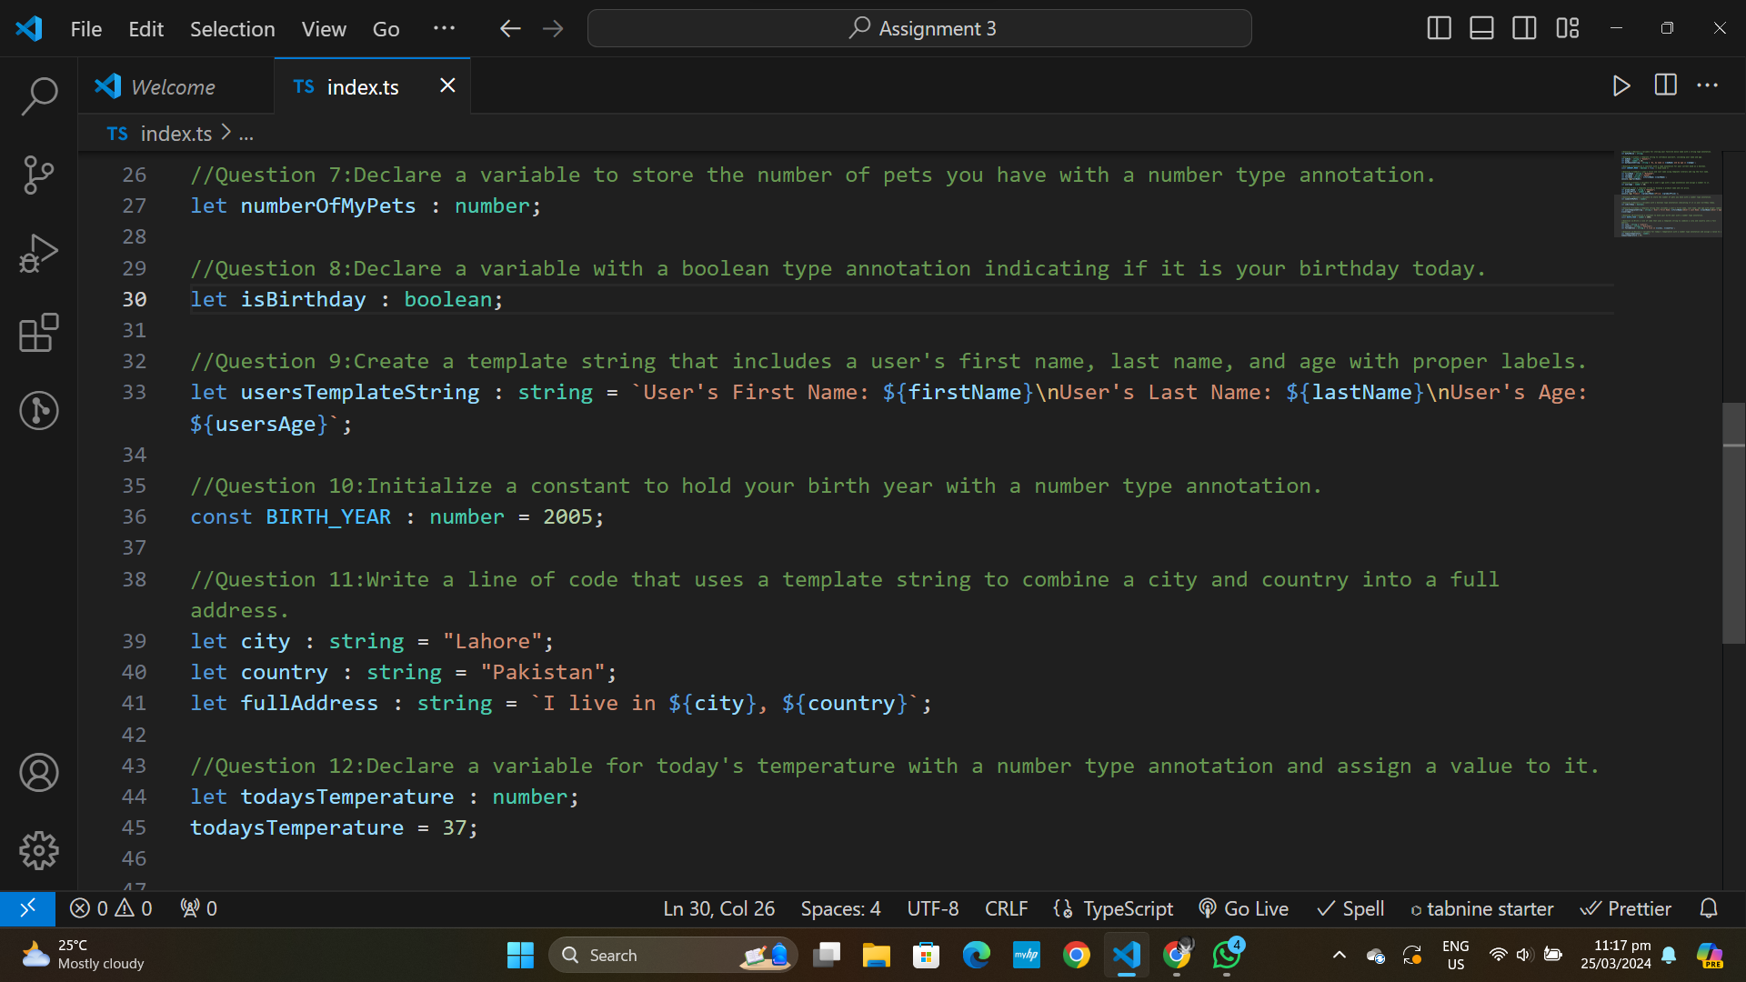

2 of 2

**OUTPUT:-**

