**Tools:**

Selenium, beautifulSoup, html.parser, python

**URL:**

<https://www.flyus.com/flights/7HW-1/LHE-DXB/03-21-2022/1-0-0-Y>

* Search above URL
* Flights listing will display ass shown in fig(1)

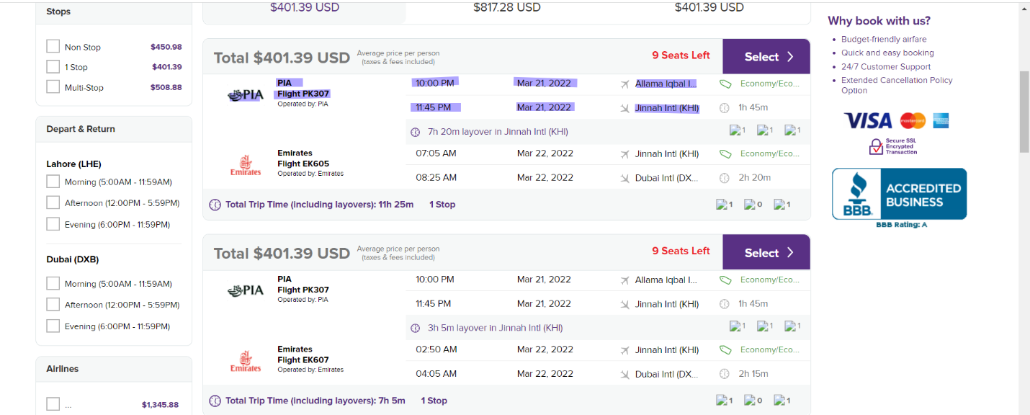

From listing page-scrape following information

* Price
* Logo-url
* Flight number (eg PIA, PC 207)
* Departure time and date
* Arrival time and date
* Departure arrival airports

Please submit code and instructions to run with the script along with the requirements.txt file

* Scrapped data can be saved into a CSV/JSON file