NBTE DIGITAL QUALITY ASSURANCE SYSTEM
Master Handover Guide
Setup, demo accounts, feature walkthrough and architecture — Phases 1 to 7, with the Phase 8 hardening started
National Board for Technical Education · ICT Directorate
Release: NBTE-QA-Phase7 · 20 October 2026

Contents

(If the contents list is empty, right-click it in Word and choose Update Field.)

1. What this release contains
The NBTE Digital QA System runs the Board's quality-assurance work end to end: institutions register and apply on the QA portal (SOP-01), approved institutions request programme QA and complete self-study questionnaires (SOP-02), NBTE runs each QA case through its stages with visits, costs and approvals (SOP-03), Finance confirms every payment, and — new in this release — institutions and resource persons raise complaints that are routed, timed and escalated automatically.

New in Phase 7
- Complaints engine. Ten complaint layers, configurable routing rules, business-hour deadlines that pause while NBTE waits for the raiser, and an automatic escalation chain (Director → Deputy Director/Division Head → Executive Secretary for critical or repeated breaches). Escalation adds a watcher and a task; it never takes the complaint away from its handler.
- Portal pages: Complaints, Raise a complaint (with knowledge-base suggestions while you type), the complaint conversation, Help articles, and a “Raise a complaint about this” link on payments, SSQs, programmes, inspections and timeline entries.
- Internal pages: Complaint queue (Assigned to me · My department · Escalated to me · All) with live deadline clocks, the complaint page with stage actions, internal notes and escalation history, an SLA dashboard with CSV export, and Settings → Complaints (layers, routing, escalation, knowledge base) — all rows, no code.
- Leadership dashboards. The ES and Director dashboards open with a QA overview: confirmed revenue by month, institutions on the register, deadlines met, open cases by stage and the top complaint layers, drawn with Chart.js and count-up figures.
- Staff home “Your desk”. Tasks, pending confirmations and recent QA activity on the home page; anything overdue or expiring today glows.
- Interface polish. A mobile-safe notification bell with “View all”, a redesigned Settings hub with switches, a featured self-registration control (with the “managed by NBTE” banner when it is off), a compact news grid with placeholder cards, and a subtle NBTE crest on the public pages.
- Phase 8 started. One command now seeds a fresh database with every role, group, flow and demo record; a security review of the user-type guard closed one gap (see section 7); a new command gives every demo account one known password for handovers.
Nothing in Phases 1–6 changed behaviour
The full automated test suite was run before and after this release. The only failures are the fifteen “review_checks” tests that document known findings in the original NBTE ICT system; they failed before Phase 7 and are unchanged.

2. Setting the system up
Run every command from the project folder — the one that contains manage.py. Python 3.12 or newer is required; development uses SQLite and needs no other service.

2.1 A fresh installation
# 1. Python environment
python -m venv .venv
source .venv/bin/activate # Windows: .venv\Scripts\activate
pip install -r requirements.txt

# 2. Database tables
python manage.py migrate

# 3. Everything the QA system needs, plus the demo data (idempotent)
python manage.py seed_startup --with-demo
python manage.py seed_phase5_demo --skip-startup # optional: SOP-03 case
python manage.py seed_phase7_demo --skip-startup # complaints, revenue
python manage.py set_demo_passwords # NBTE-Demo#2026

# 4. Your own administrator
python manage.py createsuperuser

# 5. Static files (production) and run
python manage.py collectstatic --noinput
python manage.py runserver 0.0.0.0:8000
Two addresses, one server. The internal system is http://localhost:8000/; the QA portal is http://qa.localhost:8000/. Most browsers resolve *.localhost to your own machine; if yours does not, add 127.0.0.1 qa.localhost to your hosts file. In production set QA_PORTAL_HOST (for example qa.nbte.gov.ng) and point that name at the same server.

2.2 Upgrading the database you already have
cp db.sqlite3 db.sqlite3.before-phase7 # always keep a copy first
python manage.py migrate # adds complaints 0001
python manage.py seed_startup # complaint flow, layers, rules
python manage.py seed_phase7_demo --skip-startup # optional demo data
The database delivered with this release has already been backed up (db.sqlite3.before-phase7-20261020), migrated and seeded, and its demo accounts use the password in section 3.

2.3 Scheduled jobs
The complaint deadlines, reminders and escalations are checked by the SLA sweep. In production Celery beat runs it every minute and the task itself honours qa.complaints.sla_poll_minutes (default 5).
celery -A nbte_ict worker -B -l info # worker with the beat scheduler
python manage.py complaints_sla_sweep # the sweep by hand (cron)
python manage.py qa_stage_reminders # SOP-03 stage reminders
python manage.py qa_reconcile_tasks # nightly task-link repair

2.4 Tests
pip install -r requirements-dev.txt
python -m pytest -q complaints/tests # Phase 7 (about 4 minutes)
python -m pytest -q # everything (about 2 hours on SQLite)

2.5 Removing the demo
python manage.py seed_startup --reset-demo # deletes exactly the rows tagged as demo
Before going live
Remove the demo data, change the superuser password, set DEBUG off with the production settings (settings.prod) and configure e-mail. set_demo_passwords refuses to run when DEBUG is off: a shared, published password must never exist on a live server.

3. Demo accounts
Every demo account below uses the password NBTE-Demo#2026. Staff sign in on the internal system with their e-mail address; institutions and resource persons sign in on the QA portal. The accounts are demo-tagged and disappear with --reset-demo. The superuser account is not listed: its password belongs to you.
E-mail (sign-in) | Password | Role · department · institution | Signs in at | Use it for
academic@demo-poly.local | NBTE-Demo#2026 | Institution Academic Department · Demo Polytechnic, Kaduna | QA portal | Portal: completes SSQ sections sent to the academic department
admin@demo-health.local | NBTE-Demo#2026 | Institutional Administrator · Demo College of Health Technology | QA portal | Portal: Demo College of Health Technology
admin@demo-poly.local | NBTE-Demo#2026 | Institutional Administrator · Demo Polytechnic, Kaduna | QA portal | Portal: Demo Polytechnic administrator; payments, complaints
admin@p4demo.local | NBTE-Demo#2026 | Institutional Administrator · Kaduna Demo Polytechnic (Phase 4) | QA portal | Portal: Kaduna Demo Polytechnic (the SOP-03 demo case); demo complaints
resource@demo.nbte.local | NBTE-Demo#2026 | Resource Person | QA portal | Portal: resource person
rp.yakubu@demo.nbte.local | NBTE-Demo#2026 | Resource Person | QA portal | Portal: resource person (engineering) — engagements, findings
rp.zainab@demo.nbte.local | NBTE-Demo#2026 | Resource Person | QA portal | Portal: resource person (computing)
finance.clearance@demo.nbte.local | NBTE-Demo#2026 | Officer / Technician · Finance | Internal system | SOP-01 Finance clearance
finance.director@demo.nbte.local | NBTE-Demo#2026 | Director of Finance (QA) · Finance | Internal system | Director of Finance: confirms payments (final decision)
legal.officer@demo.nbte.local | NBTE-Demo#2026 | Officer / Technician · Legal Unit | Internal system | SOP-01 Legal clearance
planning.academic@demo.nbte.local | NBTE-Demo#2026 | Officer / Technician · ASPD | Internal system | SOP-01 Academic Planning clearance
planning.physical@demo.nbte.local | NBTE-Demo#2026 | Officer / Technician · PPD | Internal system | SOP-01 Physical Planning clearance
qa.audit_director@demo.nbte.local | NBTE-Demo#2026 | Director of Department · INT. AUD. DEPT | Internal system | Audit Director (SOP-03 audit branch)
qa.audit_officer@demo.nbte.local | NBTE-Demo#2026 | Officer / Technician · INT. AUD. DEPT | Internal system | Audit officer (cost-sheet audit)
qa.busy_officer@demo.nbte.local | NBTE-Demo#2026 | Officer / Technician · DPAP | Internal system | Shows the workload rule (refused, B17)
qa.cqac@demo.nbte.local | NBTE-Demo#2026 | CQAC Member · DPAP | Internal system | CQAC member
qa.cqac_chair@demo.nbte.local | NBTE-Demo#2026 | CQAC Chairman · DPAP | Internal system | CQAC Chairman
qa.deputy_director@demo.nbte.local | NBTE-Demo#2026 | Deputy Director · DPAP | Internal system | Second endorsement layer; complaint escalation level 2
qa.director@demo.nbte.local | NBTE-Demo#2026 | Director of Department · DPAP | Internal system | Director dashboard; DPAP Director; complaint escalation level 1
qa.division_head@demo.nbte.local | NBTE-Demo#2026 | Division/Department Head · DPAP | Internal system | First endorsement layer
qa.es@demo.nbte.local | NBTE-Demo#2026 | Executive Secretary · ES OFFICE | Internal system | ES dashboard; stage 10 visit approval; level-3 complaint escalation
qa.finance@demo.nbte.local | NBTE-Demo#2026 | QA Finance Officer · Finance | Internal system | Finance officer: first-pass payment check; handles payment complaints
qa.finance_director@demo.nbte.local | NBTE-Demo#2026 | Director of Department · Finance | Internal system | Finance department Director (SOP-03 finance branch)
qa.finance_officer@demo.nbte.local | NBTE-Demo#2026 | Officer / Technician · Finance | Internal system | Finance officer (SOP-03)
qa.ict_director@demo.nbte.local | NBTE-Demo#2026 | Director of Department · ICT | Internal system | ICT Director (SOP-03 ICT branch)
qa.ict_monitor@demo.nbte.local | NBTE-Demo#2026 | ICT QA Monitor · ICT | Internal system | Read-only oversight of every QA screen (R-13)
qa.ict_officer2@demo.nbte.local | NBTE-Demo#2026 | Officer / Technician · ICT | Internal system | Second ICT officer
qa.ict_officer@demo.nbte.local | NBTE-Demo#2026 | Officer / Technician · ICT | Internal system | ICT officer; handles portal-access complaints
qa.officer@demo.nbte.local | NBTE-Demo#2026 | Officer / Technician · DPAP | Internal system | DPAP desk officer; handles SSQ and workflow complaints; QA Settings Admin
qa.pay_officer@demo.nbte.local | NBTE-Demo#2026 | Pay Officer · Finance | Internal system | Releases QA funds (stage 11)
qa.team_lead@demo.nbte.local | NBTE-Demo#2026 | Director of Department · DPAP | Internal system | Inspection Team Lead: records the visit, writes reports
qa.verifier@demo.nbte.local | NBTE-Demo#2026 | Director of Department · DPAP | Internal system | Registered QA personnel (verification)

To give the demo accounts a different password: python manage.py set_demo_passwords --password "…" --csv accounts.csv

4. Feature walkthrough
The screenshots were taken from a running copy of this release with the demo data above. Each section names the account to sign in with, so you can repeat it.

4.1 The public QA portal
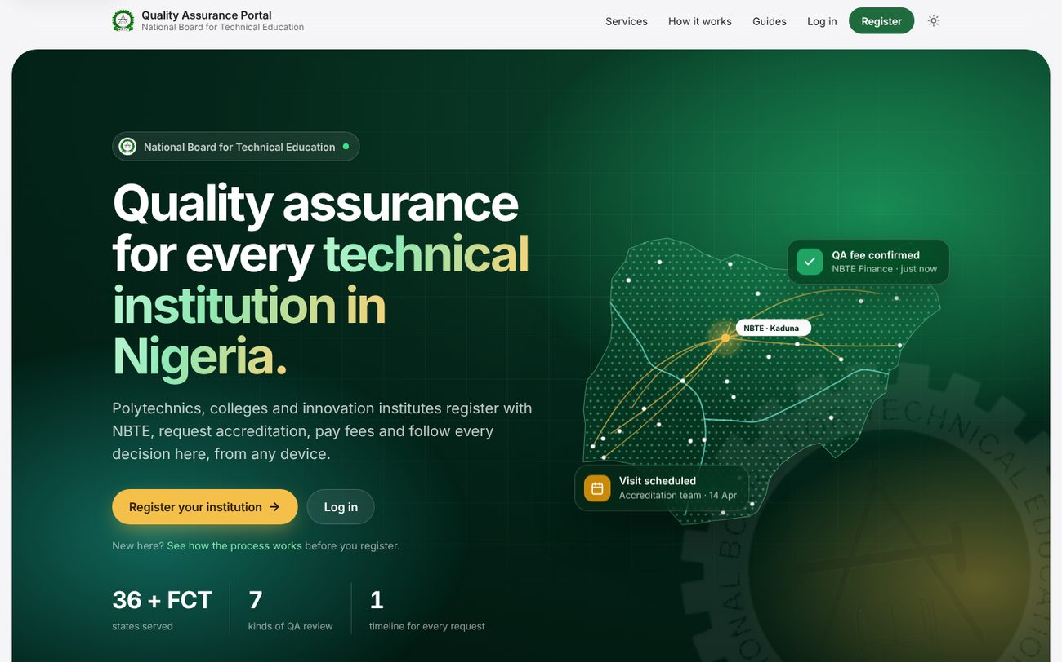
The QA portal's public page: news, events and the NBTE crest watermark.

4.2 SOP-01 — a new institution registers and applies
When qa.portal.self_registration_enabled is on, a proposed institution registers itself. When it is off, the page shows “Institution registration is currently managed by NBTE…” with the QA Directorate's contact details, set under Settings → QA → Portal and sign-in.
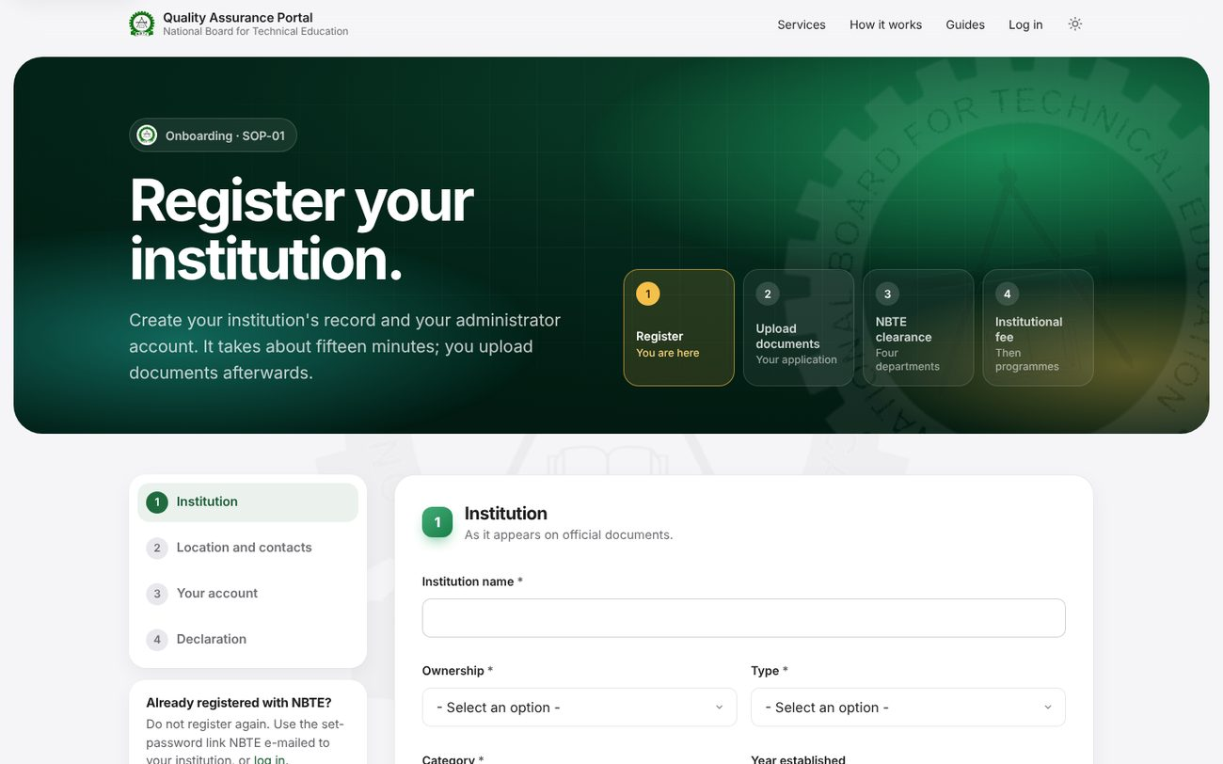
Portal → Register (self-registration on): the institution's details and its administrator's account.
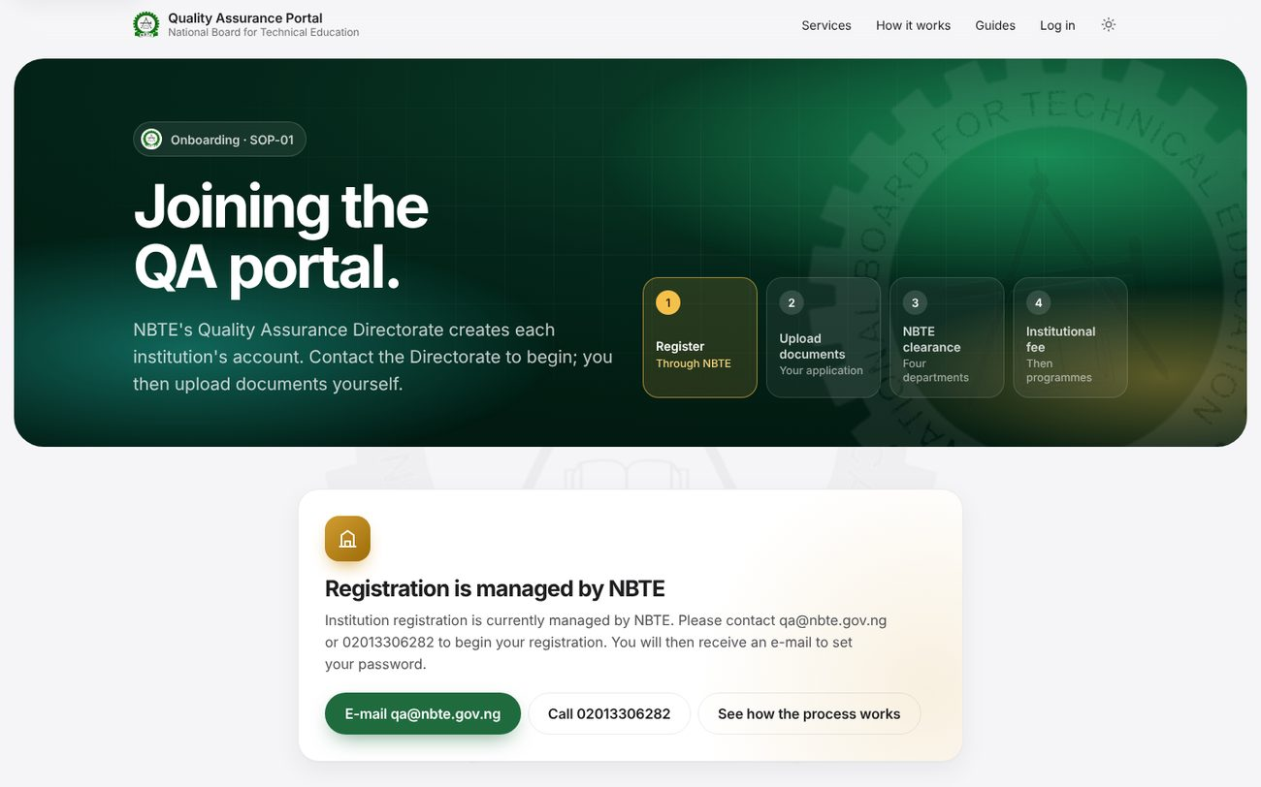
The same address with self-registration off: “Registration is managed by NBTE” and the QA Directorate's contacts.
After registering, the administrator lands on the application. The stage board shows every SOP-01 step: documents, the processing fee, departmental clearance (Legal, Finance, Academic Planning, Physical Planning in parallel) and approval.
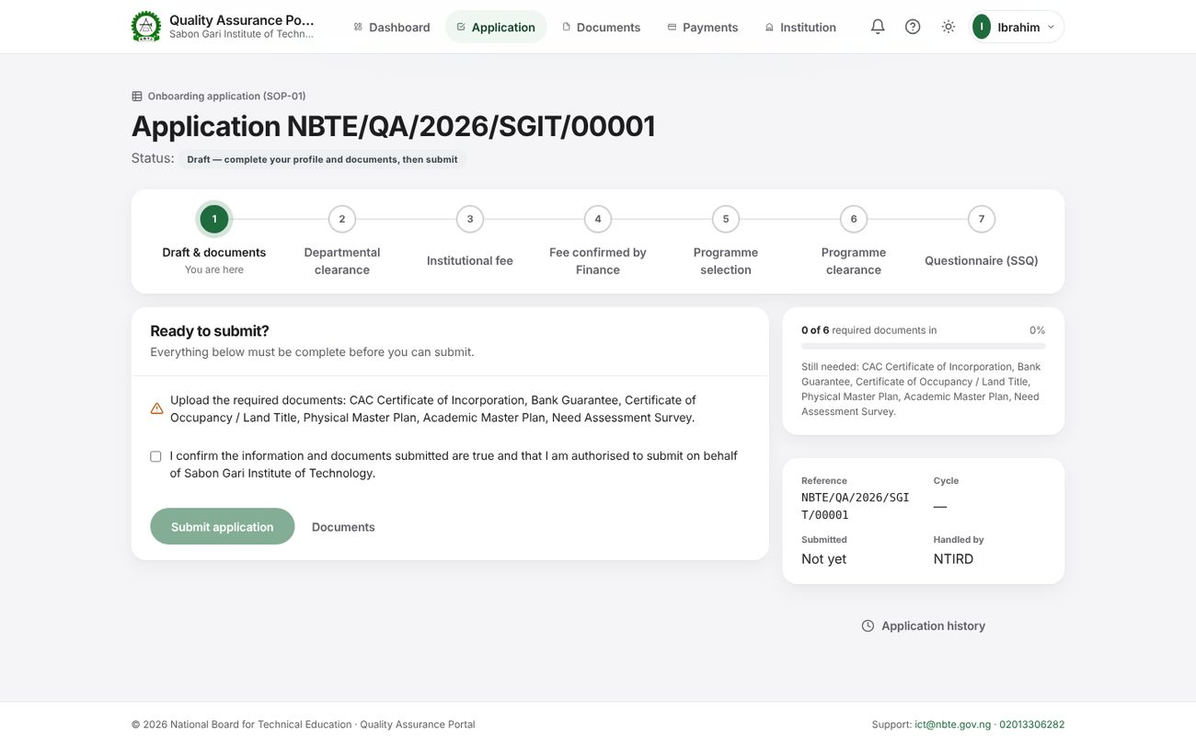
Portal → Application (admin@sgit.local in the screenshot copy; use admin@demo-health.local on your database).
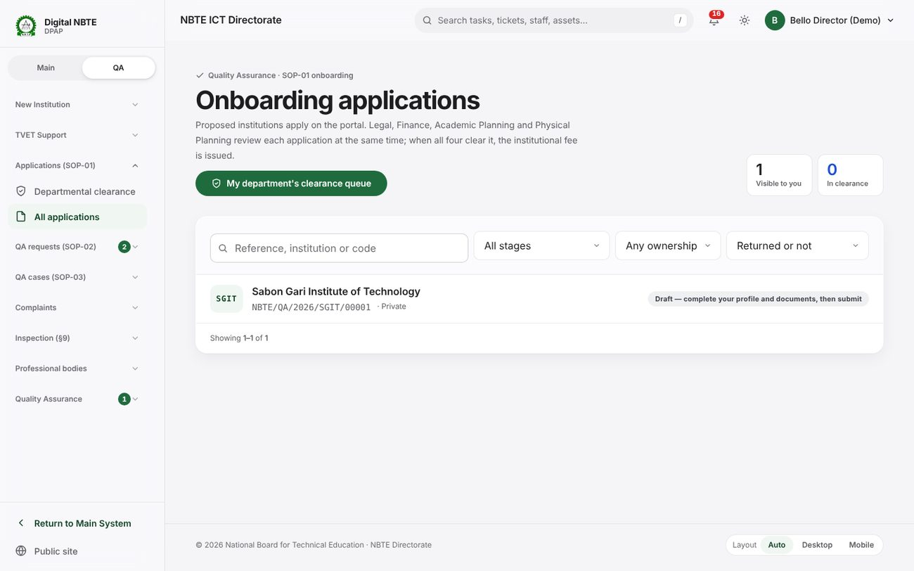
Internal → Applications (SOP-01): every application and its stage, for the clearing departments.

4.3 SOP-03 — the QA case
Sign in as qa.director@demo.nbte.local. The Case Board shows each case in its SOP-03 column; opening a case shows its stage, the people pinned to each step, the cost sheet, the visit and the history.
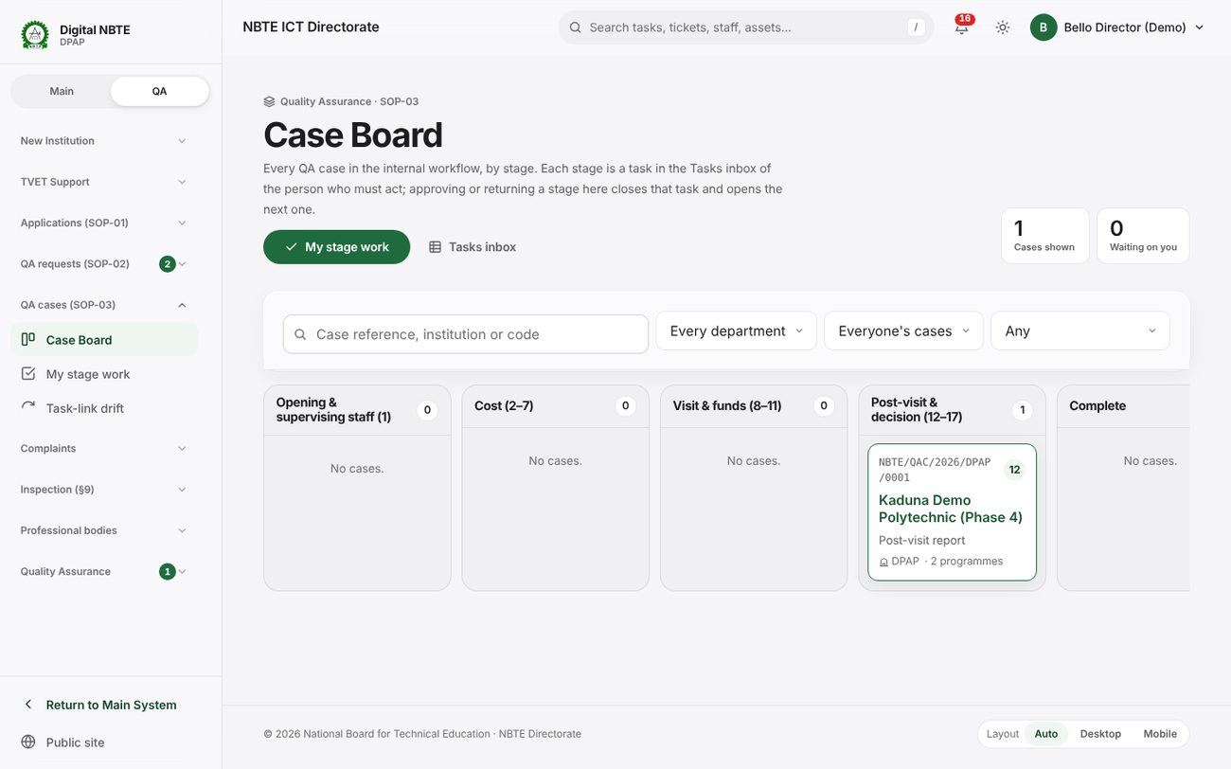
QA cases → Case Board.
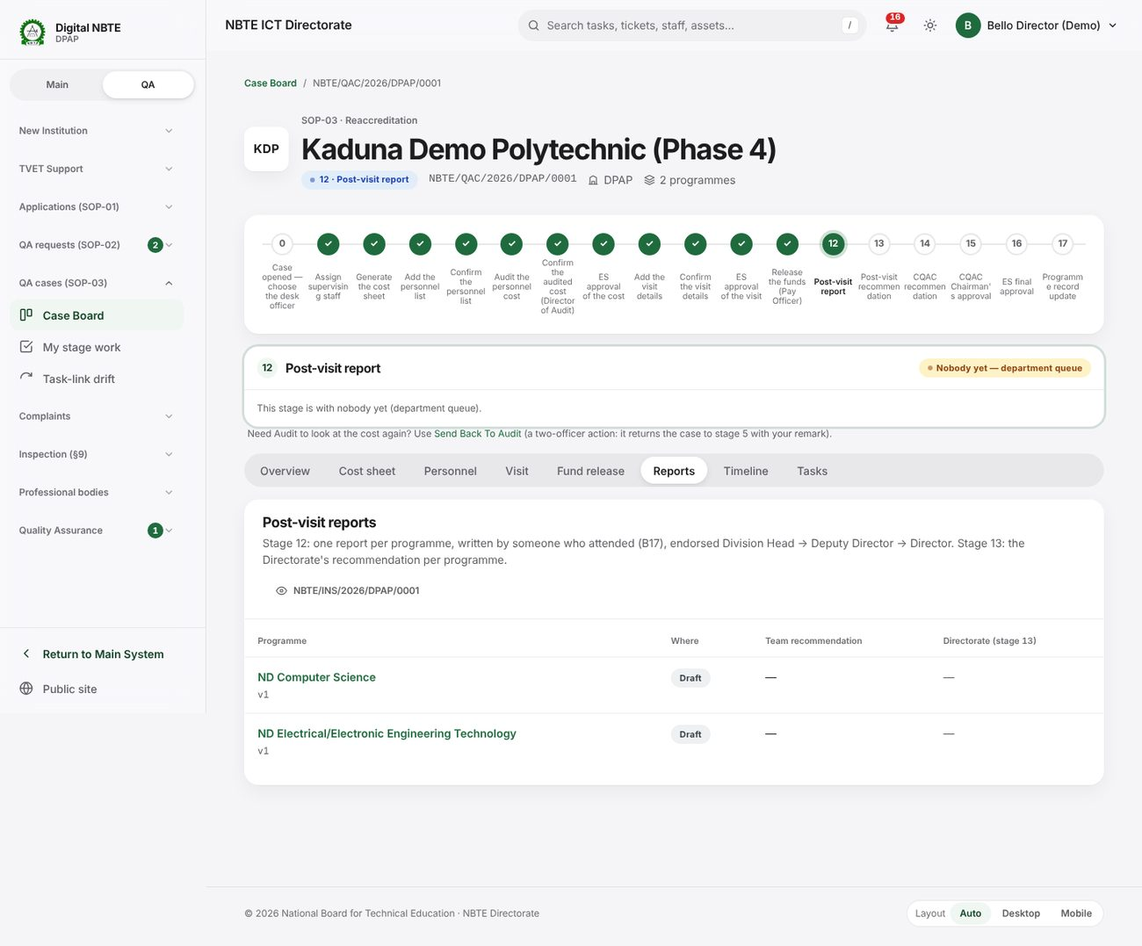
The demo case NBTE/QAC/2026/DPAP/0001 at stage 12, post-visit report.

4.4 The Director of Finance confirms a payment
A payment is confirmed only by the Director of Finance, after a different Finance officer has checked the evidence. Provider reports, uploaded tellers and bank-statement matches are evidence, never confirmation.
- The institution uploads its teller on the bill (admin@demo-poly.local → Payments).
- A Finance officer records the first pass (qa.finance@demo.nbte.local → Finance → Verification queue).
- The Director of Finance (finance.director@demo.nbte.local) filters the queue to “Ready for the Director”, opens the item and chooses Confirm payment.
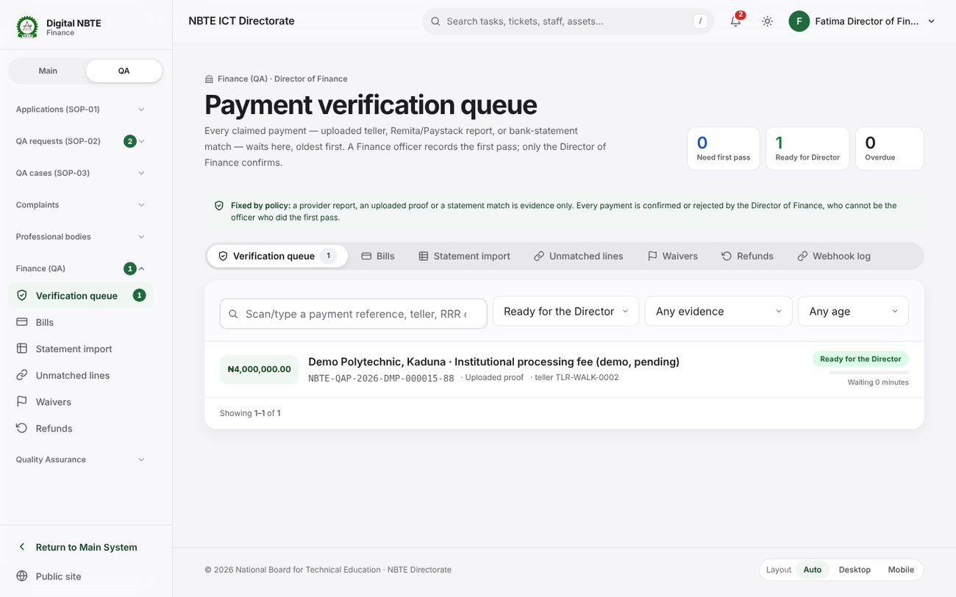
Finance → Verification queue, filtered to items ready for the Director.
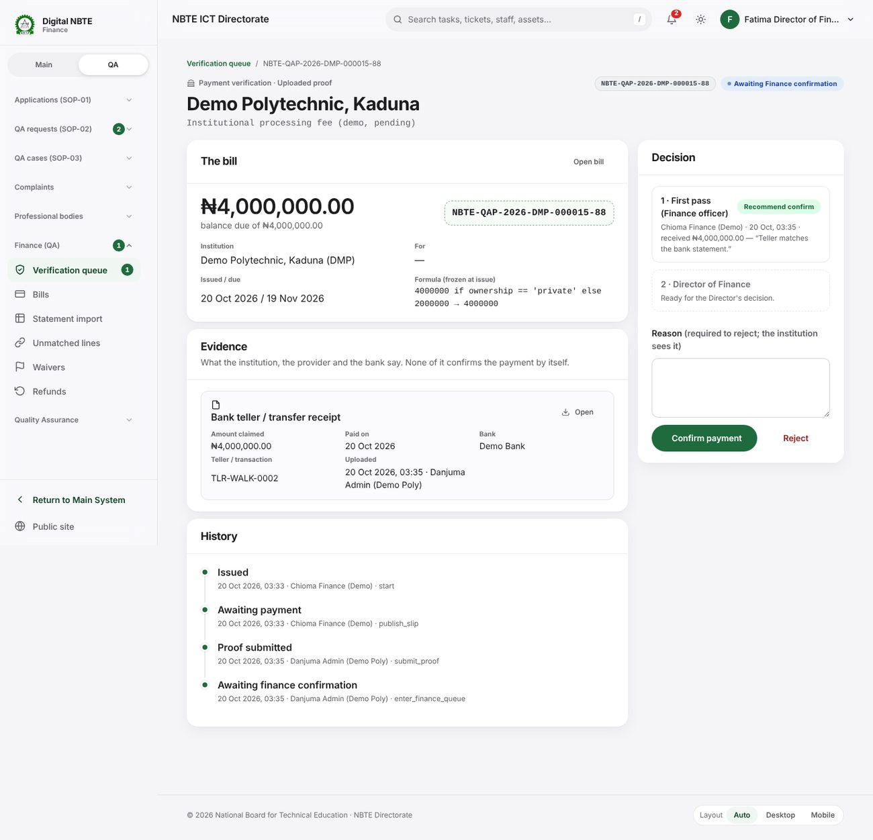
The verification item: the bill, the evidence, the first pass and the Director's decision panel.
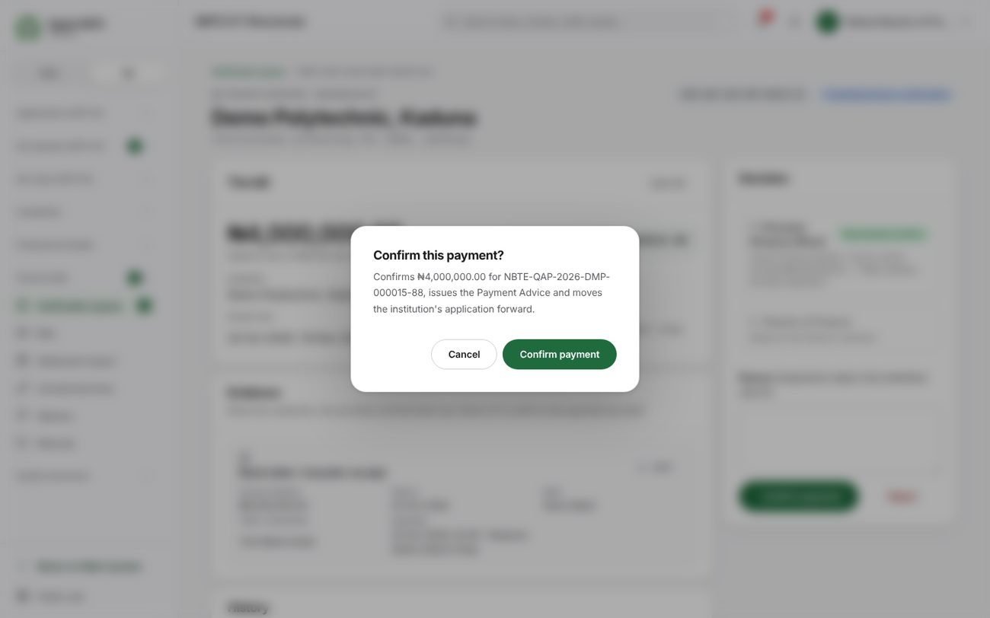
Every irreversible decision asks once more before it is applied.
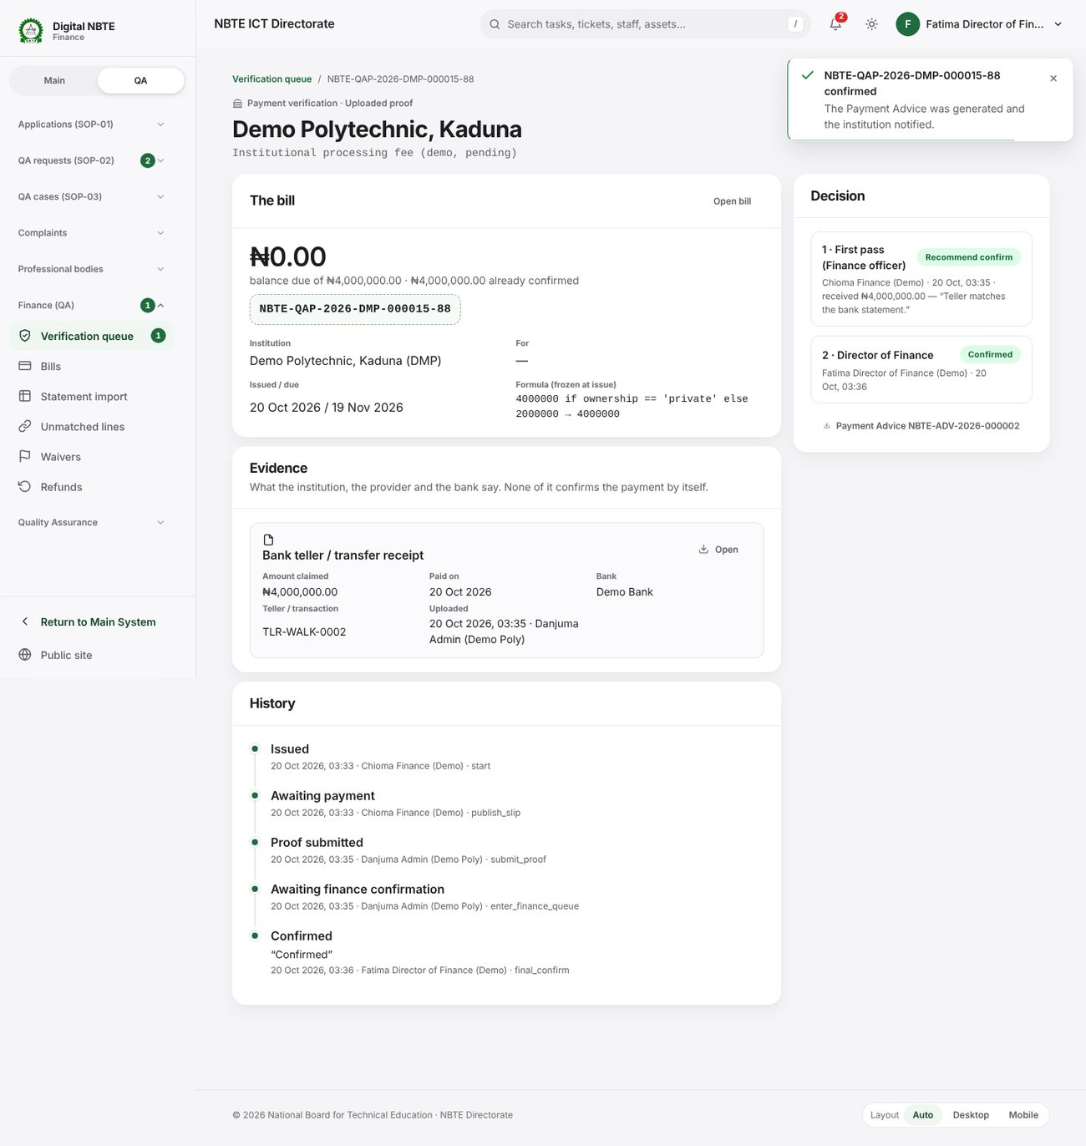
Confirmed: the Payment Advice is generated, the institution is notified and the history records who decided.

4.5 Complaints — the internal side
Sign in as qa.director@demo.nbte.local and open Complaints → Complaint queue. The three demo complaints show the three deadline states: on track (green), past half-way (amber) and overdue (red, escalated three levels because it is Critical).
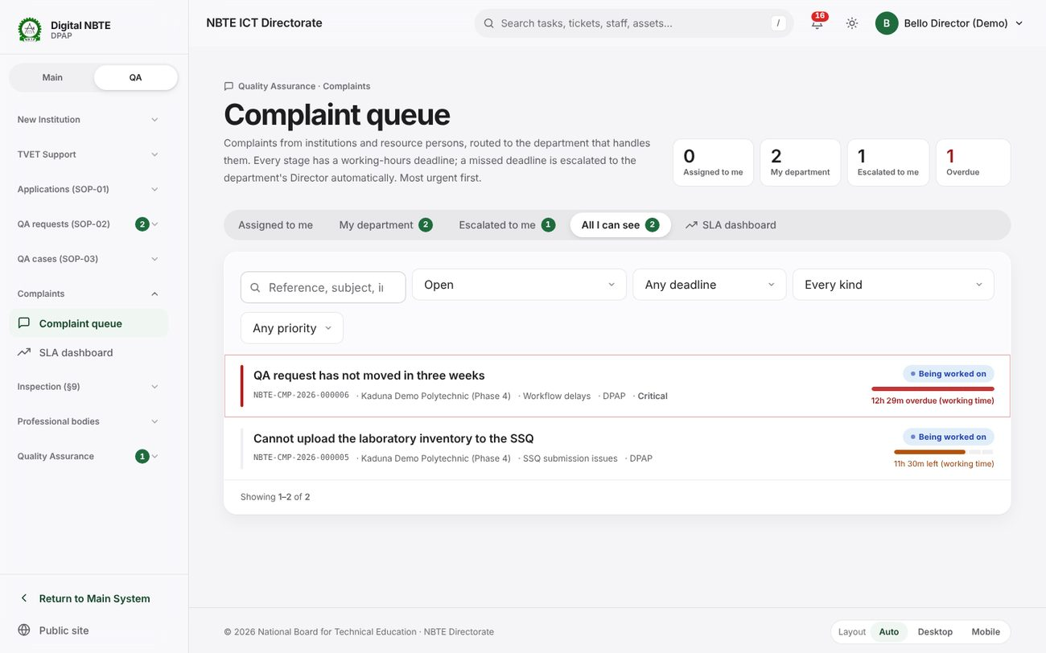
The complaint queue: most urgent first, each with its working-hours deadline clock.
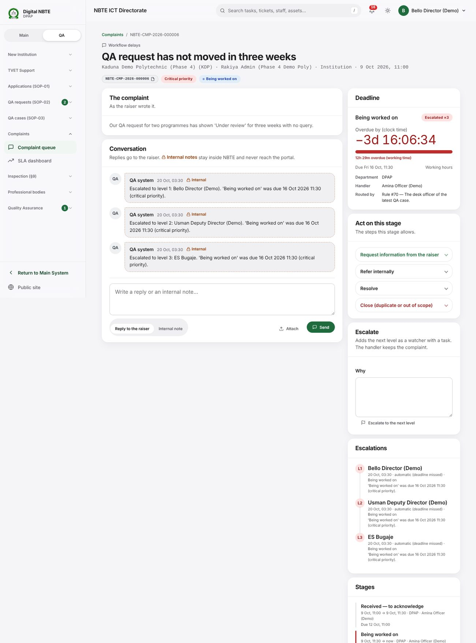
A breached complaint: the live clock, the stage actions, internal notes (striped) and the escalation ladder.
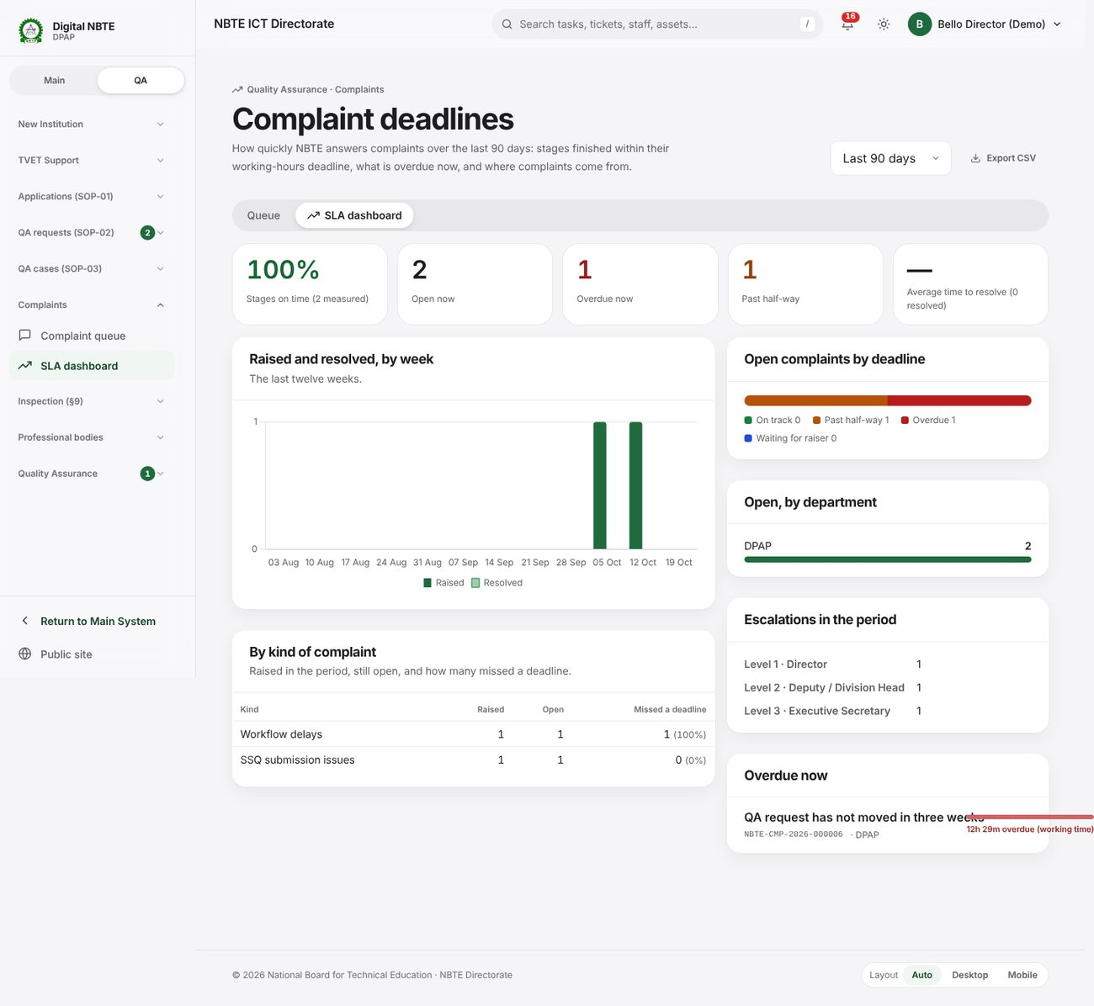
SLA dashboard: stages on time, open complaints by deadline state, by kind and by department.
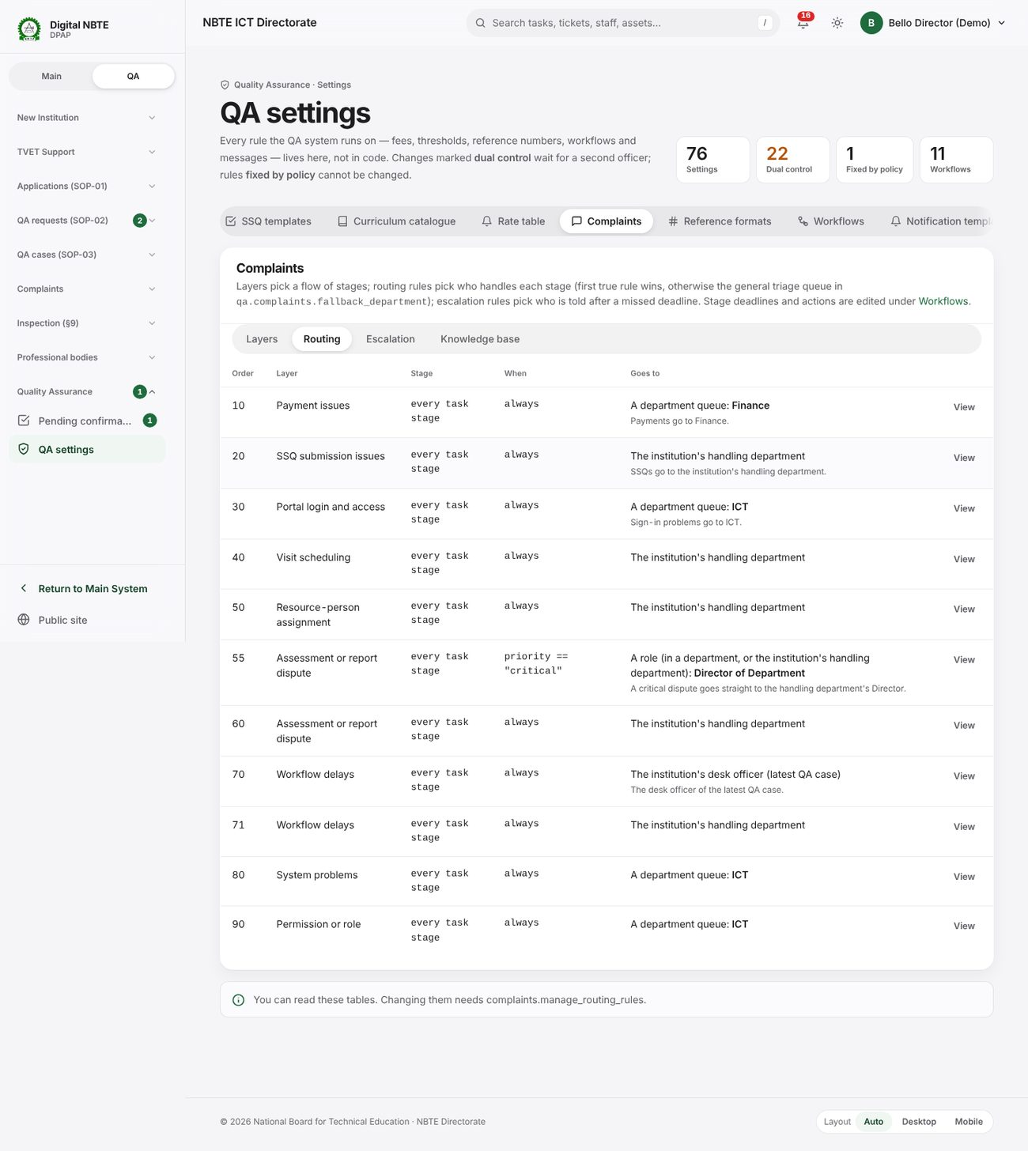
Settings → Complaints → Routing: who handles what, in order — edited as rows, no code.

4.6 Complaints — the portal side
Sign in on the portal as admin@p4demo.local. The institution sees the department and the stage, never internal notes, and sees the officer's name only when qa.complaints.show_officer_name_to_raiser is on.
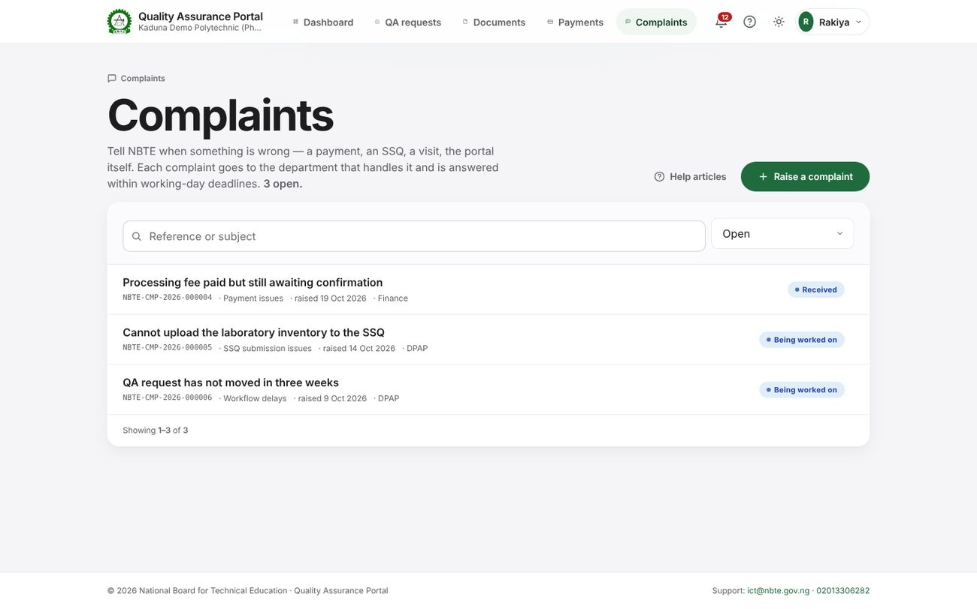
Portal → Complaints.
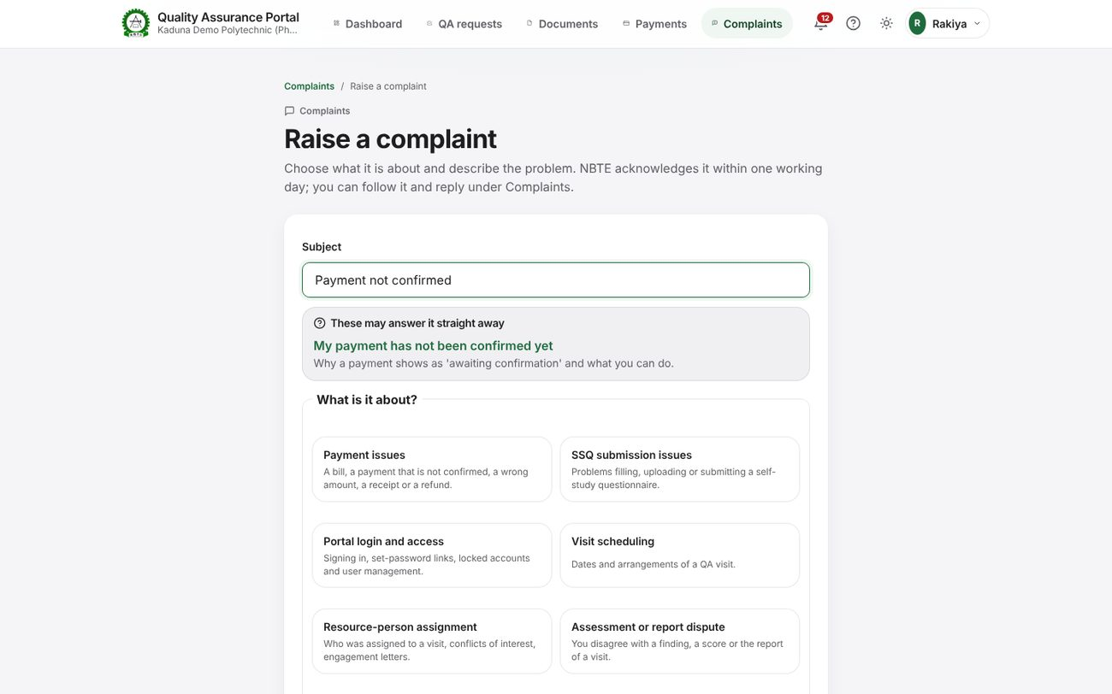
Raise a complaint: help articles are suggested while the subject is typed.
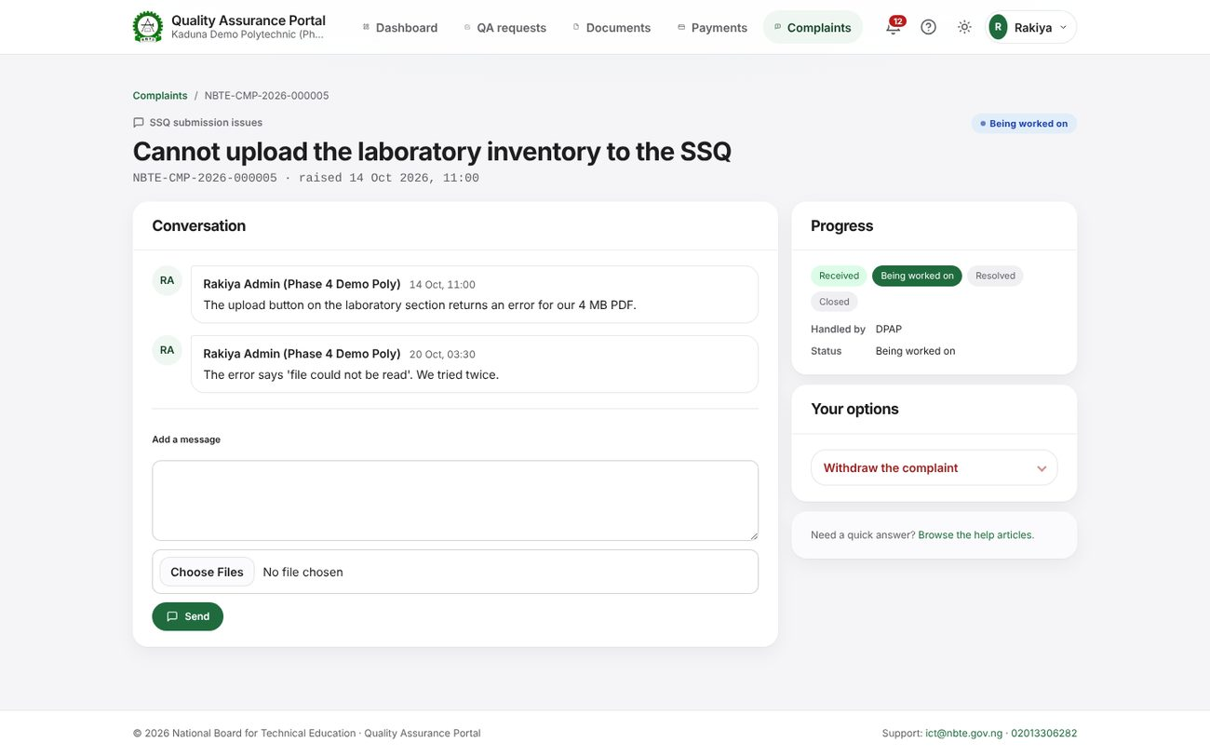
The institution's view of a complaint: the conversation, progress and its own options.
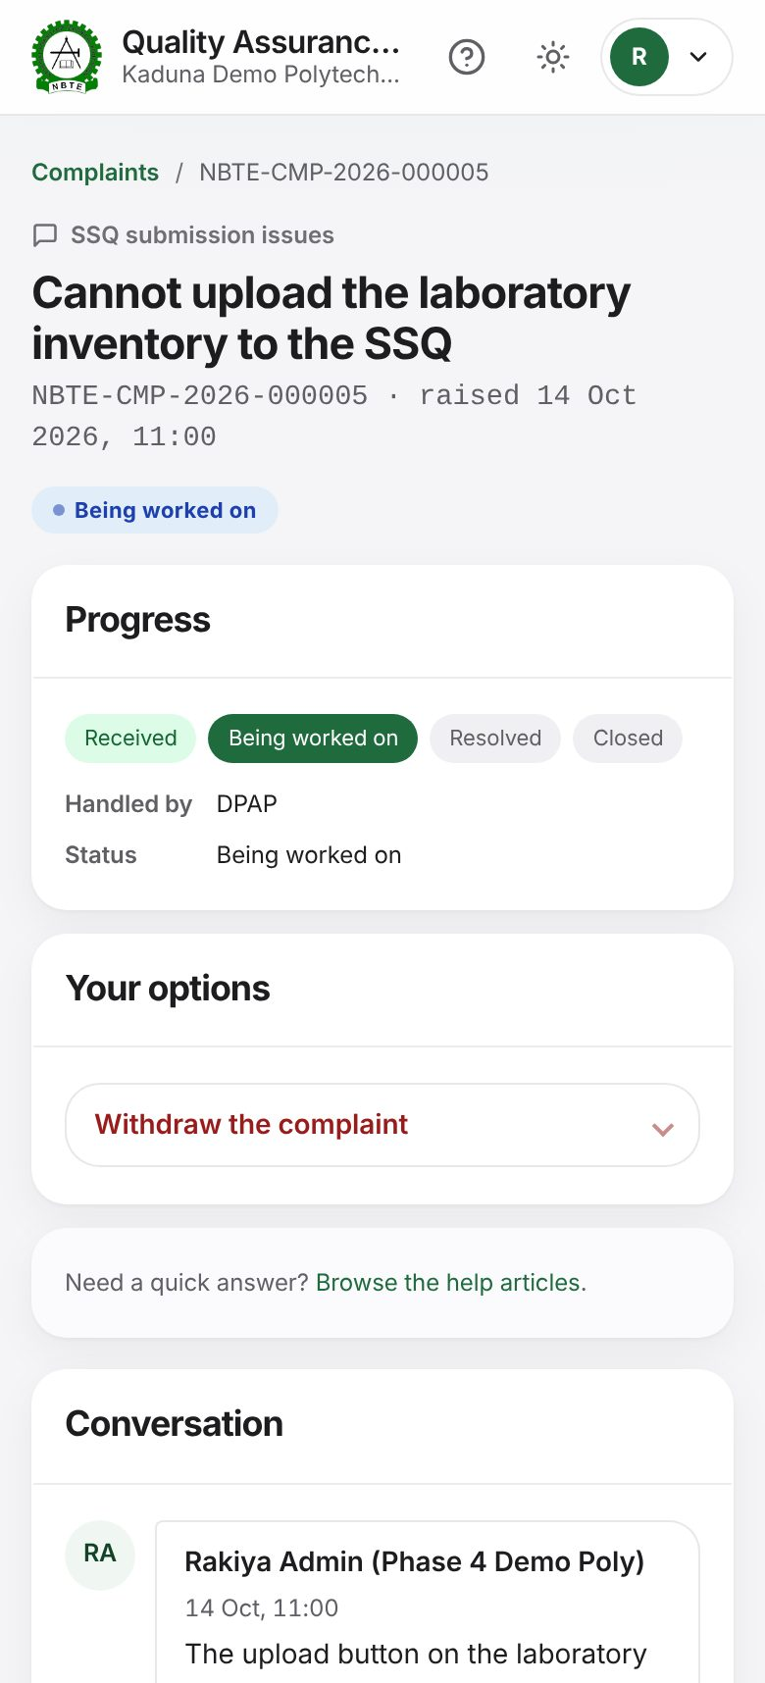
The same page on a phone.

4.7 Dashboards and the staff home
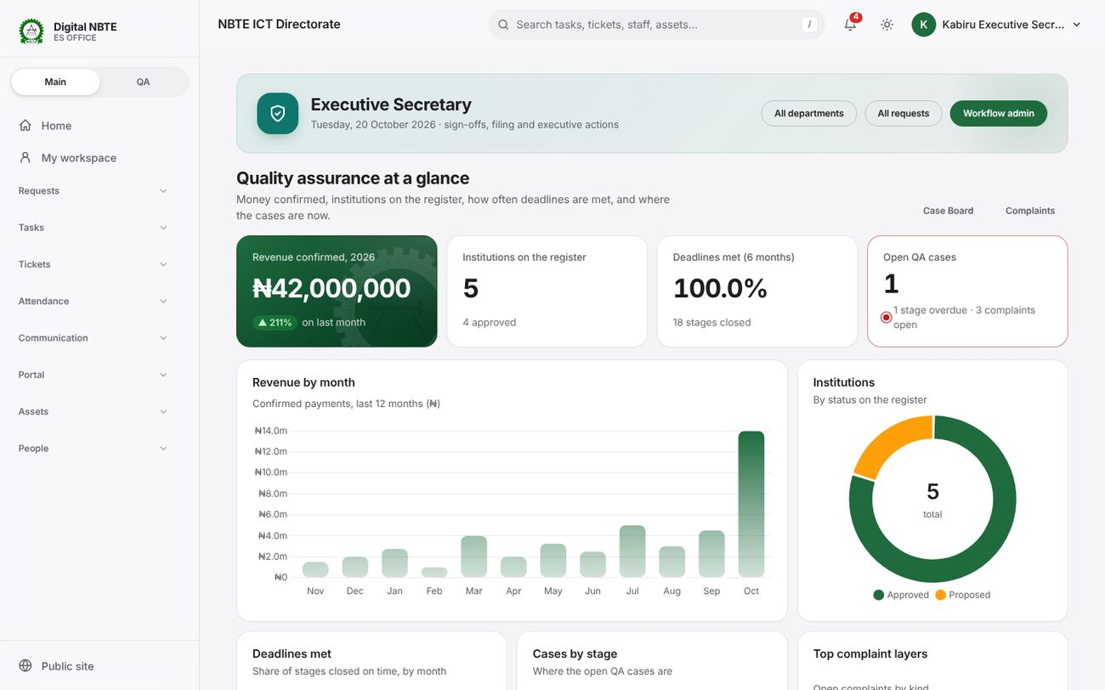
ES dashboard (qa.es@demo.nbte.local): the QA overview opens the page.
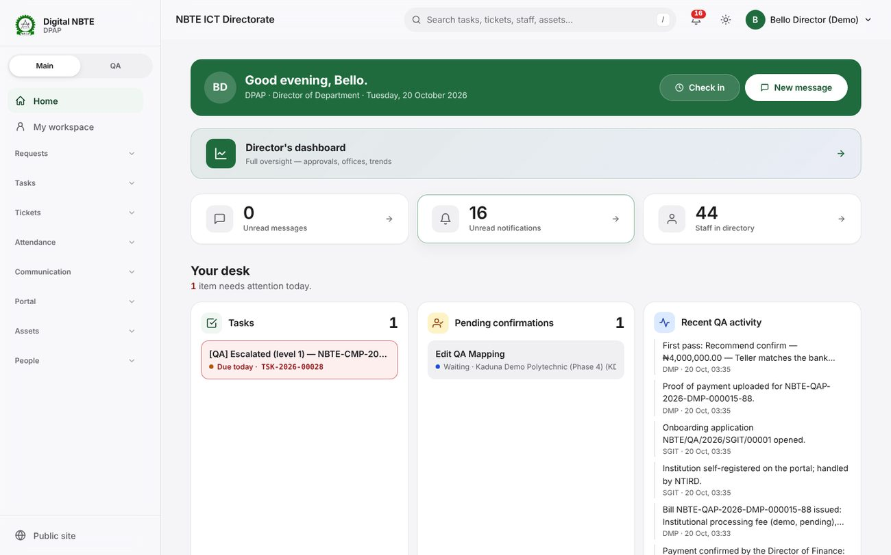
Staff home: “Your desk” with tasks, pending confirmations and recent QA activity.

5. How the system fits together
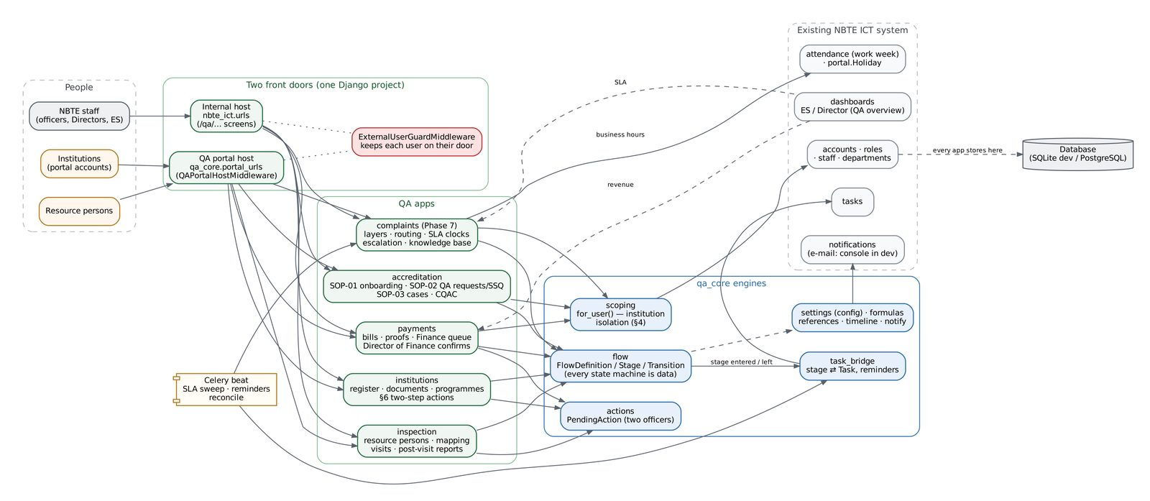
Apps, engines and the two front doors: people on the left, the shared qa_core engines and the existing NBTE ICT system on the right.

5.1 The two front doors
One Django project serves two hosts. QAPortalHostMiddleware switches every request for QA_PORTAL_HOST to the portal's own URL table, which contains no internal route. ExternalUserGuardMiddleware keeps each kind of user on its own door: institution and resource-person sessions are refused (and signed out) on the internal host; NBTE staff on the portal reach only the Staff Portal Dashboard and their own account pages.

5.2 The QA apps
App | What it owns
qa_core | The engines every QA app uses: flows (state machines as data), two-officer pending actions, reference numbers, formula settings, the institution timeline, notification templates, institution scoping, the task bridge, the portal shell.
institutions | The register of institutions, their contacts, documents and programmes, the §6 two-step actions and professional bodies.
accreditation | SOP-01 onboarding and departmental clearance, SOP-02 QA requests and SSQs, SOP-03 QA cases, cost sheets and approvals.
payments | Bills, slips, providers (Remita, Paystack, bank transfer), proofs, the Finance verification queue, waivers and refunds.
inspection | Resource persons and their vetting, the availability finder and mapping, visits and post-visit reports.
complaints | Layers, routing rules, the complaint stages and their business-hour clocks, messages, escalation and the knowledge base.

5.3 Rules the code keeps
- Every state machine is data. Flows, stages and transitions are rows (Settings → Workflows). A complaint layer can use its own flow; the engine only knows the raiser's own actions (reply, confirm, reopen, withdraw) and the system's auto-close.
- Institution isolation. Institution data is read only through Model.objects.for_user(user); evaluating an unscoped query raises an error in development. A test reads every view module and fails if one bypasses it.
- Two officers for sensitive changes. Dual-control settings and §6 actions wait for a second officer; nobody confirms their own change.
- Work becomes tasks. A stage with creates_task opens a normal Task for the person the routing picks; the QA action closes it. Escalations are tasks too.

6. Complaints reference

6.1 The default flow
Stage | Deadline | Who acts | Ways out
Received | 8 working hours | Routed handler | Acknowledge · Resolve · Close · (raiser) Withdraw
Being worked on | 40 working hours | Routed handler | Request information · Refer internally · Resolve · Close · Withdraw
Waiting for the raiser | Clock paused | The raiser | Raiser replied · Resume without a reply · Close · Withdraw
Referred internally | 24 working hours | The referred department or person | Send back · Resolve · Withdraw
Resolved | Closes itself after 5 days | The raiser | Confirm · Reopen (within 14 days) · Auto-close
Closed / Withdrawn | — | — | End
Working hours come from attendance.work_week, qa.calendar.business_hours (08:00–16:00) and the portal holiday calendar (public and religious holidays). When the clock resumes after a pause it continues from the time that was left.

6.2 Routing
On entry to each stage that creates a task, routing rules are read in order; the first whose condition is true wins. Conditions are formulas over: priority, layer, parent_layer, raiser_type, stage, institution_code, institution_zone, institution_state, handling_department and reopened — for example priority == "critical". Targets: a department queue (least-loaded handler), a role, a named person, the institution's handling department, or the desk officer of its latest QA case. If no rule matches, the complaint goes to qa.complaints.fallback_department (ICT).

6.3 Escalation
Level | When | Who is told | Condition
Reminder | At half of the stage's working time | The handler | Always
1 | On breach | The handling department's Director (or Director of Finance) | Always
2 | 8 hours after the breach | Deputy Director, else Division Head | Always
3 | 16 hours after the breach | The Executive Secretary | Critical priority or a repeated breach
Each level adds the person as a watcher and opens a task for them; the handler keeps the complaint. Officers holding complaints.escalate_complaint can also escalate by hand.

6.4 Settings
Setting | Default | Meaning
qa.complaints.fallback_department | ict | The general triage queue
qa.complaints.sla_poll_minutes | 5 | How often the sweep runs
qa.complaints.auto_close_days | 5 | Resolved → closed automatically (TR-09)
qa.complaints.reopen_window_days | 14 | How long the raiser may reopen (TR-10)
qa.complaints.show_officer_name_to_raiser | false | Show the officer's name on the portal
qa.complaints.sms_for_critical | false | SMS on critical escalations (TR-14)
qa.calendar.business_hours | ["08:00", "16:00"] | Working hours for business-hour deadlines
qa.suspension.enabled_for | [] (dual control) | Record types a complaint may place on hold; empty = holds off

6.5 Adding a new kind of complaint without code
- Settings → Workflows: copy the complaint flow, add or remove stages, set deadlines and publish it (a Director publishes).
- Settings → Complaints → Layers: add the layer, choose who may raise it and pick the new flow; add extra questions if needed.
- Settings → Complaints → Routing: add a rule that sends the layer to the right department.
An automated test does exactly this with a two-stage flow and proves the complaint is routed, worked and closed.

7. Security review (Phase 8, first pass)
ExternalUserGuardMiddleware was reviewed line by line and the Phase 7 surfaces were added to its tests (qa_core/tests/test_security_phase8.py).
Check | Result
Institution and resource-person sessions on every internal /qa/ route (including complaints) | 403 and signed out — verified for every route
Staff on the portal opening complaints, help, payments or timeline | Sent back to the Staff Portal Dashboard (HTMX: HX-Redirect)
Staff check under a script prefix (FORCE_SCRIPT_NAME) | Fixed: the guard now resolves request.path_info. Before, an unresolvable prefixed path fell into the “let the portal 404” branch.
Anonymous requests | Untouched by the guard; each view asks for sign-in
Complaint visibility | Raiser, same-institution accounts, the routed department, people the complaint was referred or escalated to, and NBTE-wide oversight (ES, ICT monitor). Seeing every institution for billing is not enough.
Internal notes | Filtered out in the portal view; a test asserts they never appear. Officer names in portal notifications follow the same setting.
Cross-institution requests | 404, never 403, on every portal and internal object route

