National Board for Technical Education
NBTE Digital Quality Assurance System
Phase 5 walkthrough — Inspection and resource persons

Version 1.0
19 October 2026
Master Plan v1.1 §5.5, §9 · SOP-03 stages 12–13

Phase 5 adds the people side of quality assurance. NBTE keeps a vetted register of resource persons and QA personnel. The Availability Finder shows who is eligible and free for a visit, with every §9 rule enforced and no override. A second officer confirms each mapping, so nobody is booked twice. When the Executive Secretary approves a visit, the inspection is created. After the visit, the Team Lead records who actually went, which writes the service history. Stage 12 is a real post-visit report for each programme: only attendees can write it (B17), and it is endorsed by the Division Head, the Deputy Director and the Director, who can each endorse, add content or return it with a remark. Stage 13 records the Directorate's recommendation for each programme.

1. Before you start
Run these once, from the project folder. Back up the database first.
- cp db.sqlite3 db.sqlite3.before-phase5-$(date +%Y%m%d-%H%M%S)
- python manage.py migrate
- python manage.py seed_phase5_demo
- python manage.py runserver 0.0.0.0:8000
seed_phase5_demo is safe to run again. It prints every demo account with its password, the case, the inspection and who holds each report. Run it with --reset-passwords for new passwords. The internal system is at http://localhost:8000; the QA portal at its own host (QA_PORTAL_HOST, for example http://qa.localhost:8000).

2. Demo accounts
Who | E-mail (sign-in) | Password | Role · department | In this walkthrough
team_lead | qa.team_lead@demo.nbte.local | zj48-gGByvPY | director · DPAP | Team Lead: records the visit, writes and submits the reports, corrects attendance
division_head | qa.division_head@demo.nbte.local | F-W41FAKH3cg | division-head · DPAP | First endorsement layer
deputy_director | qa.deputy_director@demo.nbte.local | O-G2MljFFUB4 | deputy-director · DPAP | Second layer (returns with a remark in the walkthrough)
director | qa.director@demo.nbte.local | QXIp7P4z22no | director · DPAP | Third layer; stage 13 recommendation; vets nominations; confirms mappings
desk_officer | qa.officer@demo.nbte.local | DwRu56jE6Plc | officer · DPAP | Nominates resource persons, proposes mappings
qa_officer2 | qa.verifier@demo.nbte.local | TgptssFSFlmb | director · DPAP | Registered QA personnel (verification officer)
es | qa.es@demo.nbte.local | ugERTWmjuFeo | executive-secretary · ES Office | Stage 10 visit approval (creates the inspection)
pay_officer | qa.pay_officer@demo.nbte.local | fKEL50cyyjBl | pay-officer · Finance | Stage 11 fund release
ict_monitor | qa.ict_monitor@demo.nbte.local | jsI0s5tlisqB | ict-qa-monitor · ICT | Sees every Phase 5 screen, acts on nothing (R-13)
busy_officer | qa.busy_officer@demo.nbte.local | YhlIiJih5fVe | officer · DPAP | Not on the visit: refused by B17
institution_admin | admin@p4demo.local | ARRegC36FULs | inst-admin · Kaduna Demo Polytechnic (Phase 4) | Portal: read-only Inspections list
rp_eng | rp.yakubu@demo.nbte.local | xEYxjpDlYd1k | resource-person · QA portal | Portal: My engagements, findings, service history, Profile & CV
rp_sci | rp.zainab@demo.nbte.local | SEGUsC5IrQtl | resource-person · QA portal | Portal (computing assessor)

The passwords are the ones seed_phase5_demo printed on this database. If you reset them, use the new ones it prints. Every new password must be changed at first sign-in when DEBUG is off.

3. How it fits together

The endorsement chain (B14)
Each programme's report goes through three endorsement layers. Every layer can endorse it (it moves on), add content (it stays), or return it with a remark (it goes back to whoever submitted it). A resubmitted report starts again at the Division Head.
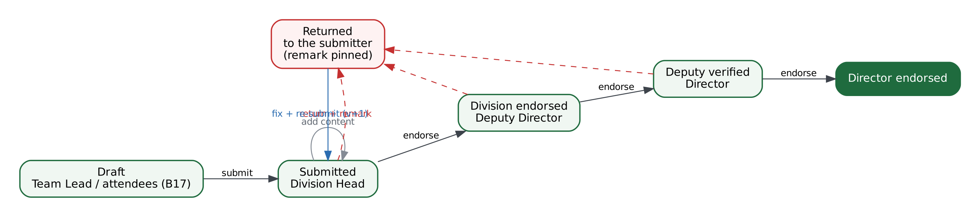
Figure 1 — Division Head → Deputy Director → Director, with returns to the submitter

Stages 8 to 13
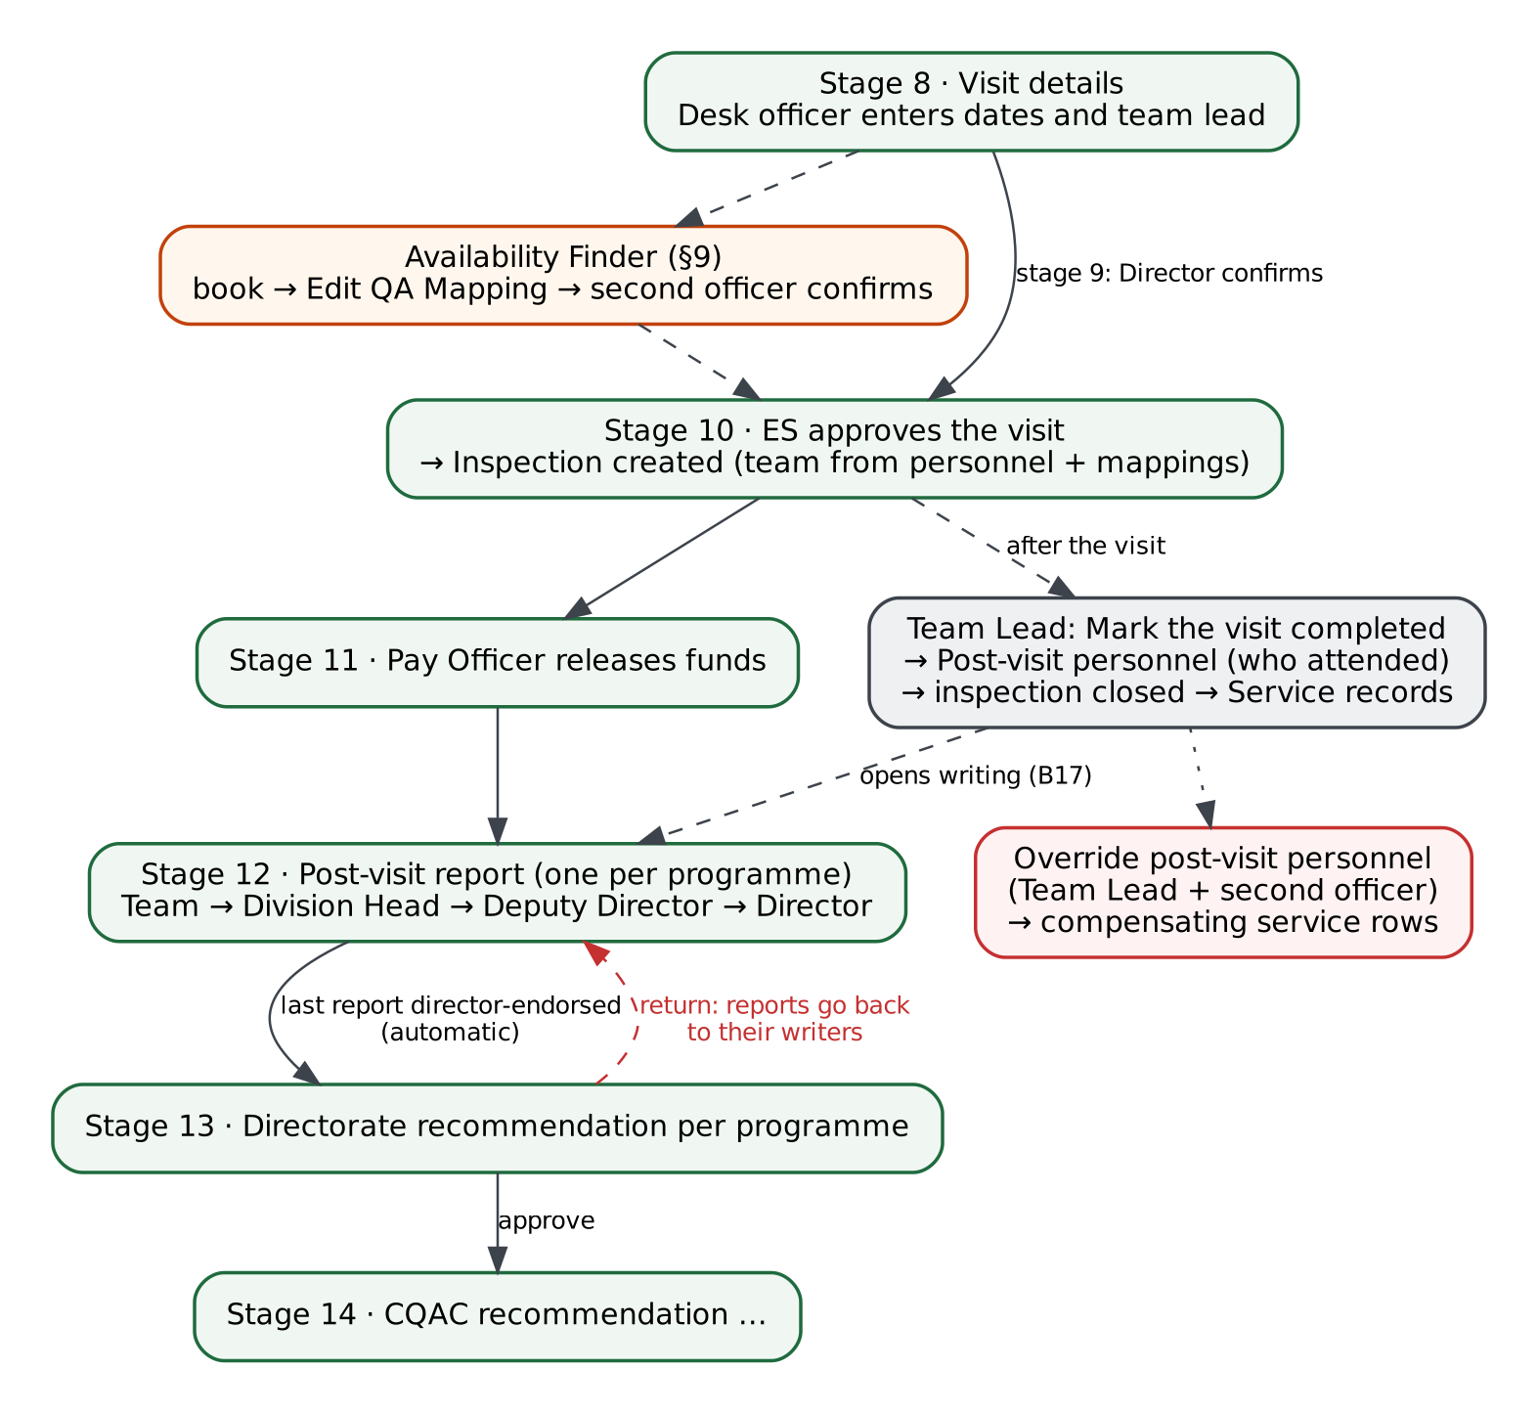
Figure 2 — From visit details to the Directorate's recommendation

4. Step-by-step walkthrough

Step 1: Log in as the Director and open the resource-person register
Sign in to the internal system as qa.director@demo.nbte.local and choose Inspection (§9) → Resource persons in the sidebar. The register lists every expert NBTE can call on, with search and four filters (status, source, discipline, eligibility), 25 per page or Show all. Mr. Garba Lawal carries the red No longer eligible badge: his rank is no longer in qa.resource_person.required_designations, so his confirmed work continues but nobody can map him to anything new.
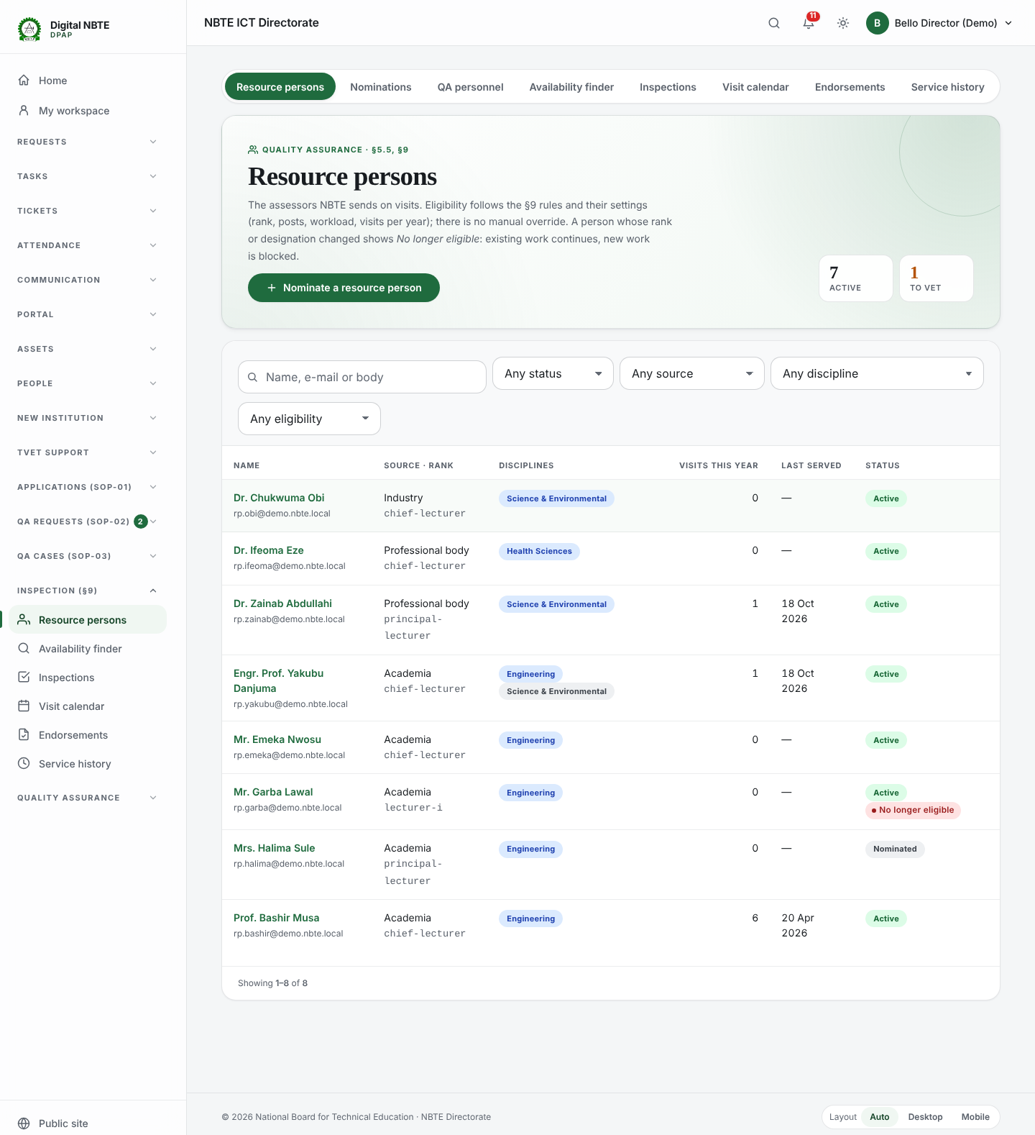
Screenshot 1 — resource persons list
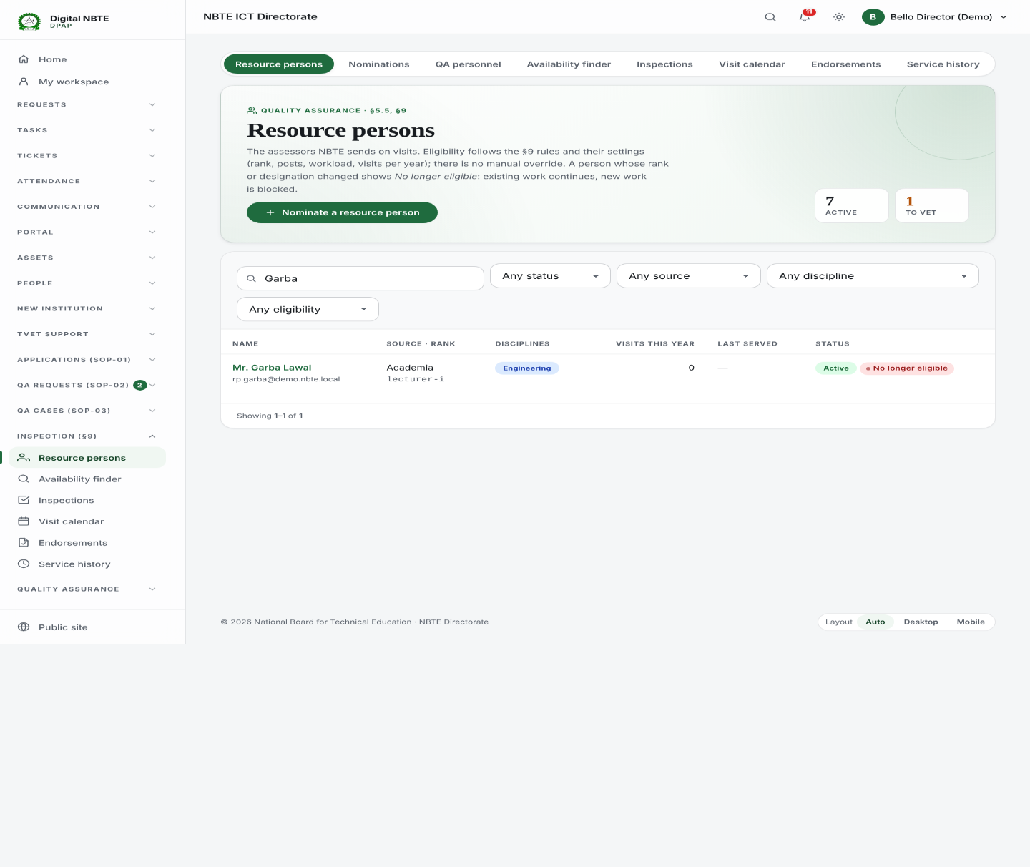
Screenshot 2 — resource persons search no longer eligible

Step 2: Vet a nomination
Open Nominations. Mrs. Halima Sule was nominated by the desk officer and waits for a vetter. Open her record: the vetting panel shows her CV and the rules checked. The nominator can never vet their own nomination, a CV is required, and rejecting needs a remark. Approving makes her active.
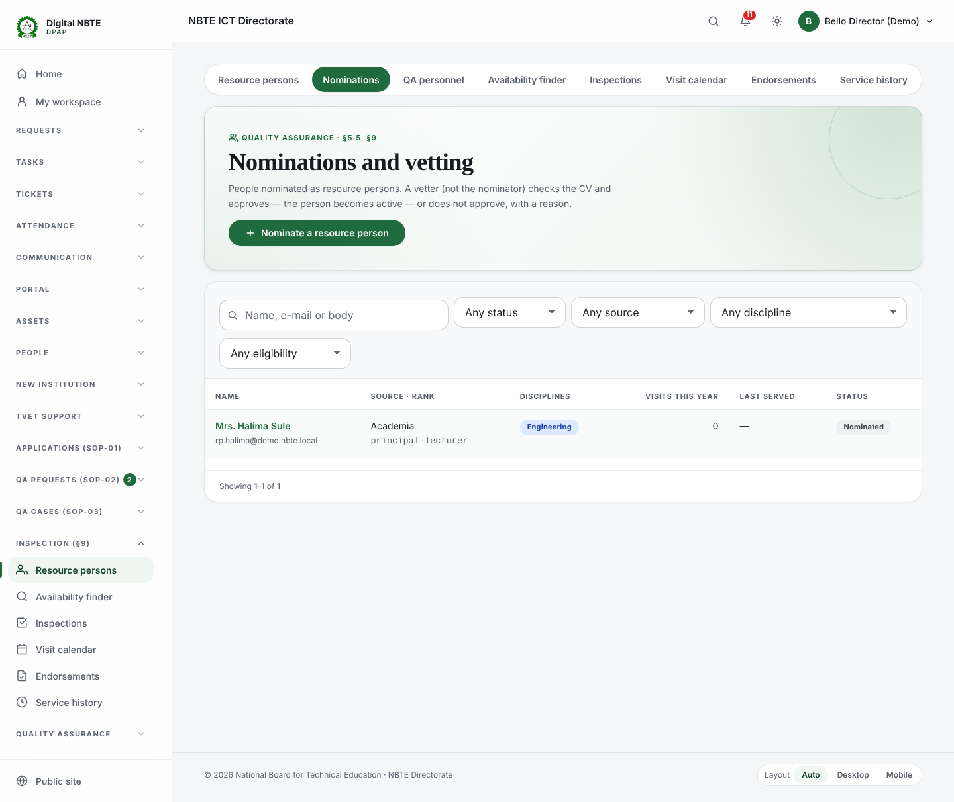
Screenshot 3 — nominations waiting for a vetter
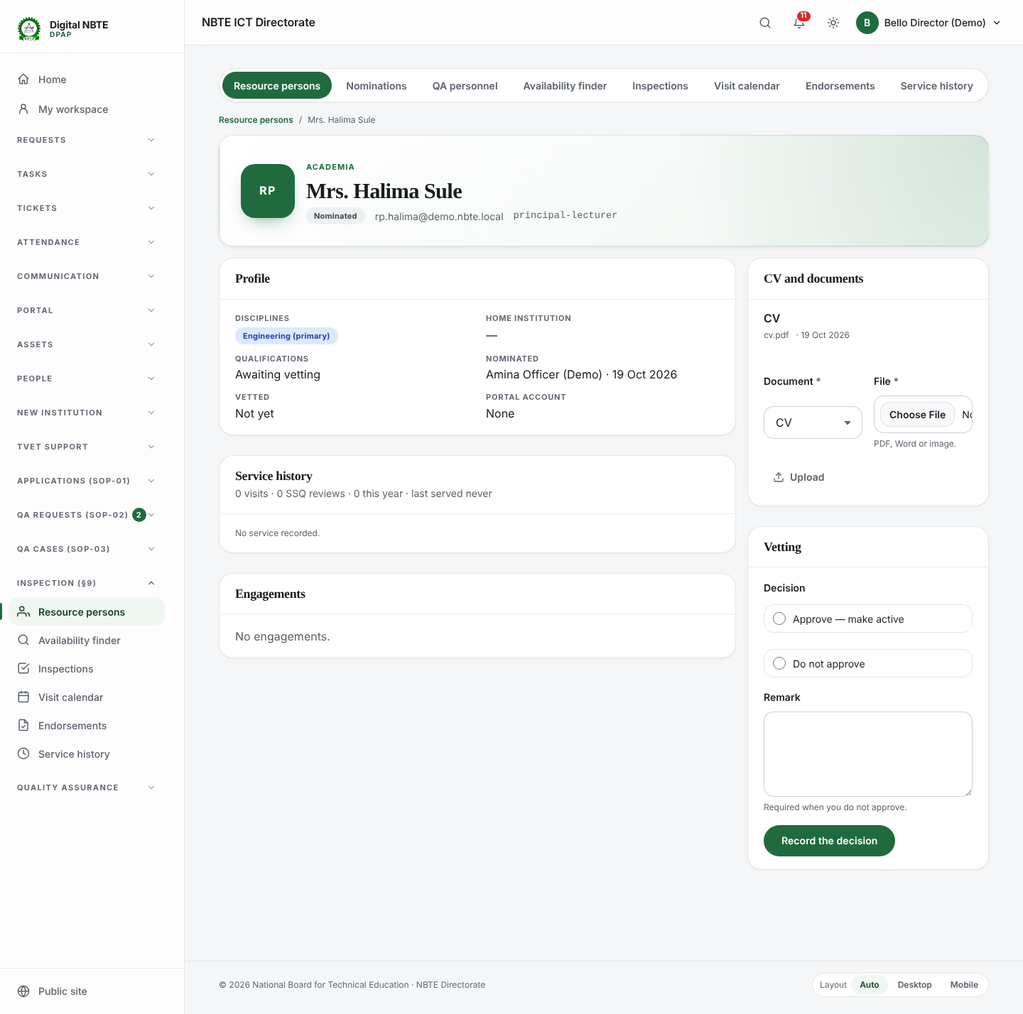
Screenshot 4 — resource person detail vetting

Step 3: Check the QA personnel
QA personnel are NBTE staff registered for QA duty through the two-officer action Edit QA Personnel. Rank (qa.resource_person.min_rank) and designation are checked when the registration is started and again when it is confirmed. There is no override.
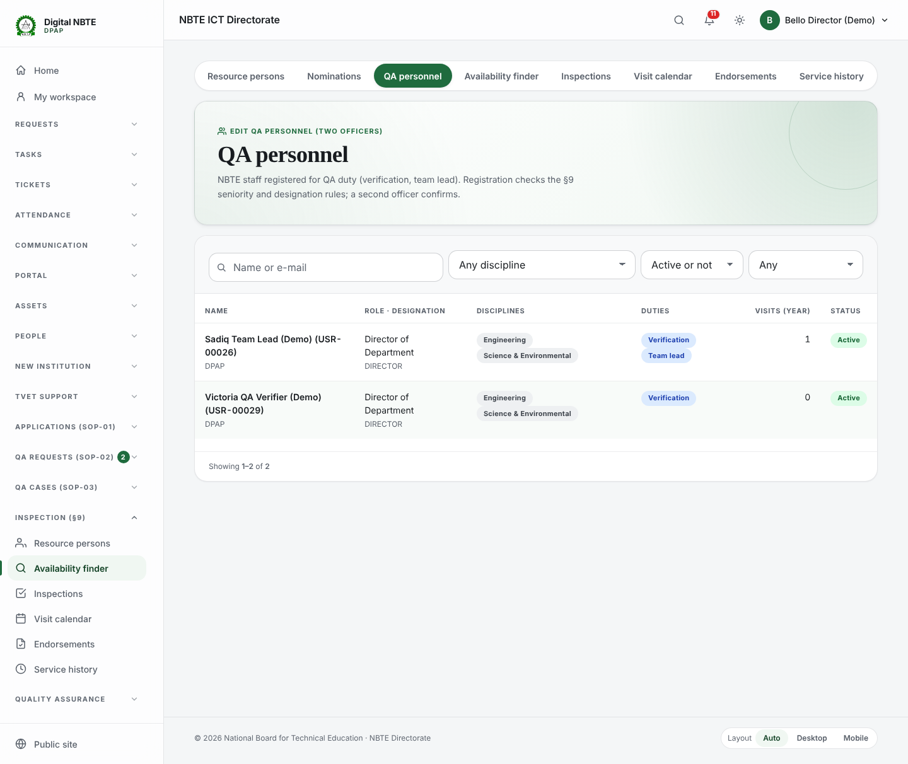
Screenshot 5 — qa personnel

Step 4: Log in as the desk officer and use the Availability Finder
Sign in as qa.officer@demo.nbte.local (officers propose mappings; a Director confirms them) and open Availability finder. Choose the demo case. The finder lists only people who pass every §9 rule for that programme, duty and dates, ranked by fewest visits this year. Switch Show to 'Also show who is not eligible, and why' to see each refusal with the rule and the setting behind it: conflict of interest (Mr. Emeka Nwosu works at the institution), annual cap (Prof. Bashir Musa), discipline (Dr. Ifeoma Eze), status (nominated), rank. Map books the person under a lock; if another officer booked the same person a moment earlier, the second save is refused.
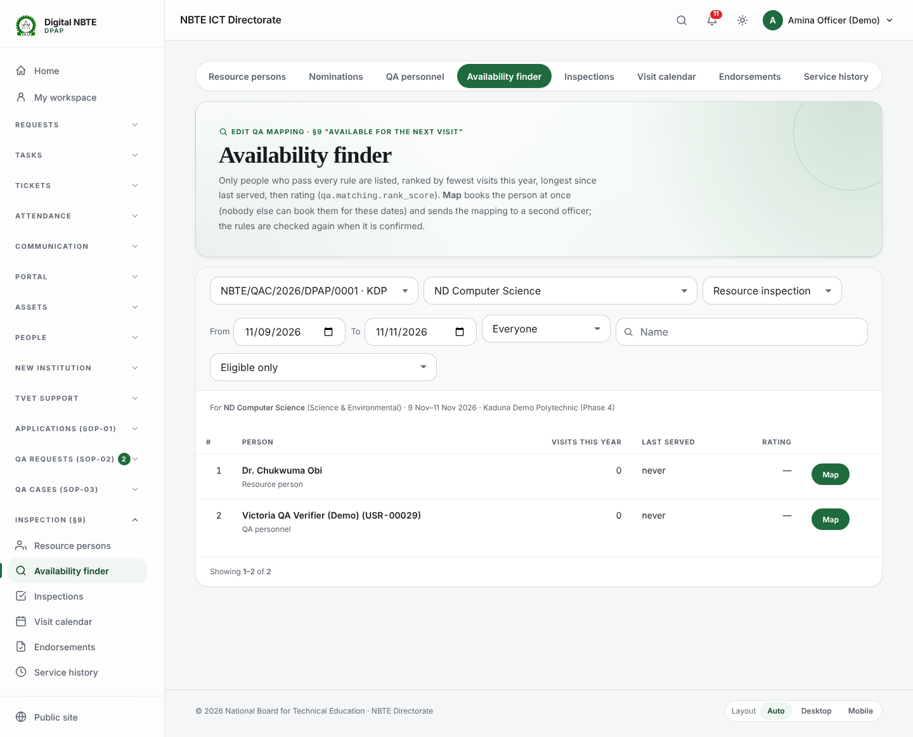
Screenshot 6 — availability finder
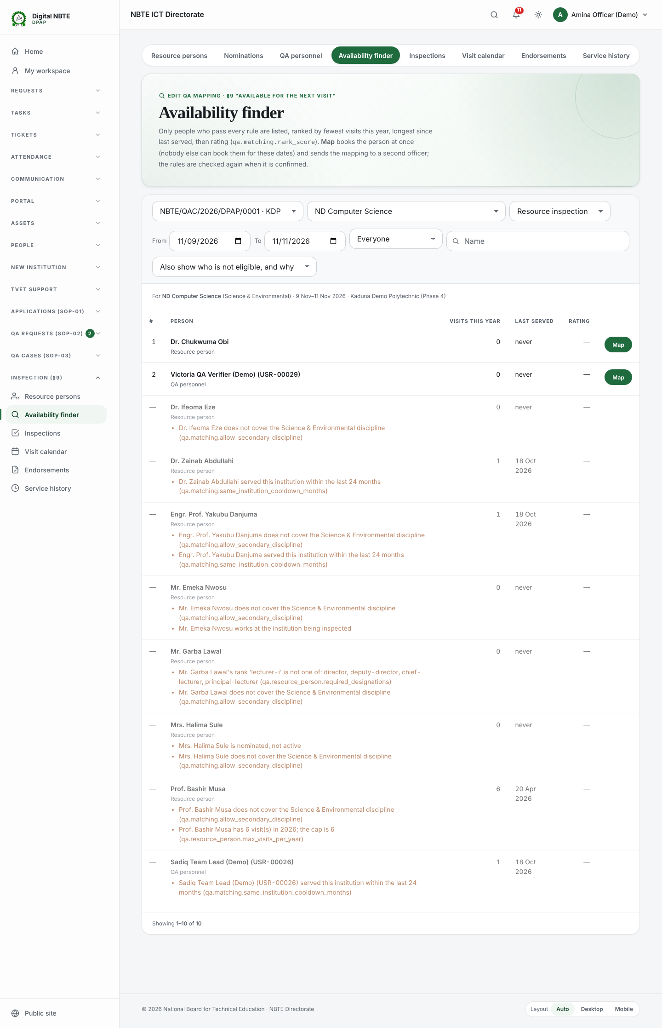
Screenshot 7 — availability finder with reasons

Step 5: Review the mappings and the Visit Calendar
QA mappings shows who is mapped to which programme, each confirmed by a second officer (the pending-action reference is shown). The Visit Calendar shows the month's visits; on a phone it becomes a list.
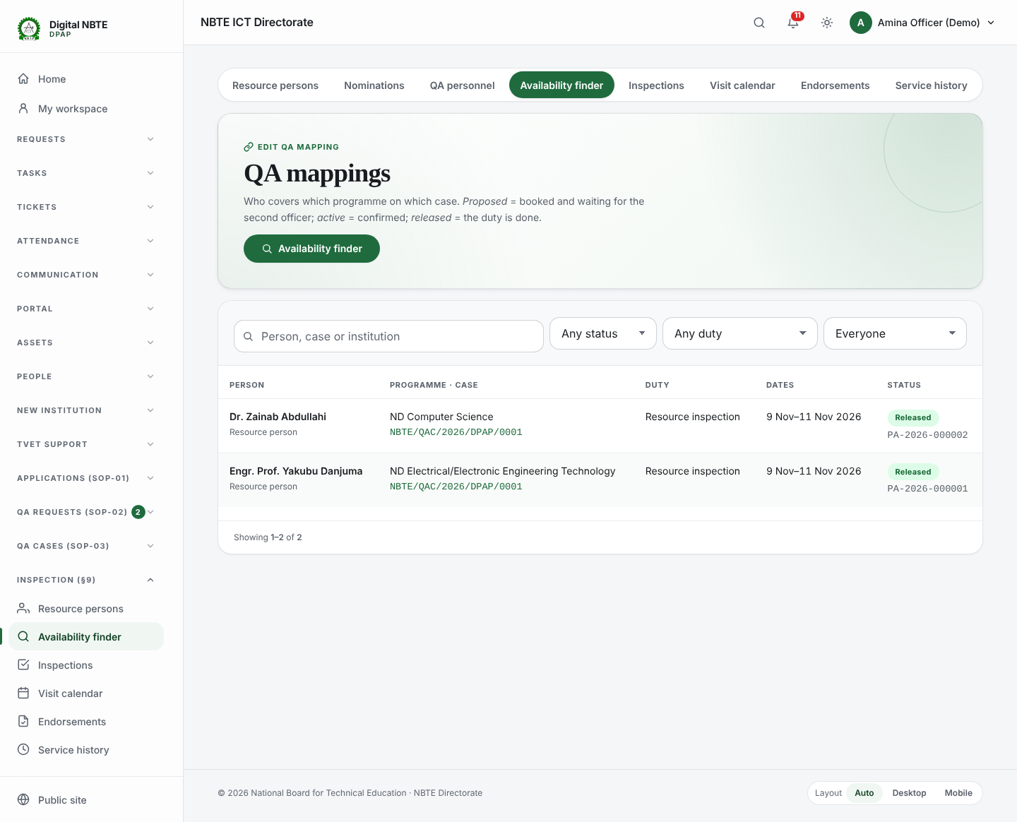
Screenshot 8 — qa mappings
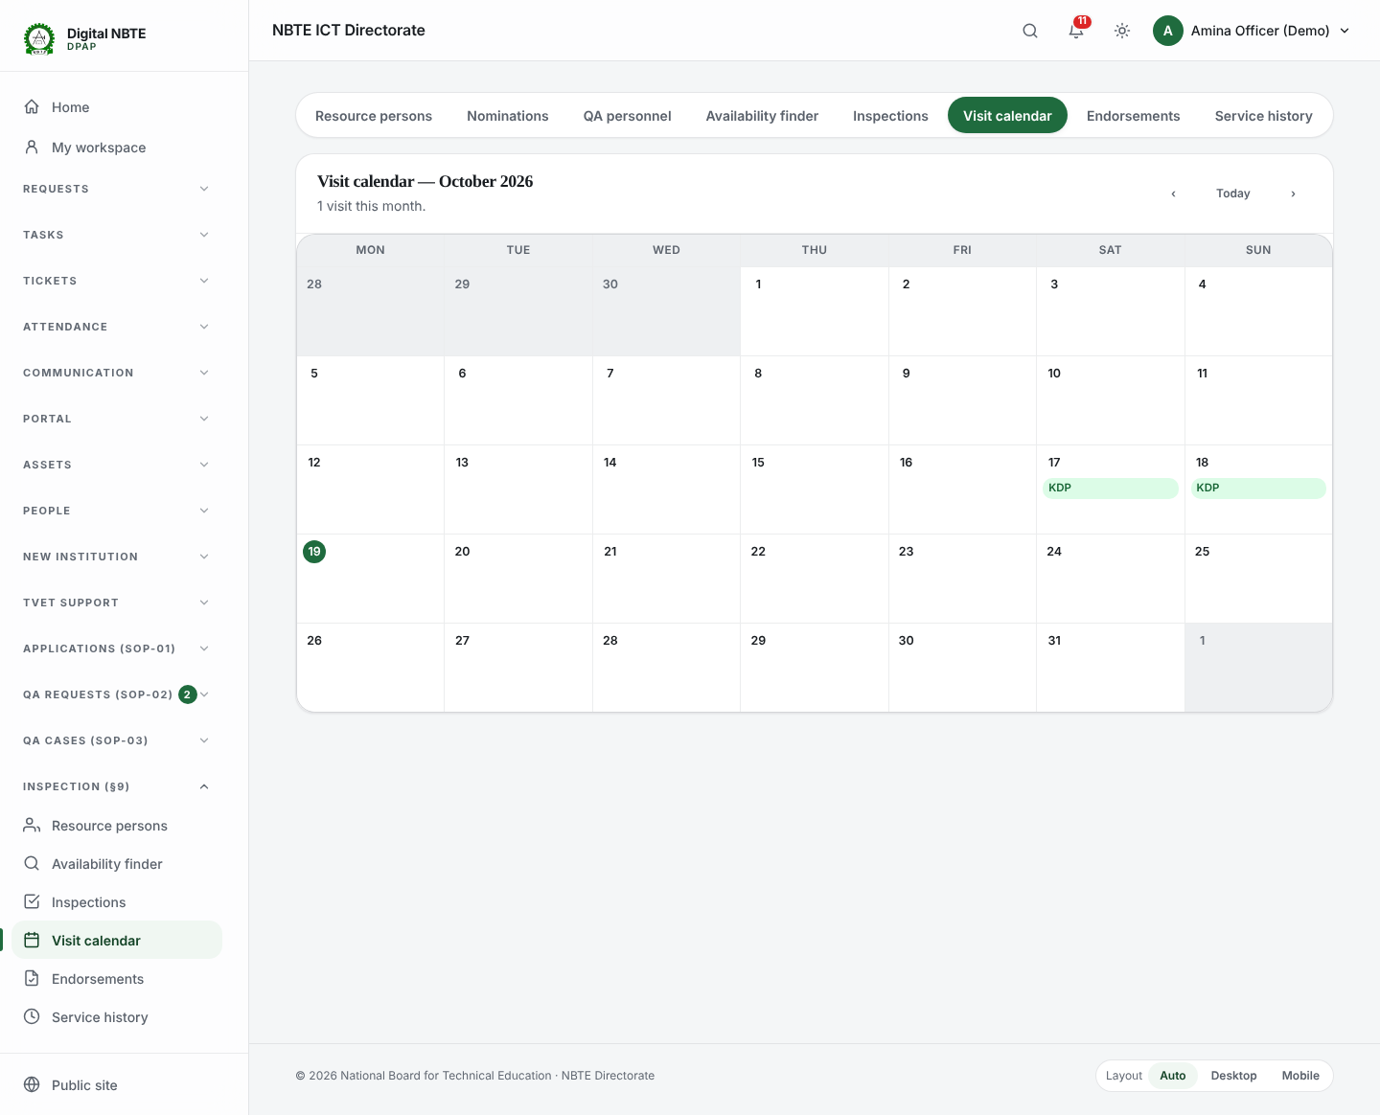
Screenshot 9 — visit calendar

Step 6: Log in as the Team Lead and look at the recorded visit
Sign in as qa.team_lead@demo.nbte.local. The ES's visit approval created the inspection; the demo has already recorded the visit (Mark the visit completed) on the two days before today — earlier than its planned dates, so that you can try stage 12 straight away; in real use the Team Lead records it after the visit. The post-visit personnel list shows who attended. Attendance is the ground truth for allowances and the service history. If it is wrong, the Team Lead uses Override post-visit personnel: a second officer confirms and the service history receives compensating rows.
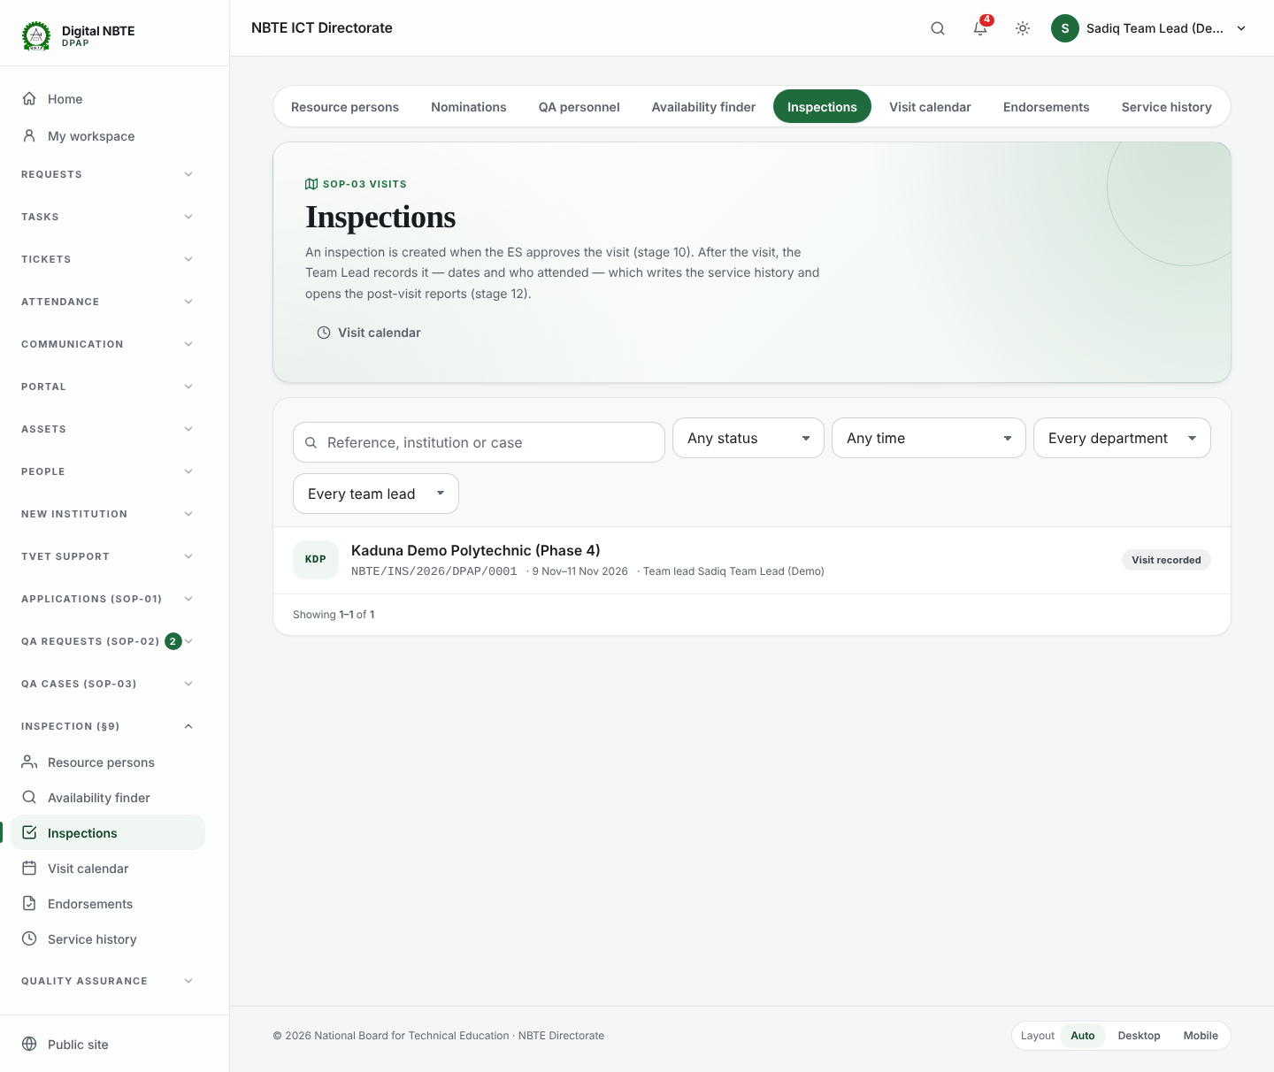
Screenshot 10 — inspections list
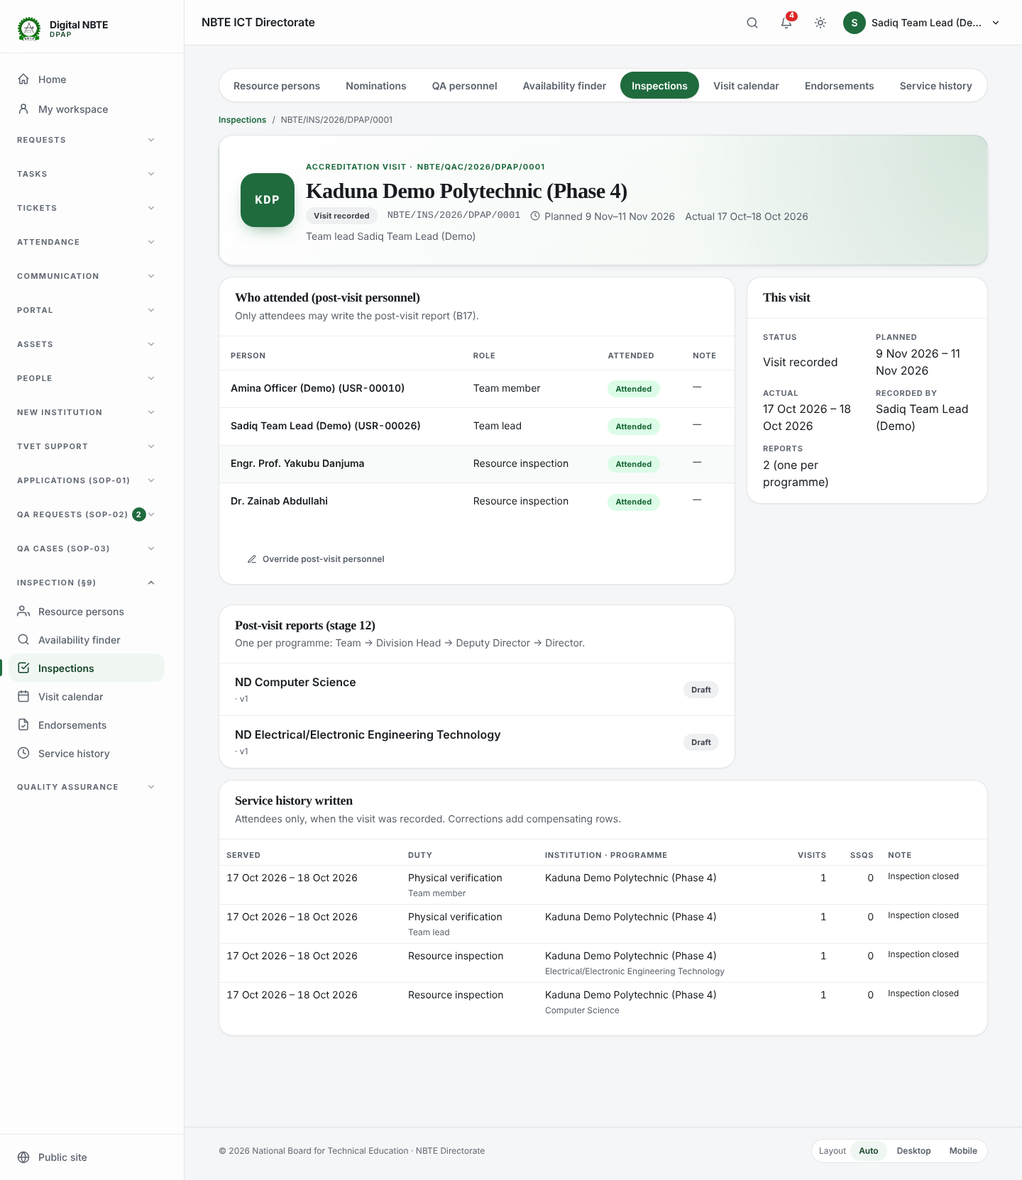
Screenshot 11 — inspection detail attendance
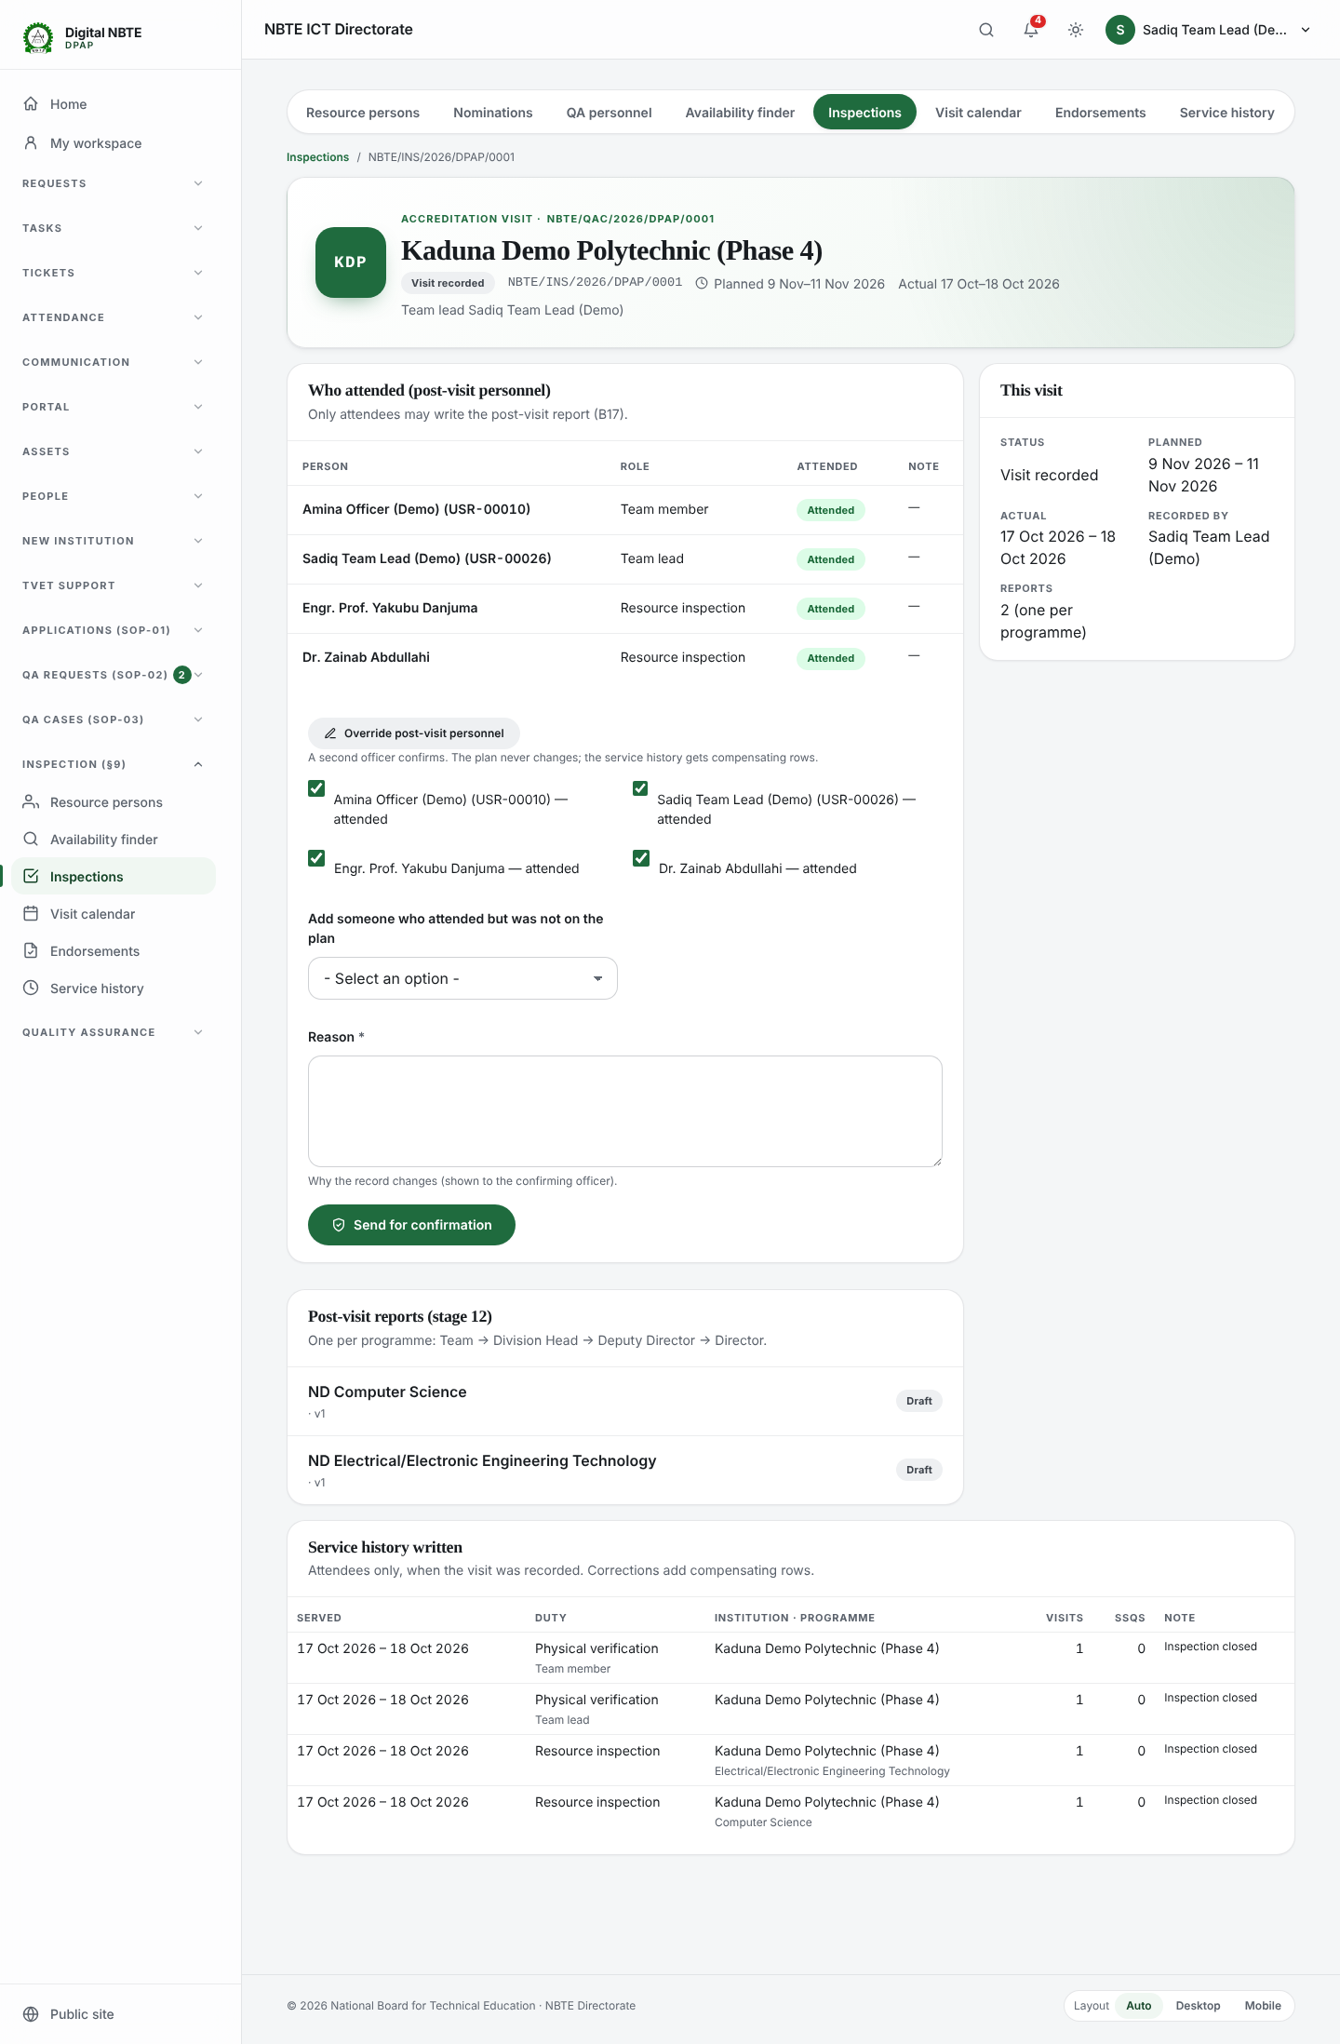
Screenshot 12 — override post visit personnel form

Step 7: Write and submit the post-visit report (verification step 3)
Open the Electrical/Electronic Engineering Technology report. Only people who attended can write it (B17). The engineering resource person's findings, submitted on the portal, are shown for the team. Pressing Submit with an empty summary shows the errors next to the fields. Fill in the sections, the summary and the recommendation, then Submit to the Division Head: the Team Lead's task closes and the Division Head gets one.
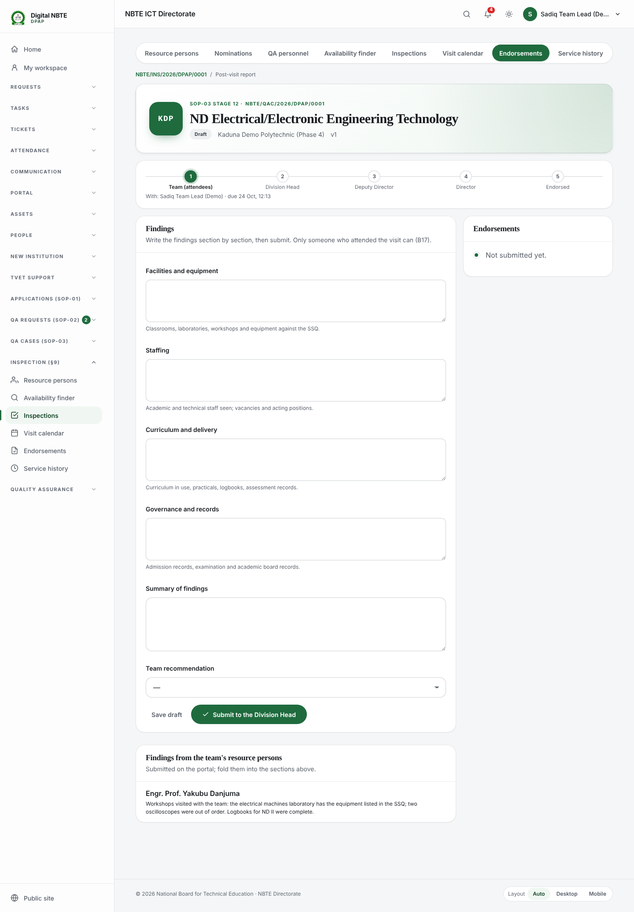
Screenshot 13 — report draft b17 with rp findings
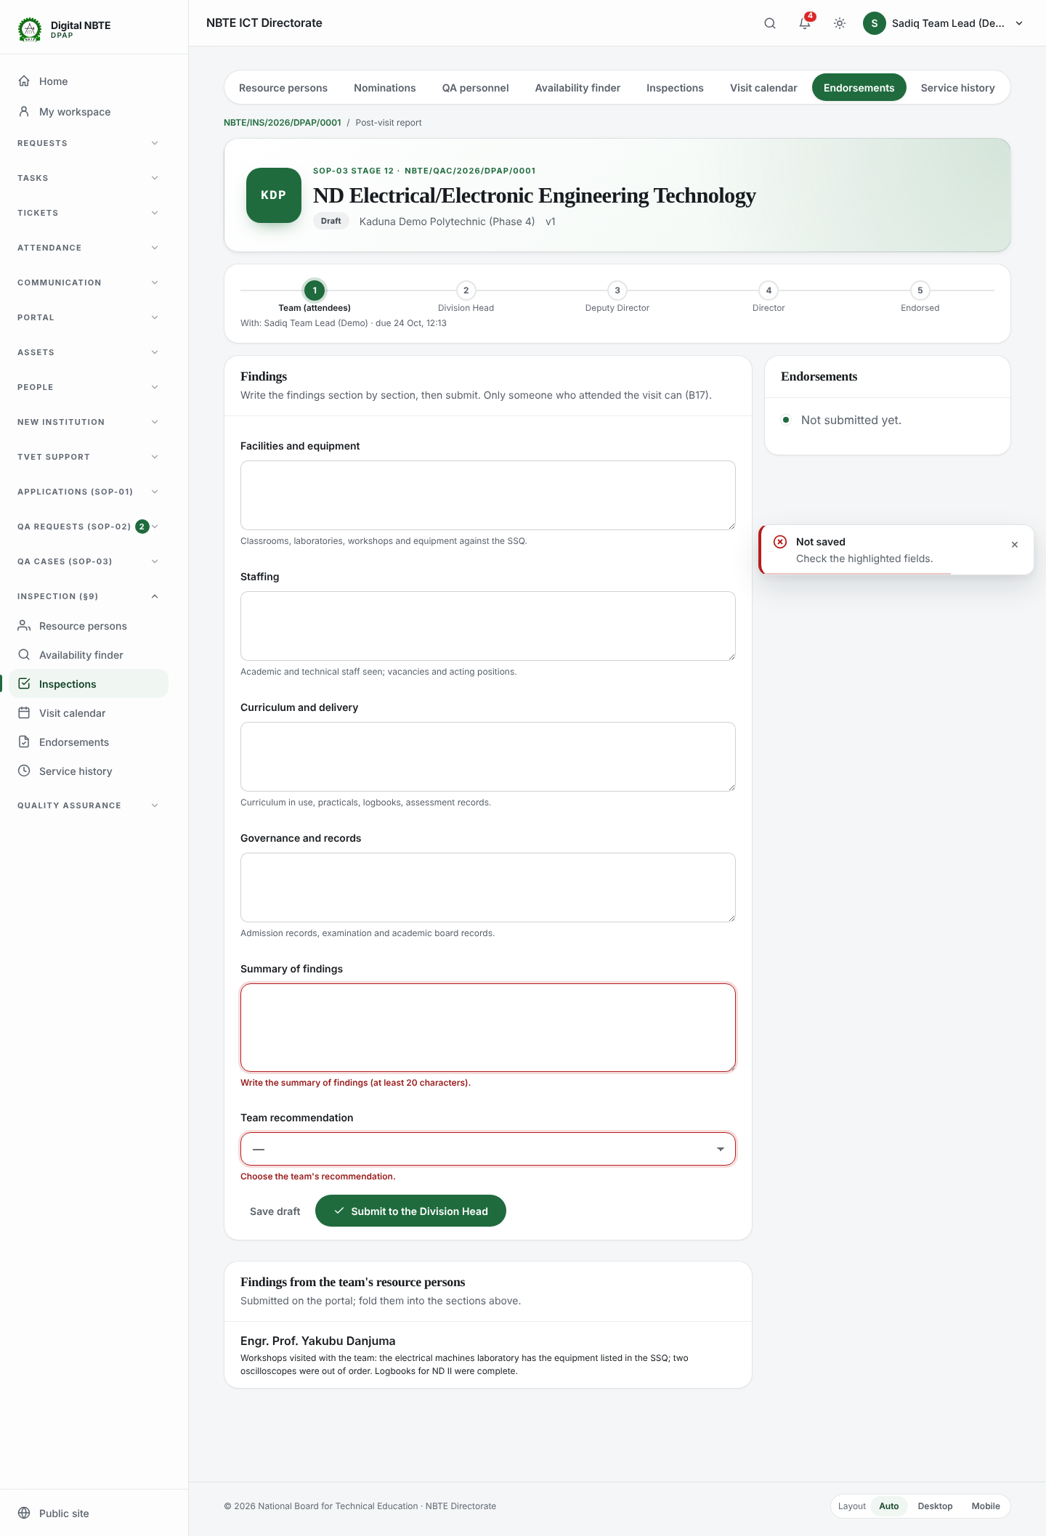
Screenshot 14 — report submit inline errors
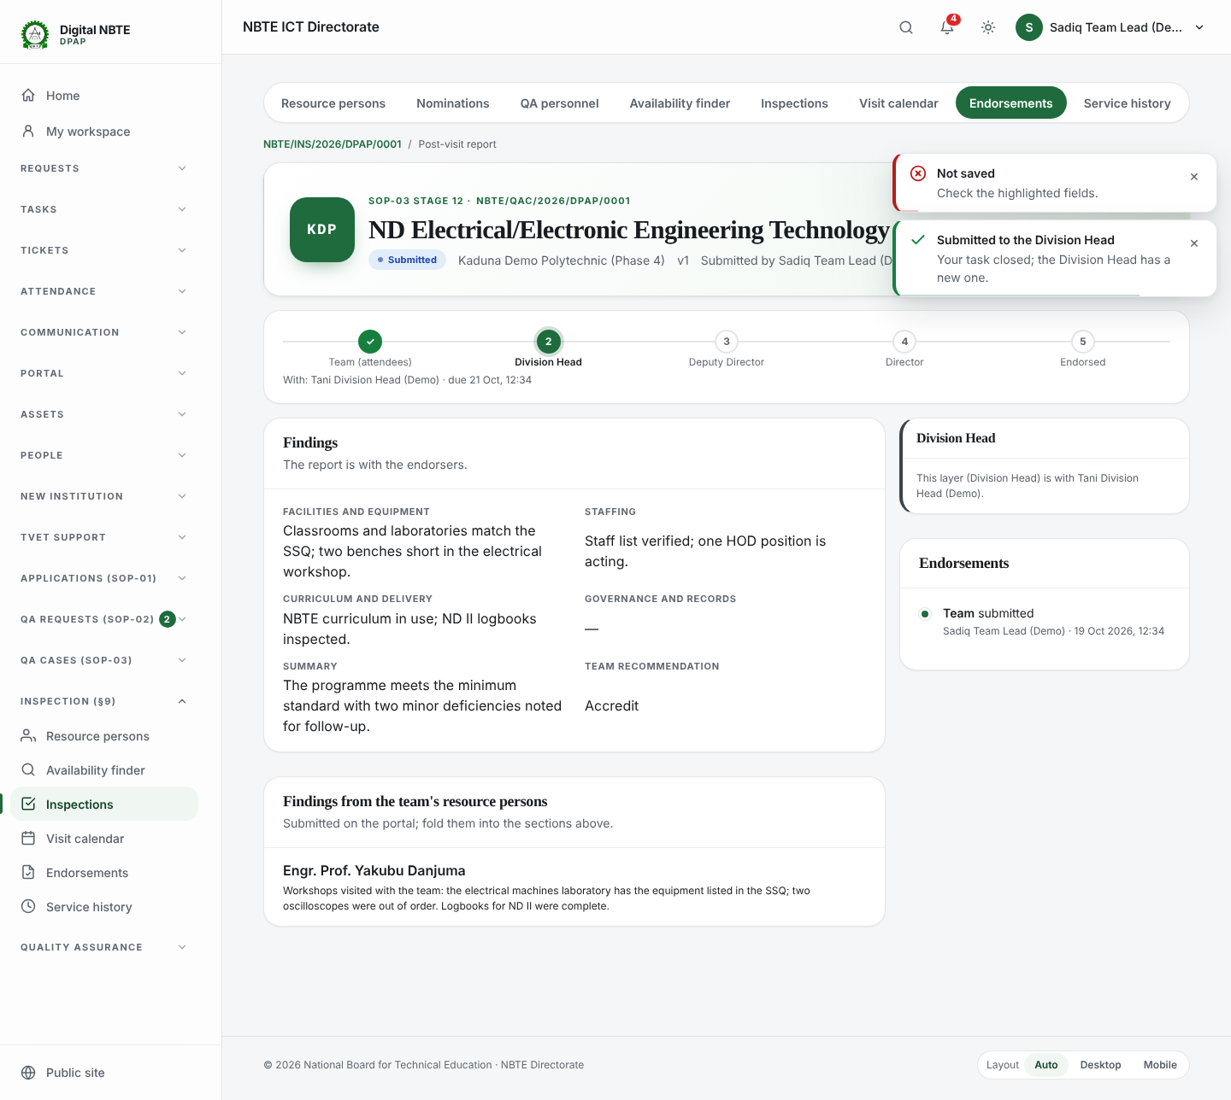
Screenshot 15 — report submitted chain

Step 8: Log in as the Division Head and endorse (verification step 4)
Sign in as qa.division_head@demo.nbte.local. Endorsements → Waiting on me lists the report. Open it, add a comment if you like, and press Endorse. The report moves to the Deputy Director.
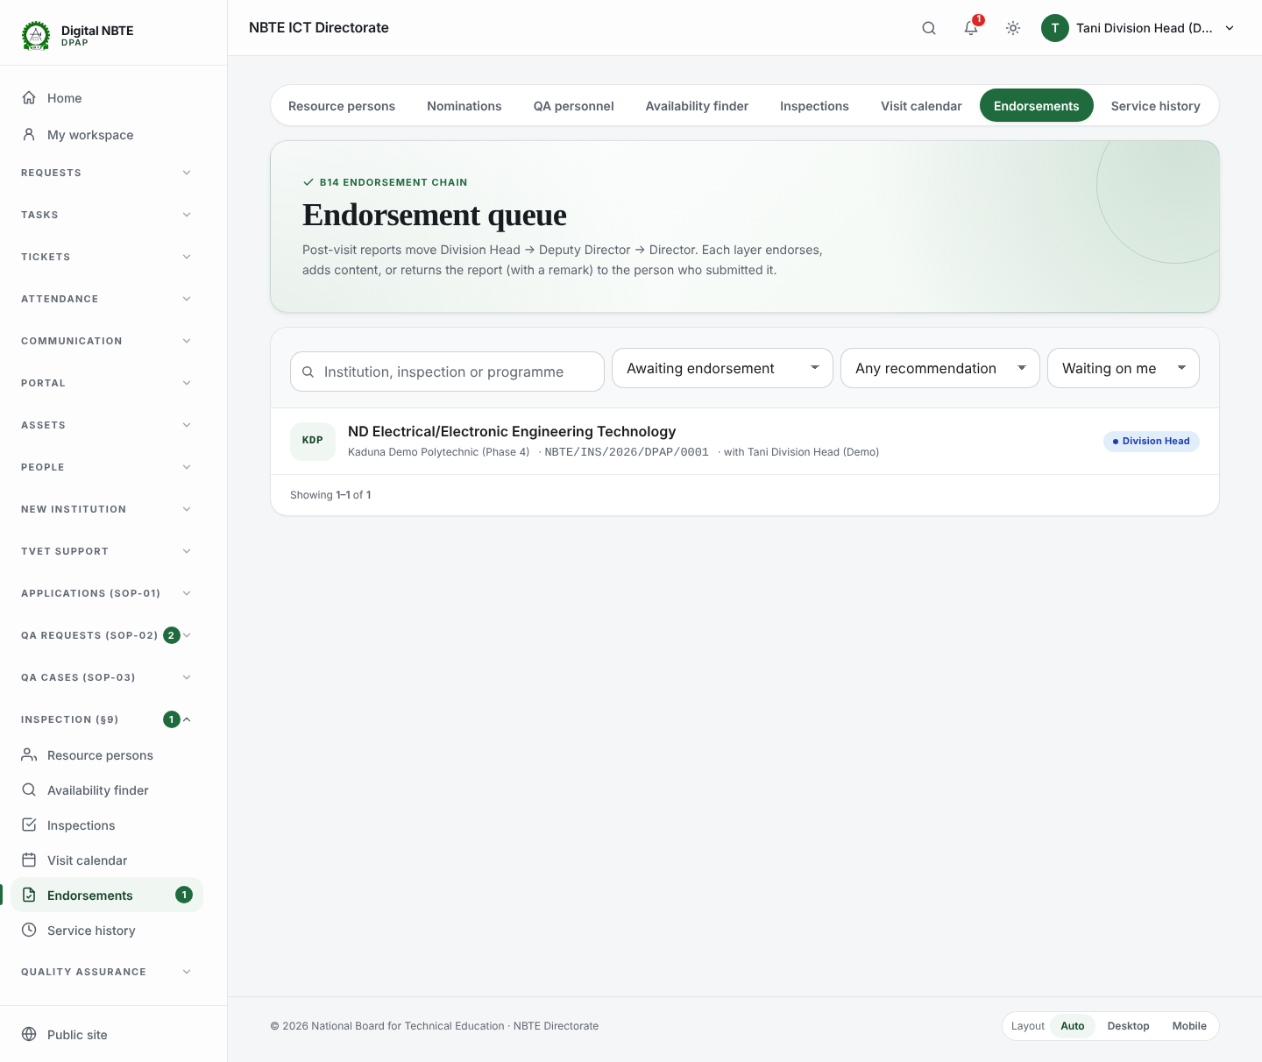
Screenshot 16 — endorsement queue division head
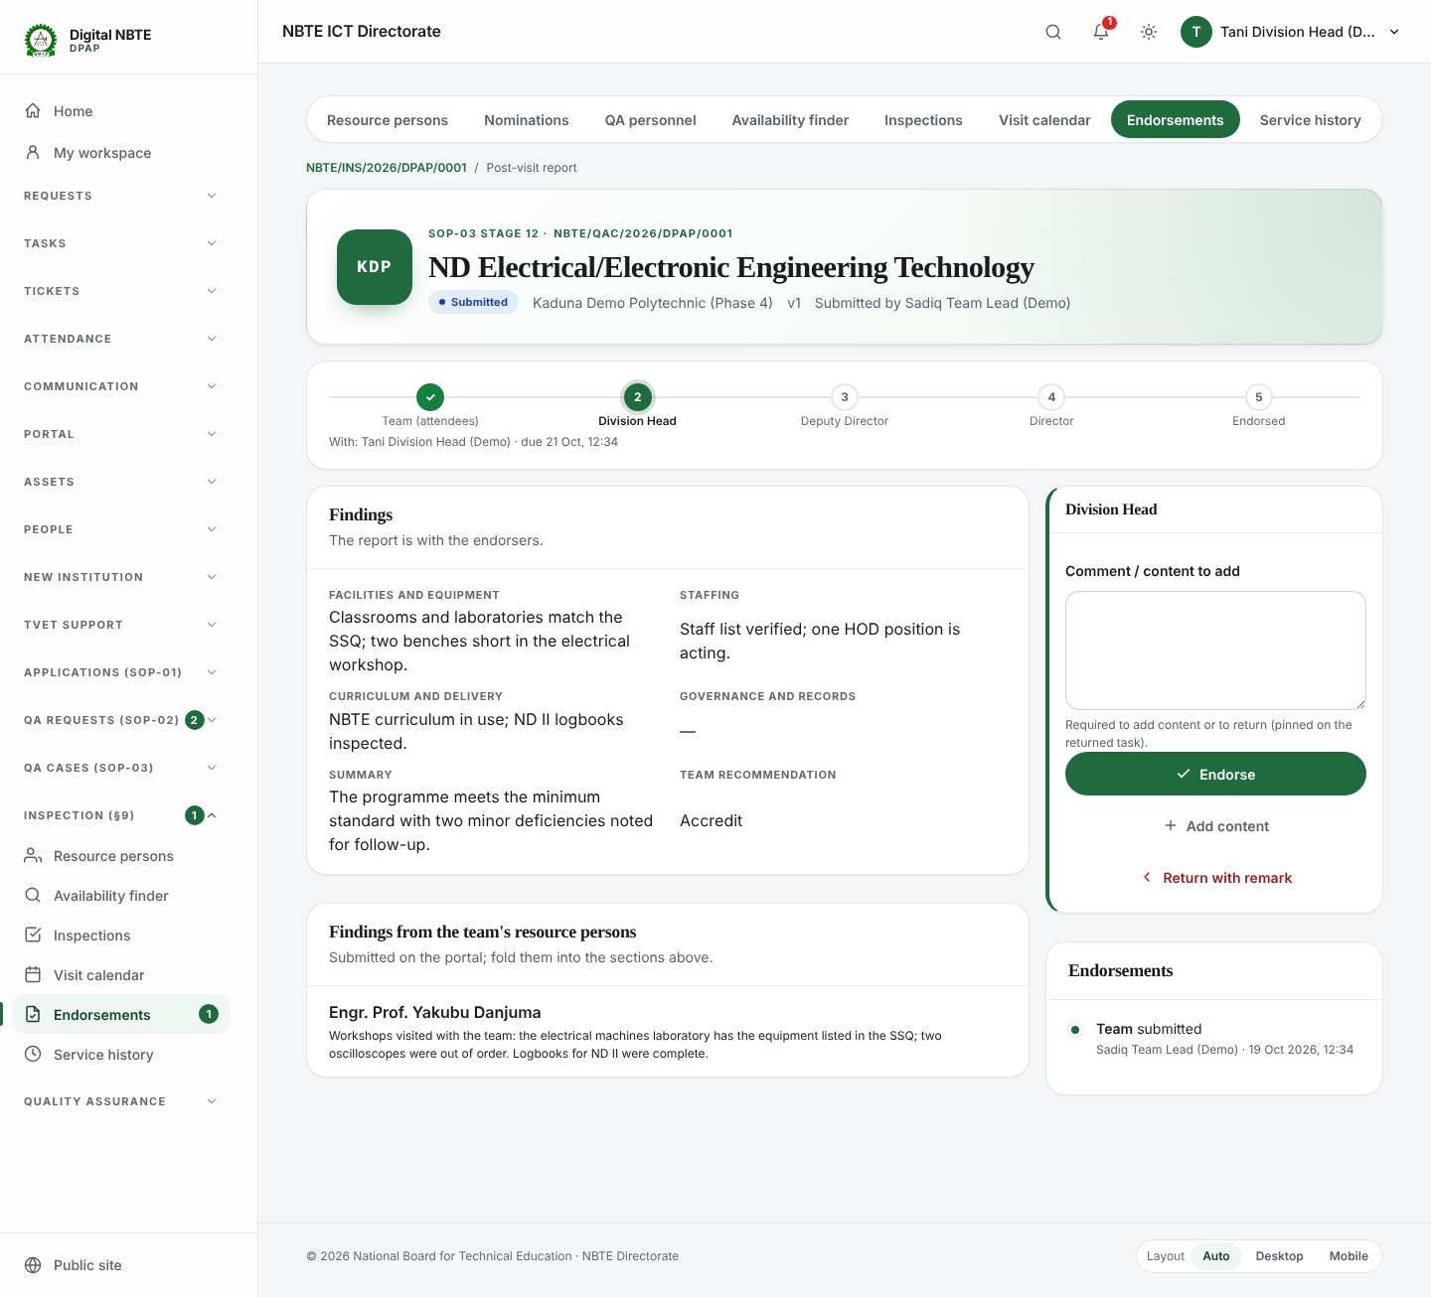
Screenshot 17 — division head endorse panel
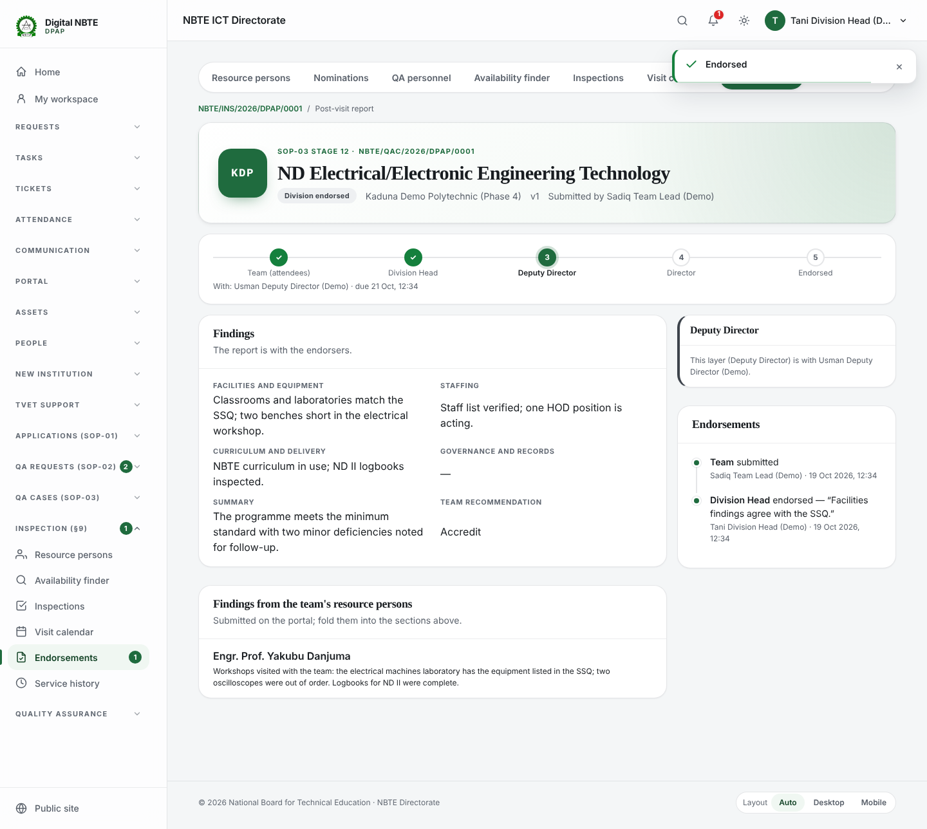
Screenshot 18 — after division head endorsed

Step 9: Log in as the Deputy Director and return with a remark (verification step 5)
Sign in as qa.deputy_director@demo.nbte.local and open the report. Press Return with remark without writing anything: the system refuses and says a return needs a remark. Write the remark and return it: the report goes back to the person who submitted it, with the remark pinned on their task.
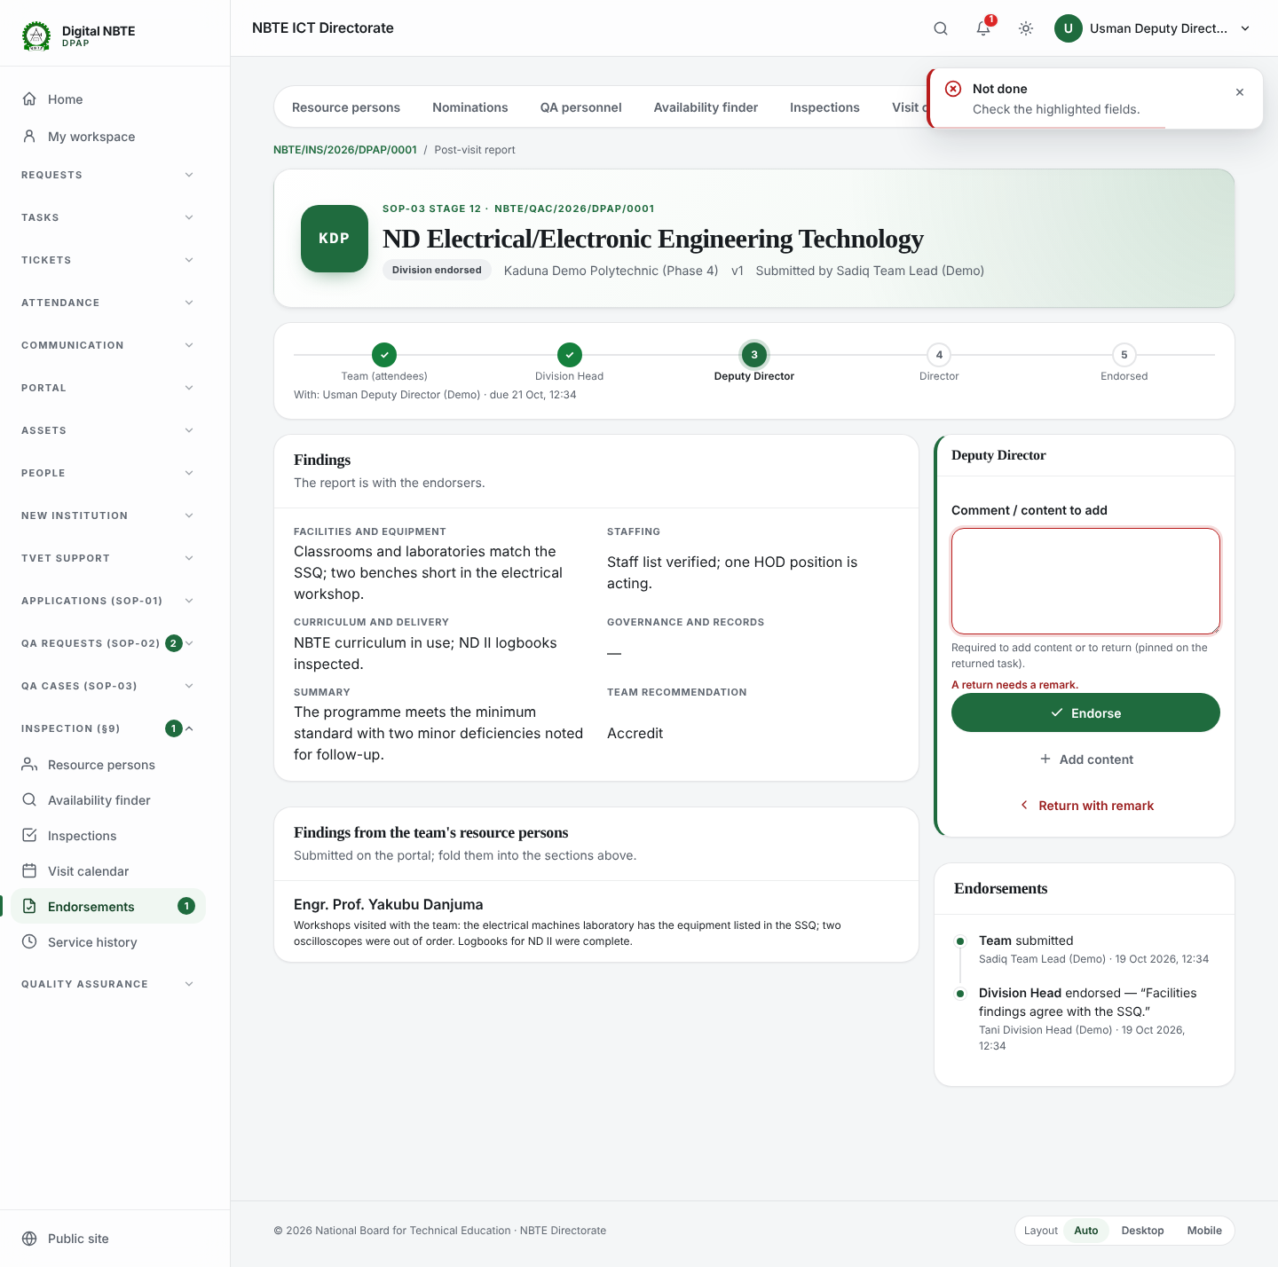
Screenshot 19 — return needs a remark
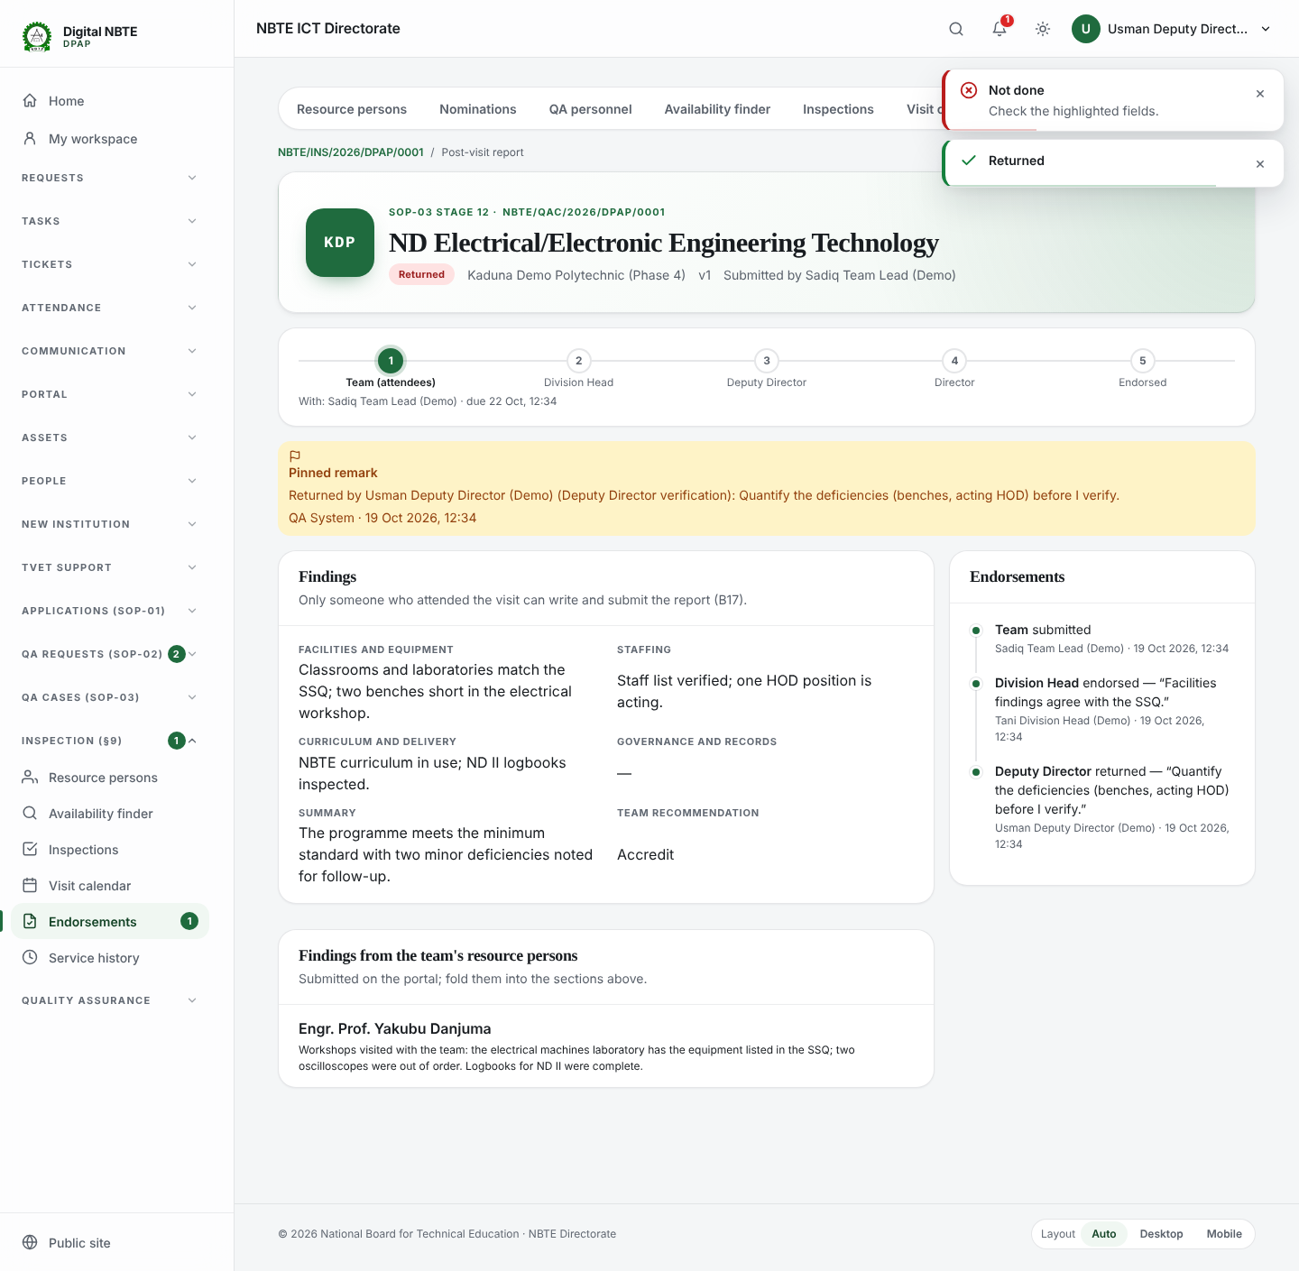
Screenshot 20 — returned to the team lead

Step 10: Log in as the Team Lead, fix and resubmit (verification step 6)
The Team Lead's Tasks inbox has the returned report, marked high priority. Open it: the Deputy Director's remark is pinned above the form. Correct the summary and press Re-submit. The version goes to 2 and the chain starts again at the Division Head.
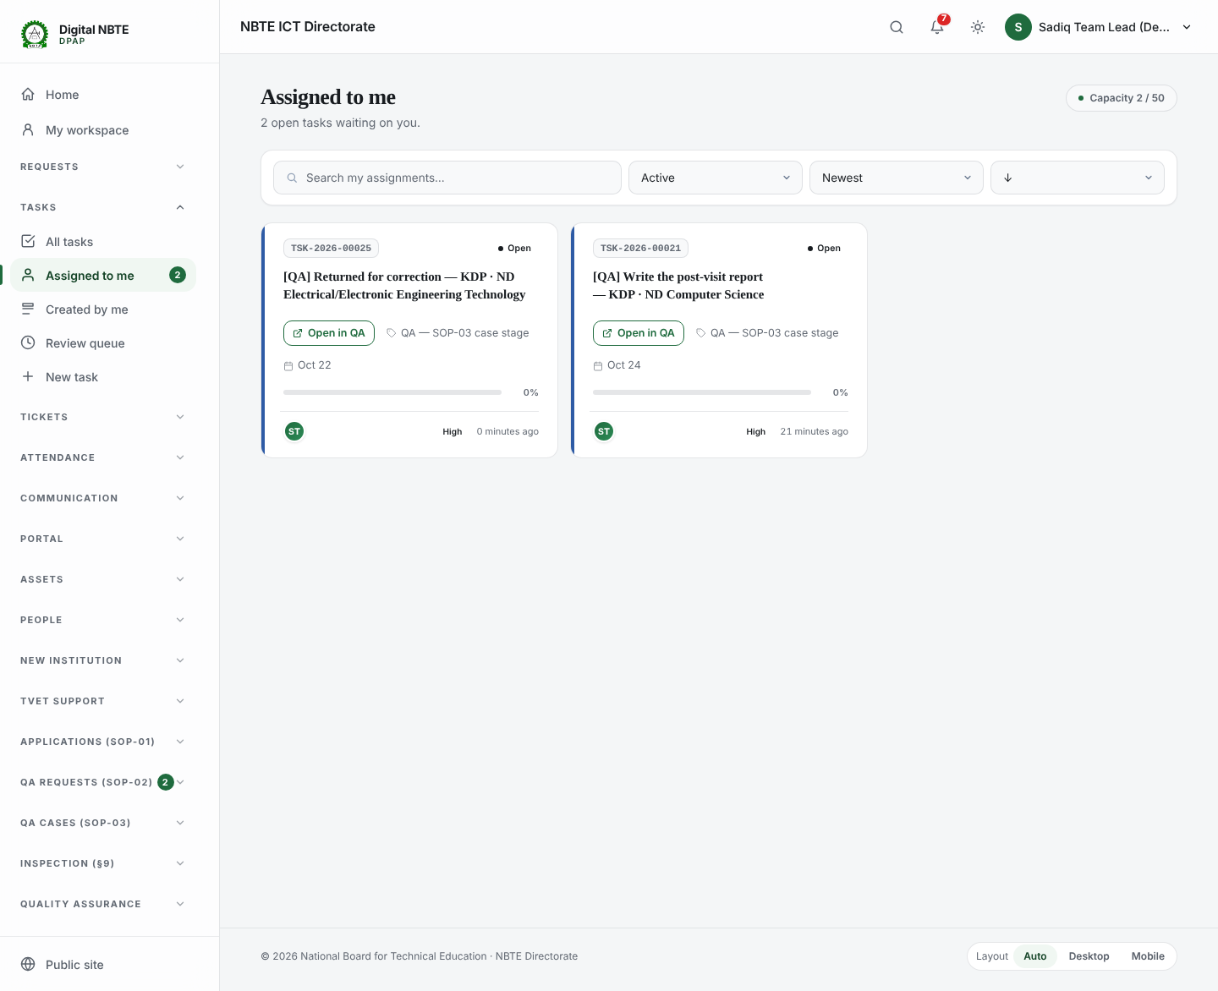
Screenshot 21 — team lead task inbox returned
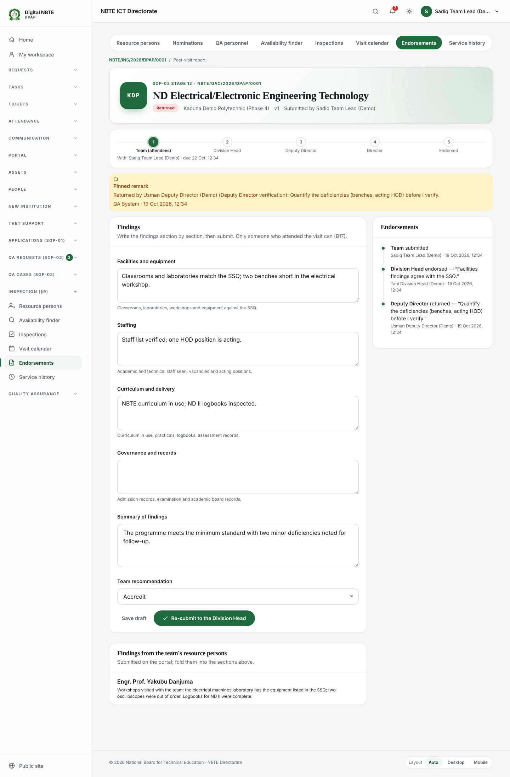
Screenshot 22 — pinned remark on returned report
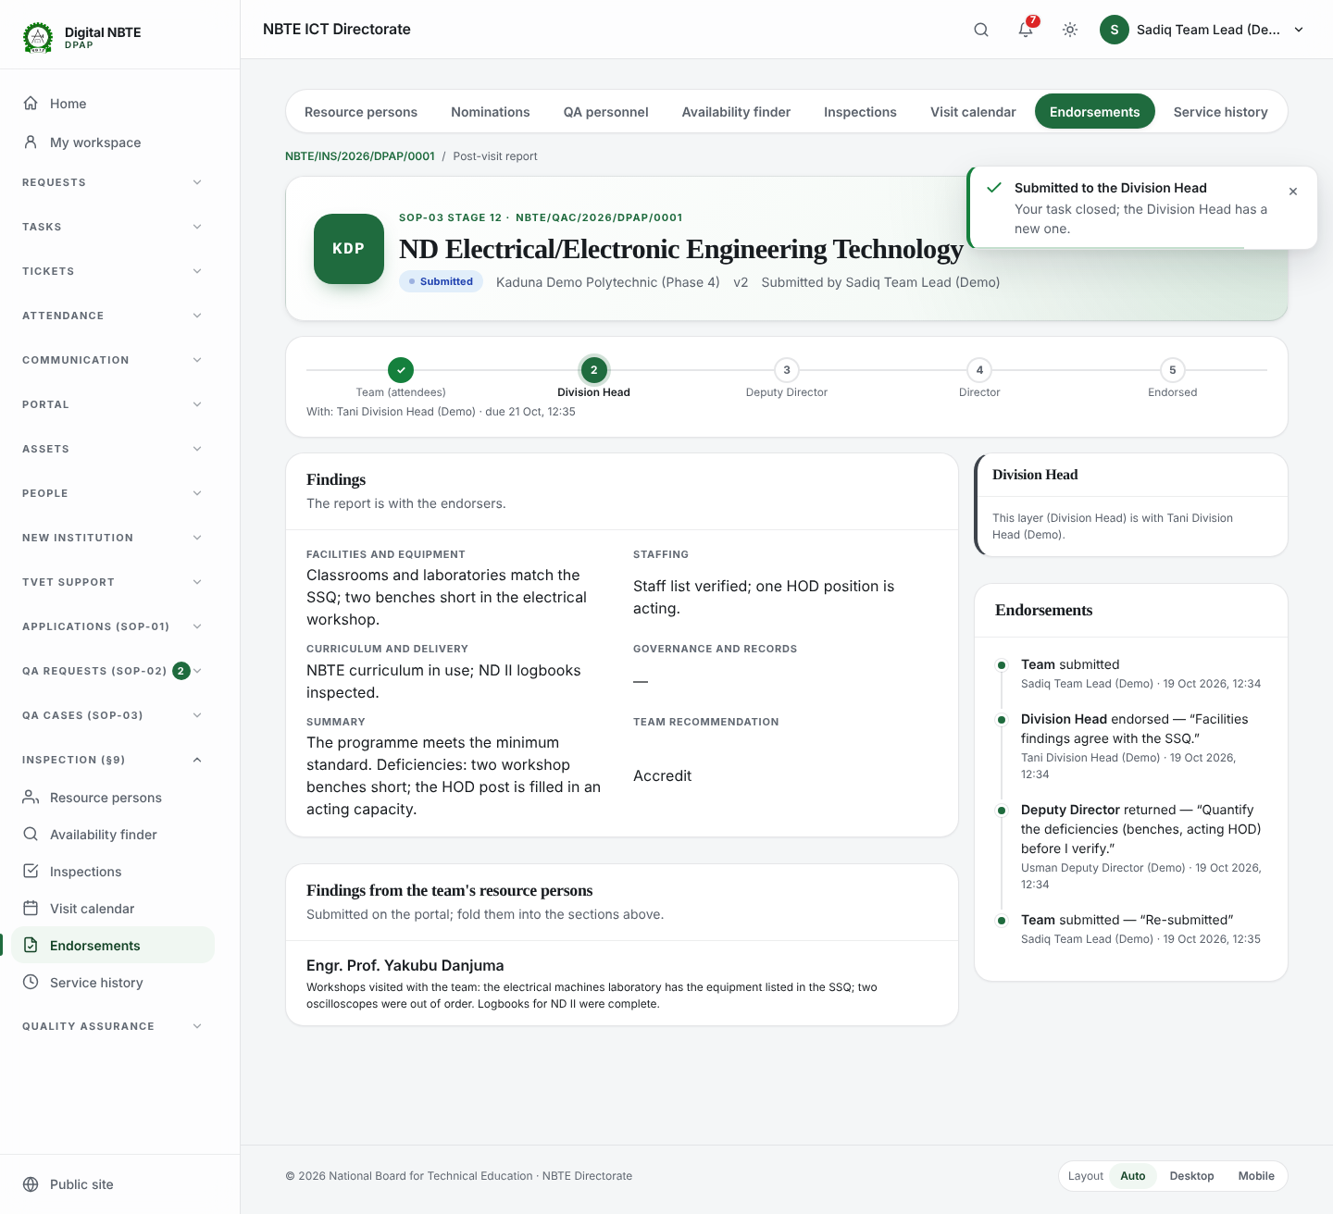
Screenshot 23 — resubmitted version 2

Step 11: The chain completes
The Division Head, the Deputy Director and the Director each endorse. The endorsement history keeps every step, including the return and its remark. When the Director endorses the last programme's report, the case moves to stage 13 on its own.
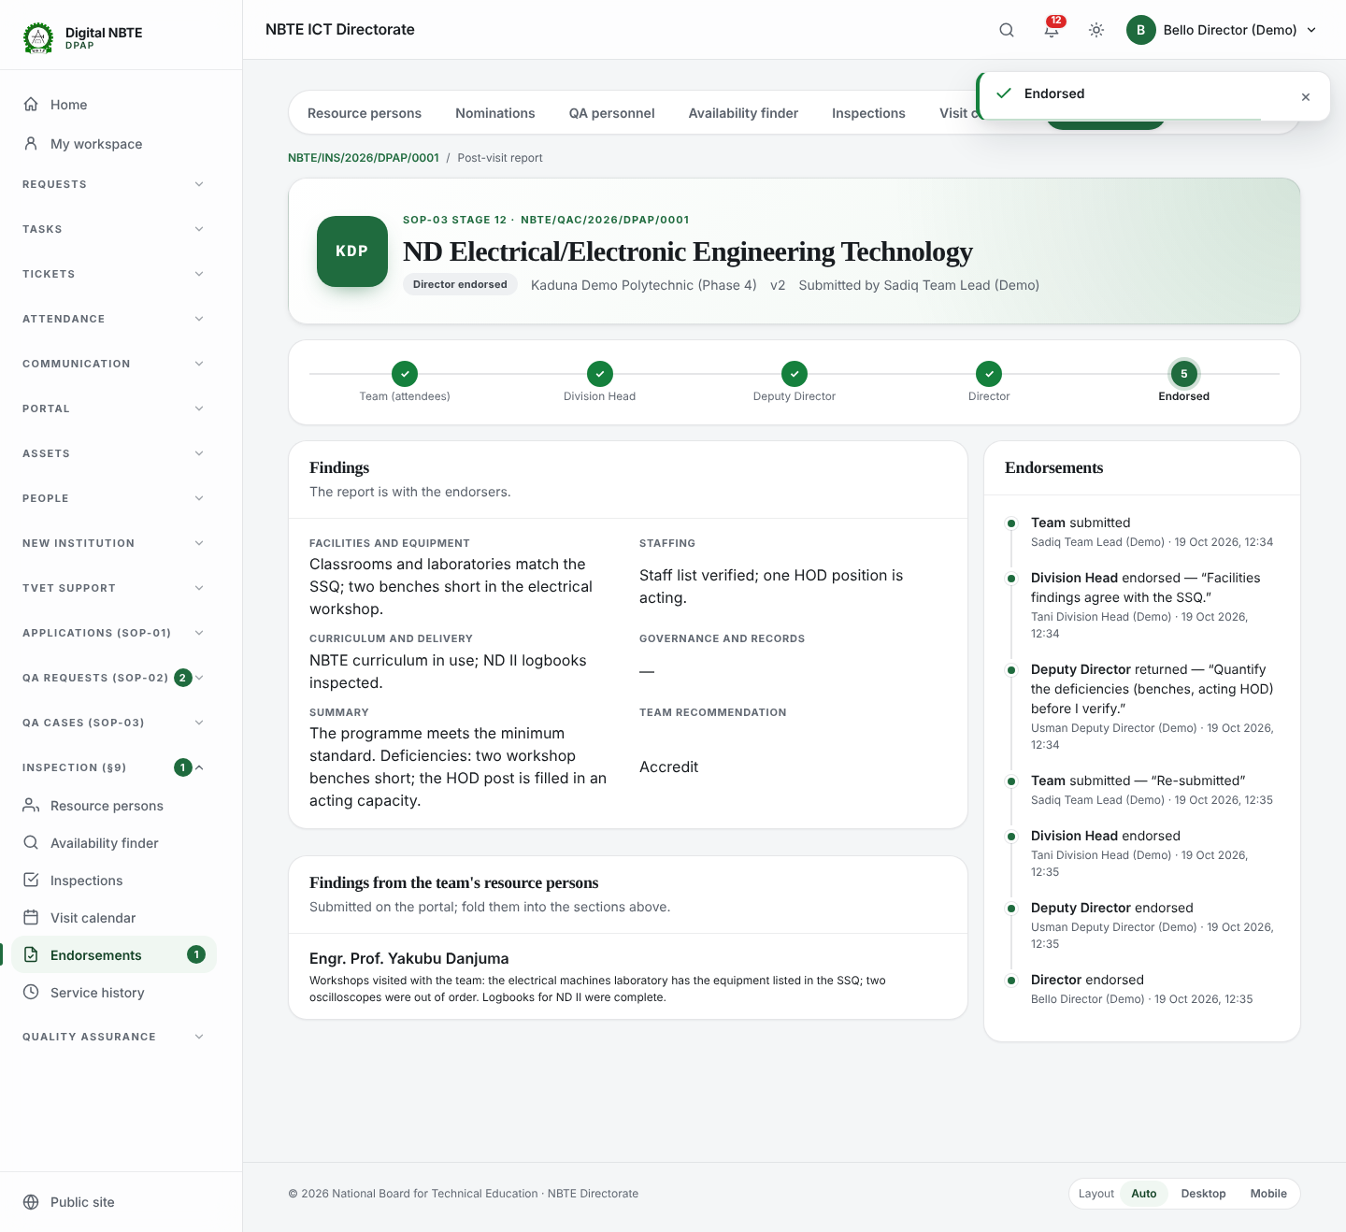
Screenshot 24 — director endorsed history

Step 12: Check the service record (verification step 7)
Open Service history. Every attendee of the visit has a row, written when the visit was recorded; filter by person (Yakubu), institution, programme, discipline, duty or dates, and export to Excel. Rows are never edited or deleted: a corrected attendance adds a compensating row. The case's Reports tab shows each report's place in the chain and, at stage 13, the Director's recommendation form per programme.
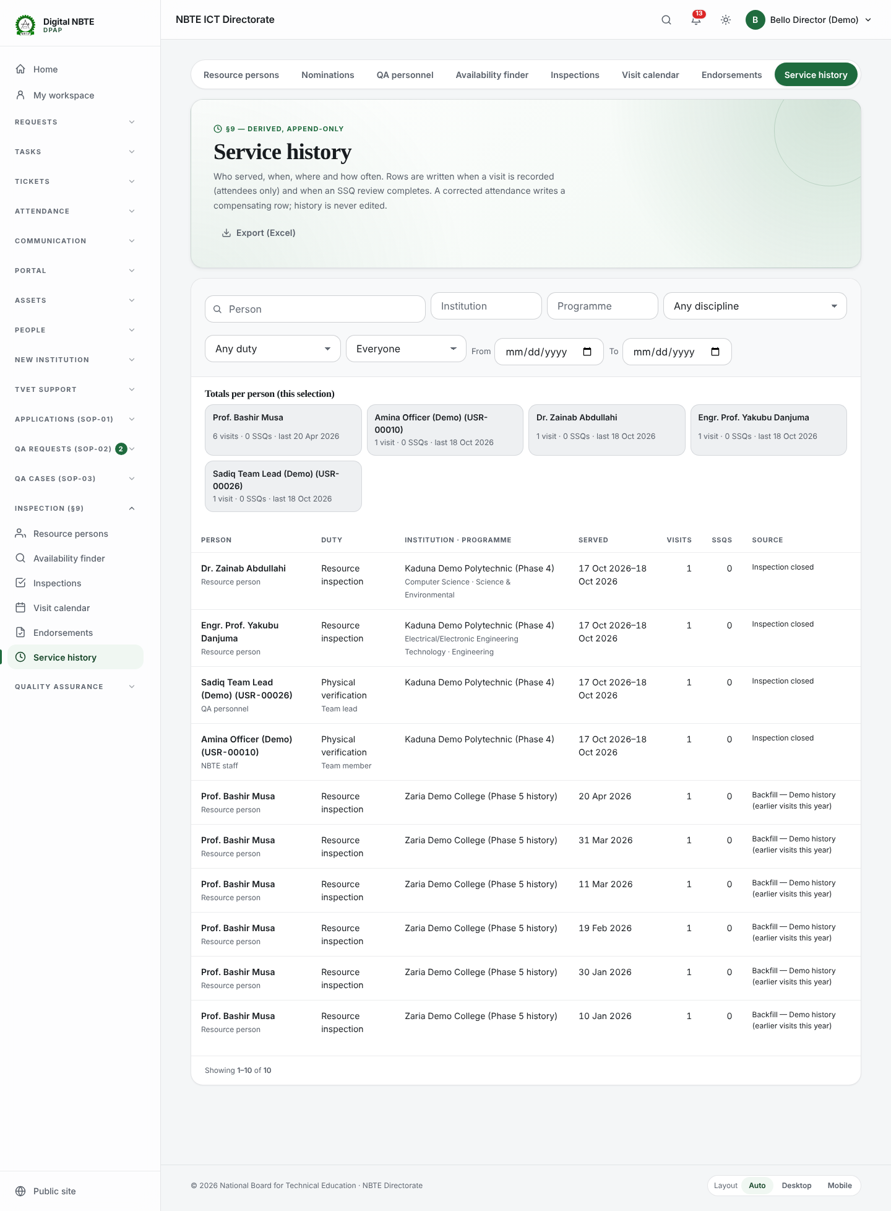
Screenshot 25 — service history
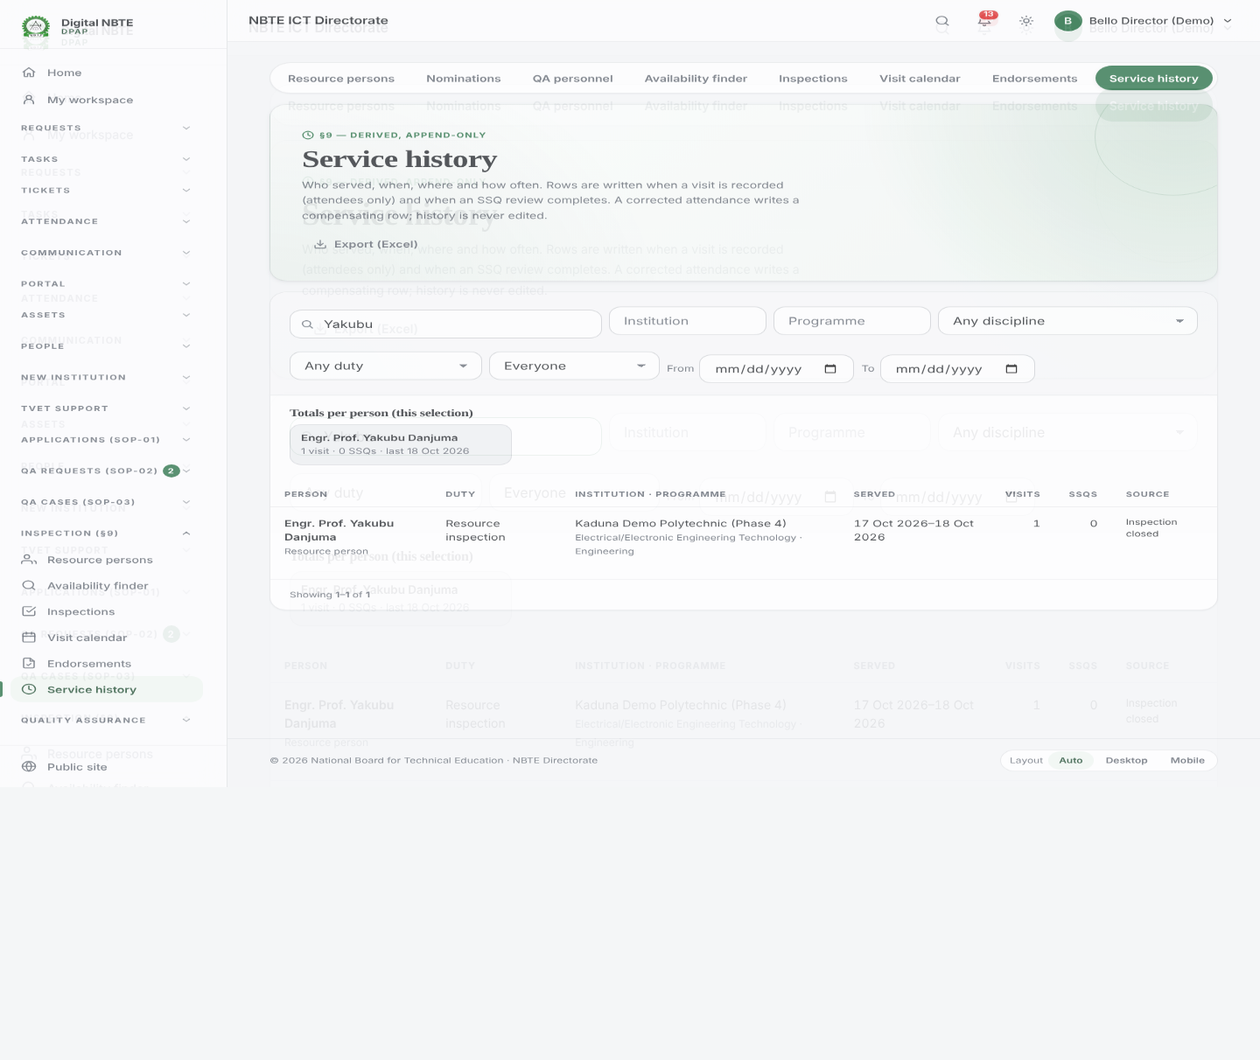
Screenshot 26 — service history filtered person
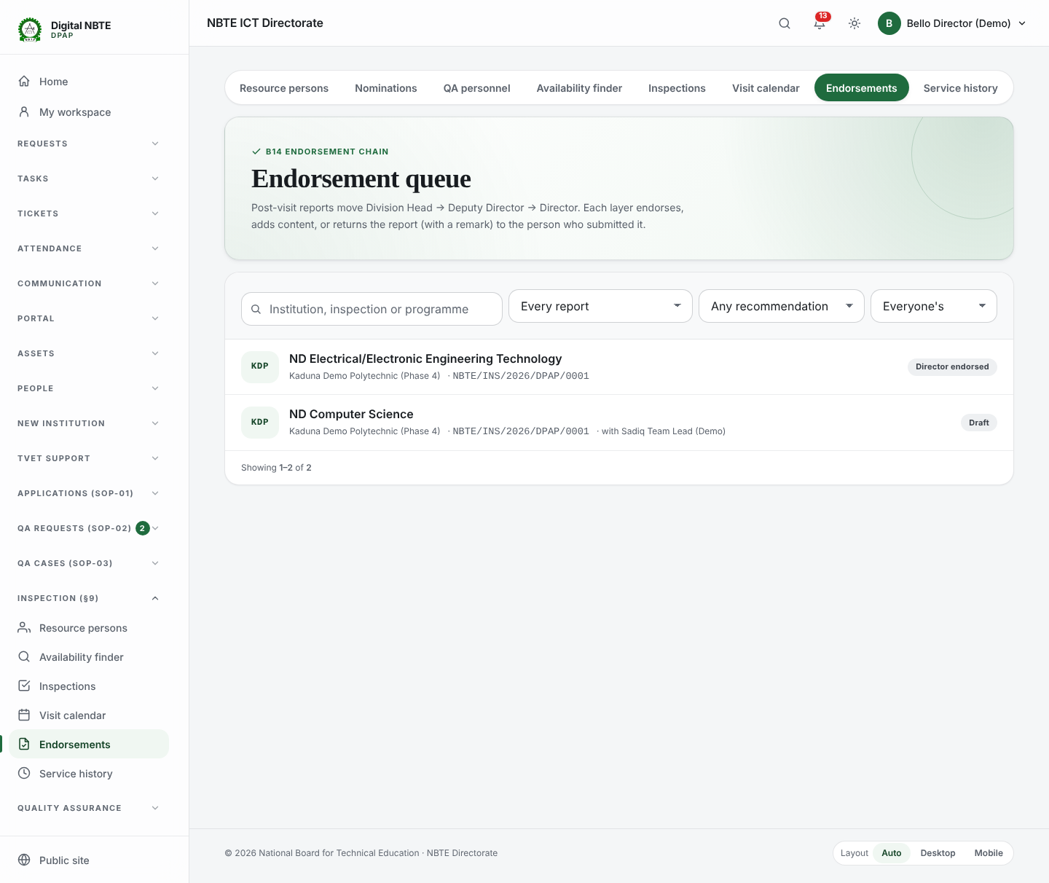
Screenshot 27 — endorsements all reports
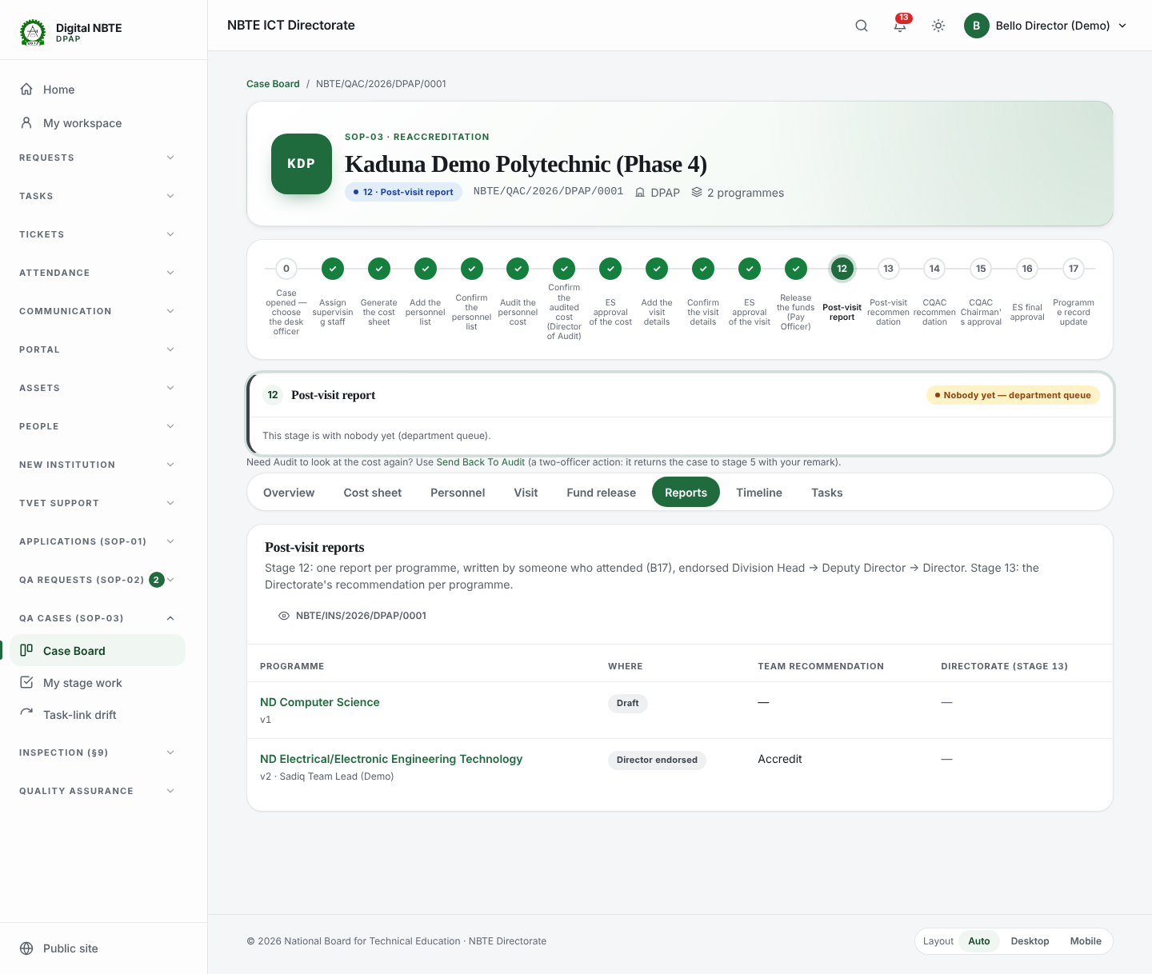
Screenshot 28 — case reports tab

Step 13: The resource person's portal and the institution's view
On the QA portal, rp.yakubu@demo.nbte.local sees My engagements (with the findings form), the service history and Profile & CV. The institution's admin (admin@p4demo.local) sees a read-only list of its inspections.
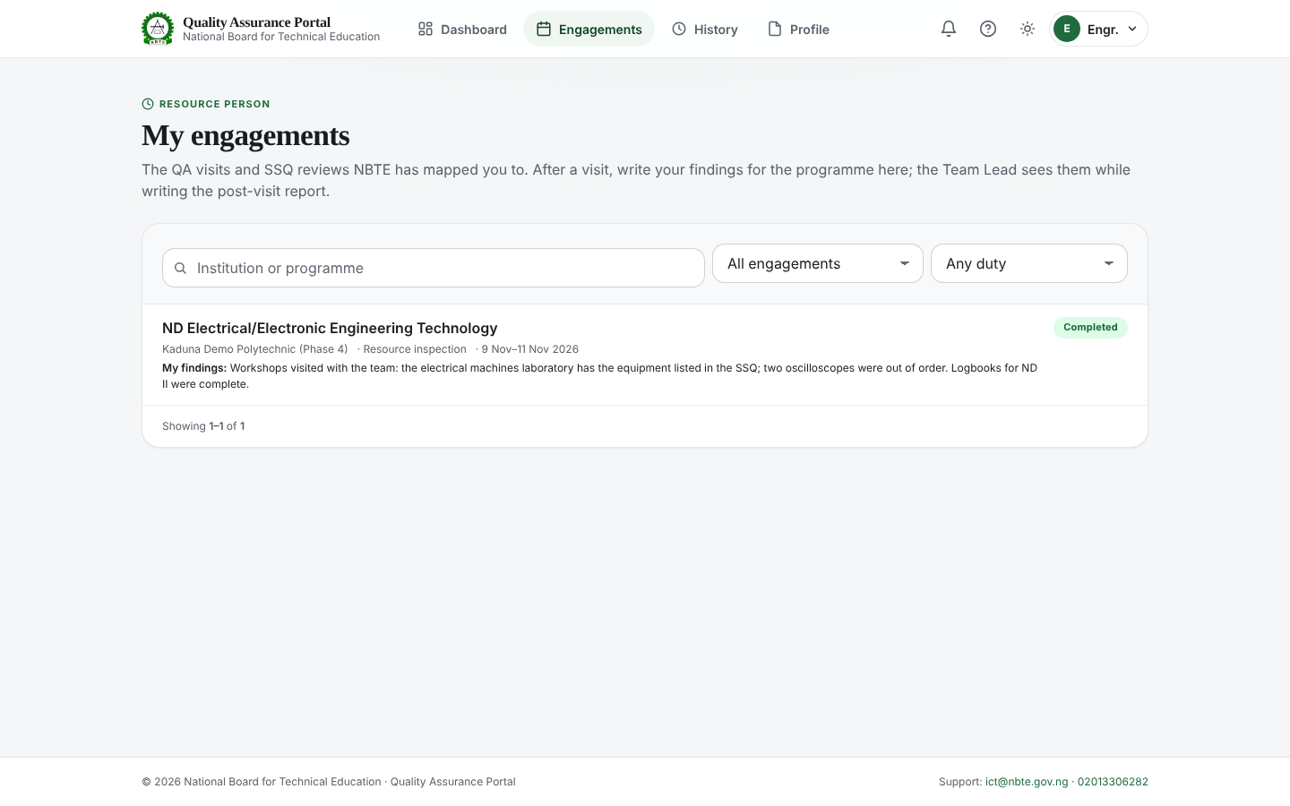
Screenshot 29 — portal rp engagements
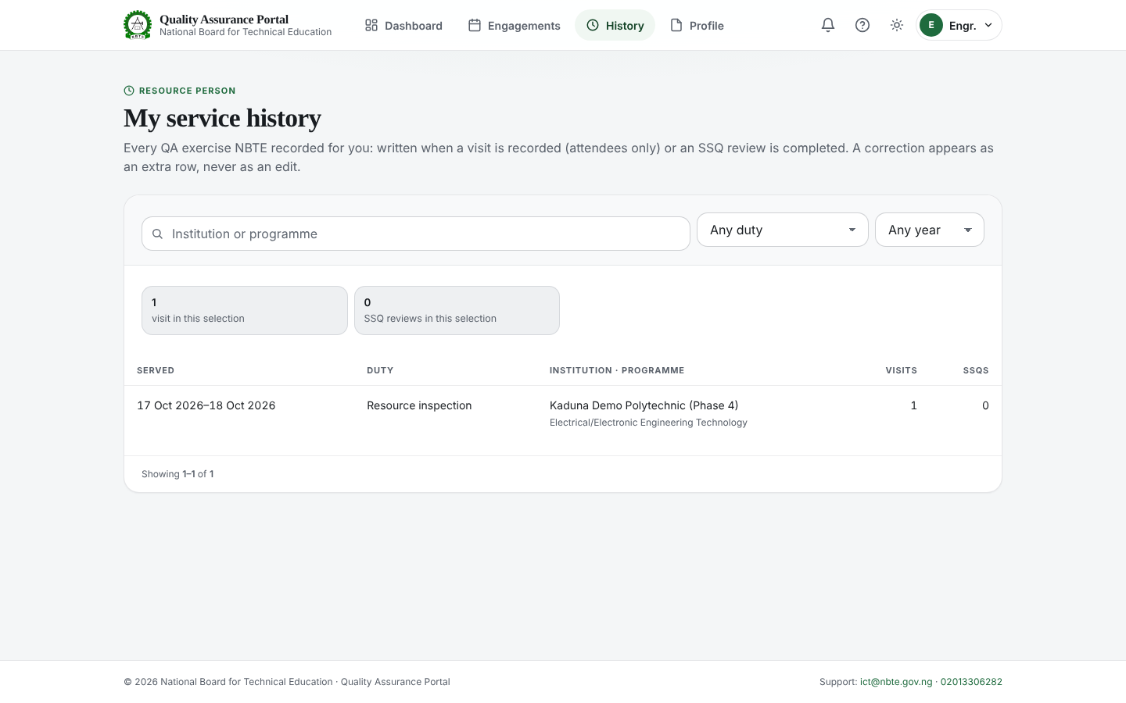
Screenshot 30 — portal rp service history
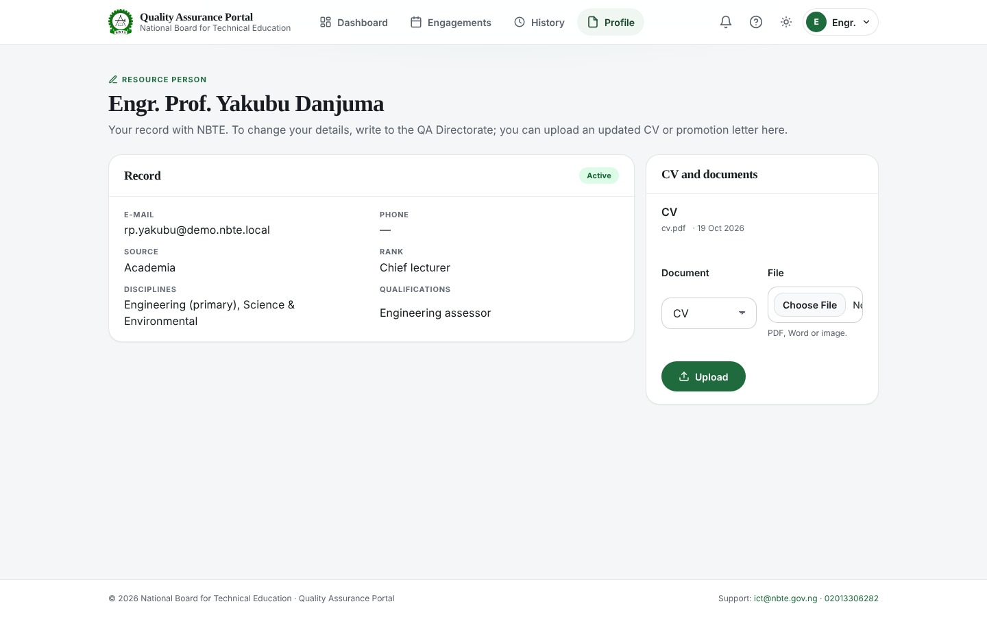
Screenshot 31 — portal rp profile cv
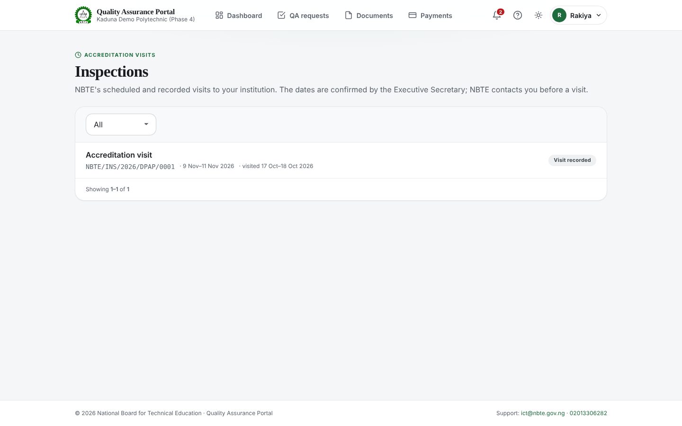
Screenshot 32 — portal institution inspections

Step 14: On a phone
Every Phase 5 screen works at phone width: the report form stacks, and the calendar becomes a list.
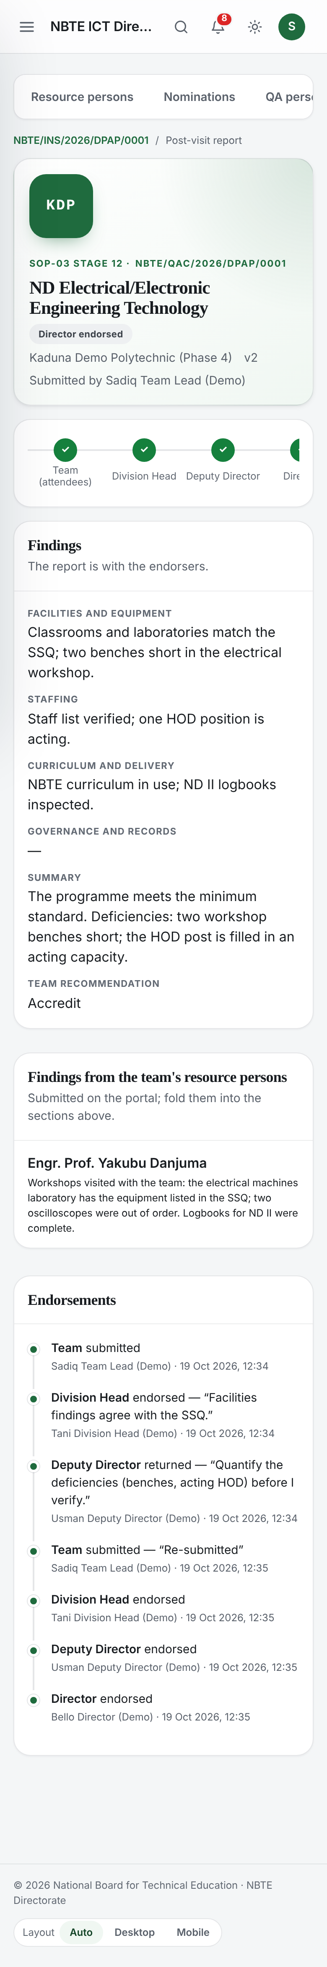
Screenshot 33 — mobile report
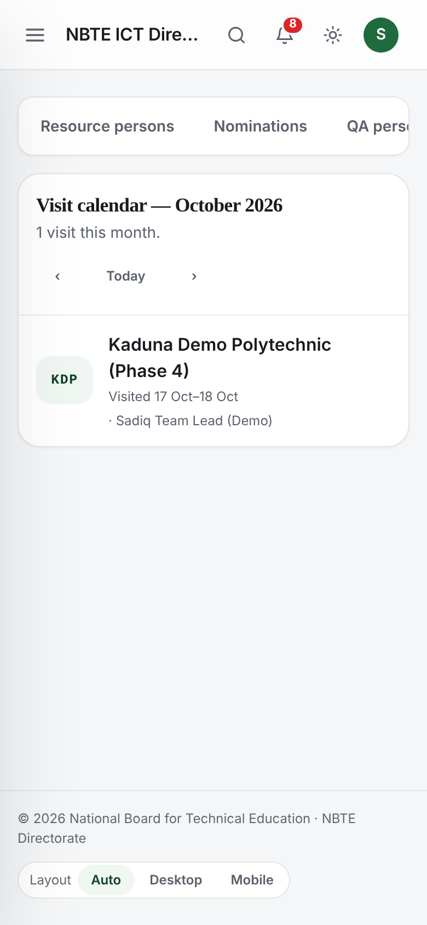
Screenshot 34 — mobile calendar list

5. Interactive verification checklist
# | Check | How | Expected
1 | Migrate | python manage.py migrate (after backing up db.sqlite3) | Two migrations applied
2 | Seed | python manage.py seed_phase5_demo | Case at stage 12, visit recorded, two reports in draft
3 | Team Lead submits the report | Steps 6–7 | Report submitted; Division Head has the task
4 | Division Head endorses | Step 8 | Report with the Deputy Director
5 | Deputy Director returns with a remark | Step 9 | Empty remark refused; with a remark → returned to the Team Lead, remark pinned
6 | Team Lead fixes and resubmits | Step 10 | Version 2, back with the Division Head
7 | Check the service record | Step 12 | A row per attendee; compensating rows for corrections

Appendix A — Master Plan references
Links open the Master Plan v1.1 (MASTER_PLAN.md in NBTE-QA-MasterPlan-v1.1-20261016) at the section this phase implements.
- §5.5 inspection (data model) — ResourcePerson, QAPersonnel, QAMapping, Inspection, InspectionTeamMember, PostVisitPersonnel, PostVisitReport, ReportEndorsement, ServiceRecord, SSQReviewAssignment
- §7 Two-step confirmation pattern — Edit QA Personnel, Edit QA Mapping, Override Post-Visit Personnel
- §8 Task bounce — Report tasks per endorsement layer; returns to the submitter; reconciliation
- §9 Resource-person and SSQ tracking — Service history, the Available-for-the-next-visit picker, double-booking enforcement
- §9 Eligibility rules (v1.1) — The seven rules, no manual override, falling below later
- §14 Dynamic settings catalogue — qa.resource_person.*, qa.matching.*
- §20 Interaction contract — Search, filters, 25-row pages, Show all, HTMX, skeletons
- PHASES.md — Phase 5 — Scope of this phase

Appendix B — Settings used by Phase 5
Setting | Default | What it controls
qa.resource_person.min_rank | director | Rule 1 — minimum role rank for NBTE staff
qa.resource_person.required_designations | director, deputy-director, chief-lecturer, principal-lecturer | Rule 2 — allowed designations / rank codes
qa.resource_person.max_active_engagements | 2 | Rule 3 — live mappings (all one programme, R-11)
qa.resource_person.max_open_ssq_per_officer | 3 | Rule 4 — open SSQ reviews (R-01)
qa.resource_person.max_visits_per_year | 6 | Rule 5 — annual visit cap
qa.institution.admin_required_department | any | Rule 6 — Institutional Admin's department
qa.institution.chief_executive_required_position | true | Rule 7 — Chief Executive is the head
qa.matching.travel_buffer_days | 2 | Days kept free before and after a visit
qa.matching.same_institution_cooldown_months | 24 | Cooldown before serving the same institution again
qa.matching.allow_secondary_discipline | false | Secondary disciplines count in the finder
qa.matching.rank_score | formula | Finder ranking (fewest visits, longest since served, rating)

Change them in Settings → QA settings. Changing a setting is audited and is the only way to change who qualifies; there is no override.

Appendix C — Automated tests
File | What it proves
inspection/tests/test_eligibility.py | The seven §9 rules at nomination and assignment; no override; vetting; nightly list of people no longer eligible
inspection/tests/test_availability.py | Every finder filter, ranking, the finder screen, two officers with the same view, two threads booking at once, re-check at confirmation
inspection/tests/test_reports.py | Inspection from the ES approval, visit record, B17, submit validation, the endorsement chain with return + remark, stage 12 → 13, stage 13 recommendation and return, compensating service rows, screens, ICT monitor read-only, the resource-person portal
accreditation/tests/test_sop03.py | Phase 4's 17-stage walks, updated for the new stage 12

Appendix D — Delivery documents
- PHASE5_CHANGELOG.md
- PHASE5_MIGRATIONS.md
- PHASE5_TEST_PLAN.md
- PHASE5_DEMO_CREDENTIALS.md
- PHASE5_DONE.md
- PHASE5_UI_SCREENSHOTS/

