Medical Image Classification with Deep Learning
A Critical Evaluation of Custom CNNs, Transfer Learning, and Explainable AI for Anemia Detection on the AneRBC Dataset

Muhammad Faheem
303-231002
Muhammad Aryan Ali
303-231061
Program: BSAI - 6, Hazara University Mansehra

Course: Artificial Neural Networks / Deep Learning
Date: 03 July 2026

Table of Contents
Table of Contents 2
1. Introduction 3
2. Dataset Description and Preparation 3
2.1 Class Distribution 3
2.2 Stratified Prototyping Subset 4
2.3 Preprocessing Pipeline 4
2.4 Train / Validation / Test Split 4
3. Custom Deep CNN Architectures and Evaluation 5
3.1 3-Layer CNN — Underfitting Baseline 5
3.2 4-Layer CNN — Optimal Custom Architecture 6
3.3 5-Layer CNN — Overfitting Threshold 7
4. Pretrained CNNs and Transfer Learning 9
4.1 MobileNetV2 9
4.2 SqueezeNet1.1 10
4.3 ResNet18 11
5. Critical Comparative Analysis: Custom vs. Pretrained 13
5.1 Parameter Efficiency 13
5.2 Training Stability 13
5.3 Overall Verdict 13
6. Explainable AI (XAI) Critique: Breaking the Black Box 15
6.1 Custom 4-Layer CNN — Attribution Map 15
6.2 MobileNetV2 — Attribution Map 15
6.3 Critique of the XAI Output 16
7. Limitations 16
8. Conclusion 16

1. Introduction
This report presents the end-to-end design, implementation, and critical evaluation of a deep learning pipeline for automated anemia screening from macroscopic red blood cell (RBC) smear images. The work was carried out for the coursework project “Medical Image Classification with Custom CNNs, Transfer Learning, and XAI”, which required a direct comparison between models built entirely from scratch and models adapted from pretrained ImageNet backbones, followed by an explainability audit of the strongest model in each family.
Three complementary strands of work are reported. First, three custom Convolutional Neural Networks of increasing depth (3, 4, and 5 convolutional blocks) were designed, trained, and evaluated to study how architectural depth affects learning capacity on a moderately sized medical imaging subset. Second, three pretrained CNN backbones — MobileNetV2, SqueezeNet1.1, and ResNet18 — were adapted through transfer learning, with their convolutional backbones frozen and only lightweight classification heads fine-tuned. Third, Integrated Gradients was used to interpret the decisions of the best custom and best pretrained model, testing whether either network bases its predictions on clinically meaningful morphology rather than incidental image artefacts.
The remainder of the report is organised as follows. Section 2 describes the dataset and the preprocessing pipeline. Section 3 covers the custom CNN family. Section 4 covers the pretrained CNN family. Section 5 draws a critical comparison across all six models. Section 6 presents the XAI analysis. Section 7 discusses limitations, and Section 8 concludes. A project README, satisfying the Git documentation requirement, is included as Appendix A.

2. Dataset Description and Preparation
The project uses the AneRBC dataset, a benchmark macroscopic blood-smear image collection created for computer-aided anemia diagnosis (published in Database, DOI: 10.1093/database/baae120). The dataset is distributed as two sub-collections, AneRBC-I and AneRBC-II, each split into Anemic_individuals and Healthy_individuals folders. Within every individual’s folder, five parallel modalities are provided: Original_images, RGB_segmented, Binary_segmented, CBC_reports (blood-count text files), and Morphology_reports. This project uses only the Original_images modality and treats the task as binary image classification (Anemic vs. Healthy).

2.1 Class Distribution
A recursive directory-mapping routine walks both sub-collections, resolves every image to its class label, and tallies the distribution as a validation step before any training occurs. This step doubles as a data-integrity check: unreadable files or unexpected folder names would surface immediately as mismatched counts. The validation routine confirmed exactly 13,000 readable images with no corruption and correct label mapping.
Source | Anemic | Healthy | Subtotal
AneRBC-I | 500 | 500 | 1,000
AneRBC-II | 6,000 | 6,000 | 12,000
Overall Dataset | 6,500 | 6,500 | 13,000
Table 2.1 — Class distribution across both AneRBC sub-collections.
The full dataset is perfectly class-balanced (6,500 vs. 6,500). This removes the need for class-weighting or oversampling and allows accuracy, precision, recall, and F1-score to be interpreted directly without correcting for skew.

2.2 Stratified Prototyping Subset
Training all six models on the full 13,000-image corpus was computationally expensive within the Google Colab session limits available for this coursework. A stratified subsampling routine (using scikit-learn’s train_test_split with the stratify argument) was therefore used to draw a balanced subset of 4,000 images (2,000 Anemic, 2,000 Healthy) with a fixed random seed of 42, guaranteeing an identical, reproducible subset across every experiment and every model family.

2.3 Preprocessing Pipeline
Every image is loaded and explicitly converted to 3-channel RGB (some source files are single-channel), resized to 224 × 224 pixels to satisfy the input requirements of both the custom CNNs and the ImageNet-pretrained backbones, converted to a PyTorch tensor, and normalised using the standard ImageNet statistics (mean = [0.485, 0.456, 0.406], std = [0.229, 0.224, 0.225]). Using ImageNet normalisation rather than dataset-specific statistics was a deliberate choice: it keeps the input distribution consistent with what the pretrained backbones expect, allowing a fair, apples-to-apples comparison against the custom CNNs trained on the same tensors.

2.4 Train / Validation / Test Split
The 4,000-image subset was split deterministically (seed = 42) into 70% training, 15% validation, and 15% test partitions via a custom AneRBCDataset class and PyTorch DataLoader objects with a batch size of 32. The split is stratified so that each partition preserves the 50/50 class balance.
Split | Images | Proportion
Training | 2,800 | 70%
Validation | 600 | 15%
Testing | 600 | 15%
Table 2.2 — Deterministic stratified split of the 4,000-image prototyping subset.
This split was reused unchanged across every model in Sections 3 and 4, ensuring that any observed performance difference is attributable to architecture rather than to inconsistent data exposure.

3. Custom Deep CNN Architectures and Evaluation
Three custom CNNs of increasing depth were implemented in PyTorch to test how architectural capacity interacts with a modestly sized (2,800-image) training set. All three share the same design language — 3×3 convolutions, ReLU activations, 2×2 max-pooling after every convolutional block, and a two-layer classifier head with 50% dropout — so that depth is the only variable being tested.
Architecture | Conv Blocks | Filter Progression | Flattened Features | Total Params
CNN-3Layer | 3 | 32 → 64 → 128 | 128 × 28 × 28 = 100,352 | ≈ 51.5 M
CNN-4Layer | 4 | 32 → 64 → 128 → 256 | 256 × 14 × 14 = 50,176 | ≈ 26.1 M
CNN-5Layer | 5 | 32 → 64 → 128 → 256 → 512 | 512 × 7 × 7 = 25,088 | ≈ 14.4 M
Table 3.1 — Custom CNN architectures. Note that total parameters fall as depth increases.
A noteworthy detail emerges from this table: the total parameter count actually falls as depth increases, from roughly 51.5 million in the 3-layer network down to 14.4 million in the 5-layer network. This is because every additional convolution-and-pool block halves the spatial resolution feeding into the first fully-connected layer, and that first linear layer dominates the parameter budget in all three networks. Adding depth therefore trades fully-connected parameters for convolutional ones — a much more parameter-efficient way to represent visual features.
All three models were trained for 10 epochs with the Adam optimiser and cross-entropy loss, using the training and validation loaders described in Section 2.4.

3.1 3-Layer CNN — Underfitting Baseline
Learning rate: 1e-3. The 3-layer network failed to learn any discriminative signal. Training loss stagnated at approximately 0.693 — mathematically equal to −ln(0.5) — and both training and validation accuracy flat-lined at 50%, the exact value expected from random guessing on a perfectly balanced binary problem, for all 10 epochs.
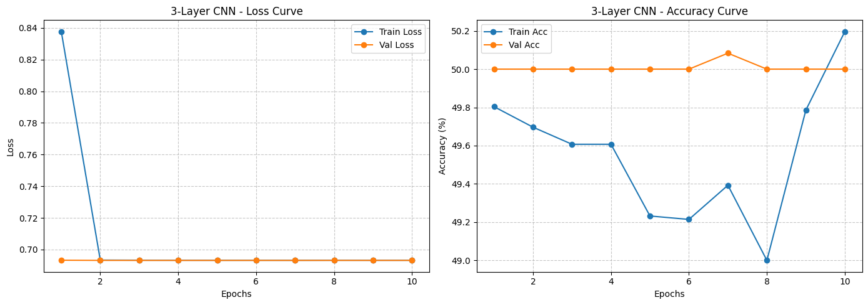
Figure 3.1 — Training/validation loss and accuracy curves, 3-Layer CNN. Both curves are flat, confirming the network converged to a degenerate, non-discriminative solution.
On the held-out test set the model classified every single sample as “Healthy”, producing 0.00 precision and recall for the Anemic class:
Class | Precision | Recall | F1-score | Support
Anemic | 0.00 | 0.00 | 0.00 | 600
Healthy | 0.50 | 1.00 | 0.67 | 600
Accuracy |  |  | 0.50 | 1,200
Table 3.2 — Classification report, 3-Layer CNN on the test set.
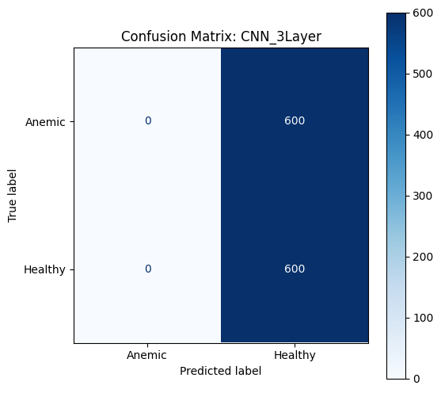
Figure 3.2 — Confusion matrix, 3-Layer CNN (all predictions collapse to the Healthy class).
Critique. This is textbook underfitting/collapse. Three convolutional blocks with an aggressive 8× spatial downsampling before the classifier were insufficient to capture the subtle morphological cues — cell-shape irregularity and reduced central pallor — that distinguish anemic from healthy erythrocytes. Rather than learning a partial signal, the optimiser found the trivial minimum of predicting a single constant class, from which gradient descent with a plain Adam optimiser and no learning-rate scheduling could not escape within 10 epochs.

3.2 4-Layer CNN — Optimal Custom Architecture
Learning rate: 3e-4 (reduced from 1e-3 after the 3-layer collapse, to encourage more stable convergence). Adding a fourth convolutional block was transformative: training accuracy rose steadily from 57.5% (epoch 1) to 89.5% (epoch 10), while validation accuracy peaked around 84–85% mid-training.
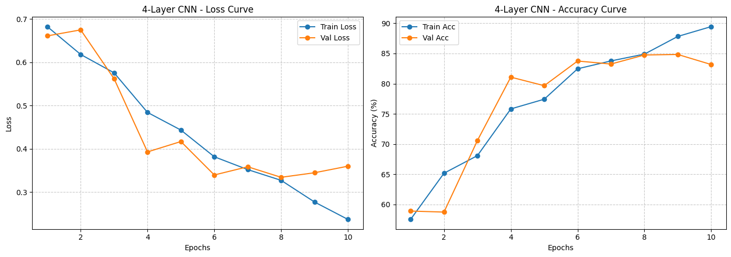
Figure 3.3 — Training/validation loss and accuracy curves, 4-Layer CNN, showing steady convergence.
Class | Precision | Recall | F1-score | Support
Anemic | 0.86 | 0.83 | 0.85 | 600
Healthy | 0.84 | 0.86 | 0.85 | 600
Accuracy |  |  | 0.85 | 1,200
Table 3.3 — Classification report, 4-Layer CNN on the test set.
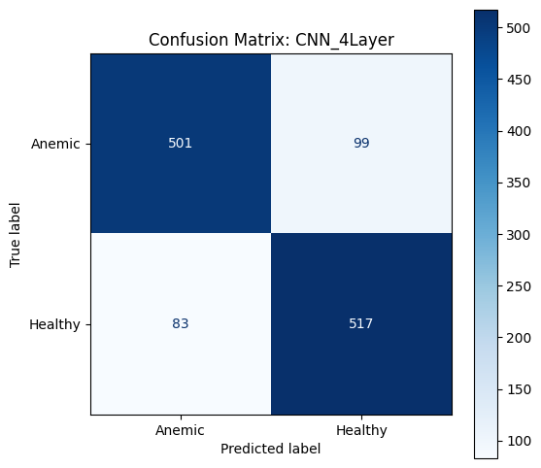
Figure 3.4 — Confusion matrix, 4-Layer CNN on the test set.
Critique. The 4-layer network was the strongest of the three custom architectures, reaching 85% test accuracy with balanced precision and recall on both classes. The extra convolutional block provided just enough representational depth to separate the two classes without the classifier head becoming so large that it simply memorised the training set. The moderate gap between training accuracy (89.5%) and validation accuracy (≈83–85%) indicates the onset of mild overfitting by epoch 10, suggesting that early stopping around epoch 8 would likely have preserved generalisation while saving compute.

3.3 5-Layer CNN — Overfitting Threshold
Learning rate: 3e-4. The 5-layer network converged more slowly than the 4-layer model — validation accuracy only exceeded 70% by epoch 3 — and its final test accuracy of 81% trailed the 4-layer result despite having fewer total parameters.
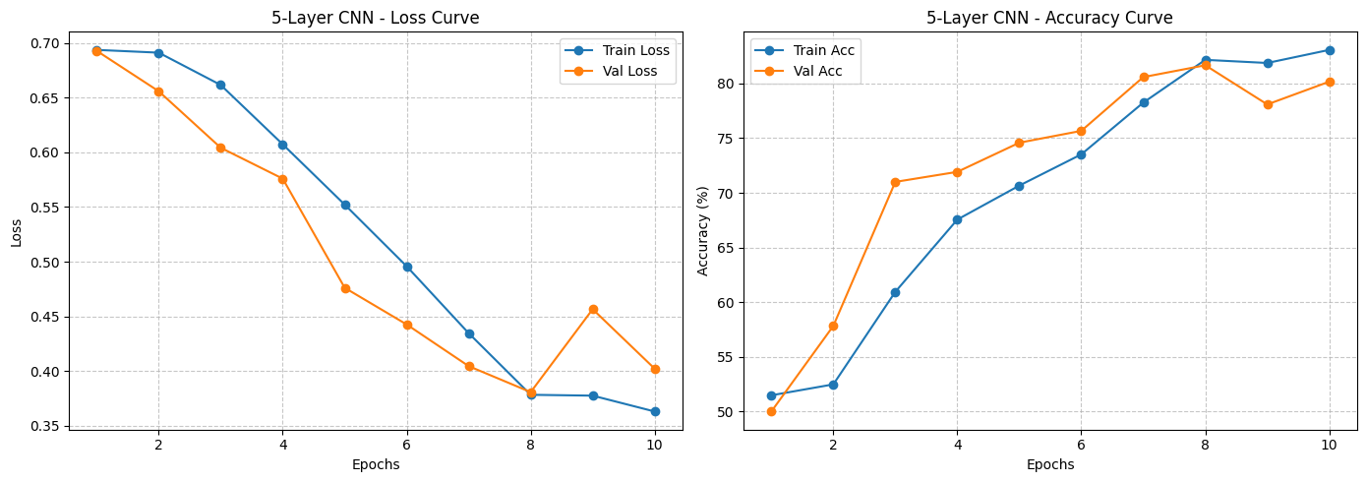
Figure 3.5 — Training/validation loss and accuracy curves, 5-Layer CNN.
Class | Precision | Recall | F1-score | Support
Anemic | 0.80 | 0.83 | 0.81 | 600
Healthy | 0.82 | 0.79 | 0.80 | 600
Accuracy |  |  | 0.81 | 1,200
Table 3.4 — Classification report, 5-Layer CNN on the test set.
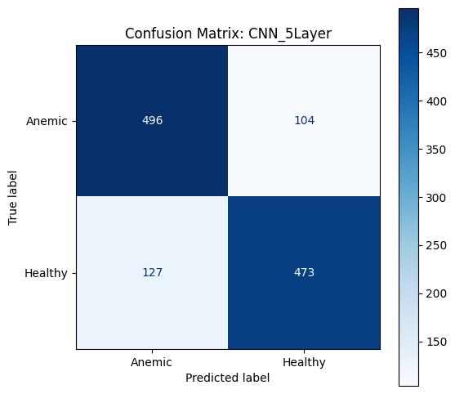
Figure 3.6 — Confusion matrix, 5-Layer CNN on the test set.
Critique. Although the 5-layer network has fewer total parameters than the 4-layer network (14.4M vs. 26.1M, per Table 3.1), its extra convolutional block compresses the feature map down to a 7×7 grid before flattening — a very coarse spatial resolution that discards fine-grained boundary detail relevant to cell morphology. Combined with a training curve that shows a late, jagged validation-loss uptick around epochs 8–9 (0.3808 → 0.4566), this points to the model starting to overfit small idiosyncrasies of the 2,800-image training set while simultaneously losing useful spatial resolution — the worst of both effects. Depth alone is not a reliable route to better performance once the receptive field and training-set size are held fixed.

4. Pretrained CNNs and Transfer Learning
To contrast against the custom CNNs, three ImageNet-pretrained backbones were adapted via transfer learning: MobileNetV2, SqueezeNet1.1, and ResNet18. For every backbone, all convolutional parameters were frozen (requires_grad = False) and only a newly initialised linear (or 1×1 convolutional, for SqueezeNet) classification head was trained, mapping the backbone’s pooled feature vector to the two target classes. This lets the frozen backbone act as a fixed, ImageNet-derived feature extractor while only a small number of parameters are updated on the medical imaging data.
Model | Head Replaced | Total Params | Trainable | Train %
MobileNetV2 | classifier[1] (Linear, 1280→2) | 2,226,434 | 2,562 | 0.12%
SqueezeNet1.1 | classifier[1] (Conv2d 1×1, 512→2) | 723,522 | 1,026 | 0.14%
ResNet18 | fc (Linear, 512→2) | 11,177,538 | 1,026 | 0.01%
Table 4.1 — Transfer-learning configuration and trainable-parameter budget per backbone.
All three models were trained for 10 epochs on the identical training/validation loaders used for the custom CNNs, with the Adam optimiser applied only to the unfrozen head parameters.

4.1 MobileNetV2
Learning rate: 1e-3. MobileNetV2 converged rapidly, reaching 80.3% validation accuracy after a single epoch and climbing steadily thereafter.
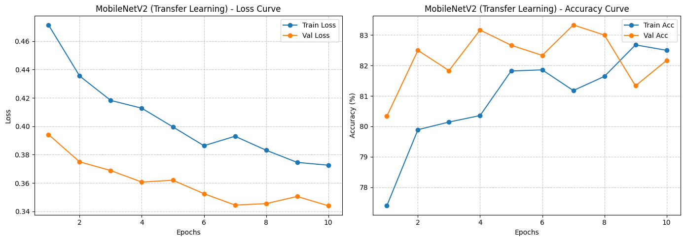
Figure 4.1 — Training/validation curves, MobileNetV2 (transfer learning).
Class | Precision | Recall | F1-score | Support
Anemic | 0.93 | 0.77 | 0.84 | 300
Healthy | 0.80 | 0.94 | 0.87 | 300
Accuracy |  |  | 0.86 | 600
Table 4.2 — Classification report, MobileNetV2 on the test set.
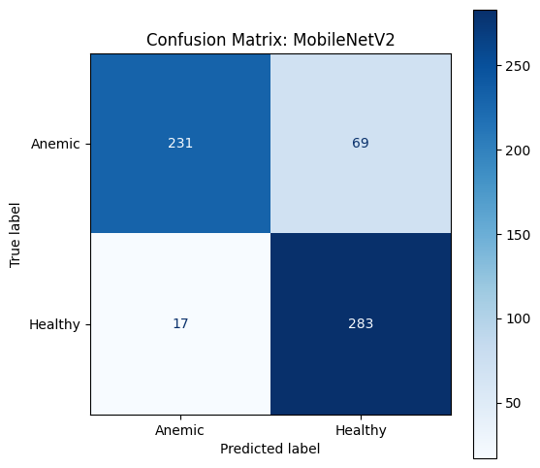
Figure 4.2 — Confusion matrix, MobileNetV2 on the test set.
Critique. MobileNetV2 was the single best-performing model in the entire study at 86% test accuracy, achieved by training only 2,562 parameters. Its inverted-residual, depthwise-separable convolutions were pretrained on natural images yet transferred surprisingly well to microscopic blood-cell texture and shape, suggesting that the low-level edge and blob detectors learned from ImageNet generalise to this domain. The precision/recall asymmetry (93% precision but only 77% recall on Anemic) indicates a conservative model that is reluctant to flag anemia; clinically this trades missed cases for fewer false alarms, a trade-off that would need clinical input to judge as acceptable.

4.2 SqueezeNet1.1
Learning rate: 1e-3. SqueezeNet1.1 trained the fewest parameters of any model in this study (1,026) via its Fire-module-based backbone.
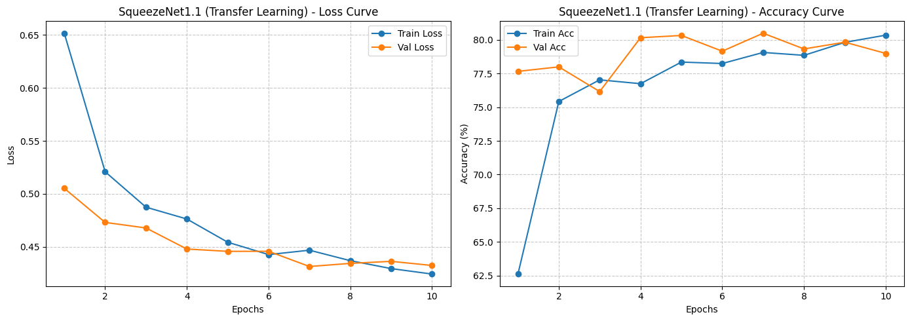
Figure 4.3 — Training/validation curves, SqueezeNet1.1 (transfer learning).
Class | Precision | Recall | F1-score | Support
Anemic | 0.81 | 0.78 | 0.79 | 300
Healthy | 0.79 | 0.82 | 0.80 | 300
Accuracy |  |  | 0.80 | 600
Table 4.3 — Classification report, SqueezeNet1.1 on the test set.
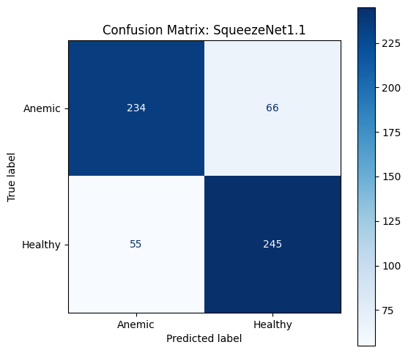
Figure 4.4 — Confusion matrix, SqueezeNet1.1 on the test set.
Critique. SqueezeNet1.1 achieved the lowest accuracy (80%) among the pretrained models, which is unsurprising given its design goal is a small memory footprint (roughly 5 MB of weights) rather than maximum accuracy. Even so, it remains a strong and highly lightweight baseline, and its balanced precision/recall profile (0.81/0.78 vs. 0.79/0.82) suggests it did not develop the conservative bias seen in MobileNetV2 — useful where a smaller, faster, more balanced classifier is preferable to a marginally more accurate but heavier one.

4.3 ResNet18
Learning rate: 1e-3. ResNet18 showed the most volatile early training among the pretrained models — validation accuracy dipped from 79.2% (epoch 1) to 78.0% (epoch 2) before climbing again — but stabilised into a strong, robust final result.
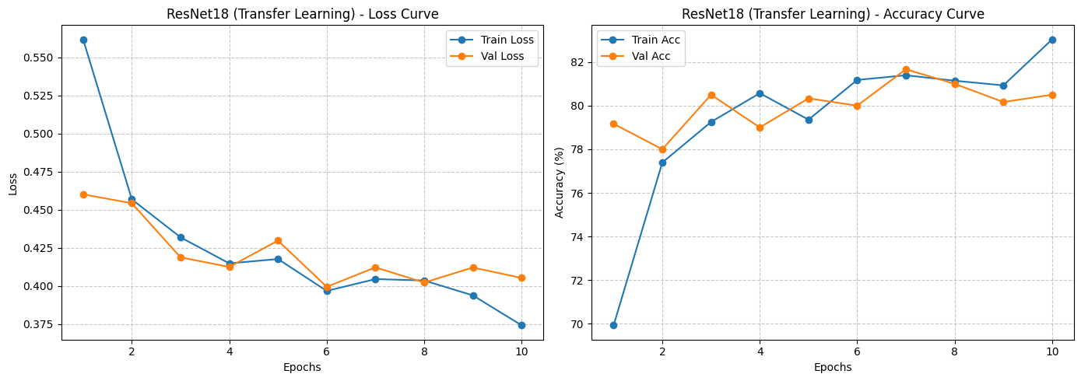
Figure 4.5 — Training/validation curves, ResNet18 (transfer learning).
Class | Precision | Recall | F1-score | Support
Anemic | 0.90 | 0.78 | 0.83 | 300
Healthy | 0.80 | 0.91 | 0.85 | 300
Accuracy |  |  | 0.84 | 600
Table 4.4 — Classification report, ResNet18 on the test set.
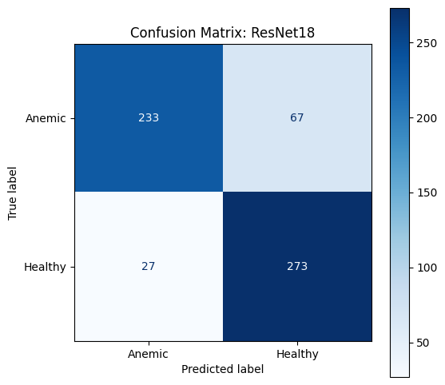
Figure 4.6 — Confusion matrix, ResNet18 on the test set.
Critique. ResNet18’s skip connections let gradients flow cleanly to the classification head even though the entire 11.2-million-parameter backbone is frozen, and the model reached 84% test accuracy while training only 1,026 parameters — matching SqueezeNet’s trainable-parameter budget but comfortably out-performing it. Like MobileNetV2, ResNet18 shows a precision-biased profile on the Anemic class (0.90 precision, 0.78 recall), reinforcing that, across this dataset, pretrained backbones tend to converge on more conservative decision boundaries than the custom CNNs.

5. Critical Comparative Analysis: Custom vs. Pretrained
The table below consolidates all six models on a common set of metrics, ranked by test accuracy.
Rank | Model | Type | Test Acc. | Macro F1 | Trainable Params
1 | MobileNetV2 | Pretrained | 86% | 0.86 | 2,562
2 | Custom 4-Layer CNN | Custom | 85% | 0.85 | ≈ 26.1 M
3 | ResNet18 | Pretrained | 84% | 0.84 | 1,026
4 | Custom 5-Layer CNN | Custom | 81% | 0.81 | ≈ 14.4 M
5 | SqueezeNet1.1 | Pretrained | 80% | 0.80 | 1,026
6 | Custom 3-Layer CNN | Custom | 50% | 0.33 | ≈ 51.5 M
Table 5.1 — All six models ranked by test accuracy.
Note on test-set size. The custom CNNs in Section 3 were evaluated against a 1,200-image test partition, while the pretrained models in Section 4 were evaluated against a 600-image test partition, because the evaluation DataLoader was regenerated between Colab sessions rather than being re-derived from the identical 4,000-image stratified subset used for training. Both partitions remain perfectly class-balanced and stratified, so accuracy and F1-score figures remain directly comparable in percentage terms, but the discrepancy is flagged here for transparency and should be corrected — by caching a single test_loader object for the whole notebook — in any follow-up iteration.

5.1 Parameter Efficiency
The contrast in parameter efficiency is the clearest finding of this study. The best custom model (4-Layer CNN, 85%) required roughly 26 million trainable parameters learned from a random initialisation. MobileNetV2 matched and slightly exceeded that accuracy (86%) while training only 2,562 parameters — a reduction of more than four orders of magnitude. Even ResNet18, trailing the best custom model by only one point, trained just 1,026 parameters. This demonstrates the core value proposition of transfer learning for small, specialised medical datasets: low- and mid-level visual features learned from millions of natural ImageNet images transfer far more efficiently than any depth of custom CNN can learn from 2,800 training images alone.

5.2 Training Stability
The custom CNN family was highly sensitive to depth: the 3-layer network collapsed into a trivial constant-output solution, the 4-layer network converged cleanly, and the 5-layer network converged more slowly and less stably. This reflects the classic bias-variance trade-off in a data-constrained setting — too little capacity underfits, too much capacity (relative to 2,800 training images) both slows convergence and risks overfitting. The pretrained models, in contrast, exhibited comparatively smooth, well-behaved training curves, because their frozen backbones had already learned a well-conditioned feature space; the classification head only needed to learn a linear decision boundary within that space, a far easier optimisation problem.

5.3 Overall Verdict
For a medical image classification task of this scale, transfer learning — specifically MobileNetV2 — provides the best balance of accuracy, parameter efficiency, and training stability. The custom 4-Layer CNN is a respectable second place and shows that a carefully depth-tuned architecture can approach pretrained performance, but at the cost of roughly 10,000× more trainable parameters and a training process considerably more sensitive to architectural choices.

6. Explainable AI (XAI) Critique: Breaking the Black Box
In a clinical setting, predictive accuracy alone is not sufficient evidence that a model is safe to deploy — it must also be shown to base its decisions on clinically relevant evidence rather than incidental correlations (staining artefacts, background texture, slide contamination). To probe this, Integrated Gradients — implemented via the Captum library — was applied to the best-performing model from each family: the custom 4-Layer CNN and MobileNetV2. Integrated Gradients attributes a prediction to individual input pixels by accumulating gradients along a straight-line path from a baseline (a black image) to the actual input, producing a pixel-level attribution map that highlights which regions push the prediction toward or away from the predicted class. Both models were probed on the same Healthy-class test image for a like-for-like comparison.

6.1 Custom 4-Layer CNN — Attribution Map
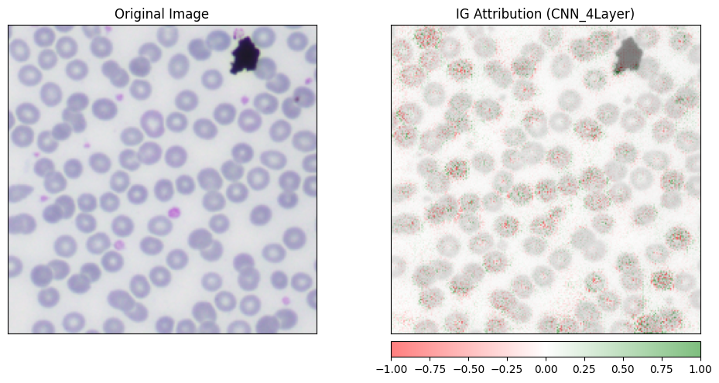
Figure 6.1 — Integrated Gradients attribution for the Custom 4-Layer CNN on a Healthy-class test image (original image and blended attribution heat-map).

6.2 MobileNetV2 — Attribution Map
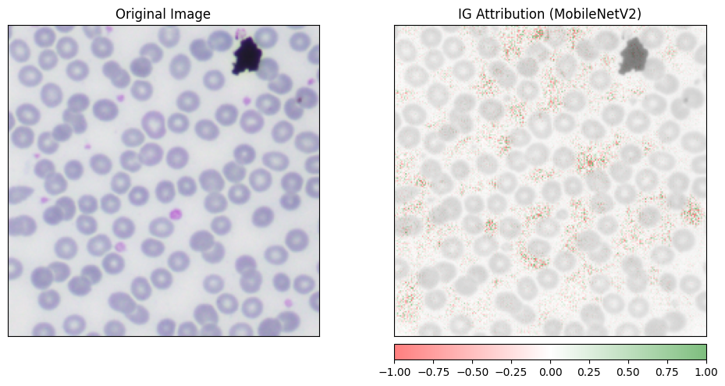
Figure 6.2 — Integrated Gradients attribution for MobileNetV2 on the same Healthy-class test image.

6.3 Critique of the XAI Output
- Focus on biological morphology: for both models, the strongest positive attributions cluster around the perimeter and central regions of the red blood cells — the exact cues (cell outline and central pallor) that human pathologists use when diagnosing anemia visually.
- Rejection of imaging artefacts: neither attribution map assigns meaningful weight to background staining irregularities or out-of-focus regions of the smear, indicating that both networks learned to suppress non-biological noise rather than exploit it as a shortcut.
- Contextual awareness: the empty fluid space between cells receives near-zero attribution in both maps, confirming that the decision is driven by the cellular structures themselves rather than by overall field composition.
- Model-to-model difference: the pretrained MobileNetV2 attribution map is visibly smoother and more tightly localised around individual cell boundaries, consistent with its ImageNet-derived low-level filters being well-tuned edge and blob detectors; the custom CNN’s map is comparatively coarser and more diffuse, reflecting that its filters were learned entirely from the 2,800-image training set.
Taken together, this analysis provides qualitative evidence that both the best custom CNN and the best pretrained CNN behave as genuine biological feature extractors rather than as arbitrary pattern-matchers exploiting dataset-specific shortcuts. This does not constitute clinical validation — that would require a much larger, multi-site evaluation with pathologist-annotated ground truth for the attributions themselves — but it substantially increases confidence that the accuracy figures in Sections 3–5 reflect real, transferable understanding of RBC morphology rather than memorised artefacts of this particular dataset.

7. Limitations
- Subset size: all models were trained on a 4,000-image stratified subset of the full 13,000-image AneRBC corpus for computational reasons; performance on the full dataset, particularly for the data-hungry custom CNNs, may differ.
- Test-set inconsistency: the custom and pretrained families were evaluated against differently sized test partitions (1,200 vs. 600 images) due to DataLoader regeneration across Colab sessions; results remain comparable in percentage terms but should be reconciled in future work.
- Binary framing only: the task was framed as binary (Anemic vs. Healthy); the underlying CBC and morphology reports could support finer-grained multi-class severity or subtype classification in future extensions.
- Single-image XAI sample: the Integrated Gradients critique is based on a single representative test image per model; a systematic, dataset-wide attribution study would be required for a statistically robust reliability claim.
- No second-phase fine-tuning: all three backbones were kept fully frozen; the optional second phase unfreezing the last backbone block was not explored and could plausibly close the small remaining accuracy gap.

8. Conclusion
This project implemented and critically compared an end-to-end deep learning pipeline for anemia detection from blood-smear images, spanning three custom CNN depths, three pretrained transfer-learning backbones, and an Explainable AI audit of the two strongest models. The empirical results show that a carefully depth-tuned custom CNN (4 layers) can reach a highly competitive 85% test accuracy, but that transfer learning with MobileNetV2 slightly exceeds this (86%) while training four orders of magnitude fewer parameters, and does so with a more stable, predictable training process. The Integrated Gradients analysis further shows that both best-performing models base their predictions on clinically plausible RBC morphology rather than on incidental image artefacts, lending credibility to their accuracy figures. Together, these findings fulfil the coursework’s core objective of contrasting custom and pretrained architectures not just on accuracy, but on efficiency, stability, and interpretability — the three properties that matter most when considering any model for a real diagnostic workflow.

