**Day 4 - Dynamic Frontend Components Implementation Report**

**General E-Commerce**

1. **Objective:**

The objective of this implementation was to develop dynamic frontend components for a marketplace using Sanity CMS or APIs. The components were built to be modular, reusable, and responsive, ensuring scalability and a professional user experience.

1. **Implemented Components**

**Product Listing Component**

* Dynamically renders products in a grid layout.
* Displays Product Name, Price, Image, and Stock Status.
* Designed using responsive UI techniques.

**Product Detail Component**

* Uses dynamic routing for individual product pages.
* Displays Product Description, Price, Available Sizes/Colors.
* Fetches product data dynamically from Sanity CMS/API.

**Category Component**

* Categories are fetched dynamically from the API or CMS.
* Users can filter products by category selection.

**Search Bar**

* Filters products by product name (tags-based filtering can be added for improvement).
* Provides real-time filtering experience.

**Cart Component**

* Displays added products, quantity, and total price.
* Uses state management (useState, useContext) to track cart items.

**Pagination Component**

* Divides large product lists into multiple pages.
* Implements previous/next buttons or numbered pagination.

**Related Products Component**

* Fetches related products based on categories.
* Displays similar products dynamically on the Product Detail Page.

**Header & Footer Components**

* Provides consistent navigation across the marketplace.
* Includes essential links like Home, About, Contact.

**Notifications Component**

* Toast notifications used for real-time alerts (e.g., adding to cart, errors, or successful purchases).
* Ensures better user interaction.

**Product Listing Component**

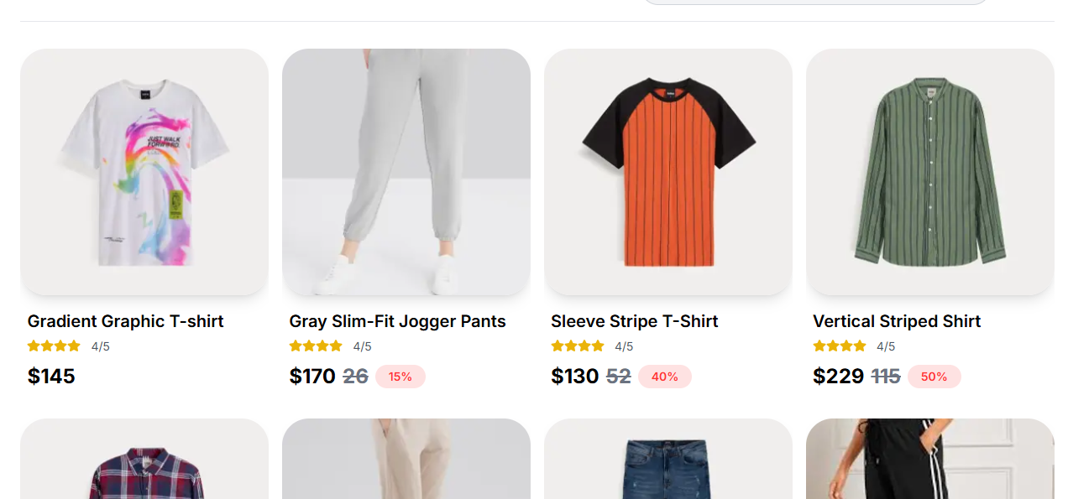

**Product Detail Component**

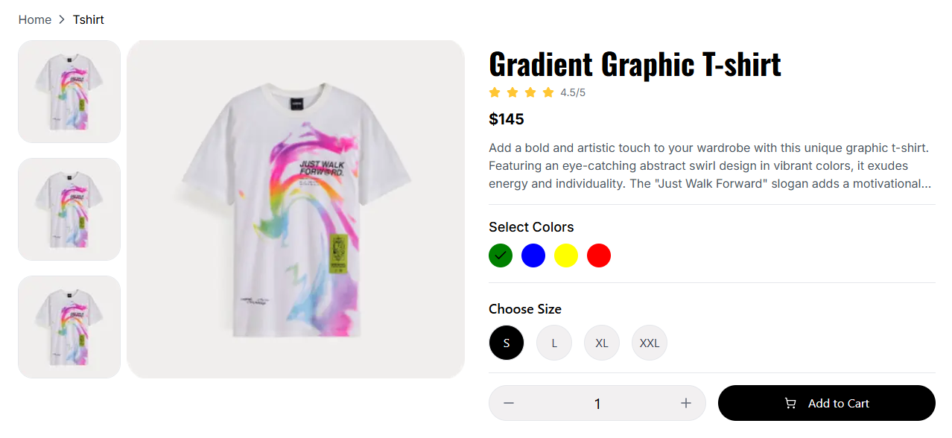

**Category Component**

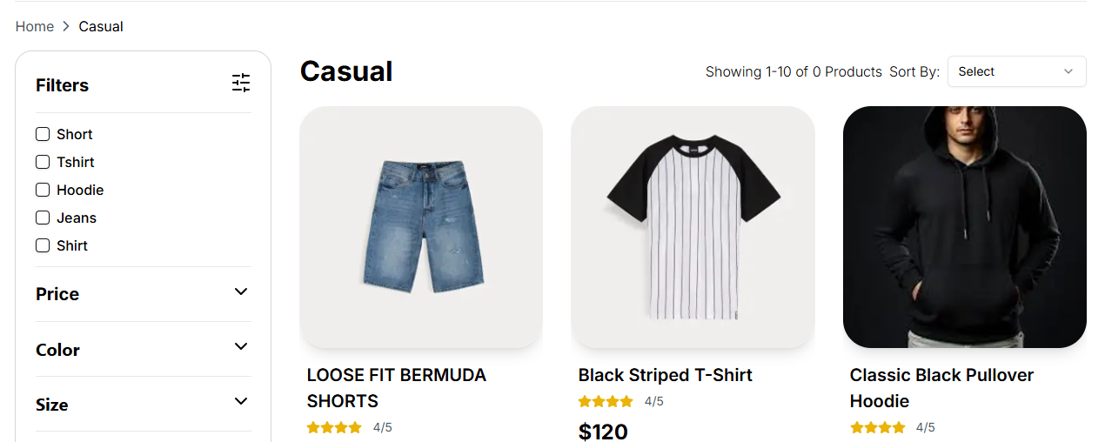

**Related Products Component**

