**Day 5 - Testing and Backend Refinement**

**General E-Commerce**

**Objective:**

The objective of this document is to ensure that the General E-commerce platform is fully tested, optimized, and ready for deployment. It focuses on testing all core functionalities, implementing robust error handling, and improving performance for a seamless user experience. The document also ensures cross-browser and device compatibility while maintaining strong security measures. Additionally, it provides structured documentation and a detailed testing report for review and future reference.

**Product Listing:**

* The product listing successfully displays products, showing essential details such as name and price.
* Products can be filtered based on categories, price range, colors, and sizes. Additionally, products can be sorted in multiple ways, including low to high, high to low, A to Z, and Z to A.
* The search functionality allows users to find products by validating search queries based on product names.

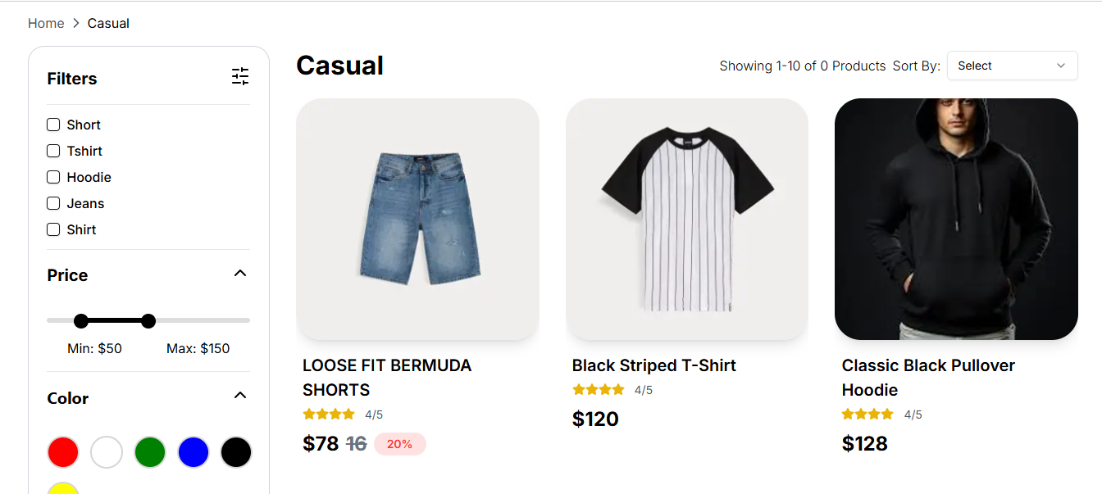

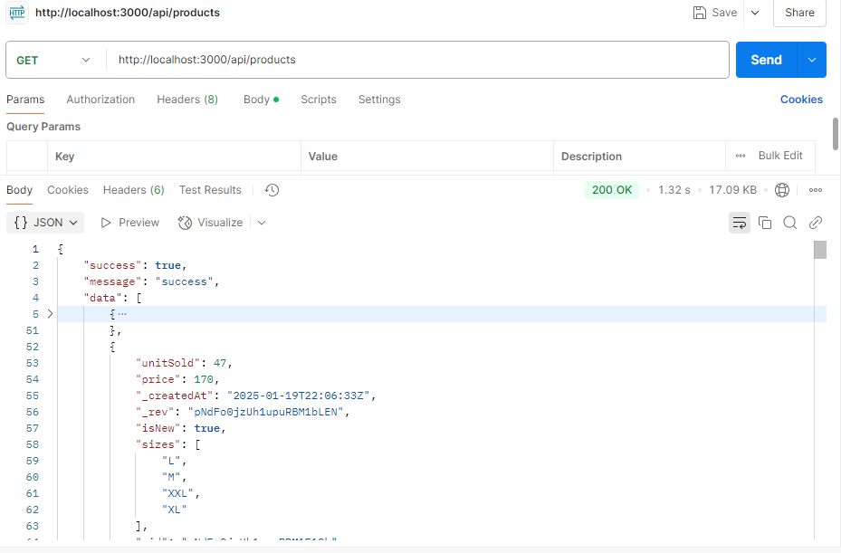

**Performance Optimization:**

**Installation Process:**

* npm install -g lighthouse
* lighthouse http://localhost:3000: --view

**Desktop View:**



**Mobile View**

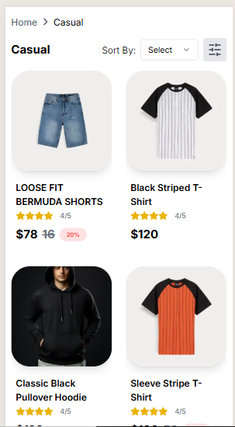 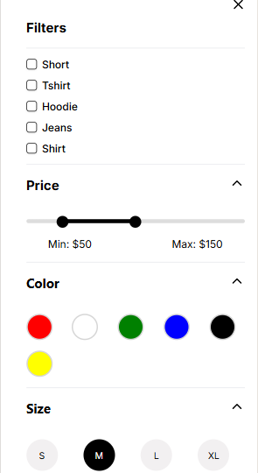

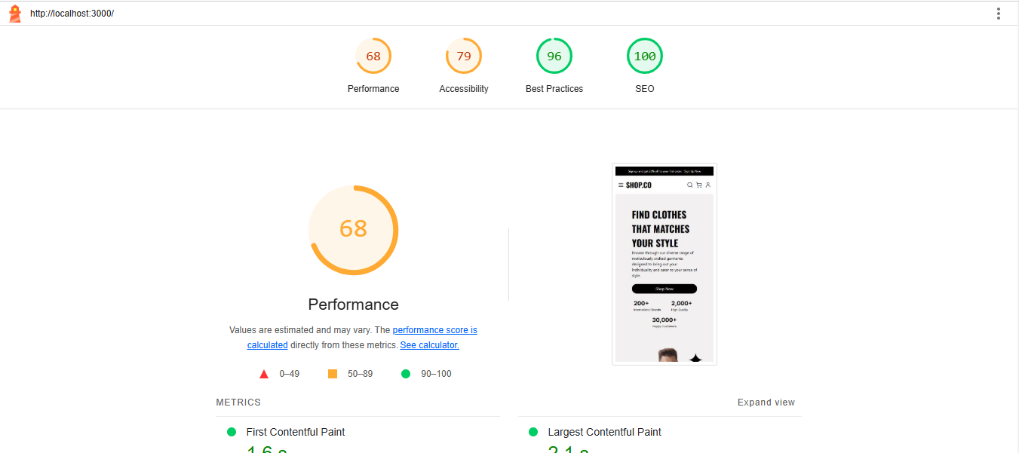

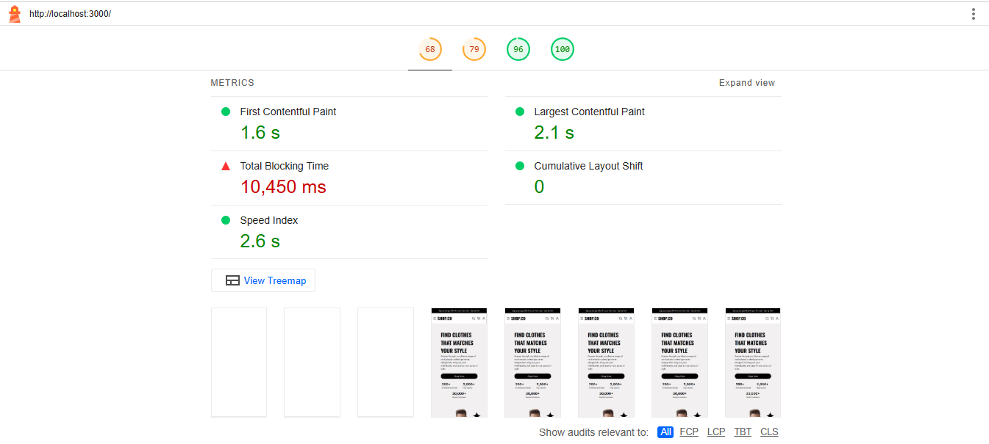

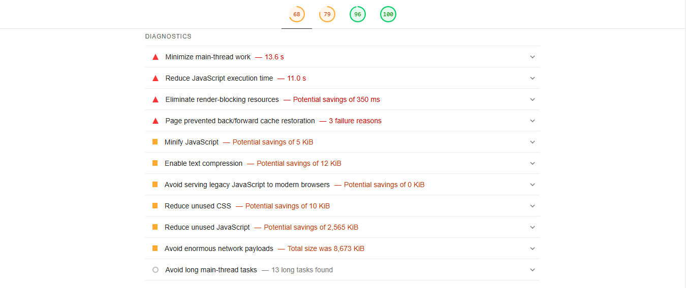

**Developer Resources:**

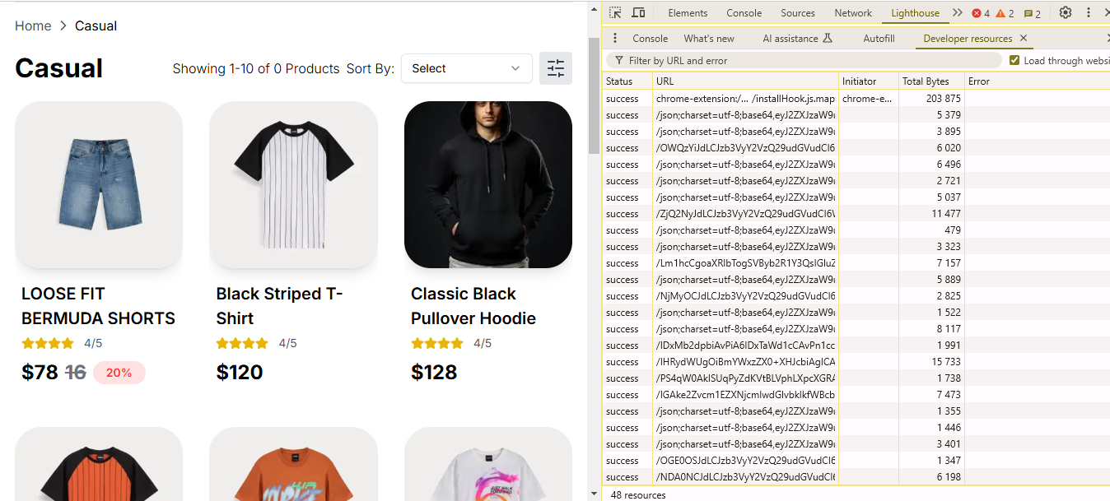

**Performance Monitor:**

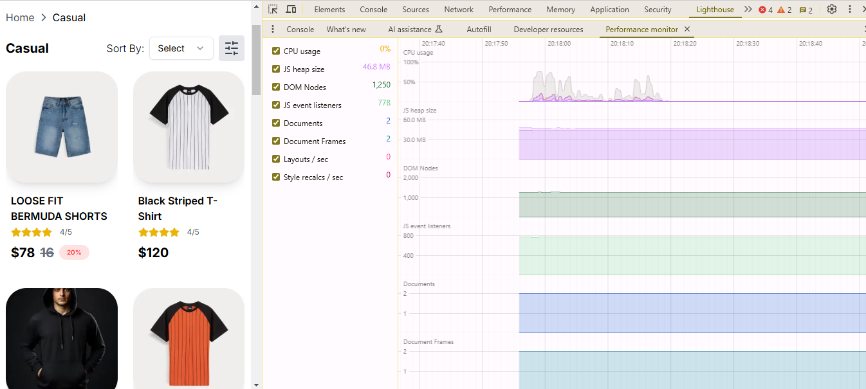

**Security:**

