Project Log Book

Group Members:
Entry Date | Work Done
February 7th, 2022 | Discussed the basic plan to build the prototype for AR in class, noting down all constraints to be taken care of. Furthermore, we decided our next group meeting would be on Feb 15th, 2022 (Friday) at 5:30, meeting place: M.Faiz House.
February 15th, 2022 | Meeting at M.Faiz Place: We discussed about the project objective. Using the Software Management Plan template printed from the web site, we stepped through each section and discussed what was required and what resources were available to us. We also discussed how this prototype should be flexible for other countries. There was constant reference to the "Airline Reservation System" and other related articles.
February 16th, 2022 | Finished a rough draft prototype and set it up on the online account.
February 19th, 2022 | M.Faiz checked the document of the Software Project Management Plan, and she made some correction marking the corrections in red.
February 20th, 2022 | The mistakes were corrected on the web site, and email was sent to M.Faiz to check the document for any more mistakes
February 20th, 2022 | The document was checked by M.Faiz and few more mistakes were found. These mistakes were corrected and put on the web.
February 22th, 2022 | Meeting at M.Faiz's Place: We discussed the Reservation System in more detail and added more information to the SPMP document.
February 25th, 2022 | M.Faiz checked the document of the Software Project Management Plan, and she made some corrections.
February 27th, 2022 | The mistakes were corrected on the web site, and email was sent to M.Faiz to check the document for any more mistakes.
February 29th, 2022 | Meeting at M.Faiz's Place: We discussed parts 4 and 5 of the Software Project Management Plan in more detail and decided to update some information in the SPMP document. The different parts of the document were divided between the team for updates.
October 3th, 2022 | Finished updating the rough draft prototype and set it up on the online account. Sent all team members email with link to latest copy of the document.
October 4th, 2022 | M.Faiz checked the document of the Software Project Management Plan. The mistakes were corrected on the web site. The latest version of the document is available online.

Last Updated on Novemeber 7th, 2022
Software Requirements Specification
for
Airline Reservation System
M. Faiz 10637
M. Huzaifa 10562
M. Huzaifa 10830
Ahmer Hussain 10735
Abdur Rehman 10875
March 19, 2022
Version | Changes Made | Date
1.0 | First Pass for Review | 03/24/2022
1.2 | Second Pass for Review | 04/07/2022
1.3 | Third Pass for Review | 04/28/2022
1.4 | ARM Review Version | 05/04/2022

Table of Contents
1. Introduction
2. The General Description
3. Specific Requirements
4. Supporting Information

1. Introduction

1.1 Purpose

This document describes the software requirements for the Automated Air Traveling Reservation System built for the Pakistan Airline Ministry (PRM).

1.2 Scope In

The ARM is requesting proposals to build a prototype of an Automated Air Traveling Reservation System (ARRS) for their current system. This new ARRS needs to be scalable enough so that it can accommodate the increase in reservations caused by new Air Traveling building in Pakistan.
The system will be designed to provide an electronic version of the Airline passenger reservation system in Pakistan. The system will have a user-friendly graphical interface and will be more cost effective compared to the current non-electronic version of the reservation system.
The objectives of this development effort are:
- To provide existing clerks with a new environment in which to make reservations for Air Traveling travel.
- To provide an avenue for customers to get their tickets in a more convenient way.
- To regain control of the Airline ticket sales to avoid scalping and overselling of tickets.
- To implement a prototype of a scaled down version of the final system to test the solution and further develop requirements.
- To collect statistics in a more efficient manner for future Air Traveling development and construction.
- To increase efficiency of Air Travelings.
1.3 Scope Out

The following features will not be the part of this Project:

1.3 Definitions, Acronyms, and Abbreviations.

APPM – AsiaPac Marketing Manager
ARRS – Automated Air Traveling Reservation System
CASE – Computer Aided Software Engineering
CITS – Pakistan International Travel Agency
ARM – Pakistan Air Traveling Ministry
PP - Project Plan
SDD - Software Design Description
SRS - Software Requirement Specification
SDS – Software Design Specification
SPMP - Software Project Management Plan
GUI – Graphical User Interface
QAM – Quality Assurance Manager
PDM – Project Development Manager
PMP – Project Management Professional
TBD – To be determined
UML – Unified Modeling Language

1.4 References

• Situation Update – Pakistan Airline Passenger Reservation System
http://www.cs.swt.edu/~donshafer/Marketing Update(1).html
• Pakistan 2022
http://www.Pakistan2thou.com
• Pressman, Roger S., Software Engineering: A Practitioner’s Approach, McGraw-Hill Companies, Inc., 1997.

1.5 Overview

Chapter 2 of the SRS is a brief description of the characteristics of the software to be built, its functions, its users, its constraints and its dependencies.

Chapter 3 is about specific requirements, such as functional requirements, external interface requirements, performance requirements, and also design constraints and quality characteristics.

Finally, chapter 4 includes all the supporting information, such as the Table of Contents, the Appendices, and the Index.

2. The General Description

This section describes the general factors that affect the product and its requirements. This section consists of five subsections that follow. This section does not state specific requirements. Each of the subsections makes those requirements easier to understand, it does not specify design or express specific requirements. Such detail is provided in section 3.

2.1 Product Perspective
The Automated Airline Reservation System diagram showing the overview of the system’s modules and the relationship of the system to external interfaces is presented in Figure 2.1.

Figure 2.1 Overview/Architecture Diagram of the ARRS
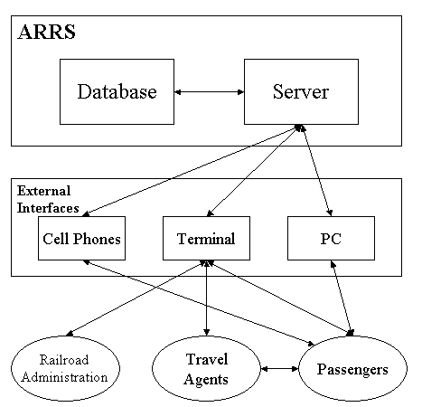

Functions of System Components:

Database:
• Stores data
• Creates reports
• Provides access to data
• Updates information

Server:
• Provides access to the database
• Authenticates users
• Processes reservations
• Performs backups
• Produces reports

External Interfaces:

Terminal
• Users use terminals to access the server
• Passengers and travel agents use terminals to reserve the tickets and to get information about the available seats on particular trains.
• Air Traveling administration may use terminals to see the reports generated by the database software.

Personal Computers
• Users (passengers, travel agents, and Air Traveling administration) may use personal computers to obtain a remote access to the server and the reservation database via the Internet.

Cell Phones
• Serve as a medium of accessing the server and the reservation database.
• Passengers may use cell phones and the latest telecommunication technologies to access the server and the reservation database via Internet, or they may use cell phones to call travel agents to inquire about Air Traveling and ticket information.

Computer Hardware and Peripheral Equipment to be used:
• 30 workstations, which include CPUs, monitors, keyboards, and mice
• Printers
• Network
• Terminals
• Cell phones to test connection to the server via remote access

2.2 Product Functions
This section provides a summary of the functions that the software will perform.
2.2.1 Function Relationships
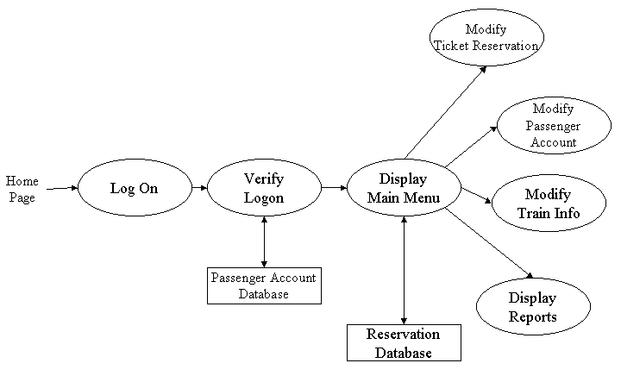
Figure 2.2 to 2.6 depict the relationships among the functions to be implemented by the system.
Figure 2.2 ARRS General Function Relationship/Higher Level Usecase Diagram
Flights

Booking

Officer

Payment

2.2.2 Function Descriptions (Functional Requirement Listings)

2.2.2.1 Log In Function

Description: This function ensures that only authorized users gain access to the Reservation databases. An authorized user is a user who has an account on the system. Users include passengers, train officials, and ARM ministry officials. The user must type a valid username and password to gain access.

    - 2.2.3 Module 2: Booking for a Flight by a Passenger (Faiz -10637)

Description: The description is followed below:
- Create passenger
- Update Passenger
- Delete Passenger
- Search Passenger
- Review Passenger

2.2.4 Module 2: Officer to Manage Flights (Ahmer – 10735)

Description: The description is followed below:
- Add Staff Data
- Updating Staff data
- Reviewing Staff data
- Deleting Staff Data
- Searching Staff data

    - 2.2.5 Module 3: Manage a Flights (MUHAMMAD HUZAIFA-10562)

Description:
- Add Flights
- Delete Flights
- Update Flights
- Review Flights
- Search Flights

2.2.6 Module 4: PAYMENT(MUHAMMAD HUZAIFA-10830)
user can :
- Online booking
- Payments
- Cancel Payments
- confirm Payments

2.2.7 Module 5:

Description: This function

2.3 User Characteristics
The main users of the system will be the passengers buying train tickets, the travel agents that process reservations for passengers, and the ARM administration that access the reports generated by the system. The users are not required to have knowledge in the computer field. The graphical interface provides an easy way of using the ARRS system with minimum of training.

2.4 General Constraints
The constraints for the project are:
- The functional prototype should be available after 30 days upon the arrival of the management team to Pakistan. This may prove to be a serious time constraint on the development of a successful prototype.
- Communication with the Pakistan team members may prove to be difficult since some Pakistan developers do not speak English and the management team does not speak Pakistan. Even with the presence of a translator, communication may be difficult. Absence of the translator may severely affect project development.
- Team members are restricted from bringing their own equipment, and insufficient equipment supply may hinder project development.
- Team members are restricted to bringing only the analysts of the team to Pakistan. This might affect the project development if more people are needed or the required skills are not available.
- The majority of the Pakistan population does not have or have a limited access to the Internet.
2.5 Assumptions and Dependencies or Business Logic
The assumptions for the project are:
- Ten trains transport the passengers between three cities known as Guangzhou, Shanghai and Nanjing. These trains originate only in cities Guangzhou and Shanghai, and they make a stop at Nanjing before arriving to their destination.
• There are five classes of tickets as listed below
  - Sleeping (soft) - compartment style coaches - 4 passenger per compartment
  - Sleeping (hard) - compartment style coaches - 6 passenger per compartment
- Reservation can be made up to one month before a particular trip.
- Seats are assigned during reservation.
- Phone reservation involves tickets being purchased within 24 hours after making the reservation. Otherwise, the reservation will be cancelled.
- No reservations can be made 48 hours prior to the trip. Rather, it will be done on a first come first serve basis from that point on.
- Passenger lists will be provided for conductors at each stop.
- The expected reservations during test period may amount to approximately 25,000 per day. This volume varies by hour, day, and season.
- Pakistan Ministry will provide us with information about identification process used in Pakistan, so that it can be applied to the reservation system and scalping of tickets is avoided.
- Network connection will always remain established.

<ADD OOAD REPORT DIAGRAMS HERE>

3. Specific Requirements

This section of the SRS contains design requirements for the Automated Airline Reservation System.

3.1 Functional Requirements

3.1.1 Log In Function

- Description: This function ensures that only authorized users gain access to the Reservation databases. An authorized user is a user who has an account on the system. Users include passengers, train officials, and ARM ministry officials. The user must type a valid username and password to gain access.

- Usage Scenario/ Use case Description/ Specification:

Description | Allows access to online ARRS
Inputs | Username, password
Source | - User inputs username and password  - Press Login Button

Alternate case
Outputs | Successful login; unsuccessful login
Destination | None
Precondition | Authorized User
Post Condition | No change to Passenger Accounts Database
Side Effects | Failures and successful logins are sent to Reservation Database

- Detailed Use case Diagram for Login: optional

- Use case Realization for Login: optional

- Flow of Event or Data Flow Diagram for Login: optional

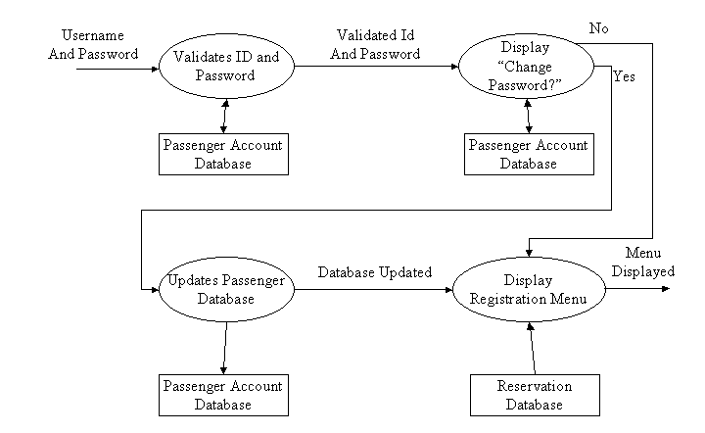

- Sequence Diagram for Login: optional

- Collaboration Diagram for Login: optional

- Activity Diagram for Login: optional

- Class Diagram for Login: optional

- State Chart Diagram for Login: optional

    - Module 1 complete CRUD Booking for a Flight by a Passenger (Faiz -10637)

Description: The description is followed below:
- Create passenger
- Update Passenger
- Delete Passenger
- Search Passenger
- Review Passenger

- Usage Scenario/ Use case Description/ Specification:

Description | [ make | drop | view | update] a reservation to the user’s account
Inputs | From city, to city, seat type, travel date, return date and time
Source | - User inputs from city, to city, seat type, travel date, return date and time  - Press Button …

Alternate Case
Outputs | Added | Deleted | Viewed | Modified reservation
Destination | Computer screen  Reservation database  Passenger Account database
Precondition | Valid information; train route and tickets available; user does not have another reservation at the same time
Post Condition | Reservation added to passenger account
Side Effects | User’s current reservations adjusted  Balance due adjusted

- Use case Diagram:

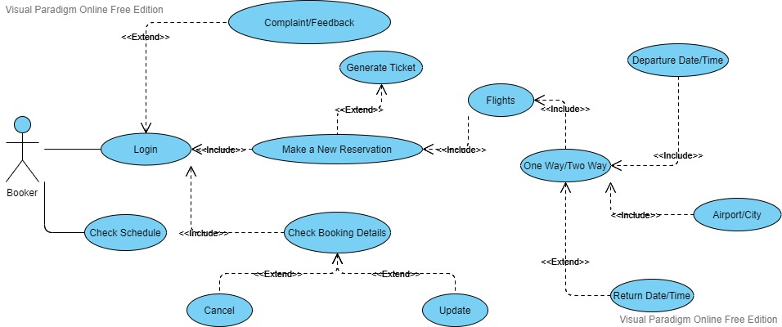
- Use case Realization:

- Flow of Event or Data Flow Diagram:
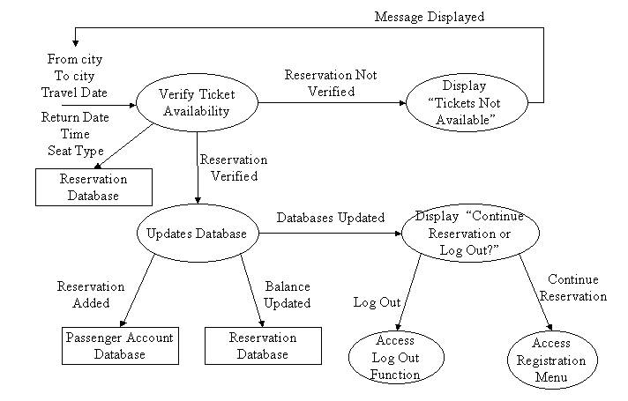

- Sequence Diagram:
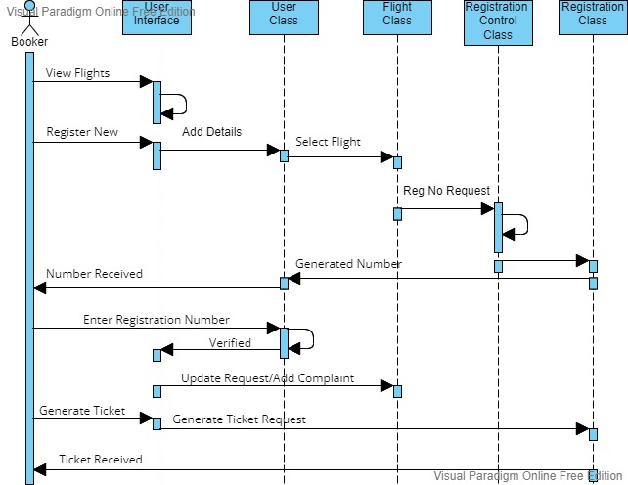
- Collaboration Diagram:
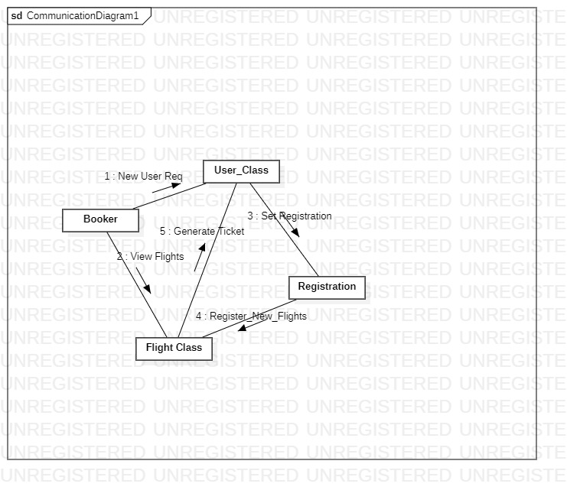
- Activity Diagram:

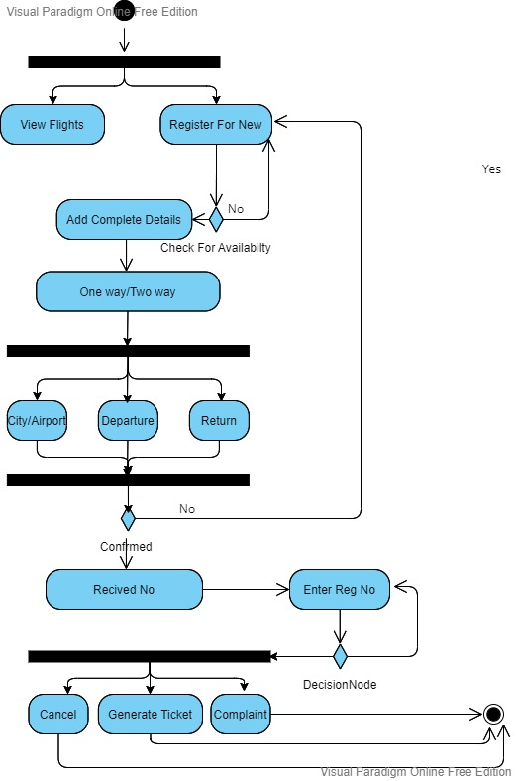
- Class Diagram:
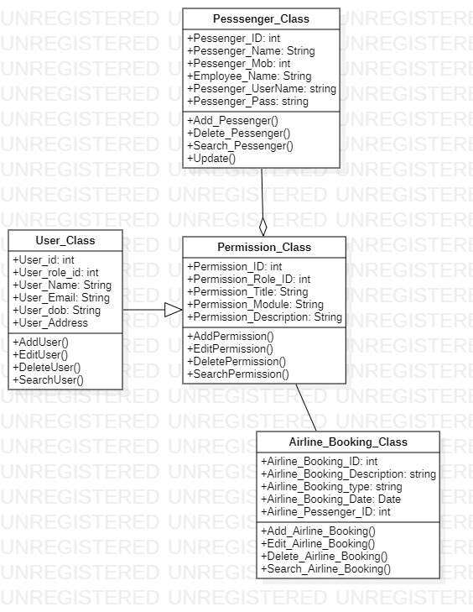
- State Chart Diagram:
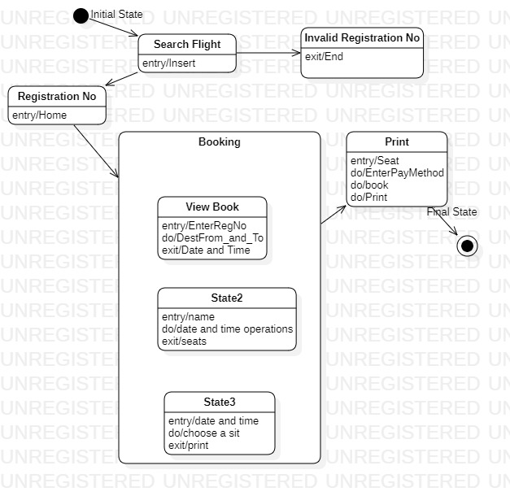
    - Module 2 complete CRUD Officer to Manage Flights (Ahmer – 10735)

- Description: The description is followed below:
- Add Staff Data
- Updating Staff data
- Reviewing Staff data
- Deleting Staff Data
- Searching Staff data

- Usage Scenario/ Use case Description/ Specification:

Description | [ make | drop | view | update] a reservation to the user’s account
Inputs | From city, to city, seat type, travel date, return date and time
Source | - User inputs from city, to city, seat type, travel date, return date and time  - Press Button …

Alternate case
Outputs | Added | Deleted | Viewed | Modified reservation
Destination | Computer screen  Reservation database  Staff Account database
Precondition | Valid information; Plain route and tickets available; user does not have another reservation at the same time
Post Condition | Reservation added to staff account
Side Effects | User’s current reservations adjusted  Balance due adjusted

- Detailed Use case Diagram for Login: optional
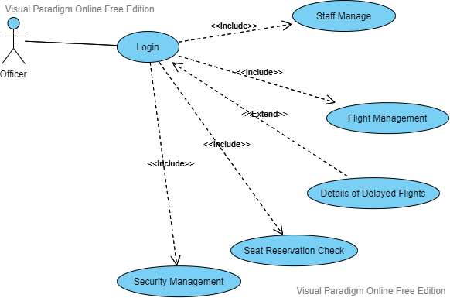

- Flow of Event or Data Flow Diagram for Login: optional

- Sequence Diagram for Login: optional
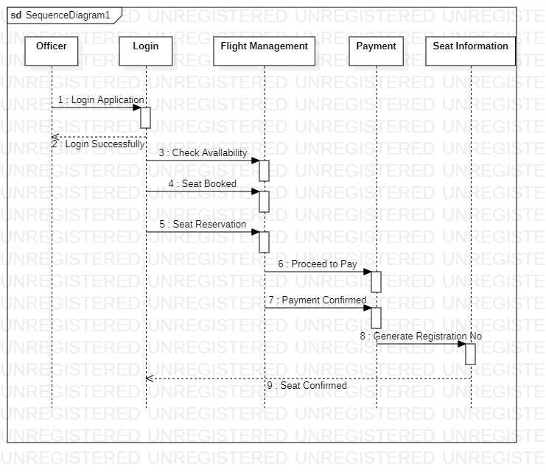

- Collaboration Diagram for Login: optional
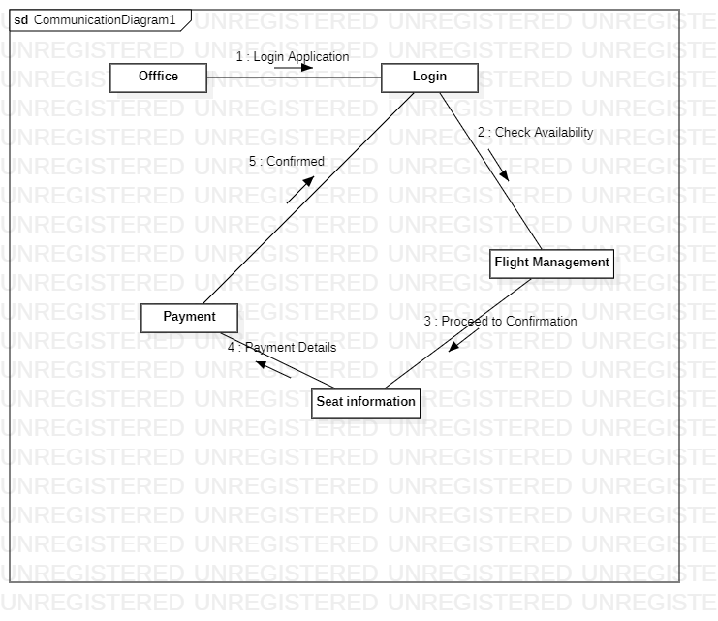

- Activity Diagram for Login: optional
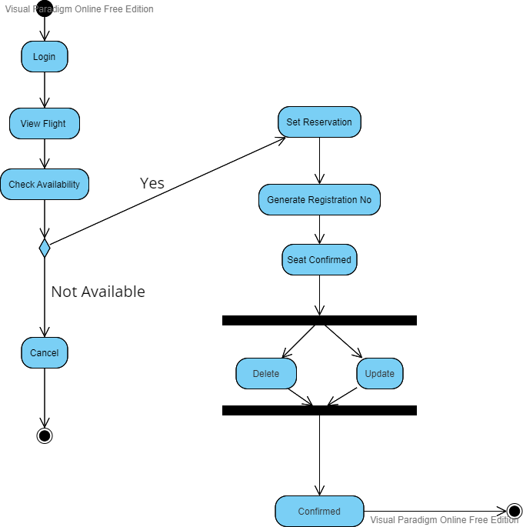

- Class Diagram for Login: optional
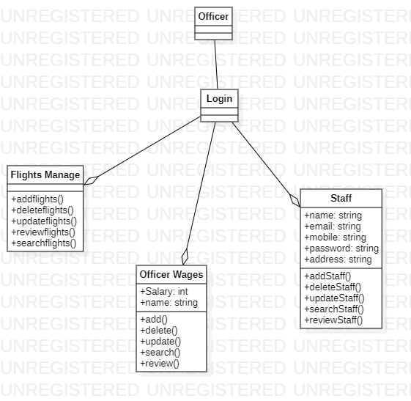

- State Chart Diagram for Login: optional
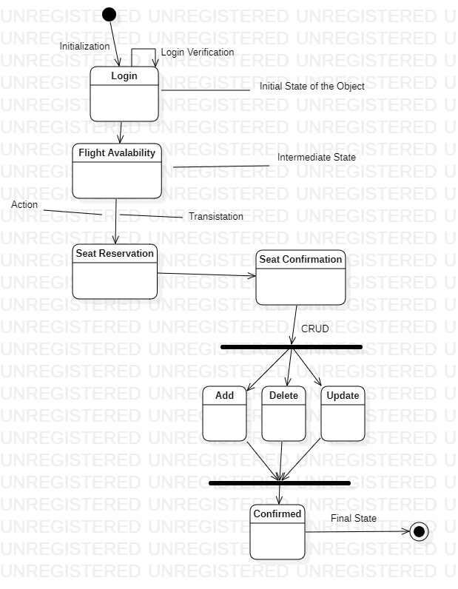

    - Module 3 complete CRUD Manage a Flights (MUHAMMAD HUZAIFA-10562)
- Description:
- Add Flights
- Delete Flights
- Update Flights
- Review Flights
- Search Flights
- Usage Scenario/ Use case Description/ Specification:

Description | [ make | drop | view | update] a reservation to the user’s account
Inputs | From city, to city, seat type, travel date, return date and time
Source | - User inputs from city, to city, seat type, travel date, return date and time  - Press Button …

Alternate case
Outputs | Added | Deleted | Viewed | Modified reservation
Destination | Computer screen  Reservation database  Staff Account database
Precondition | Valid information; Plain route and tickets available; user does not have another reservation at the same time
Post Condition | Reservation added to staff account
Side Effects | User’s current reservations adjusted  Balance due adjusted

- Detailed Use case Diagram for Login: optional
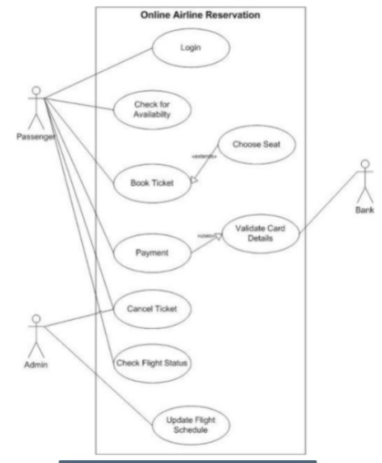

- Flow of Event or Data Flow Diagram for Login: optional

- Sequence Diagram for Login: optional

- Collaboration Diagram for Login: optional
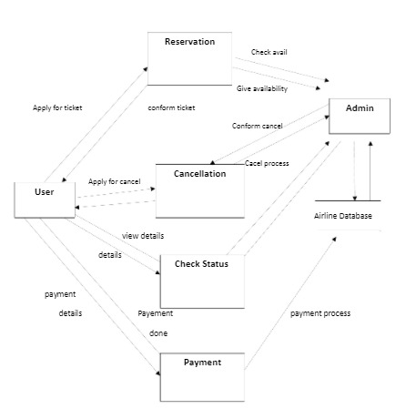

- Activity Diagram for Login: optional

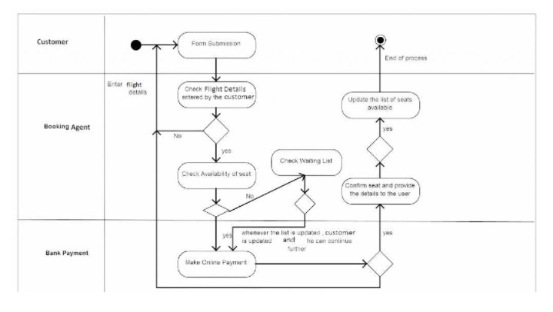

- Class Diagram for Login: optional

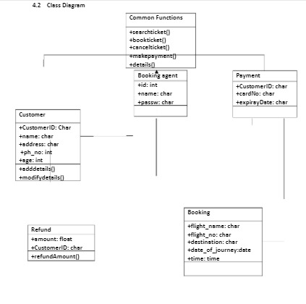

- State Chart Diagram for Login: optional
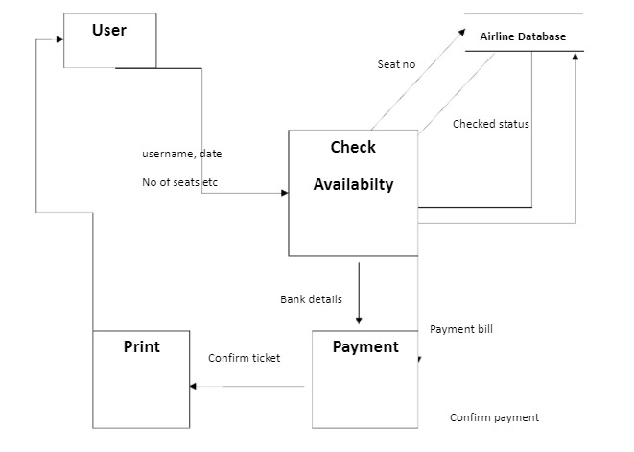

    - Module 4 complete CRUD Make a Reservation Function
FLIGHT SHEDULING (Abdur Rehman{10875})
- Schedule Flight after Book.
- Cancel Flight After Booking.
- Searching Flight after Booking.
- Change in Payment.
USE CASE DIAGRAM:
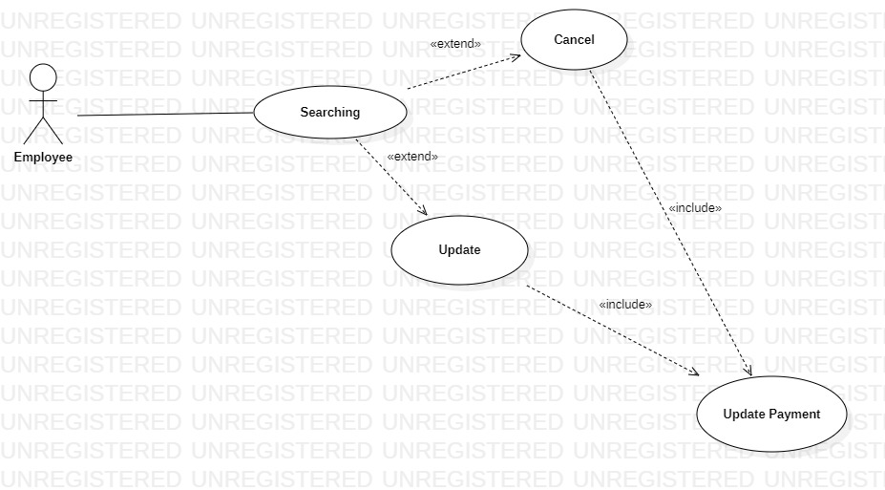
SEQUENCE DIAGRAM:
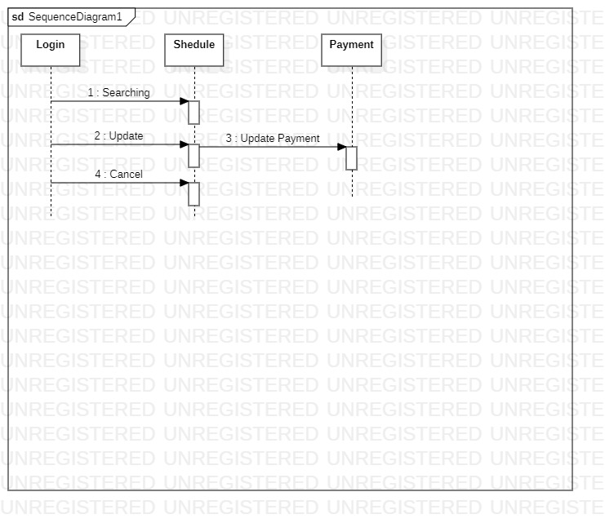
ACTIVITY DIAGRAM
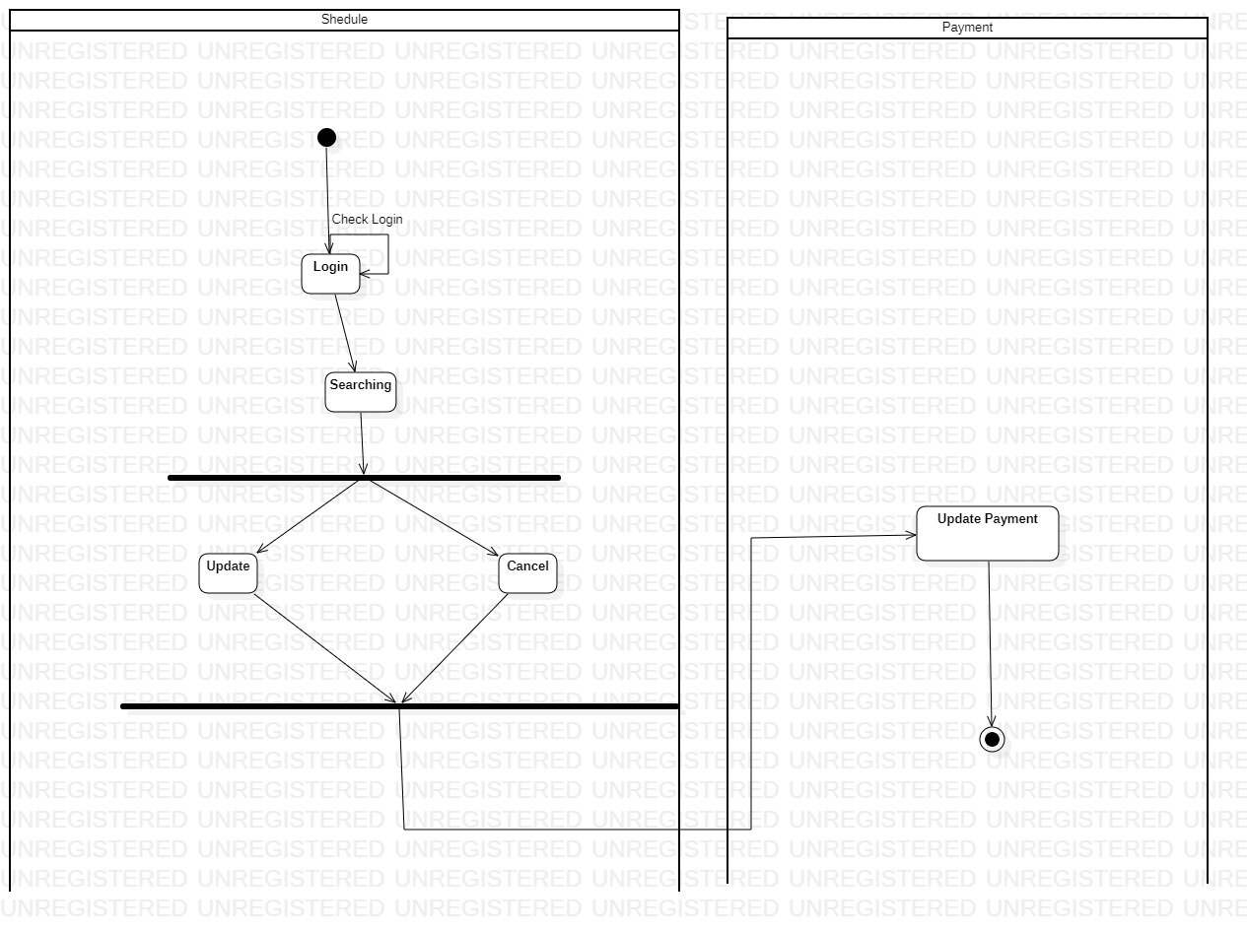
COMMUNICATION DIAGRAM:
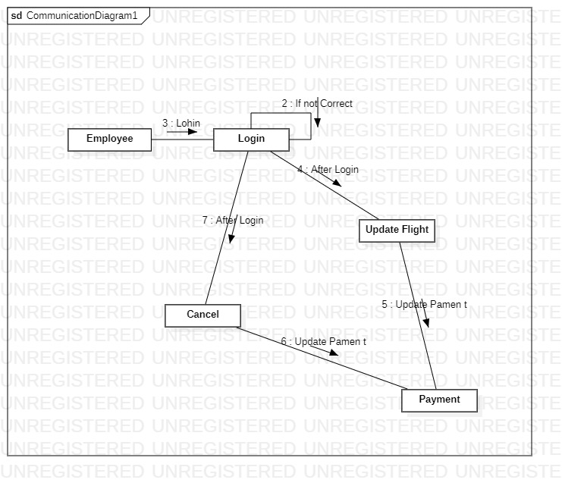
CLASS DIAGRAM: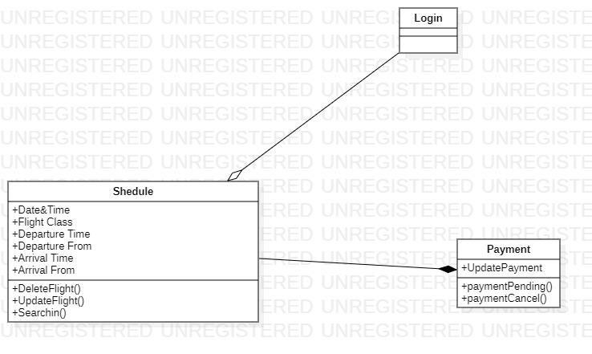

3.1.6 Module 5 complete CRUD Make a Reservation Function
PAYMENT(MUHAMMAD HUZAIFA-10830)
user can :
- Online booking
- Payments
- Cancel Payments
- confirm Payments

USE CASE DIAGRAM:
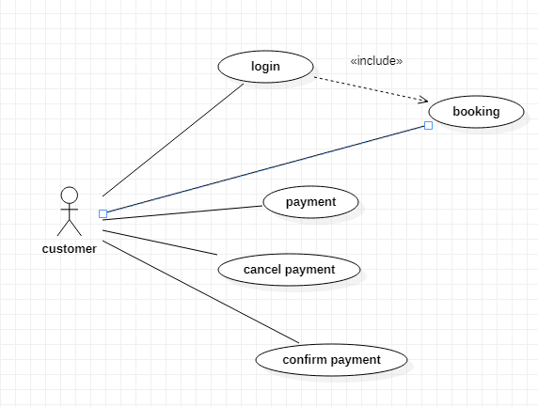

SEQUENCE DIAGRAM:
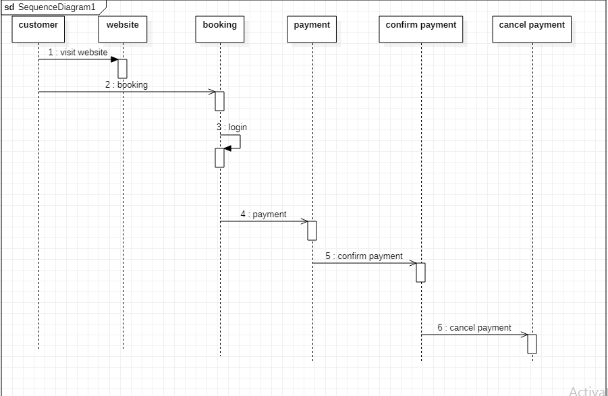

ACTIVITY DIAGRAM

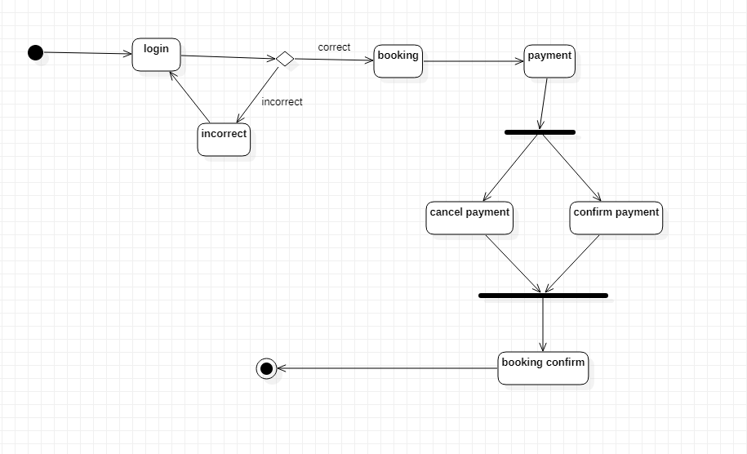

COMMUNICATION DIAGRAM

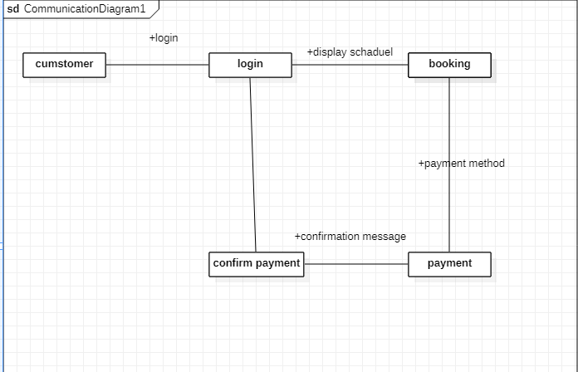
3.2. External Interface Requirements
3.2.1 User Interfaces
The user interfaces are divided into two major components. One part includes the user accessing the system using a cell phone. The other portion involves accessing the system through a remote site or at a particular location specifically designed to access the system. For instance, the clerks and the ARM access the reservation system from the reservation or ARM office.
The diagrams and explanations below demonstrate the major transition from one user interface to another. This is a brief description. However, a more detailed demonstration is done in the prototype. The purpose of this interaction is to illustrate the overall view of the ARRS.
The diagram below illustrates the four major functionalities or modules . These functionalities will be displayed depending on the user. For instance, the ARM will see all four functionalities while the normal user and the clerks will only see the Ticket Reservation and the Passenger Account.

Selecting one of these functions will take the user to a different user interface. For instance, choosing Ticket Reservation will display the following web page. The title of this page is consistent with the function selected, and since the Ticket Reservation was selected, the title displays Ticket Reservation. The purpose of this is to allow the user know what part of the system they are accessing. Furthermore, the user can select any of the four functions.

The user can select any of the four functionalities. For the sake of this demonstration, if the user clicks on the Make Reservation function the diagram below is displayed. Once again the title is the same as the main function and a subtitle indicates the second function selected. In addition, the person can fill up the following information and the date of travel or return if he/she wishes. The three buttons allow the user to navigate through the interfaces. For instance, the back button will take the user to the above page, and the clear button will clear the form of any selection he/she made before. The Display Available displays the available trains, seats and what city they want to travel to. However, before we get to the next page when clicking Display Available the picture below illustrates the Make Reservation function.

The Display Available function displays all the trains traveling from one city to another and the seats available on that train. Furthermore, the last list displays the number of tickets available for the particular train on the selected route. The back button will take the user to the above picture, and the confirm button takes the person to the payment page.

The following page allows the user to pay for the ticket as appropriate. Now, this page is part of the Passenger Account function, and it is used here to make payment for the ticket selected. This makes it easier for the user since they do not have to go back to the main menu and to access their account.

Finally, the submit button displays the appreciation page as shown below with a button to go to the main menu.

The above illustration has shown a brief overview of the user interfaces involved for the normal and clerk users. However, the ARM have specifically requested a number of reports, and they must be able to adjust their train schedule as the trains become unavailable. Therefore, the ARM interface is able to access all four functionalities as shown in the main menu (first diagram). Once the ARM selects the Reports function, a list of five reports is displayed as linked list. This is shown in the diagram below:

The report selected here shows the number of reservation for each departure. This report indicates the major traffic flow, and what trains are needed where during varying time and season. The diagram below shows the report format to be displayed.

As mentioned earlier, the system can also be accessed through the wireless phones. In that case, the overall system will be the same as the above presentation except that the format will be simplified, since the phones do not have graphic support. The phones will have access to the Make Reservation and Passenger Account, however it is difficult to display the reports and trains information on a small screen for the ARM.

3.2.2 Hardware Interfaces
The ARRS includes two major hardware components: cellular phones and regular PC's. The cell phones require WAP (wireless application protocol) network protocol, which is already programmed in the latest phones.
The second component involves the regular PC’s, which communicate with the server. The server then communicates with the database. The protocol involved between the PC's and the server is the HTTP protocol, which allows communication between the PC's and the Server. The remote PC's, such as someone accessing the ARRS from home using the Internet, are able access the information through the CGI. The requests come in through the HTTP protocol, and using an ODBC the database results are returned and processed using Perl to give an HTML web page. The format of the output is displayed as web pages.

3.2.3 Software Interfaces
An Oracle DBMS will be used to manage the database and any changes made to it. Furthermore, the DBMS will make regular backups of the database and generate reports regularly so that they can be accessed by the ARM. The Apache server between the client and the database will handle all communication, and the server will run on a Linux operating system. Furthermore, the HTML pages must be implemented such that they can be displayed on two common browsers: Netscape and Internet Explorer.

Information about the products used for the ARRS:

(1) Name: Asp.Net
(2) Mnemonic: Asp.Net
(3) Version Number: ?
(4) Source: Asp.Net

(1) Name: Windows
(2) Mnemonic: Windows
(3) Version Number: 6.2
(4) Source: Unix

(1) Name: Internet Explorer
(2) Mnemonic: IE
(3) Version Number: 5.00
(4) Source: Microsoft

(1) Name: Apache
(2) Mnemonic: Apache
(3) Version Number: 1.3.14
(4) Source: Apache Software Foundation

3.3 Performance Requirements
The following sections list the performance requirements for the system.

3.3.1 User Requirements

User Requirements | Description of Requirement For Design Environment
Location(s) and Number(s) of Users | Karachi, Islamabad
Expected Growth in Number of Users
After 1 Year | 50%
After 2 Years | TBD
After 3 Years | TBD
User Expectation
Interactivity | User expect that it provides a very easy to use graphical user interface
Reliability | For some applications, reliability must be 100% during the application session
Adaptability | Network must adapt to user additions, deletions and changes
Security | Encryption software would be used for Credit Card transactions
Cost / Funding | Less than $250K

3.3.2 Application Requirements

Since no specified service is indicated, then we have listed the applications as best – efforts. This may change as we learn more about the application.

The communication package is determined to be bursty in nature, with small data sizes and frequent transmissions. We can consider this application to be interactive-burst, while the database transaction-processing application is described by the ARM as transferring large amounts of data (initial estimates are 1 MB/transaction), we have listed this application as interactive-bulk.

Categorizing  Applications | Best-Efforts | Application  Locations
Communication | 100 Kb/s | Karachi And Islamabad
Database Access | 400 Kb/s | All Locations
Database Transaction processing | 1.5 Mb/s | All Locations

3.3.3 Host Requirements

 | Type of Host or  Equipment | Numbers and  Locations
Host A | PC | Karachi (10), Islamabad(7)
Host B | Database Server | Karachi
Host C | Application Server | Islamabad

3.4.1 Standards Compliance
There are no design constraints that can be imposed by other standards limitations.

3.4.2 Software Limitations
• must be able to run Internet Explorer or Netscape Communicator web browsers to access the system.
• must have cell-phone web based capability to access the system from a mobile phone.

3.4.3 Hardware Limitations
• Input/Output: One or two-button mouse, keyboard, cell-phone, or touch screen required.
• Network card required at thin-client terminals to make communication with server possible.

3.5 Quality Characteristics
There are a number of quality characteristics that apply to the ARRS software system.

3.5.1 Portability
The ARRS system will be developed using MVC so that it can be accessed from any type of system using just a regular web browser. It will also be available to users that have web access on their cellular phones. The system will be tested on all types of hardware before being released to ensure that is it compliant with this requirement.

3.5.2 Reliability

The system should be capable of processing a given number of reservations within a give time frame with no errors and the system should be available and operational all the time. During the development of the prototype for the 3 cities, the system will be tested in its actual environment to ensure that it can handle the load of reservations that occur during a regular workday.

3.5.3 Usability
The ARRS system will be developed so that it is an easy to use system that requires the least amount of user input possible. Every input will be validated. The user should only have general computer use knowledge. Error messages will be displayed if the user enters an invalid value or tries to access a function without the required permissions. An easy and well-structured user manual will be provided to the ARM and the system will include descriptive help for all operations allowed.
3.5.4 Correctness
The ARRS system will be considered correct when the ARM approves the prototype presented and agrees that all the functions they require are implemented as stated in the Software Requirements Specification.
3.5.5 Flexibility
The ARRS system should be developed in such a way that it is easily customizable. If new functions are required by ARM, there will be little effort required to update the system to support new cities or new transactions.
3.5.6 Security

The ARRS system should not compromise the customer information at any time. The user information will never be sold to other parties and will be kept secure at all times. Users will be authenticated to ensure that no unauthorized users gain access to private information.

3.5.7 Maintainability
The ARRS source code will be kept well structure and documented so that it is easier to maintain and extend the system. All changes to the system shall be documented.

3.6 Other Requirements
Certain requirements may, due to the nature of the software, the user organization, etc., be placed in separate categories such as those below.

3.6.1 Data Base

The Automate Airline Reservation System will have two main databases. One is the Reservation Database, and another is the Passenger Account Database. These database will be created with Oracle8i (Client/Server) version 8.1.6.0.0 Release 2. The following are the requirements for these databases that are to be developed as part of the product. They include:

Reservation Database
Types of information | Schedule information for the trains, including date, time, departure city, destination city, ticket cost and ticket availability for a particular train
Frequency of use | Depends on the passenger demand, which may reach 25,000 per day during peak periods
Accessing capabilities | The database should allow access to at least 1,000 people at once; the users will have a general access to the information about the train schedule, and a secure access to the reports (available only to ARM officials) using a username and a password
Data element and file descriptions | To be determined
Relationship of data elements, records and files | To be determined
Static and dynamic organization | To be determined
Retention requirements for data | Train schedule information will be available as long as the train for a particular route is in use and at least one year after the train has been cancelled. The reports information will be available at least for 5 years

Passenger Account Database
Types of information | Passenger account information including their name, address, phone numbers, last reservations, balance owed, credit card number (if they paid by a credit card)
Frequency of use | Depends on the passenger demand, which may reach 25,000 per day during peak periods
Accessing capabilities | The database should allow access to at least 500 people at once; the users will have a secure access to the database using a username and a password
Data element and file descriptions | To be determined
Relationship of data elements, records and files | To be determined
Static and dynamic organization | To be determined
Retention requirements for data | Passenger account will be available for as long as a passenger is using the account, and at least for 6 month since the passenger logged on last time.

3.6.2 Operations
The normal operations required by the user can be viewed as the following:
User-initiated Operations:
These operations include the login operation, which is initiated by the users. Also, the process of becoming a new user is in this category. Building, changing, and viewing itineraries, as well as paying for the itinerary are all initiated by the users. The user initiates the report generation activity, as well as changing train schedules.
Interactive Operations and Unattended Operations:
The users initiate all the operations mentioned above, and almost all of them are somehow interactive. Displaying the train schedule is non-interactive. The report display is a non-interactive operation, although selecting the desired reports will require user input.
Data Processing Support Functions:
The user account data is used to create new accounts, as well as to validate user id's during login functions. For building itineraries, user input, user account data, and train schedule data are used, and processed. User data along with final results of user interaction (whether the user purchased a trip, number of tickets bought, etc.) are collected, and used for report generation purposes. Administrative users' inputs are collected in order to modify and present schedules.
Backup and Recovery Operations:
Both databases used (passenger account database and reservations database) are production databases. The main operation used for the backup and recovery is Oracle's built-in cold backup, which is also known as the "archive mode". Depending on the customer's needs and budget, additional redundancy can be added using systems like RAID 5 and tape backup.
3.6.3 Site Adaptation Requirements
There are no site adaptation requirements for this project.

4. Supporting Information.
There is no supporting information required for this project.

