Measurement Scarcity Limits Multi-Channel Cardiac Ion-Channel Liability Prediction: A Public-Data Audit
Muhammadjon Tursunbadalov* and Mustafojon Tursunbadalov
School of Science and Technology, Champions College Prep, Houston, TX, USA
*Corresponding author: yaiuftuto@gmail.com
Abstract—Robust assessment of drug-induced proarrhythmia is widely held to require several cardiac ion channels rather than the human ether-a-go-go-related gene (hERG) channel alone. The Comprehensive in vitro Proarrhythmia Assay (CiPA) framework names hERG, the cardiac sodium channel Nav1.5, and the L-type calcium channel Cav1.2 as core targets. Yet most published machine-learning (ML) liability models address hERG in isolation. This study investigates whether the public data needed to build the multi-channel models the field calls for actually exists, treating data availability as the explicit object of study. We use a large hERG benchmark from the Therapeutics Data Commons together with all public half-maximal inhibitory concentration (IC50) measurements for Nav1.5 and Cav1.2 in ChEMBL. We quantify four aspects: per-channel data volume and class balance; compound overlap across channels; the effect of training-set size on a controlled hERG learning curve; and the reliability of real Nav1.5 and Cav1.2 classifiers under random and scaffold splits with bootstrap confidence intervals. We find a steep scarcity gradient (hERG, 12,101 compounds, 50.1% active; Nav1.5, 2,830, 8.2%; Cav1.2, 463, 6.9%). Only 90 compounds are measured against all three channels. hERG performance degrades smoothly as data is withheld. Most importantly, low-active-count channels yield point estimates that appear strong but carry intervals so wide they are uninformative (Cav1.2 area under the receiver operating characteristic curve, 95% confidence interval [0.70, 1.00]). Scaffold splitting barely changes these estimates, indicating that the binding constraint is the number of labeled actives, not train–test similarity. Our findings indicate that public measurement scarcity appears to be the primary factor limiting multi-channel cardiac-liability modeling, rather than channel-specific difficulty. We provide a reproducible audit protocol. This work is a data and benchmarking analysis; it does not introduce a new modeling method.
Index Terms—cardiotoxicity, hERG, Nav1.5, Cav1.2, CiPA, machine learning, data scarcity, benchmarking, uncertainty estimation, ChEMBL.

I. INTRODUCTION
Drug-induced blockade of the hERG-encoded potassium current can prolong cardiac repolarization and the QT interval. In the worst case it triggers the arrhythmia torsades de pointes. Because hERG liability is a leading cause of late-stage attrition and market withdrawal, in silico hERG filters are now standard early in discovery, and a large literature of ligand-based machine-learning (ML) classifiers exists for this single target.
Proarrhythmic risk, however, is not governed by hERG alone. A compound that blocks hERG may be clinically safe if it also modulates inward currents. This is the rationale for the CiPA framework, which evaluates multiple channels—most prominently hERG, the cardiac sodium channel Nav1.5 (gene SCN5A), and the L-type calcium channel Cav1.2 (gene CACNA1C). A recent scoping review notes that ML cardiotoxicity work has nonetheless remained concentrated on hERG, leaving the multi-channel picture comparatively unmodeled.
The usual explanation is methodological habit. We test a more basic explanation: that the labeled data required to build reliable non-hERG models may simply be too sparse. Rather than propose another model, we audit the data. Because integrated multi-channel models require measurements from the same compounds across all channels, overlap—not merely per-channel dataset size—is the fundamental limiting resource. The main contributions of this work are summarized below.
- A per-channel scarcity and class-balance characterization for hERG, Nav1.5, and Cav1.2 from public sources.
- An exact-structure overlap analysis quantifying how few compounds are measured against all three channels.
- A controlled hERG data-starvation experiment that isolates training-set size as a driver of performance.
- Interval-estimated Nav1.5 and Cav1.2 classifiers under random and scaffold splits, showing that the count of labeled actives, not the split, is the limiting factor.
All results are reproducible from public data. The end-to-end workflow is summarized in Fig. 1.
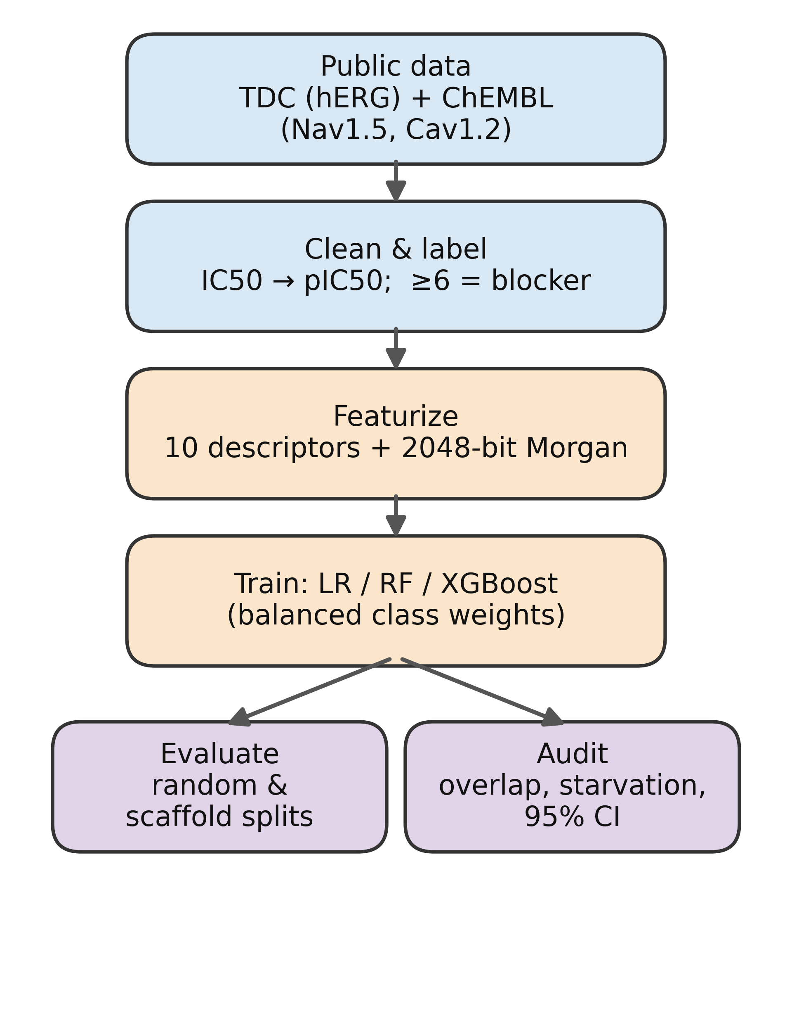
Fig. 1. End-to-end audit workflow, from public data acquisition through labeling, featurization, model training, and evaluation/audit.
II. MATERIALS AND METHODS
A. Datasets
hERG binary blocker data were obtained through the Therapeutics Data Commons (TDC). The larger hERG_Karim set (9,412 training and 2,689 test compounds; 50.1% blockers in training) served as the primary resource, and the smaller TDC hERG set was used for cross-source comparison. Nav1.5 (ChEMBL target CHEMBL1980) and Cav1.2 (CHEMBL1940) activities were retrieved from ChEMBL as IC50 measurements (accessed June 2026; the exact release is recorded in the repository). For these two channels, records reported in nM were retained, non-positive or missing values were discarded, and replicate measurements of a compound were collapsed to the median.
IC50 values were converted to pIC50 = 9 − log10(IC50 in nM). A compound was labeled active (a blocker) if pIC50 ≥ 6 (IC50 ≤ 1 µM) and inactive otherwise. Cleaning yielded 2,830 unique Nav1.5 compounds (8.2% active) and 463 unique Cav1.2 compounds (6.9% active).
B. Molecular featurization
Each compound was parsed from its SMILES string with RDKit and represented by ten interpretable physicochemical descriptors (molecular weight, MolLogP, topological polar surface area, hydrogen-bond acceptors and donors, rotatable bonds, aromatic-ring count, total ring count, fraction of sp3 carbons, and heavy-atom count) concatenated with a 2,048-bit radius-2 Morgan fingerprint, giving 2,058 features per compound. The identical featurizer was applied to every channel.
C. Models and reproducibility
Three classifiers were trained for hERG: L2-regularized logistic regression (C = 1.0, max_iter = 2000), a random forest (300 trees, Gini criterion, bootstrap sampling), and gradient-boosted trees (XGBoost; 300 estimators, max depth 6, learning rate 0.1, subsample 0.9, log-loss objective). Tree ensembles received unscaled features; logistic regression received features standardized with a scaler fit on the training partition only and applied unchanged to validation and test data, preventing information leakage from evaluation data. For the imbalanced Nav1.5 and Cav1.2 channels, a balanced-class-weight random forest was used. A fixed seed (42) was used throughout. Analyses ran in Python 3.12 with scikit-learn 1.2.2, NumPy 1.26.4, RDKit, XGBoost, and PyTDC on Google Colab (CPU runtime); all package versions are pinned in the repository requirements file.
D. Evaluation, overlap, starvation, and splits
Performance was summarized with the area under the receiver operating characteristic curve (ROC-AUC), the Matthews correlation coefficient (MCC), F1, and balanced accuracy. MCC and balanced accuracy were emphasized because they are robust to class imbalance. Cross-channel overlap was measured by converting every compound to a canonical SMILES string and counting exact-structure matches between channels, including the count present in all three. To isolate the effect of data volume, random forests were trained on random subsamples of the hERG training set at eight sizes from 9,412 down to 120 compounds, each repeated five times, and evaluated on the fixed, balanced hERG test partition. For the Nav1.5 and Cav1.2 models, both a stratified random split and a Bemis–Murcko scaffold split (whole scaffold families assigned entirely to train or test) were used. The 95% confidence intervals (CIs) for every metric were obtained from 1,000 bootstrap resamples of the test set (percentile method).
III. RESULTS
A. A steep per-channel scarcity gradient
The three channels differ by more than an order of magnitude in data volume and also in class balance (Table I, Fig. 2). hERG is large and balanced; Nav1.5 is roughly a quarter of its size and strongly imbalanced; Cav1.2 is 26 times smaller than hERG and contains only 32 actives in total.
TABLE I. Per-channel data volume and class balance (public sources).
Channel | Compounds | Actives | Inactives | Active %
hERG (KCNH2) | 12,101 | 6,057 | 6,044 | 50.1
Nav1.5 (SCN5A) | 2,830 | 231 | 2,599 | 8.2
Cav1.2 (CACNA1C) | 463 | 32 | 431 | 6.9
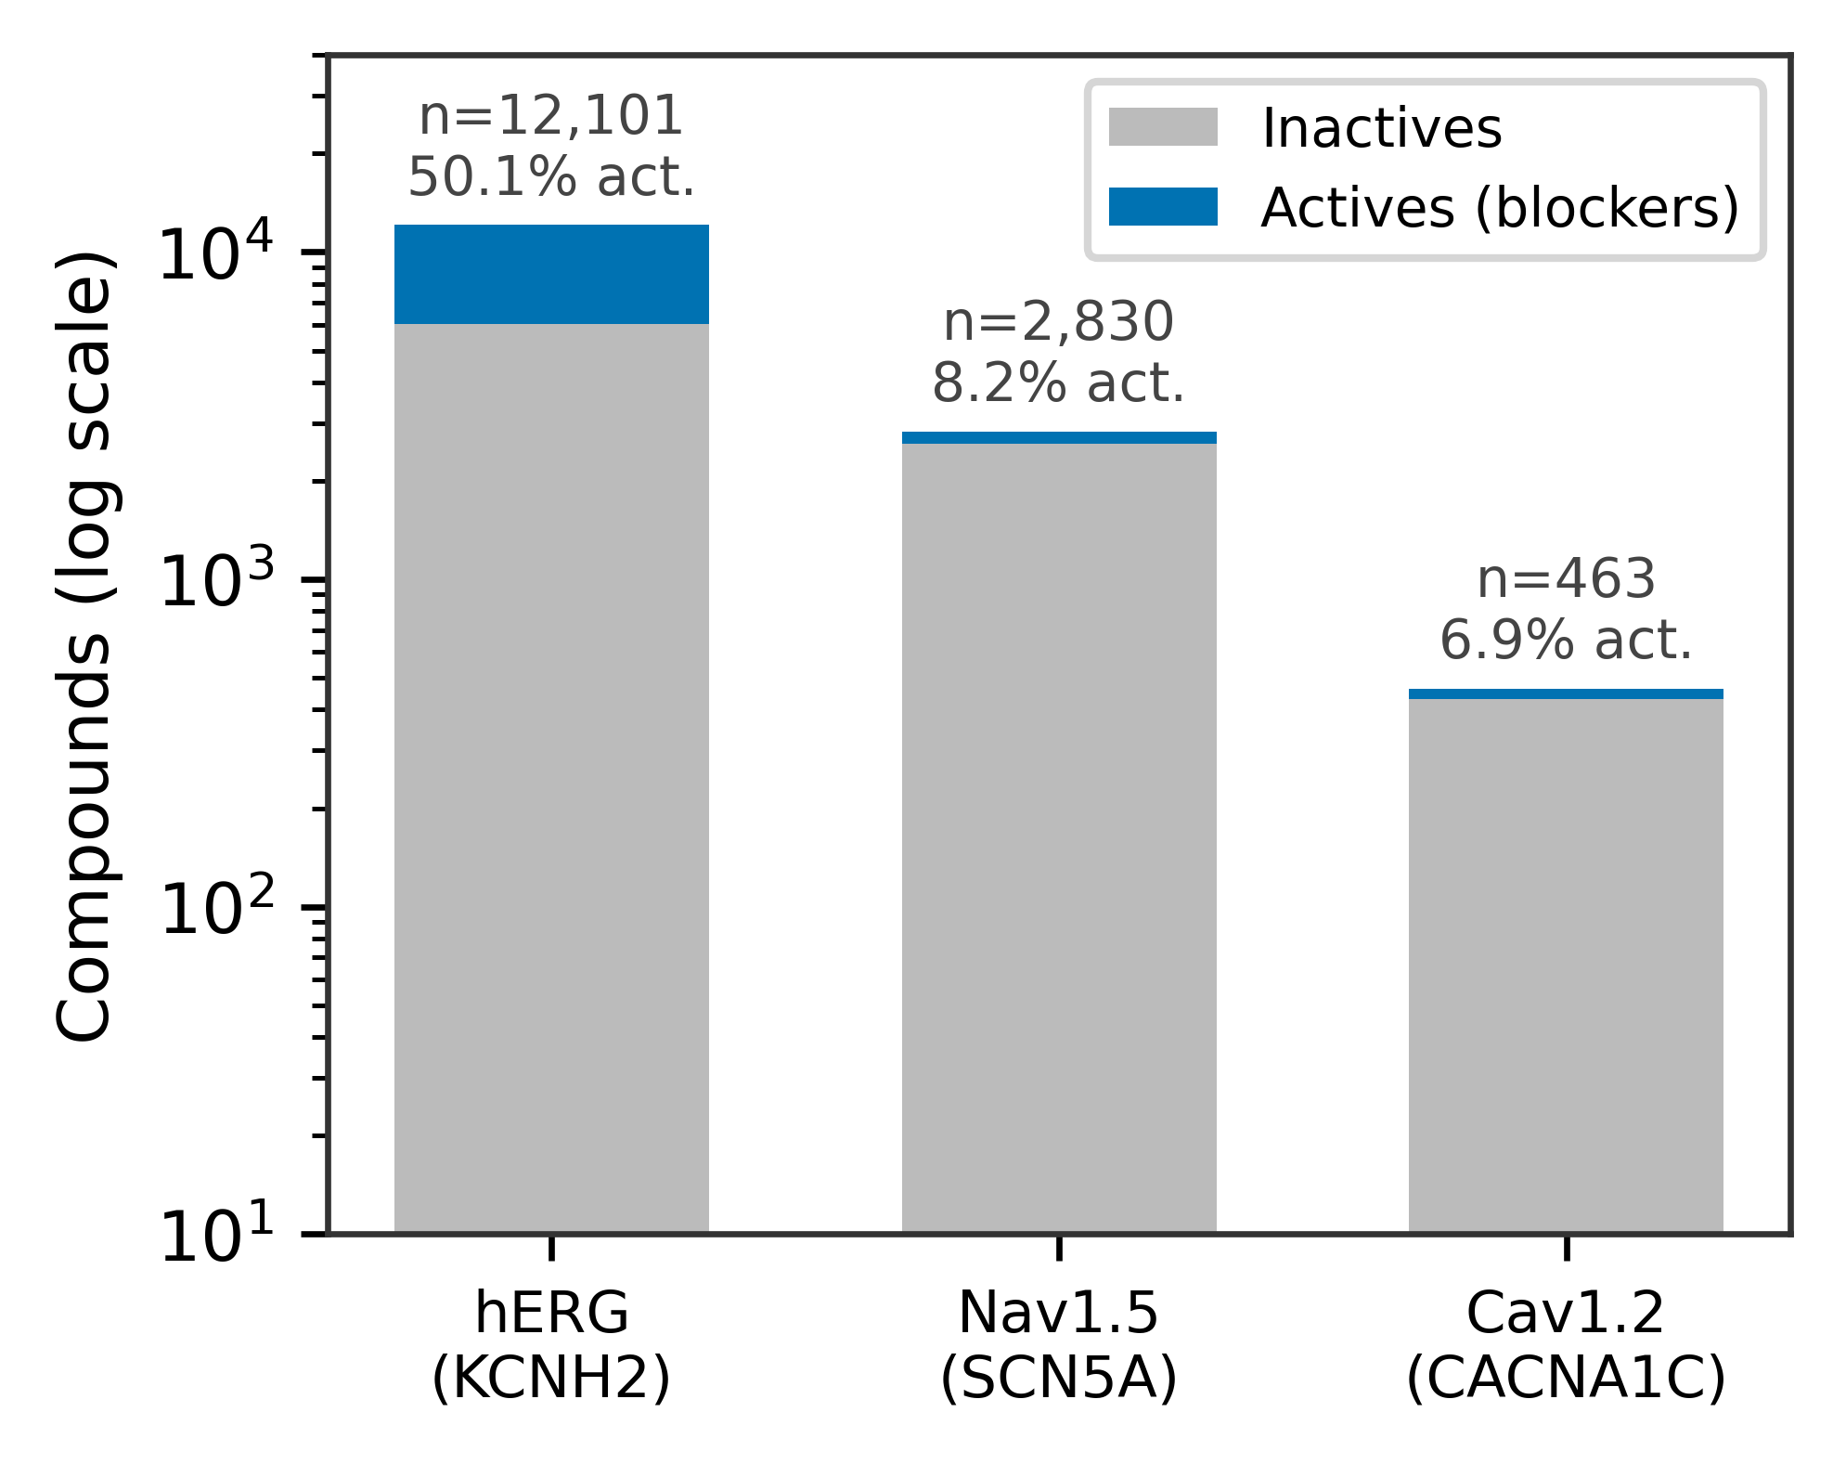
Fig. 2. Compound counts per channel (log scale), split into actives and inactives. Data shrink and grow more imbalanced from hERG to Cav1.2.
B. The complete three-channel dataset is essentially empty
Exact canonical-structure matching shows that the channels barely overlap (Fig. 3). Only 306 compounds are common to hERG and Nav1.5, 116 to hERG and Cav1.2, and 221 to Nav1.5 and Cav1.2. Critically, just 90 compounds have been measured against all three channels. A per-compound, fully labeled multi-channel dataset—the natural input to any integrated proarrhythmia model—therefore does not meaningfully exist in public IC50 data; after a train/test division only a few dozen such compounds remain.
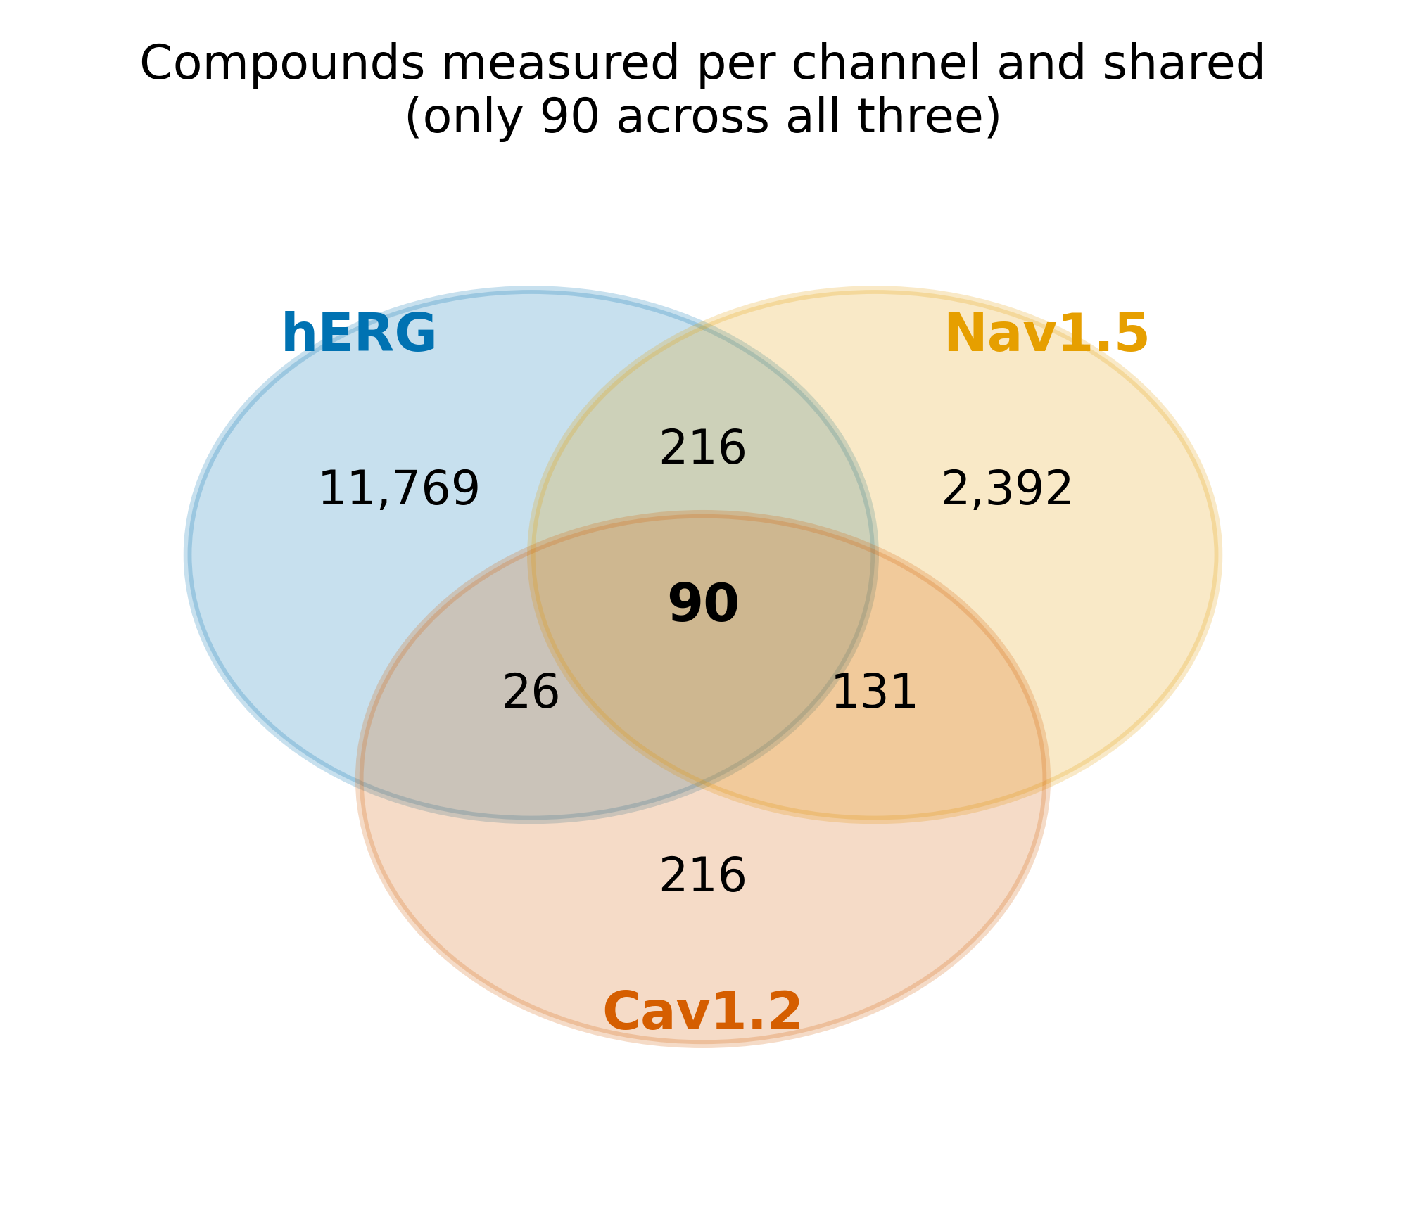
Fig. 3. Cross-channel compound overlap (not to scale). Only 90 compounds are measured against all three channels.
C. Training volume bounds achievable performance
Holding the model, features, chemistry, and balanced test set fixed, hERG ROC-AUC declines smoothly and monotonically as training data is withheld: from 0.928 at the full 9,412 compounds to 0.873 at Nav1.5-equivalent volume (2,830), 0.782 at Cav1.2-equivalent volume (463), and 0.698 at 120 compounds (Fig. 4; run-to-run standard deviation ≤ 0.008). Because only the amount of training data changes, this isolates data volume, not anything channel-specific, as a direct driver of achievable performance on a clean benchmark.
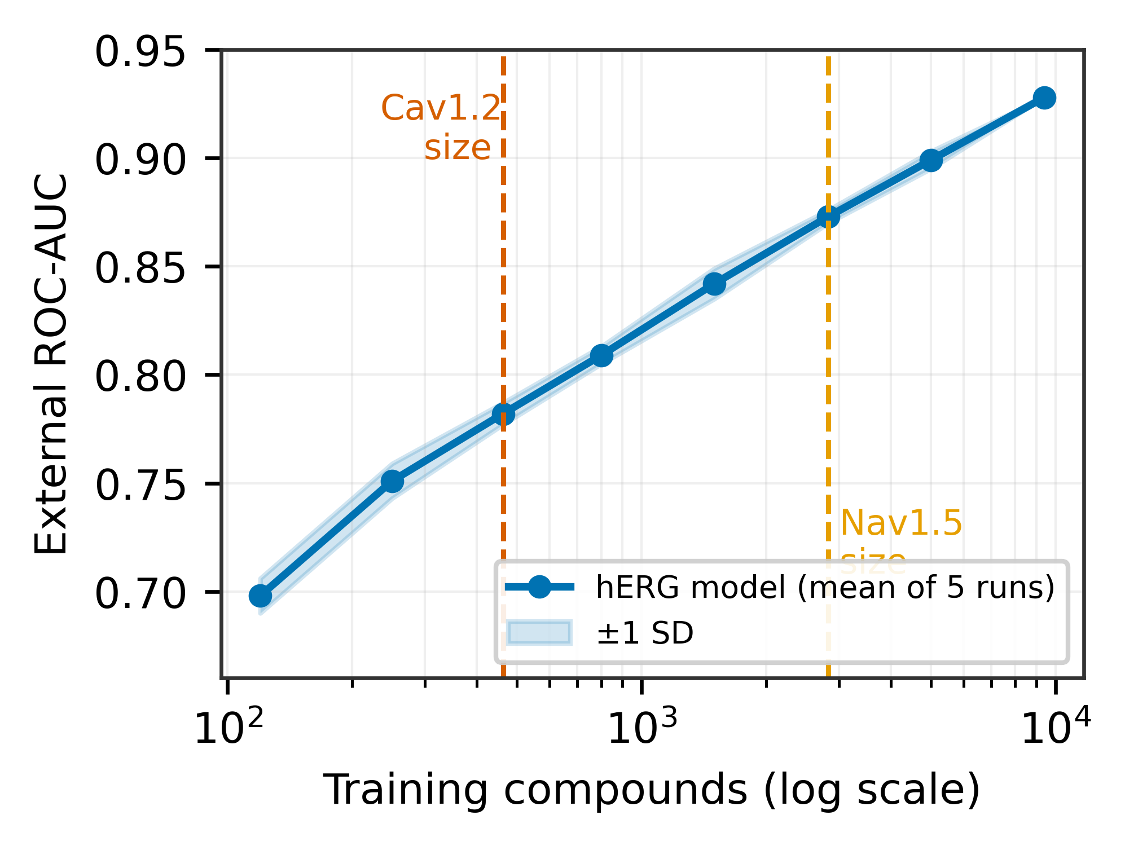
Fig. 4. hERG ROC-AUC versus training-set size (log scale; mean of five runs, shaded ±1 SD). Dashed lines mark the real data volumes of Nav1.5 and Cav1.2.
D. Low-active channels are not measurable, and splits do not rescue them
Real Nav1.5 and Cav1.2 classifiers post high ROC-AUC point estimates (Table II, Fig. 5), but the estimates must be read together with their CIs and active counts. Nav1.5, with 58–78 test actives, attains ROC-AUC near 0.95 with a moderate interval that survives scaffold splitting. Cav1.2, with only eight test actives, returns ROC-AUC near 0.92 but a 95% interval spanning [0.70, 1.00] and an MCC interval spanning [0.19, 0.91]—from near-chance to near-perfect. The point estimate is therefore uninformative. Moving from a random to a scaffold split changes the estimates by at most 0.007 ROC-AUC, indicating that train–test structural similarity is not what supports these numbers; the binding constraint is the scarcity of labeled actives, which no choice of split can remedy.
TABLE II. Nav1.5 and Cav1.2 under random and scaffold splits; median [95% bootstrap CI]. na = actives in test set.
Channel | Split | na | ROC-AUC | MCC
Nav1.5 | Random | 58 | 0.952 [0.914, 0.975] | 0.597 [0.476, 0.712]
Nav1.5 | Scaffold | 78 | 0.945 [0.920, 0.965] | 0.591 [0.491, 0.680]
Cav1.2 | Random | 8 | 0.922 [0.782, 0.996] | 0.658 [0.277, 0.900]
Cav1.2 | Scaffold | 8 | 0.921 [0.697, 1.000] | 0.627 [0.193, 0.909]
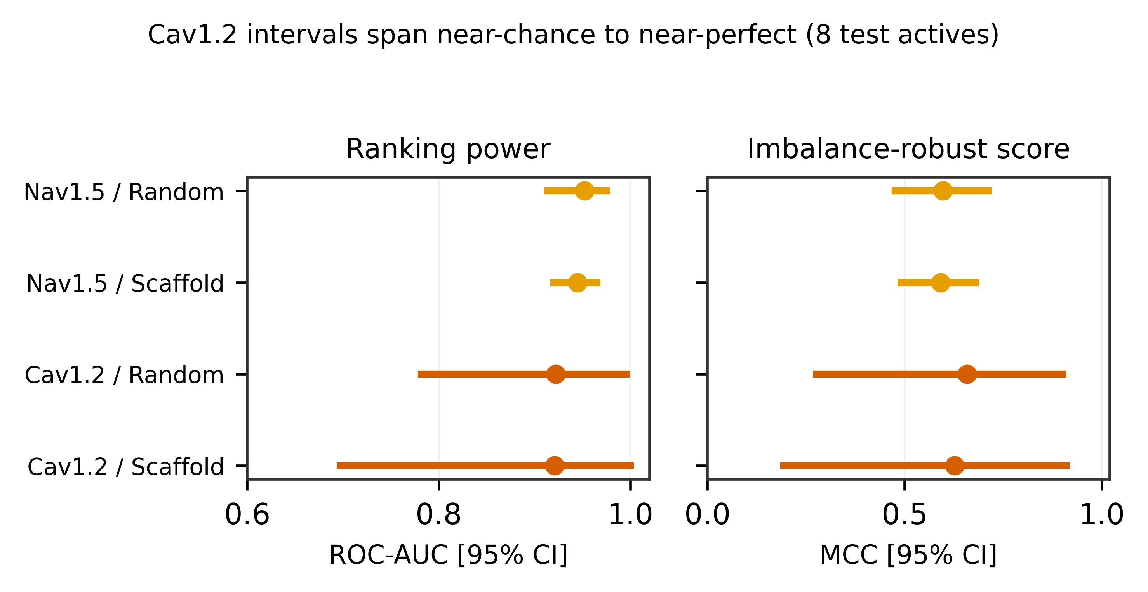
Fig. 5. Bootstrap 95% CIs for ROC-AUC and MCC. Cav1.2 intervals span near-chance to near-perfect because only eight actives appear in its test set.
For reference, the hERG ensembles reached internal ROC-AUC 0.927 (random forest) and 0.911 (XGBoost), with a logistic-regression baseline of 0.841, consistent with the published hERG literature and confirming that the pipeline is sound.
IV. DISCUSSION
Two complementary results define the bottleneck. The controlled starvation curve shows that, on a clean and balanced benchmark, the performance a model can achieve is bounded by how many training compounds it has seen. The real-channel experiment shows that, separately, the performance a model can be shown to have is bounded by how many actives appear in the test set: with eight Cav1.2 actives, the CI swallows the estimate. Both point to limited experimental coverage as the dominant contributor, rather than to an intrinsic difficulty of sodium or calcium channels, although channel-specific effects cannot be entirely excluded.
A natural assumption is that more careful evaluation, such as scaffold splitting, would expose inflated small-data scores. Our data do not support that assumption here: scaffold and random splits gave almost identical estimates for both channels. The honest reading is not that the under-studied channels are well modeled, but that at these sample sizes the evaluation is too underpowered for the split protocol to matter. Reporting a single strong AUC on a few hundred compounds with a handful of actives therefore conveys little, regardless of how the split is constructed.
The practical implication is that the multi-channel cardiac-safety modeling the CiPA framework motivates is, at present, data-limited rather than method-limited. Progress likely depends first on generating and openly sharing Nav1.5 and Cav1.2 actives—and, ideally, compounds profiled across all three channels—before further architectural sophistication can be expected to help.
V. LIMITATIONS
Several limitations bound these conclusions. Overlap was detected by exact two-dimensional canonical-structure matching only; analogs, salts, stereoisomers, and tautomers were not merged, so the true three-channel overlap is at most 90 and likely smaller. Public bioactivity data are also subject to publication bias, assay heterogeneity, and differences in experimental protocol between source datasets, which add noise to the labels. A single descriptor and fingerprint representation and conventional models were used; graph neural networks and pretrained molecular encoders were not assessed and could shift absolute performance, though not the active-count limit on measurability. Binary labels inherit the 1-µM threshold and the curation choices of the source datasets. The Cav1.2 test set is very small, so its intervals are wide by construction; this is the finding, but it also precludes fine model ranking. No prospective or temporal validation was performed, and results are specific to the public resources analyzed. This study makes no claim of methodological novelty.
VI. CONCLUSION
Public data for the non-hERG channels central to multi-channel cardiac-safety assessment are scarce and heavily imbalanced, and almost no compounds are profiled across all three. A controlled experiment shows that training volume bounds achievable accuracy, while the under-studied channels show that the number of labeled actives bounds whether accuracy can be measured at all, independent of the train/test split. Multi-channel cardiotoxicity modeling therefore appears to be constrained primarily by measurement scarcity rather than by channel difficulty. We hope this audit provides a benchmark for future multi-channel cardiotoxicity datasets and encourages community-wide reporting standards that emphasize uncertainty alongside predictive accuracy.
Data and Code Availability
hERG data are available through the Therapeutics Data Commons; Nav1.5 and Cav1.2 data are available through ChEMBL. Code, cleaned datasets, trained models, and figures are available at https://github.com/Muhammadjon-crypto/multichannel-cardiotox-audit and archived on Zenodo (DOI: 10.5281/zenodo.21054505).
Use of AI Tools
AI-assisted tools were used for code scaffolding and manuscript drafting. All analyses and results were independently executed and verified, and the authors take full responsibility for the content.
REFERENCES
[1] J.-Y. Han et al., “Machine learning for predicting human drug-induced cardiotoxicity: a scoping review,” Toxics, vol. 13, no. 12, art. 1087, 2025.
[2] T. Colatsky et al., “The Comprehensive in Vitro Proarrhythmia Assay (CiPA) initiative—update,” J. Pharmacol. Toxicol. Methods, vol. 81, pp. 15–20, 2016.
[3] X. Bai et al., “Machine learning-enabled drug-induced toxicity prediction,” Adv. Sci., 2025.
[4] A. Karim, M. Lee, T. Balle, and A. Sattar, “CardioTox net: a robust predictor for hERG channel blockade based on deep learning meta-feature ensembles,” J. Cheminform., vol. 13, art. 60, 2021.
[5] C. Cai et al., “Deep learning-based prediction of drug-induced cardiotoxicity,” J. Chem. Inf. Model., vol. 59, no. 3, pp. 1073–1084, 2019.
[6] I. Arab and K. Barakat, “ToxTree: descriptor-based machine learning models for hERG and Nav1.5 cardiotoxicity liability prediction,” arXiv:2112.13467, 2021.
[7] K. Huang et al., “Artificial intelligence foundation for therapeutic science,” Nat. Chem. Biol., vol. 18, pp. 1033–1036, 2022.
[8] D. Mendez et al., “ChEMBL: towards direct deposition of bioassay data,” Nucleic Acids Res., vol. 47, no. D1, pp. D930–D940, 2019.
[9] G. Landrum, “RDKit: open-source cheminformatics,” https://www.rdkit.org (accessed Jun. 2026).
[10] G. W. Bemis and M. A. Murcko, “The properties of known drugs. 1. Molecular frameworks,” J. Med. Chem., vol. 39, no. 15, pp. 2887–2893, 1996.
[11] T. Chen and C. Guestrin, “XGBoost: a scalable tree boosting system,” in Proc. 22nd ACM SIGKDD, 2016, pp. 785–794.
[12] F. Pedregosa et al., “Scikit-learn: machine learning in Python,” J. Mach. Learn. Res., vol. 12, pp. 2825–2830, 2011.
[13] R. P. Sheridan, “Time-split cross-validation as a method for estimating the goodness of prospective prediction,” J. Chem. Inf. Model., vol. 53, no. 4, pp. 783–790, 2013.
[14] J. Bernett et al., “Guiding questions to avoid data leakage in biological machine learning applications,” Nat. Methods, vol. 21, no. 8, pp. 1444–1453, 2024.
[15] B. W. Matthews, “Comparison of the predicted and observed secondary structure of T4 phage lysozyme,” Biochim. Biophys. Acta, vol. 405, no. 2, pp. 442–451, 1975.

